Chapter Twenty One
Estranged but Never Forgotten

AUGUST 29, 1998
5PM

Michael’s 40th birthday had arrived and the Pop star’s home was beautifully decorated to commemorate his special day. Balloons, streamers, lights and pictures of the King of Pop during his early years were hung on every wall in his home. Jasmine ordered 110 mini gloves as a party favor resembling Michael’s iconic trademark along with black penny loafer shaped candies, clicking pens with Michael’s signature toe stand pose and small sheets of colored sticky notes signed with the icon’s autograph.
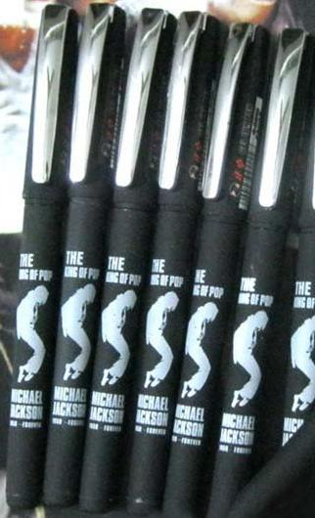

Mac arrived from New York and everyone wished him a happy belated birthday in unison. For his gift, Jasmine gave the child actor an oversized poster of Neverland with a handwritten message in the middle of the photo:

Mac,
Without you, we are home alone.
Happy 18th birthday!
Love, the Jacksons and Aversons.’

Mac loved the banner and said he’d hang it up on his living room wall. As a special surprise, Diana arranged to have Mac’s father Christopher, brother Kieran and sister Rory join him and the rest of us on his special day.

Michael was at the recording studio with Teddy all day giving the caterers and decorators plenty of time to put everything in place. Earlier, Jasmine and the future Mrs. Jackson went shopping for their Michael themed dresses then headed to the spa to get their hair, nails and makeup done. The entire security staff at Neverland patrolled the grounds regularly making sure no reporters or paparazzi would try and sneak onto the premises wanting to take pictures of Michael and his children for their false, malicious stories.

Kai spent all morning in the kitchen preparing her organic cuisines while Bev took care of the children making sure they were perfectly groomed for their daddy and godfather’s special evening. Jasmine had a seamstress custom make the Pop star’s children’s clothing for the event that included sparkles, black shoes and a small black fedora for Prince. Paris wore an adorable black and red baby dress with gold tassels sewn into her little sleeves similar to the ones her daddy had sewn onto his signature military themed jackets.

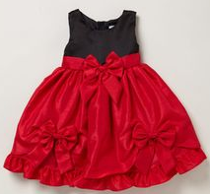

Several of Michael’s record breaking awards and achievements were placed in a locked display case in the foyer for his guests to see and admire with the original edition of ‘Thriller’ as the center of attention. The Pop star’s immediate family also came to the party wearing single gloves and sparkly clothing hoping to make their beloved family member happy on his day of birth. Everyone took turns holding Paris and Prince was definitely wowing everyone with his strikingly familiar dance moves.

“Welcome, everyone!” Mac said in the grand dining area that was now fully decorated as a gigantic and elegant ballroom. “Thank you for attending. As you know, the guest of honor has not yet arrived and I wanted to say a few words—“
“Shut up, Mac!” Jasmine said snatching the microphone from his hands that was set up near the DJ equipment. “This is YOUR party too!”
The entire crowd laughed as they waited anxiously to see the other birthday boy.

“Good evening, everyone!” Jasmine said into the microphone getting everyone’s attention. “Michael just called. He’s on his way home and will be here very soon. Please feel free to eat and drink to your heart’s content and enjoy mingling amongst each other.”

The entire crowd did just that with Kai making sure Prince wasn’t eating too many sweets and adhered to his strictly organic diet. Mac and Jasmine left to change into their evening wear. Javon entered the main house with his boss’s three angels and each of them was dressed eloquently. Bev took photos of the little ones next to their idol’s display case. Abby, Beth and Paige came dressed as their favorite singer during different eras of his life, courtesy of Jasmine.

“Don’t you three look Michaelicious?” Kai said as she entered the foyer and hugged the girls. “I love all of your outfits!”
“Thank you!” They said together.
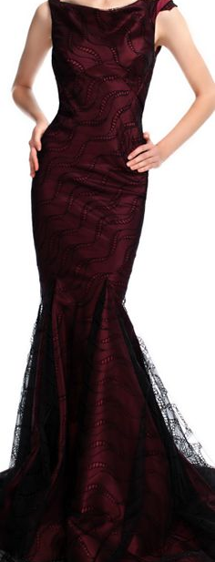
“Little Miss Thriller, Little Miss Dangerous and Little Miss Off the Wall!” I said coming down the grand staircase in my burgundy, black laced evening gown with red stiletto heels. “Michael will be so flattered.”

“I know which one is my favorite.” Quincy said eyeing Abby who was wearing a red and black outfit resembling ‘Thriller’. “Abby knows a good album when she hears one.”
“They’re all lovely.” Jasmine said entering the foyer wearing a silver gown encrusted with crystals resembling Michael’s “Rock With You” music video. “Michael will be so happy to see his little munchkins again.”
“Munchkin…” Beth said. “I like that name.”
“It’s yours now, sweetie.” Jasmine said kissing the little girl’s cheek.

“Is Mike here yet?” Mac asked entering the foyer wearing a three piece black Armani suit.
“DAAAAAANG!” Jasmine yelled. “MAC! You clean up REALLY well.”
“You’re not so bad yourself.” He said winking at my married right hand assistant.
“AHEM!” I yelled purposely clearing my throat. “We have children here and you two are both taken. Jas, go and drink some water to cool off!”
“Oh, trust me, Diana…” She said not taking her eyes off Mac. “He’s fine. I MEAN I’M FINE!”
“Got that right.” Mac replied as he left the room with the girls.

“DID YOU SEE HOW HOT HE LOOKS?”
“Jasmine, he’s 18.”
“I know. Why the hell do we have to be so old?”
“SPEAK FOR YOURSELF!” I said nudging her playfully. “I’m not old yet.”
“And you never will be dear.” Katherine said entering the foyer. “This is a wonderful party, but where is Michael?”
“On his way.” I said looking at my future mother in law’s right hand. “Nice glove, Mrs. J.”
The beautiful matriarch giggled just like her beautiful baby boy.

“I wanted to make my son smile the way he made me smile 40 years ago today.”
“You’re very sweet.” Jasmine said hugging Michael’s mother affectionately. “I wish I had a mother like you.”
“You do now.” She said as she smiled and left the room to mingle with the other guests.

AN HOUR LATER

Michael finally arrived and entered the house with Javon and Teddy. His guests screamed and hollered as they stood in the foyer and wished the king a happy 40th birthday. Michael turned to me and smiled shaking his head with great amusement.

“Happy birthday, Moonwalker.” I said approaching him proudly with Paris in my arms and Prince by my side who jumped into his daddy's arms kissing his cherry lips.
“You are the greatest woman in the world.” He whispered as he put his son down, kissed his daughter’s cheek and handed her to Bev as he held me in his arms. “You look beautiful. I love you. Thank you so much for doing this.”
“I love you more and you are so welcome.”
“Happy birthday, Mike!” Quincy said as he, Siedah and John came next to greet their friend. “We hope this year brings you tons of happiness.”
“Thank you so much.”

“Happy birthday!” The girls yelled as they stood in a straight line in front of the Pop icon. “We love you, Michael.”
“Oh my god.” Michael replied laughing. “My little girls look so beautiful dressed like me!”
“Thank you for bringing us again.” Abby said hugging her idol.
“We love you very much.” Beth said grabbing his right leg.
“And we always will.” Paige said grabbing his left leg.
“Aww, girls…” Michael said patting the girls’ heads and hugging them all. “I love you too. Thank you for being here with me.”
“Happy birthday Michael!” Mac said as he hugged his dear friend. “How does it feel to be 50?”
“40, MAC!” Michael yelled as the girls let go of him. “I’m not that old.”
“At least not at heart.” Jermaine said as he and his siblings came next to greet the Pop star.
“Happy birthday little brother.”
“Erms! Dunk! Toya!” Michael said trying to hold back tears. “I can’t believe you’re here and you’re all wearing gloves!”
“They’re not the only ones.” Katherine said as she approached her child flashing her right hand at him. Tears of joy streamed down her rouge filled cheeks as she smiled and hugged her seventh child affectionately. “Happy birthday, son.”
“Thank you, mother.” Michael replied embracing the woman who gave him life on that day. “I know you don’t celebrate these things but—“
“Hush, child.” She said wiping the fluid from her baby boy’s divine eyes. “You know your happiness means more to me than anything.”
“I love you mother.”
“I love you too, Michael.”

“Ok, enough with the water works!” Mac said. “Let’s PARTAAAY!”
“Not yet.” Michael said. “I need to shower and—“
“Change! We know.” Jasmine said interrupting him. “We’ll see you down here in a few days.”
“Days?” Janet asked. “More like years!”
“Hey!” Michael said giggling. “Am I really that bad?”
“YES!” Everyone yelled at once.
“But we love you anyway!” I added.
“I’ll be back soon.” He said darting up the grand staircase.

The guests at Neverland were in full swing and everyone was having a blast dancing, eating and mingling. The girls were enjoying themselves with Bubbles as he too was dressed up in clothing similar to his owner and danced with the little ones making them laugh and swoon. Paris was still being passed around from person to person and Prince kept a close eye on her making sure his baby sister was being handled carefully.

“I’m ready.” Michael said softly as he entered his grand dining hall blowing everyone away with his gorgeous black and silver dragon lined wardrobe and freshly washed raven dark hair.

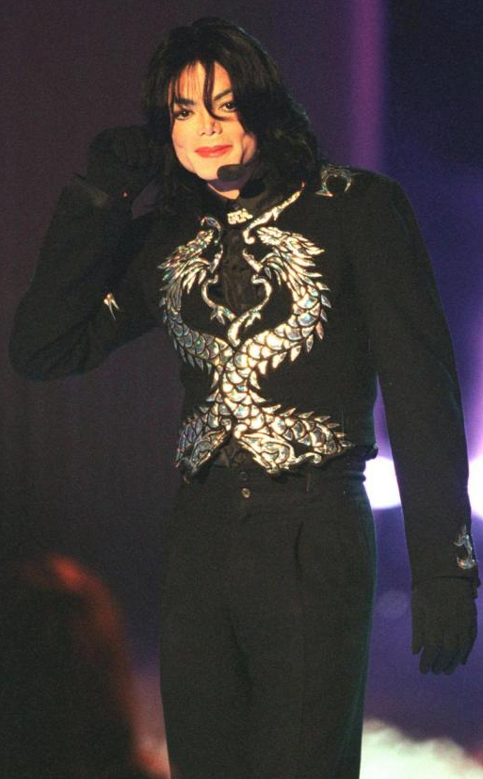
“WOW.” A few guests said. “Michael, you ARE a King.”
“Oh my god…” I said under my breath. “How did I get so lucky?”
“Do I look ok?” He asked innocently walking towards Jasmine and I.
“OK? OK?” Jasmine said. “You are hotter than a-“
“JASMINE!” Mac and I yelled. “You’re married.”
“You look very handsome, Michael.” She said trying to regain her composure.

“Thank you.” He replied as he greeted everyone at his home including Mac’s family shaking their hands and bowing respectfully to Christopher.
“We have a few surprises for you.” I said as I linked his arm with mine and showed him all of the exquisite decorations and display case.
“Oh my god…” Michael said eyeing every wall in his home laughing out loud. “These are pictures of me!”
“Well, duh!” Jasmine said. “We have pictures of Mac too as a baby and when he first came to Neverland to visit you.”

The Pop star walked around every corner and couldn’t help but cry seeing pictures from his childhood. Some of them he had never seen before and some he wished he could go back to. Katherine comforted her baby boy and informed him she had never been more proud to call him her child hugging him again and wishing him nothing but the very best.

“Remember this, Mike?” La Toya asked pointing to a picture of the two of them.
“Yes, I do!” He replied smiling brightly.

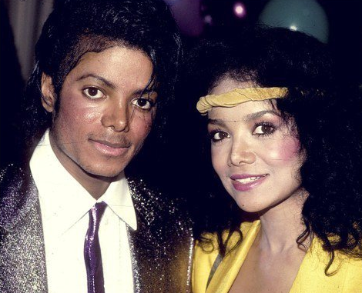

“Look!” Janet said pointing to picture of her and Michael standing together. “When I presented you with the Grammy Legend Award!”
“I won’t ever forget that night.” Michael said hugging his baby sister. “I love you, dunk.”
“I love you too, Mike.”
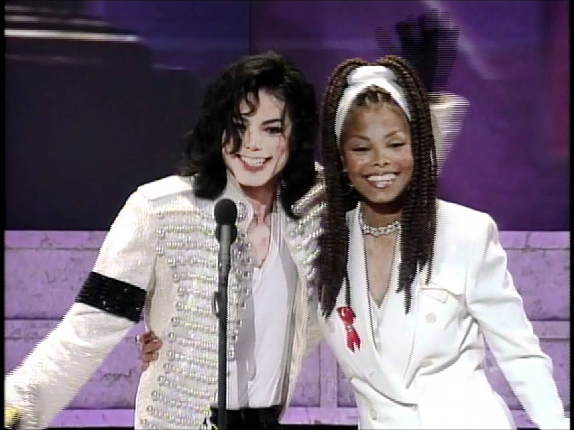

“Oh man, check this one out!” Jermaine said. “Our ‘fro’s were on point!”
“They sure were!” Michael said laughing. “Mother’s sewing skills always came in handy back then too.”
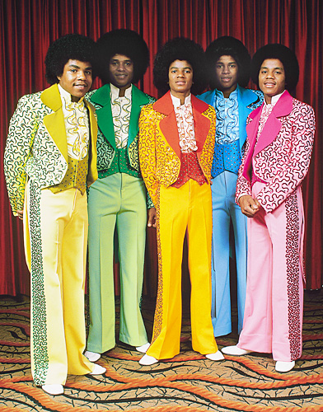

“Not to mention my sequined black jacket.” She replied referencing the signature piece of clothing Michael wore on stage during his legendary Motown 25 performance.
“This is one of the happiest days of my life.” The birthday boy said as he thanked his friends and family for joining him on his special day.

“Michael!” The girls yelled running towards him.
“My angels!!” He said kissing their little cheeks. “Are you three having fun?”
“YESSSS!!” They all said.
“You look very nice.”
“Thank you, Paige. How are you feeling, Abby?”
“Fine!”
“Please let me know if you feel sick?”
“I will!” She said wrapping her tiny arms around Michael’s waist.
“I love you, Michael.”
“I love you more, my sweet little Beth.”

“Cake time!” Jasmine yelled.
“YES!” Mac said. “It’s the best looking cake in the world!”
“Not yet!” Kai announced. “He needs to eat dinner first.”
“Have my children eaten already?” Michael asked concerned.
“Yes, they have.”
“It’s diaper change and bed time for our little princess.” Bev said holding Paris in her arms.
“Oh no…” The Pop star said taking his daughter from his employee. “Can’t she stay with me a little longer?”
“Sorry…” Bev said taking her back. “She needs to be changed, burped and in her crib before you all start dancing. I’ll stay with her in the nursery just in case the loud music wakes her up.”
Michael felt horrible for his wonderful staff member. He knew she and the others went through so much trouble organizing his special event but the thought of Bev not being able to enjoy herself because of his daughter was not something he was ready to handle.

“I’ll stay with her after a while.” Jasmine said. “We can take turns watching her to make sure she won’t be disturbed.”
“I’ll also keep an eye on her.” Katherine added.
“Great! Now that’s taken care of.” Kai said. “You, sir must eat before it gets too late. You know how fussy that stomach of yours is!”
Michael giggled as his chef grabbed his hand and dragged him into the dining area near the large buffet tables where his mouthwatering organic meal awaited him. Kai lovingly prepared her boss’s plate and made sure he ate to his heart’s delight. After devouring his pleasant and personalized meal, the Pop star kissed his chef’s forehead and thanked her for putting so much effort into his birthday feast. Kai smiled in relief knowing Michael was properly fed and wouldn’t have to worry about him eating too late or feeling sick.

LATER THAT NIGHT

Michael and Mac’s cake was presented thirty minutes after dinner. The Pop star blushed profoundly and Mac snickered seeing the wonderfully creative confection Jasmine had designed.

“It’s beautiful.” Mac said eyeing the tasty treat.
“How did you do this, tea flower?”
“It was easy!” She explained. “I wanted to come up with something that would represent both of you and I knew Mac’s favorite album of yours is Thriller. He always talked about how much he loved to see you dance so I drew this design on Diana’s paint program on her laptop. I submitted the drawing to the baker, and VOILA!”

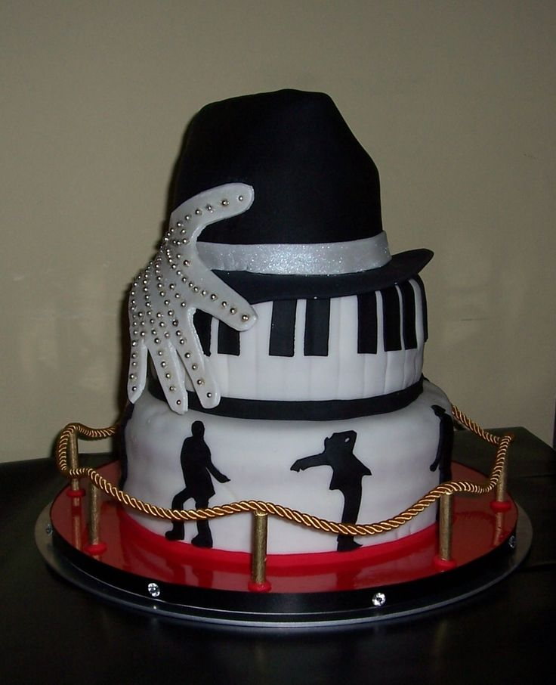
“It’s lovely.” Quincy said. “I almost don’t want to eat it!”
“Me neither!” Michael said laughing. “Thank you so much.”
“You’re welcome.”
“LET’S DIG IN!!” Mac yelled making everyone laugh.

Unsure of how Katherine would feel and out of respect for her religious beliefs, Mac and Michael asked everyone to skip the singing of ‘happy birthday’ and cut opposite ends of their cake while Jasmine and I took photos of the two from each side. The caterers served two small slices (one from each side) on beautiful silver sparkled china plates to all of the guests with their choice of coffee, tea or freshly made fruit juice.

The DJ played Michael’s music throughout the entire evening and not one guest stayed in their seat. A bar had been setup at the far end of the room where sparkling cider, wine and champagne was being served in fluted gold rimmed glasses. Everyone requested the guest of honor to dance and he happily obliged.

Prince couldn’t resist not sharing the spotlight with his daddy and he too joined him halfway through his ‘Dangerous’ routine mimicking his father and getting a thunderous round of applause from everyone in the room. Gifts were then given to the birthday boys and a few guests including Katherine, Quincy, Christopher and Jasmine gave beautiful speeches and told humorous stories about both of them. With only one hour remaining for the event, Javon came into the dining hall with a surprise announcement.

“Sir, there’s an unknown vehicle at the gate with a disguised woman in the backseat.”
Michael smiled brightly knowing exactly who came to visit him.

“Send her in.”
“Who is it, baby?”
“Diana, where’s Jasmine?”
“Upstairs with Paris.”
“Good. Keep her there for now.”
“But, Michael, what’s--”

He grabbed my hand and dragged me out of the dining hall running towards the foyer. A black limousine pulled up in front of the main house and Michael grinned happily looking like he just won the lottery. To my surprise, a tall woman with large black sunglasses and a scarf wrapped around her head wearing a white fur coat and diamond necklace approached the front door. It was then that I realized Michael’s surprise guest was none other than the infamous Dita Parlo.

“Happy birthday, Michael.” She said as she made her way through the front door. “I’m sorry I couldn’t be here earlier. May all your wishes come true.”
“Thank you and don’t worry about it.” Michael said kissing the female Pop star’s cheek. “There’s someone special I’d like you to meet…”
She removed her scarf and sunglasses and examined me from to bottom as if I were a dancer auditioning to be in one of her music videos.

“It’s nice to meet you, Diana.” She said holding out her hand.
“Likewise.”

For some reason, tension started to immediately build between Madonna and myself. She continued gazing at me as if I were an alien from outer space and the thought of her being friends with my fiancé made my palm twitch.

“Thank you for coming.” Michael said breaking the awkward silence between us.
“It’s my pleasure.” Madonna replied handing him a small gift box. “This is for you.”
“You didn’t have to bring me anything.”
“I wanted to.” She said as Bev and Kai came into the foyer to greet the legendary singer. “I know it’s something you will love.”

“It’s an honor to meet you ma’am.” Kai said as she and Bev took her coat and bag. “We will put your things upstairs for you.”
She thanked Michael’s staff as they headed up the grand staircase. It wasn’t long before Jasmine came downstairs and saw her idol and started screaming like the obsessed fan she was.

“OH.MY.GOD.” She said hurrying down the staircase. “Is it really you?”
“Yes, it is.” Michael said giggling at his tea flower’s fan-like behavior. “Jasmine, this is Madonna also known as Dita. This is Jasmine. Diana’s best friend and business assistant.”

Jasmine held her shaky hand out and Madonna returned the gesture. Mac entered the foyer and also met the world famous singer. While the gang was taking group photos, I still couldn’t shake the feeling that Madonna was not someone I wanted Michael to be friends with. Despite the negative rumors Marie had once told me about, Madonna was an icon with almost as many fans as Michael. Being hateful towards her was not the right or mature thing to do so I pulled myself together and kept an open mind trying my hardest not to assume the worst.

TWO HOURS LATER

“Great party, Mike!” Siedah said as she and Quincy headed towards the door. “I’m so glad you celebrated your birthday this year.”
“It was these two.” Michael said pointing to Jasmine and me. “They told me the party was for Mac. I had no idea they were going to trick me like this.”
“They told me it was for YOU!” Mac explained. “Sneaky little buggers!”
“We knew you two would be surprised.” Jasmine explained. “I’m really glad everything worked out perfectly. Now, we have to wrap up a few more things for the wedding.”
“I can’t wait to see you dressed as a groom, Michael.” Quincy said hugging his protégé. “No one will happier than me seeing you marry Diana.”
“Thank you.” The Pop star replied with a big smile and rosy cheeks.

Michael and I stood by the door wishing everyone a good night while Javon and several other guards opened the main gates watching closely for any intruders. The Jackson family left with Katherine saying she would be back to help with the wedding planning if necessary. Janet and La Toya did not wish to be bridesmaids as they felt it would draw too much attention and take away Diana’s spotlight. Respecting their wishes, I told my future sister in laws it would be ok if they just came as VIP guests with the rest of their family.

“Has Diana picked out a dress yet?” Janet whispered in Jasmine’s ear.
“Yes, and it’s gorgeous!” She whispered back. “It’s couture. She designed it herself months ago is will be getting it in a few weeks. Don’t tell anyone!”
“That’s great!” La Toya said also speaking softly. “I can’t wait to see what Michael’s going to wear!”
“We told him no signature outfits!” Jasmine replied. “He’s going to wow everyone with something completely different.”
“Hmm…” Janet said. “Mike wearing something different? This I have to see!”

“What are you three whispering about over there?” I asked making my way towards the ladies.
“NOTHING!” They yelled in unison. “Well, look at the time. We have to go, Toya!”
“Uhh, right!” She said trying not to sound obviously distracted. “Well, goodnight everyone!”

“We need to head to the airport, sir.” Javon said bringing his boss’s luggage into the foyer from his office. “Mr. Talal called and said he’s on his way there.”
“Perfect, thank you.” Michael replied saying goodbye to the rest of his guests.

Abby, Beth and Paige also said their goodbyes to their favorite Pop star and Bill took each of them home. Michael waited until his little angels were fastened safely in the car and watched them leave through the main gate waving at them with a smile.

“Is the great Gloved One leaving town again?” Madonna asked coming into the foyer with her things.

Michael explained to his friend that was he had to leave for Miami on business. Her knowing that he was leaving town irked me. Jasmine immediately caught on and questioned my needless behavior.

“What’s wrong?”
“I don’t like her, Jas.”
“What? Why?”
“She’s bad news.”
“Diana, you’re being ridiculous. They are just friends.”
“I don’t like the way she looks at him and she’s always putting her hands on him.”
“Stop it.” Jasmine said nudging me back to reality. “Michael is not interested in her and she’s getting over a bad break up from her baby daddy.”
“Michael has a tendency to attract broken women, Jasmine.”
“True, but he’s also smart enough to know that he’s engaged to you and is a father of two children. Michael is a very good role model and would never dream of saying or doing anything to distort his image in front of Prince and Paris.”

Jasmine’s words comforted me but still wasn’t enough for me to feel satisfied with the fact that Madonna only wanted a friendship with my future husband.

“Again, it was a pleasure meeting you, Diana.” She said approaching me. “I can’t wait to see you dressed as a bride. Assuming that I am invited to the wedding.”
“Of course you are!” Michael said as Javon placed his boss’s bags in his SUV. “Jasmine is couriering all of the invitations next week. We only have two and a half months left.”
“Oh man!” Jasmine said. “I didn’t realize how fast time is flying. It was a pleasure to meet you, Ms. Ciccone.”
“Madonna.” She replied shaking Jasmine’s hand.

“I prefer Dita.” Michael said giggling.
“She prefers you too.”

I glanced at Jasmine who closed her eyes and shook her head no at me as if she were trying to say ‘it’s not a big deal.’ Michael hugged Madonna and walked her to the front entrance where her chauffeur was waiting. Once she left through the gates, the next person to leave was Mac due to having an important meeting in New York in the morning.

“Thank you for everything.” He said to Michael, Jasmine and myself. “I really love you guys.”
“We love you more.” Michael said.
“I can’t believe the next time I’m going to be here it’ll be for Mike’s wedding.” The child star said trying to hold back tears. “I am so happy for you two.”
“Thank you.” I said hugging him. “You’re a great friend, Macaulay.”
“I learned from the best.”

The birthday boy said goodbye one more time then jumped into the backseat of Javon’s SUV. Since he and Michael were both going to the same place, they decided to go together. Michael quickly headed upstairs to check on his children and Jasmine said her goodbye before heading to bed. Feeling incredibly tired, I quickly changed into a pair of sweat pants and one of Michael’s black t-shirts before washing off my makeup and putting my hair into a ponytail.

“Diana, I have to leave now.” Michael said coming into the bedroom and closing the door. “I’ll call you when I get to the hotel.”

I came out of the bathroom and threw myself into his arms not wanting him to leave me for a second time.
“I hope you enjoyed your birthday.”
“I did. Thank you.”
“You’re welcome.”
“I’ll be back soon.”
“Be safe, baby.”
“I always am.”
“I love you.”
“I love you more, Liberian girl.”

He kissed me passionately placing his hands firmly at the small of my back. I pulled away slightly not wanting to start something we couldn’t finish. Of course, this didn’t stop Michael from trying. He snuck his warm hands underneath his t-shirt that I was wearing and fondled my breasts one at a time. Wanting to go further, he then reached down and started tugging at the waistband of my pants.

“No, baby.” I said breaking our kiss. “We can’t.”
“I know but you look so incredibly sexy.”
“Michael I’m wearing sweat pants.”
“I know and you look amazing in them.”
“I look like a bum!”
“No, you don’t!” He said kissing my cheek. “I love when you dress casually, Diana.”
“And why is that?”
“Because it leaves so much to the imagination.”

“You do the same when you dance on stage.”
“I do?”
“PLEASE! Don’t even TRY to act like you didn’t know that!”
He giggled adorably.

“Yes, I can do that at times.”
“Enjoy your flight. See you in a few days.”
“Diana?”
“Yes?”
“Will you marry me?”
“SERIOUSLY?”
“Yes. Will you?”
“Do these rings not speak for themselves?”
“Is that a yes?”
“Boy, get your Moonwalking ass to Miami!”

He pecked my lips one more time then wrapped his arms around me not wanting to let go.

“I love you, Diana.”
“I love you too.”
“You and the kids are my reason for living.”
“I know, baby.”
“Please take care of them for me while I’m gone?”
“You know I will.”
He held my hand and asked me to walk him outside. I happily obliged and the two of us made our way downstairs. Bubbles greeted his owner at the main entrance door and held onto Michael’s leg whimpering for him not to leave.

“I won’t be gone long.” He said pulling his beloved pet into his arms. “I promise I’ll spend lots of time with you when I get back. I love you.”
The adorable chimp gave his owner a high five and hugged him tightly before Javon handed him to his keeper to put him to bed. Michael and I walked outside to the vehicle where his guards were getting ready to sit inside with him seated between them. The entire procession was put in place including a few police cars for Michael’s and Mac’s safety.

Michael let go of my hand and kissed my cheek before sitting inside the vehicle. I watched and laughed as he waved goodbye from the sunroof of the SUV. Jasmine joined me at the door and we both waved back as the greatest entertainer of all time and his close friend headed for the airport. After the SUV left the main gates, Jasmine and I plopped down on the chaise sofa in the living room waiting for the cleaners Jasmine hired to finish their duties. Kai and Bev were exhausted but also helped with clean up and said they were almost done. The kids were fast asleep and things were normal again at Michael’s beloved home.

“What a great night.” Jasmine said propping her feet up on the couch. “I can’t believe we got to meet Madonna!”
“Yeah, yeah…”
“She’s a lot prettier in person.”
“I guess.”
“Diana, she doesn’t want your man.”
“I know. I just can’t shake the feeling that she does.”
“Well, snap out of it!”
“Let’s work on the wedding details, shall we?”
“Where’s your laptop?”
“Upstairs. I’ll get it.”

I ran up the grand staircase and headed towards the master bedroom. I opened my bottom nightstand bottom and saw the mystery note was still there in the open making me believe that Michael still hadn’t seen it. Why was it in MY drawer and not his? Did he already know about the note? Did he want me to see it on purpose? Did Madonna write this note to Michael? Is that why I felt so uncomfortable around her?

Not wanting to over think and drive myself crazy, I reached for my laptop and simply closed the drawer. I convinced myself that Michael and Madonna were just friends and needed to stop feeling so insecure about their strictly platonic relationship. I returned to the living room and sat with Jasmine as we both finalized a few more very important wedding details.

BROOKLYN, NEW YORK

A small, unknown dark shadow sits in their black chaise lounge at home reading the New York Times. Headlines of Michael and Diana’s engagement were plastered on every single media source around the world. The shadow read an article about Michael’s upcoming nuptials and a smile appeared on their face along with a brilliant idea.

After reading the entire column, the shadow walks to a nearby desk and sits in an office chair viewing several different online travel websites on their laptop. A few clicks of the mouse later, the shadow laughed out loud as it purchased an itinerary for themselves.
The anonymous shadow turns off their living room chandelier and walks into their bedroom. Resting on their platform bed, the shadow looks up at the ceiling and sighs happily feeling an incredible sense of euphoria with a hint of nostalgia.

“I miss you, Michael.”

