Chapter Twenty Three
A Glance into the Future

OCTOBER 21, 1998

Jasmine, Tina, Christy, Kai, Bev and Michael’s sisters were busy planning and putting together Diana’s wedding shower and the beautiful CEO had no idea what her closest friends and future family members had in store for her special day. Diana, Prince and Paris spent the past week with Katherine at Havenhurst while Joseph and his sons were away on a business trip. The future Mrs. Jackson and her mother in law were getting along perfectly and like the others (with the exception of one) Katherine could not wait to include Diana Dean and her two children as the newest additions to her renowned, iconic family.

Elizabeth was due to arrive from her London estate in the morning to join in on the pre-wedding festivities. David was expected to return from his duty tour in three weeks and Mac was arriving in three days. The entire gang could not stop bantering about the exciting day coming up in less than a month. Knowing Michael was one of the most powerful people on earth and couldn’t get married in a public environment, the soon to be newlyweds agreed on having their wedding at Neverland. The gang loved the idea and knew that space would definitely not be an issue.

Michael’s cottage houses were ready for anyone who wished to stay overnight and all of the spare rooms in the main house were also prepared for overnight guests. Loving the idea of being surrounded by beautiful ladies, Brad and Ashley stayed at Neverland to help the gang plan their older sister’s shower then left with Bill and Javon to do some sightseeing in Santa Maria. Like always, Kai organized the menu and Bev agreed to look after Paris. After having several boutique store workers come to Neverland to show Diana various party dresses, she finally chose a beautiful purple summer dress to wear to her special event.

Michael’s new project was coming along smoothly. With the genius minds of Teddy Riley and Rodney Jerkins by his side, the King of Pop knew his tenth album would definitely become a success. With several recordings left, he arranged to meet with the executive members of Sony to discuss marketing strategies in order to promote the album. With an actual release date still unknown, Teddy and Rodney both suggested their mentor go on a world tour again just like he did with his HIStory album.

Being older, wiser, a father and soon to be husband, Michael thought his touring days were now over. In the back of his mind, he knew he could not leave his wife and children behind for several months for the sake of his beloved fans and continued success. Knowing it could still be an option, the Pop star agreed to give it some more thought and re-consider the idea of a possible tour somewhere near the album’s date of completion.

“Hey, Mike!” Teddy said excitedly as he and Rodney entered the sound booth with a file folder. “You have a surprise collaborator on the album?”
“Yes.” Michael said smiling. “Someone I’ve wanted to work with for quite some time.”
“Who?” Rodney asked curiously. “Do we know them?”
“Possibly.”
“Oh man, don’t tell me it’s Prince!” Teddy said rolling his eyes.

Michael giggled and shook his head.

“What’s wrong with Prince?” Michael asked.
“You’re creating a song with HIM?” Rodney asked amazed.
“I didn’t say that.” The Pop star replied. “And even if I was, what’s the big deal?”
“He turned down Bad.” Teddy said. “He could’ve been a big star!”
“He already IS a big star and had his reasons for refusing to work with me back then.” Michael replied. “I have nothing against him.”
“So, we’re clear that it’s NOT Prince?” Rodney asked again.
“I didn’t say that.”
“MIKE!” Teddy yelled frustrated. “Why are you being so secretive?”
“You’ll find out when the time is right.”
“And when will that be?”
“Maybe next year.”

“NEXT YEAR?!” Teddy and Rodney asked.
“I’m in no hurry to release this album.” Michael explained. “I’m simply recording new material right now. I have all the time in the world to release this project and put it on music store shelves. I know my fans love me enough to wait patiently for anything that I create for them.”
“You are so right.” Rodney said. “But it wouldn’t hurt to release this project sooner rather than later!”
“I agree!” Teddy said. “The world is waiting for Michael Jackson to return.”
“You have to leave in order to return.” Michael said proudly. “I never left the music business but I now have a wife and two children to think about. In addition to my work and my fans, they too are at the top of my priority list.”

Prince was enjoying his time with his cousins swimming in the family pool at Havenhurst. Katherine and Diana sat poolside on chaise lounges while the family maid looked after Paris who was having a nap in a guest room. The matriarch told her future daughter in law that she couldn’t have asked for a more perfect match for her seventh child. Humbled by Katherine’s words, Diana thanked the simple minded soul and promised she would never do or say anything to hurt her baby boy ever again.

“Grandma!” Prince yelled. “Look at me! I can swim!”
“I know, baby.” Katherine said feeling proud of the child. “Mommy told me you’ve been taking lessons for a long time!”
“I can go under water too!
“Prince, no!” I yelled. “Not in grandma’s pool. The water is much deeper here. You can only do that in daddy’s pool where the waters are shallow.”
“Ok, mommy.”

“You raised him well.”
“No, Mrs. J. I didn’t.” I said looking into her chestnut brown eyes. “Jasmine and David did. I was just their financial support.”
“Don’t say that.” Katherine said squeezing my hand. “You did what you thought was best. Michael has forgiven you. It’s now time for you to forgive yourself, Diana.”
“I love you, Mrs. J.”
“I love you too, dear.”

“Lunch is ready!” Katherine’s maid Betty announced meeting us by the pool.
“We’ll be right there.” Katherine said as she asked the kids to get out of the pool and dry off.
“I wonder what the gang at home is doing right now.” I said getting up from my chaise chair and closing the overhead umbrella on top of Katherine and me.
“I’m sure everyone is having a great time preparing for your shower.” Katherine explained. “Janet called and said things were going great and for you to stay here until tomorrow morning when all of the preparations are completed.”

“I’d really like to be included in my own wedding plans.” I said as my wet son came over to me and lifted his arms in the air wanting me to dry him off with his special towel with a picture of his father standing on his toes.
“It’s all part of the new generation traditions.” Katherine explained. “In my day, we didn’t do such things like wedding showers and bachelor parties. Man created those things over time.”
“I agree.” I said kissing my baby boy’s head. “My parents didn’t have either of those. They had a civil court marriage and nothing else.”
“Just like Joseph and myself.” Katherine replied. “But I’m glad that you and Michael are having a dream wedding. He’s always wanted one of those.”
“Really?”
“Oh, yes. Michael always said that he wanted a big family wedding with the woman of his dreams as his bride.”
“I don’t know if that’s me, Mrs. J.”

“Trust me…” She said putting her hand on my right shoulder. “If you weren’t, Michael wouldn’t have given you those rings. He loves you and he loves the children you’ve given him.”
“Thank you.”
“No, Diana. Thank YOU.”

We both hugged and Prince clung to his grandma’s leg also trying to hug her. The beautiful mother of nine laughed as she scooped her grandson in her arms and led us both towards the house to enjoy Betty’s delicious lunch.

“Diana is going to love this!!” La Toya said hanging balloons and streamers all over the living room walls. “Are you sure purple is her favorite color, Jas?”
“Positive!” Jasmine said sitting on the black leather couch with party favors. “She chose a purple dress to wear tomorrow. Kai is making her favorite finger foods and Bev is organizing the games. Everyone will have a blast.”
“I hope she feels surprised when she sees all that we’ve done.” Janet said holding the step ladder for her older sister. “I want her to feel welcomed in our family.”
“I think mother is doing a very good job in that department.” Rebbie said as she wrote ‘thank you’ cards to each of the wedding shower guests. “She did that with her other daughter in laws and will do the same for Michael’s lovely bride.”

“Do you think mother will have the same talk with Diana that she had with Hazel?” La Toya asked.
“Probably.” Rebbie explained. “Although that was clearly a match made in hell.”
“Ouch!” Jasmine said. “Was it really that bad?”
“Yes.” Janet said. “We Jackson kids have had our share of bad luck with relationships.”
“So I hear…” Jasmine replied.
“Back to the wedding…” Rebbie said wanting to keep the aura positive. “I know Michael and Diana will stay together forever.”
“You do?” La Toya asked.

“Yes.”
“I like your confidence.” Jasmine said.
“They’ve both been to hell and back over the past six years. Any relationship that can survive as many storms as theirs is definitely one that nothing and no one can tear apart.”
“Well said.” Janet replied. “Spoken from a woman who’s survived a few nasty storms herself.”
“Exactly.” Rebbie said not wanting to elaborate on her own past difficulties. “Let’s get back to Michael and Diana. Is everything else ready to go, Jas?”
“Yup!” The beautiful right hand assistant said. “I just have to wait for Tina and Christy to get back from the mall so we can hang more decorations and help set up the tables for the food and Kai’s special organic juice bar.”
“Her menus are always the best.” Janet said. “I remember when she and Michael first met. He made her make a three course meal in an hour using nothing but raw organic foods. Without touching the stove, Kai had made a five course meal in less than 45 minutes. That was when Michael knew Kai would be the perfect one for the job of being his personal chef.”
“There is no doubt that Kai has taken good care of our brother.” La Toya said as she stepped down the ladder. “She and Beverly have both done a wonderful job making sure he always has a smile on his face.”

“Lunch is ready ladies!” Kai said as she and Bev came into the living room.
“Oh, my!” Bev said looking at the beautifully decorated home. “This looks wonderful!”
“Thanks!” Janet said taping the last streamer across the stone wall fireplace. “I hope Diana likes it too.”
“I’m sure she will.” Kai said as she told the ladies their meal was ready on the veranda.
“OOO fancy!” La Toya said. “You spoil us, Kai!”
“It’s not that.” She explained. “I just don’t want any of you dirtying my dining room after I spent all morning cleaning it thoroughly.”
Jasmine cracked up laughing while the others humorously crossed their arms and teased their brother’s lovely chef.

“What are you saying? We’re messy people?” Rebbie asked standing next to her sisters.
“Uhhh….SO BEV! ARE THE GAMES READY?”

Michael’s maid laughed as she tried to save her co-worker from a potentially friendly argument.

“Yes, everything is prepared. We just have to wake up, cook and set up the food and look presentable before the guest of honor arrives.”

The gang made their way to Michael’s veranda and anxiously waited for Kai’s mouthwatering meal to be served. Each lady had their own guesses as to what the organic chef would give them to eat and to everyone’s surprise, it wasn’t anything they expected.
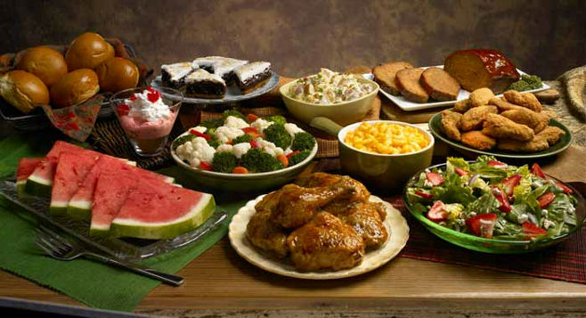

“My special ‘every once in a while’ surprise meal.” Kai said as she opened each silver tray and displayed a delicious fried chicken dinner with corn, biscuits, gravy and potato salad. “Enjoy.”
“OH MY GOD!” Jasmine yelled running towards the buffet table. “I can’t believe we get to eat like normal people!”
“Me first!” Janet said shoving Jasmine out of her way.
“No way! The oldest sibling goes first!” Rebbie said pushing past both of them.

“Looks like we got back just in time!” Christy said as she and Tina headed towards the buffet table to grab a plate and join the others.
“Will there be enough for Michael to eat when he gets home from the studio?” Jasmine asked feeling concerned for her Pop star friend who she knew also loved fried chicken.
“Yes. I’ve set aside a large portion for him.” Kai said. “Please go ahead and help yourselves.”

Kai stood aside and laughed watching the group of ladies scoop massive amounts of food onto their plates. It wasn’t every day that Kai would allow her boss and his loved ones the chance to devour fried foods and carb loaded side dishes but because of the wonderful event that was now just weeks away, she knew everyone could use a special treat.

THE NEXT DAY

“Welcome home!” Kai said as Katherine, myself and the kids entered the main house.
“Thank you. Why are the living room doors closed and covered with sheets?”
“Top secret!” She said trying not to give too much away. “Mrs. Jackson. It’s always a pleasure to see you. Please make yourself comfortable in the living room.”
“Thank you. Where is Michael?”
“At the studio. Brad went with him. Mr. Jackson said he wouldn’t be back until later this evening after the shower. He also requested Prince be dropped off at the studio by Javon so that Diana could enjoy herself today.”

“It’s fine with me.” I said kissing my son’s cheek. “Please go up to your room and change, honey. Daddy would like you to join him at the studio today with Uncle Brad.”
“Ok, mommy.”
“I’ll help you change, little man.” Jasmine said entering the foyer and giving me a hug before taking her step son’s hand as they both went up the grand staircase.
“What time does the shower begin?” Katherine asked standing by the closed living room doors.
“In about an hour.” Bev said coming into the foyer. “You still have time to freshen up and change, Diana. I’ve laid your dress on Mr. Jackson’s standing mannequin for you.”
“You are the sweetest person in the world. Thank you, Bev.”
“Don’t thank me. It’s my pleasure. I’ll take this little princess upstairs so I can feed her and change her little diaper.”

“Where is Ashley?”
“Bill took her to the mall.” Bev said as she took Paris from me. “She wanted to grab a few last minute things for the party. She should be back very soon.”

The pleasantly charming maid headed upstairs with my little girl in her arms. Feeling incredibly curious, I watched Katherine closely as she opened the double glass doors and entered the living room. I was hoping to catch a sneak peek of what was inside but Kai saw me from above the staircase and scolded me for trying.

“AHEM!” She said loudly making me shudder. “What do you think you’re doing?”
“Oh, nothing.” I said with flushed cheeks as I slowly climbed up each step.
“No peeking!”
“Yeah, yeah. Has Elizabeth arrived yet?”
“She has but she’s taking a nap in the cottage house. She requested not to be woken up until 30 minutes before the party starts.”
“Mac will be here tomorrow?”
“Yes. Javon will pick him up from the airport.”

Prince came out of his room smiling dressed in his daddy like clothing. I shook my head and laughed seeing my little boy resemble his father by wearing a red shirt, black pants and black penny loafers with white sparkly socks and single white glove. Jasmine came out of Prince’s room feeling incredibly proud to call him Michael’s child and said that Prince was definitely the King of Pop’s mini me.

“How do I look mommy?”
“Adorable like always.”
“See my glove?”
“Yes, baby. It looks just like daddy’s!”
“He gave it to me.”
“That’s great. You behave at the studio ok? Don’t push any buttons without daddy’s permission and please do your best not to make a lot of noise ok?”
“Yes, mommy.”
“Good boy.”

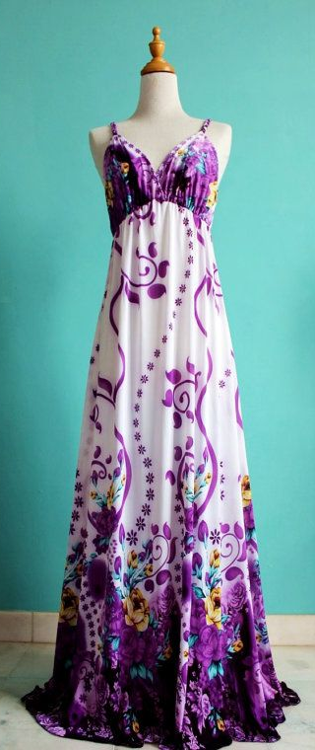
Jasmine escorted Prince downstairs and waited in the foyer for Javon to take him to the studio. I made my way into the master bedroom and noticed Bev had ironed my dress and placed it neatly on Michael’s mannequin that his staff members use to hang his military style jackets when he wants them clean and wrinkle free.

After unpacking my things from my bag that I took to Havenhurst, I quickly hopped into the shower. As I let my hair down allowing the hot, steamy water to penetrate through each strand, I lathered my strawberry scented shampoo into my hands before applying it to my now damp scalp.

After rinsing myself off, I stepped out of the shower and noticed a small purple jewelry box with a silver ribbon wrapped around it sitting near one of the marble lined sinks. Judging from the way my name was written on the front of the small cream colored envelope next to it, I knew it had to be from none other than my fiancé. I dried myself off and wrapped my nude body in one of Michael’s signature white towels with a gold crown and his initials written in cursive letters before opening the envelope and reading the written scripture inside of it:

‘A gift for my pleasantly plum colored wife.
Enjoy your shower - now and later.
Your fiancé,
Michael.’
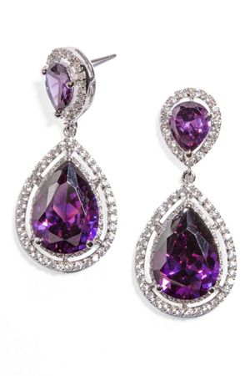

I peered inside the box and couldn’t help but gasp as I saw the most stunning looking purple diamond earrings. How did he know the color I had chosen to wear? Then, like always, the answer suddenly came to me.

“He’s Michael…”

“Come on, Mike! You’re killing us here!” Teddy said sounding whiny. “Please tell us who’s collaborating with you!”
The Pop star giggled as he watched his future brother in law playing around with the microphones in the recording room trying to sing like the superstar he wasn’t.

“I told you, T. You will know when the time is right.”
“And when the heck is that gonna be?” Rodney asked sounding irritated.
“In a year or so.”
“FOR REAL?” Teddy asked.
“You two need to learn to be patient.” Michael said. “Nothing good comes out of being hasty.”
“Says the man who has recorded more than five hundred songs in the past two months!” Rodney joked.

“I’m just making good use of my studio time.” Michael explained. “The more songs I write and record, the more material my fans will get to hear from me which also means more recognition for you two.”
“Good point!” Teddy said. “Let’s get on it!”
“Wait...” Rodney said as an imaginary light bulb turned on above his head. “So, technically speaking you can’t record your music without us, correct?”
“I could but I’d like you both to be included on this project.”

“Yo Ted! I say we haul production until Mike spills the beans about his mystery collaborator.”
“You wouldn’t dare do that to me!” Michael said lowering his voice to a more serious tone.
“Uhhh…Rod? That’s blackmail.” Teddy said with a hint of fear in his now cracked voice.
“It most certainly is.” Rodney explained. “Either Mike tells us who’s joining him on this project or we both walk away and never look back.”
“ARE YOU NUTS?” Teddy yelled. “He doesn’t speak for me, Mike. I’m still with you—“
“Shut up!” Rodney said covering Teddy’s mouth. “It’s all or nothing, Mike.”
“You’re serious?”
“YES!” Rodney said while shaking Teddy’s head ‘yes’ for him.

Michael sighed deeply as he unintentionally turned his head to the right. He suddenly noticed Javon and Prince entering the main studio doors in the distance and laughed to himself trying his hardest to keep a straight face.

“Ok, you win.” Michael said. “I’ll tell you who it is.”
“THAT’S what I’m talking about!” Rodney said as he and Teddy sat in the booth chairs.
“It’s someone you both know….”
“Yeah?”
“Someone who’s won numerous awards…”
“Yeah?”
“He’s really talented and the world adores him.”
“In the words of your song – WHO IS IT?” Teddy asked anxiously.

Just as Michael planned, he continued stalling his two favorite producers and discreetly looked to his right again seeing his son and bodyguard just seconds away from entering the sound booth.

“He’s—“
“DADDY!” Prince yelled as he flung the booth doors open and jumped into his father’s arms.
“There’s my little boy!”
“DAMN IT!” Teddy and Rodney said as they both slammed their fists onto the audio panel. “WE WERE SO CLOSE!”
“Um, did we interrupt something, sir?” Javon asked.
“Not at all. It was all part of my little plan.”
“You saw them coming in here!” Teddy said.
“YOU SET US UP!” Rodney yelled.
“Of course I did.” Michael replied as he kissed his firstborn’s cheek. “Did you really think I was going to let you two threaten me into telling you something confidential about my own project?
“He got us, Rod.”
“I know.” Teddy said rolling his eyes. “Clever little backwards dancer!”
“I love you guys too. Now let’s get back to work!” Michael said with a huge smile on his face.

“SURPRISE!” The gang yelled as I walked into the living room filled with purple decorations, huge tables with food and drinks and an entire setting full of lovely ladies.
“OH MY GOD! THANK YOU ALL SO MUCH! THIS IS WONDERFUL!”

My eyes instantly filled when I saw how dressed up everyone was and the way the entire living room was decorated in my favorite color.

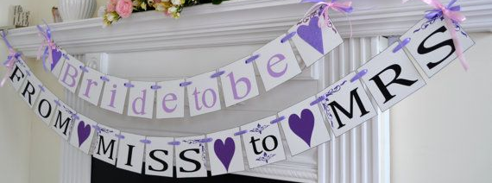

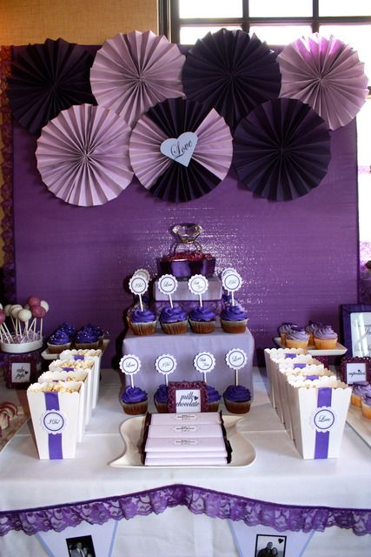
“This looks really beautiful.” I said admiring the hard work of everyone in the room. “How did you manage to do all of this?”
“It was easy.” Janet said. “I just had to hold the ladder. La Toya did all the hard stuff.”
“Yes, I did.” The second oldest Jackson sister said. “But, I think we all agree that Rebbie did most of the work.”
“It was a team effort.” Rebbie said as she came over and hugged me. “Congratulations, Diana. Thank you for making our brother so happy.”
“It was my pleasure. Thank you all for doing this and for welcoming Jasmine and I into your family.”

“Enough talking!” Ashley said. “Let’s pig out on food, play games, open gifts and dance until our feet swell up and fall off!”
“I’m down with that.” Janet said.
“You all bring me so much joy.” Katherine said. “I’m so blessed to have wonderful children and a wonderful new daughter in law.”
“You flatter me, Mrs. J.”
“You deserve it.”
“LET’S EAT NOWWWW!” Jasmine said sounding hungrier than ever.

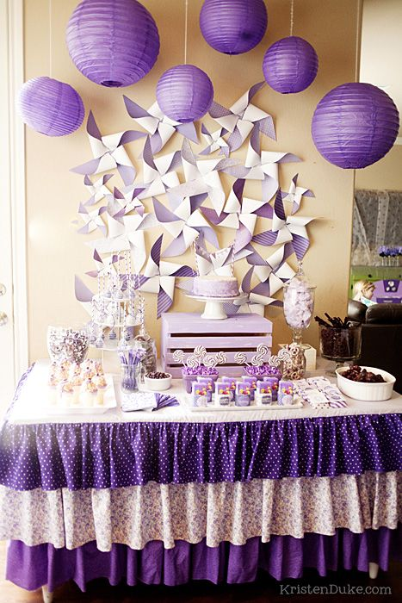
Kai’s delicious finger foods and organic juices were devoured in a matter of minutes. The Jackson sisters wouldn’t stop teasing me about their brother and how much of an impact I made on his life ever since the first day we met each other at the museum in Manhattan.

“I still can’t believe that was six years ago.” Jasmine said placing a gourmet stuffed mushroom in her mouth. “It seems like that only happened a year ago.”
“It feels like centuries for me.” I said eating a cupcake with purple icing. “As difficult as it’s been, I wouldn’t trade my relationship with Michael for anything.”
“AWWWW…..” Everyone said in unison making me blush all shades of red and pink.
“It’s funny. He said the exact same thing about you.” Liz said entering the room wearing a gorgeous purple dress with matching purple beads across her perfectly arched neck.”
“LIZ!”

“I see you got the earrings?”
“I did. You knew?”
“He asked me to bring them from England for you.”
“Oh gosh. He is something else.”
“Congratulations, Diana.”

I stood up and hugged the Hollywood icon as she sat next to me on the leather couch. Katherine sat on the opposite side of me and the others sat in a circle on purple decorated chairs. Kai made sure the snacks and punch bowl was filled at all times and Bev brought Paris to join us when she woke up from her nap.

“There’s my little pumpkin!” I said scooping her into my arms. “How was my little Paris’s nap?”
“She missed you.” Bev explained. “When I went upstairs to check on her she was wide awake with her head facing sideways. She was looking at a picture of you and Michael.”
“That’s so sweet.” I said kissing my little girl’s soft nose. “I love you, my precious.”
“My turn!” Janet said snatching her away from me.

Elizabeth let everyone else in the room hold Paris before taking her into her own arms. She wanted to be the last one to have her so that she could keep her the longest.

“She is definitely a looker.” Elizabeth said kissing Paris’s forehead. “She has her daddy’s giggle.”
“Yes, she does!” Katherine said. “I noticed that too.”
“So, Diana…” La Toya said. “Are you ready to become a Jackson?”
“I think so…”
“It won’t be easy.” Janet added. “You’ll forever be known as the wife of the King of Pop.”
“Also known as the Queen of Pop.” Rebbie said.

“Your career will be disregarded.” La Toya said trying to scare me. “No one will remember you as the beautiful, intelligent CEO of TSG records.”
“Michael’s profession will always overshadow your success…” Liz said trying to keep a straight face.
“Why are you all trying to scare her?” Jasmine asked. “It won’t be that bad. Stop teasing her.”
“Diana will always have to look her best.” Katherine added joining in on one of Bev’s clever games against the future bride. “You will have the media watching your every move. You can’t wear sweatpants and messy hairstyles. You will need to conduct yourself accordingly every second of every day.”

Hearing everyone’s comments made me feel queasy. I knew it was all fun and games at first but after giving it more thought, I couldn’t help but wonder if marrying Michael would be something I’d end up regretting one day. The ladies continued poking fun at me and all I could do was think about my life and if I was really ready to become Mrs. Michael Jackson.

“I think it’s safe to assume we won that game.” La Toya said jokingly. “You can relax now, Diana. It was all in good fun.”
“I know.”
“Are you alright dear?” Katherine asked seeing the look of confusion on my sweat forming face. “I hope we didn’t frighten you.”
“No, you didn’t.”
“Are you sure?” Jasmine asked offering me a napkin to wipe my forehead.
“I’m fine. What’s the next game?”

BROOKLYN, NEW YORK

Emmanuel Lewis stood in front of his master bedroom bay window smiling from ear to ear admiring the brightly lit view of Central Park in his two story apartment. After finalizing a trip to Los Angeles to visit his estranged childhood friend in a matter of days, the 27 year old TV star couldn’t have been more excited to see the King of Pop again. Would Michael be just as happy to see him? What would he say? What would he do? Did he tell his soon to be bride about him and their past friendship?

Dozens of thoughts crossed the ‘young’ man’s mind as he paced back and forth in his room too eager to sleep. Feeling a strong sense of nostalgia, Emmanuel walked towards a nearby book shelf and dusted off an old video cassette with him and Michael dancing together as well as footage of them at the 1984 Grammy Awards.

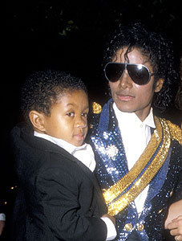
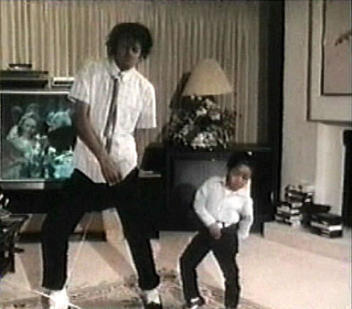

“It’s been so long…” He said to himself as he sat on the edge of his canopy bed watching the contents of the tape on his big screen TV. “I can’t wait to see you again, Michael…”

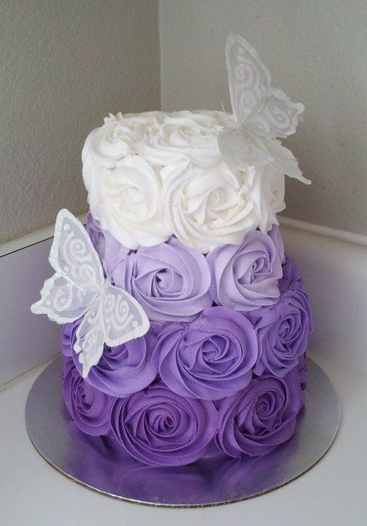
“Thank you all so much.” I said as everyone finished eating the beautiful purple rose cake Jasmine ordered. “This was a beautiful shower.”
“We’re glad you enjoyed it.” Rebbie said gathering everyone’s purple colored paper plates, napkins and forks. “You deserve the best.”
“I agree.” Jasmine said licking icing off her fingers. “Next up is the bachelorette party!”
“Oh Lord…” I said rolling my eyes. “Do we have to do that?”
“Of course, it’s tradition!” La Toya said.
“Christy, you booked the strippers, right?” Janet asked.
“Hell yeah!”
“AHEM! EXCUSE ME? MOTHER IN LAW IN THE ROOM!!”

Katherine laughed and shook her head.

“You are all going straight to hell.” She joked. “May God have mercy on your souls!”
“Well, if I’m going to hell I might as well go happy by stuffing a whole lot of dollar bills down some hot guy’s—“
“JASMINE!” I yelled. “That’s enough.”
“No, please continue!” Tina said being Jasmine’s new perverted friend.
“I’m just kidding, girls.” Katherine said laughing beautifully. “I really don’t mind. You all come from different generations than me. Those things were taboo in my day but I know times have changed. I hope you all enjoy yourselves.”
“You will be joining us too, mother.” Janet said wanting to see her mother’s reaction.
“GIRL, ARE YOU CRAZY?!”

Everyone in the room laughed. As religious and highly spiritual as she was, the Jackson matriarch learned very quickly that even though she raised her children in her Jehovah’s Witness faith, her job as a mother raising her children was now over and they were all entitled to living their own lives and walking their own paths. As long as they respected their mother’s upbringing and the morals she instilled in all of them, Katherine was more than happy.

“I know that my children were well raised.” She explained. “I have no doubt in my mind that they all have respect for others and are as kind as they can be.”
“Diana and I see that in Michael every single day, Mrs. J.” Jasmine said. “I’ve never seen or heard of Michael turning his cheek away from anyone.”
“And you never will.” I said proudly. “If there’s one thing I know about Michael Jackson, it’s his tireless desire to be kind and loving towards all mankind.”
“Michael is very special.” Katherine said. “I love all my children differently but equally. Michael has a heart of gold and as long as he is alive he will never stop giving and loving everyone he comes in contact with.”

“That’s my baby brother.” LaToya said proudly. “Look at where we are right now. Michael built this home for himself but also for all the children in the world.”
“He’s also broken records for his humanitarian efforts.” Rebbie added. “Michael always said he wanted to help people who were less fortunate than us.”
“And that’s a mission he definitely accomplished all over the world.” Katherine said smiling. “Michael will always be remembered for his wonderful achievements. Even after he travels on…”

“I hope he gets more awards for all that he’s done to help heal the world.” Jasmine said. “It’s obvious he wrote that song for more than just recognition.”
“That song and HIStory are his messages to the world.” I explained. “Michael will never give up on making the world a better place.”

“He’s about to do more.” Katherine said intriguing everyone in the room.
“Oh? How do you know, Mrs. J?” Christy asked.
“I know my son.” She said. “He is planning something very big. I can feel it.”
“Well, he is working on a new project.” Elizabeth added.
“I know that but I can sense it is something else.”
“Like what?” I asked feeling slightly worried.

“He’s planning some kind of a comeback…”
“Michael making a comeback?” Tina asked confused. But he never left.”
“It’s not about him leaving my dear.” Katherine said smiling beautifully. “Michael is secretly devising a plan to wow the world.”
“No offense, Mrs. J but if that were true Michael would have told me about it.” I said.
“He’s won’t tell anyone until he knows for sure that he can make it happen.”

“I think mother may be on to something.” Rebbie explained. “She’s been right about Michael before. If we were betting I’d put my money on her.”
“You’ve got me thinking now, too.” Janet added.
“Well, I’m sure whatever it is it will be fabulous.” Bev said wanting to break the awkward tension in the room. “I think we all agree that anything Mr. Jackson touches turns into brilliant magic.”
“Indeed.” I said as Kai entered the room with a stack of Michael’s CD’s.
“Let’s end this wonderful celebration with some dancing!” She said happily.

“I’m down for that!” Jasmine said as she helped Kai carry the CD’s over to the stereo. “What song should we play first?”
“THRILLER!” Christy yelled in excitement.
“Why don’t you all start from the beginning of Michael’s career?” Katherine suggested.
“When he was in the Jackson 5?” Tina asked.
“No, dear. With his first album as a solo artist – Off the Wall.”
“That’s a great idea!” Jasmine said inserting the CD into the sound system.
“I can’t believe it’s been almost 30 years since that album came out.” La Toya said as she helped Kai and Bev move the large glass coffee table off to the side to make room for dancing.

In that moment, Katherine suddenly had an epiphany. Not wanting to jinx her thought, she kept it to herself but smiled to her heart’s content as she watched all of the ladies in the room dancing to her son’s beautiful ballads. She knew her instincts about her seventh child were always right and felt flattered that even after 40 years, her intuition about Michael didn’t fail her. The beautiful mother of nine sighed in relief as she stood up and joined her daughters and future daughter in law on the dance floor singing and swaying happily to the words her beloved child and soon to be wed son sang almost three decades ago.

