Chapter Twenty Six
Born as Two, United as One

Michael & Diana’s Wedding Day

PART I

NOVEMBER 14, 1998

NEVERLAND
5AM

“Diana! Wake up!” Jasmine yelled banging on my bedroom door. “GET OUT OF THAT BED! WE HAVE SO MUCH TO DO AND JUST A FEW HOURS TO DO IT IN!”
“Go away, Jas…” I muttered half awake. “It’s too early.”
“Ummm…have you forgotten what today is?”
“I don’t care, leave me alone!”
“IT’S YOUR WEDDING DAY, WOMAN!”

My eyes opened instantly bugging out as if they were going to come right out of their sockets. The day had finally come. This was my day. This was Michael’s day. This was OUR WEDDING DAY!

“OH MY GOD!” I yelled jumping out of bed. “I’m getting married….I’m getting married…”
“DIANA!” Jasmine yelled banging loudly again. “WAKE UP NOW! YOUR PHOTO SESSION AT THE GARDEN IS IN TWO HOURS AND WE HAVE TO GET YOU READY!”

I quickly put on my plush white robe and opened the door seeing a whole stack of women rushing their way inside the room shoving me in different directions. Everyone was already elegantly dressed in their photo session dresses except me. Jasmine was also ready in her beautiful lavender chiffon dress and shoved me into the bathroom asking the others to wait outside while I showered, washed my hair and face and tried to get into bride mode.

JAVON’S HOUSE

“Yo, Mike! You done yet?” Rodney asked as he knocked on Javon’s bedroom door. “There’s about 6 of us that need to use a bathroom and Javon said he’s got one in there!”
“There are four bathrooms in this house!” Michael yelled as Karen helped the Pop star look and feel his best with his makeup and hair. “I’m going to be a while.”
“Oh man!” Rodney said. “All the other bathrooms are taken! Mac’s been putting on his stuff for like two hours! Ya’ll take longer than girls to get ready!”
“It’s his wedding, fool.” Teddy said coming out of a guest bedroom wearing a dark grey tuxedo. “Let the man take his time today.”

“Dang, Ted!” Rodney said eyeing his producer friend. “You look like you just stepped out of GQ magazine!”
“I get that all the time.” Teddy said smiling.
“Where’s the man of the hour?” Javon asked wearing his navy blue tuxedo with black tie.
“Still getting dressed.” Rodney said.
“Where’s Mac?”
“Still getting dressed.” Teddy said.

“We gotta hustle up! The photo session is two hours long and the drive over there will take more than an hour. We can’t be late.”
“Don’t worry.” Jermaine said coming out of another guest room wearing his black groomsmen tuxedo with a red rose on his lapel and a single white glove on his right hand. “Michael won’t miss this day for the world.”
“You look great, bro.” Rodney said to his mentor’s older brother.
“Thank you, so do all of you.”

“Do you think he’s nervous?” Bill asked wearing a stunning cream colored tuxedo with a small black bowtie.
“Nah, not our brother.” Tito said coming out of one of the bathrooms in his groomsmen tuxedo. “He’s been performing in front of millions of people since he was five years old. If that never made him nervous, making someone his bride sure as hell won’t.”
“Well, if he doesn’t hurry up that might not happen.” Mac said wowing everyone in his first wardrobe of the day.
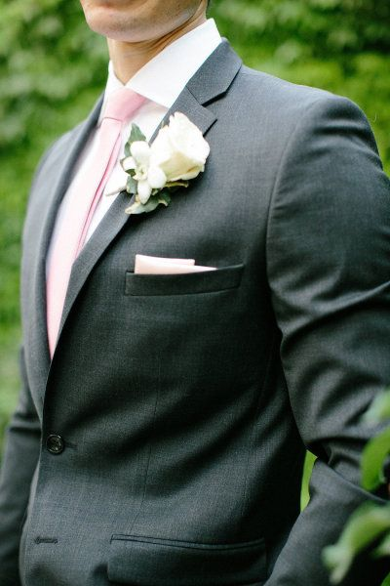
“DAAAMN!” Everyone said in unison. “Where did you get that suit, Mac?”
“It’s couture and custom made.” The ‘Home Alone’ star said proudly as everyone admired his charcoal Armani threads with pink tie and matching pink handkerchief. “You won’t find it in stores.”
“Well, aren’t you just the king of class!” Marlon said joining the others in his groomsmen tuxedo. “Looks like Mr. Best Man over here is ready to seize the day.”
“I am indeed.”

“Where’s my brother in law?” Brad asked coming out of another bathroom in his groomsmen outfit. “We have to get going. Don’t tell me he’s still asleep!”
“No, of course not!” Javon said. “He’s getting ready. Karen is with him.”
“All done.” Michael’s adoring makeup artist said coming out of Javon’s room. “He’s on his way out now but DON’T make him cry! I just spent the last hour doing his eye makeup.”
“Thank you, Karen.” Jermaine said hugging his brother’s friend. “You’ve always done a great job making my brother look and feel his best. He didn’t want anyone but you to touch him today. He also said he wanted you to be the first one who sees him as a groom.”
“Well, he looks smashing in outfit number one if I must say so myself.”
“Number ONE?” Mac asked confused. “You mean to tell me this curly haired man in the glass is going to change a billion times today too?”
“Man in the MIRROR, Macaulay.” Karen corrected. “And yes, he and Diana will both be changing wardrobes after each part of the festivities take place.”
“I can’t wait to see what they’ll be rocking!” Teddy said excited. “We all know Mike has more swag than any other artist in the world.”
“Indeed.” Mac said.
“Ok, let’s get going!” Javon said. “The limos just turned onto the street!”
“What do you mean limos?” Jermaine asked.

“Yeah!” Rodney said. “Aren’t we all going together?”
“Hell no!” Javon said humorously. “This is the legendary, once in a lifetime Jackson wedding party. We’re all rolling up in style with two different limousines!”
“Besides, I don’t want your cheap clothes ruining the look and feel of my suit.” Mac joked.
“Boy, please!” Teddy said. “My pinky ring costs more than that Ken doll suit you got on!”
“Funny, I saw the exact same ring in a five cent candy machine the other day.” Mac said.
“Listen, boy!”
“GUYS!” Karen yelled. “This is a wedding, not a wrestling match!”

“It’s all in good fun.” Mac said.
“Right.” Teddy added not completely agreeing.
“Oh yeah, baby!” Jackie and Randy both said seeing their luxurious modes of transportation pull into Javon’s driveway.
“The limos have arrived!” Javon said proudly. “Michael, Mac, Brad and all of Michael’s brothers are in the black limo. Myself and everyone else are in the white limo. We’ve got security and policemen in unmarked cars in front and behind us.”
“Sounds good to me!” Mac said excited. “I hope there’s a bar in there.”
“I think you’ve had enough alcohol, Mac.” Brad said reminding the child star of his bachelor party hangover.

Just then, Javon’s bedroom door opened. Small, familiar sounding footsteps were heard as each person turned around and noticed the Gloved One coming towards them as he continued walking forward.

“Oh my god…” The men standing in Javon’s front entrance said as they caught a glimpse of the man who was about to take his vows in front of 500 people.

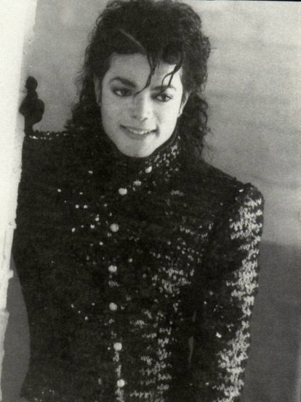

“Do I look ok?”

Not one person spoke. In that moment, time itself had stood still admiring the one man the world adoringly called The King of Pop. Michael’s brothers all stood with their jaws wide open and Karen smiled proudly admiring her greatest accomplishment to date. Javon and Bill gulped loudly and Mac was so taken aback he had to cling to the wall behind him in order to stop himself from falling over.

“You all hate it!” Michael said. “I need to change again.”
“NOOOO!” Everyone yelled in unison. “Michael, you look….really handsome.” Tito said admiring his little brother.
“We all agree with him.” Jermaine said hugging the soon to be groom. “I can’t believe it’s you. It’s so amazing to see you wear something out of the norm.”
“Thank you, Erms.”

“ALRIGHT, LET’S ROLL!” Javon said. “We are really pressed for time!”
“Has anyone heard from the girls?” Michael asked.
“Jasmine called.” Brad said. “They’ve already left Neverland. We need to jet now.”
“I’ll meet you all outside.” Michael said. “I need to speak to Karen and Mac alone.”

The gang left Javon’s house and jumped into their assigned vehicles. Karen and Mac stayed in the foyer entrance wondering what their friend was going to say to them on his special day.

“What’s up, Mike?” Mac asked.
“I just wanted to thank you both personally.” The Pop star said. “Karen, thank you for spending so much time on me today. I know Diana wanted you to do her hair and makeup but I couldn’t handle anyone else touching me today.”
“It’s my pleasure, Michael.” The beautiful blonde makeup artist said. “This is my job. I’m honored to help you look and feel your best today.”
“Are you sure you’ll make it to the house in time for the meet and greet?”
“Yes, I promise.” She replied. “I just have to run home and get ready. I’ll be there with plenty of time to help you get dressed for your second fitting.”
“Perfect. Mac, I wanted to thank you for agreeing to be my children’s godfather and my best man today.”
“No problem.” Mac replied. “I wouldn’t have missed this for the world.”

“HEY! MR. GROOM! GET YOUR RECORD BREAKING SUPERBOWL PERFORMING SELF OUT HERE NOW!” Rodney yelled.

Michael giggled beautifully before hugging his two friends and leaving with them to head to his photo session to take pictures of his big day with his most favorite men in the entire world.

“LADIES! THE BRIDE IS READY IN WARDROBE NUMBER ONE!” Janet announced to everyone in the living room feeling super anxious to see the soon to be spouse.
“The one and only - Ms. Diana Elizabeth Dean!”
“A lovely middle name I must say.” Elizabeth said smiling brightly in her elaborate, hand embroidered red gown.

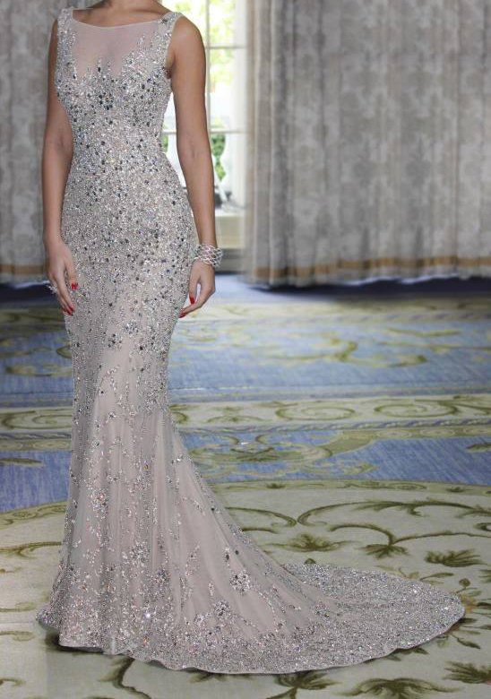
Katherine and Prince escorted the lovely bride down the grand staircase in her dazzling light grey, crystal embedded gown while Jasmine used her video camera to capture each second of the exciting event.

“Absolutely beautiful.” Kai and Bev said as they kissed their boss’s fiancé lightly on her cheek being careful not to smear her makeup.
“Do I look ok?”
“You sound just like him now.” Kai said giggling.
“I’m sure he’s just as nervous as I am.”
“There is NO need to be dear.” Liz said hugging me. “Michael is a very lucky man.”
“Thank you, Liz.”

“Alright, the kissy fest is over!” Ashley said. “The limos are here.”
“Oh, goody!” Christy said as she and Tina excitedly opened the main entrance door.
“Here’s the buddy list for the vehicles.” Jasmine announced. “I gave Javon the list for the guys. We’re going to switch it up and do the opposite as them. Diana, myself, Ashley, Kai, Bev and two others will be coming with us in the white limo. Mrs. J, Liz, Christy, Tina, and the Jackson sisters are in the black limo.”

“Wait, Jasmine.” I said as everyone made their way outside to the vehicles. “Who are these other two people you mentioned?”
“I was just getting to that.” She said. “Close your eyes and turn around.”

I did as I was told and heard two sets of footprints fast approaching. Jasmine kept my back turned towards the grand staircase. I could hear faint whispers echoing through my ears. My heart skipped a beat thinking about who could possibly be standing behind me.

“Diana, I know you were afraid you wouldn’t have anyone to give you away. But as your matron of honor, I took the liberty of taking care of that for you.”
“Jasmine, you’re making me nervous.”
“Don’t be. Turn around.”

I slowly spun myself in my heavily embroidered dress and opened my eyes gasping at the couple standing before me.

“OH MY GOD!”
“Diana, it’s so wonderful to see you. My goodness, you are so grown up.”
“MR AND MRS HARPER!”
“Congratulations.” Marie’s father said kissing my forehead. “We are so proud of you.”
“Thank you. How is Marie? Where is she?”
“We really don’t know.” Her mother Angela said. “She came home and told us what happened.

After a week of staying with us she said she needed to be on her own. Nobody has seen or heard from her since then.”
“Macaulay has been trying to track her down for months.” Marie’s father John said. “He’s been in close contact with me and we’re still trying to find her.”
“I hope you do.” I said trying not to cry and ruin my makeup that Jasmine spent hours on. “I’m so glad you two are here. Thank you for wanting to give me away.”
“Don’t be ridiculous.” John said. “You’ve always been like a daughter to us. Eric and Becky would have wanted us to do this for you.”
“I agree. You are family to us.” Angela said.
“Well, now that the reunion is over, LET’S MOVE!” Jasmine yelled in her colorful red and black ombre halter dress with black beading.
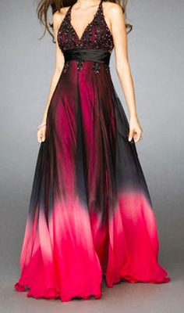

We all hurried out the main entrance and hopped into our vehicles. Christy and Tina popped their heads out of the sunroof of their limo screaming ‘IT’S THEIR WEDDING DAY’ to thousands of fans and reporters that were standing anxiously outside Michael’s main entrance gate. It took more than 45 minutes to exit the property but once we did, I sighed deeply in relief knowing that my big day was finally about to begin.

GREYSTONE MANSION & PARK
BEVERLY HILLS, CA

“We’re here!” Brad yelled as the limo drove into the garden parking lot. “Right on time too!”
“Thank God.” Michael said under his breath. “Is Diana here yet?”
“You can’t see her.” Jermaine said rubbing it in. “Sucker!”
“I know that but I’m worried about her.” Michael explained. “The media and my fans must have swarmed her vehicle for miles.”
“She’s fine.” Mac said hanging up his cell phone. “Jasmine just called to see if we had arrived and I told her we just got here. They’ll be here soon.”
“Good, let’s roll.” Jackie said glancing at his watch. “We’re pressed for time thanks to SOMEONE taking hours getting his suit on!”
“Beauty takes time.” Mac said proudly. “Besides, I’m the best man. I have to look and feel the role you know.”
“Yeah, yeah whatever.” Marlon said with a hint of jealousy in his voice. “Where are the photos being set up?”
“There!” Tito said rolling down the window and pointing towards a large camera and video crew.
“How’s my hair?” Randy asked running his hands through his scalp.
“Fine.” Everyone said.

“Are you sure?” Randy asked turning around and looking at himself in the rearview mirror. “I think it’s doing some kind of bird nest thing.”
“It’s MICHAEL’S wedding, Randy!” Tito yelled.
“Yeah, but we’re his brothers!” Randy explained. “We’re part of the wedding party. We need to roll up in style next to him.”
“He’s right!” Jermaine said. “Move over, Randy!”
“HEY!” Randy yelled. “I was using that!”

“GIRLS!” Mac yelled imitating Diana. “Can we please get over ourselves?”
“Says the guy with the biggest role of all.” Jackie said under his breath.
“Oh, crap.” Mac said hearing Jackie’s words. “MOVE OVER YOU TWO!”
“GUYS!” Michael yelled. “Umm…can we please go? It’s my wedding day.”

Everyone melted hearing Michael’s sweet voice and words. No one bothered about their looks in that moment and focused on the groom and how proud he was to finally be making Diana Dean his lucky bride. The limo driver parked the vehicle and opened the back door letting everyone out. The white limo pulled up seconds later with everyone else jumping out and straightening their clothes wanting to look absolutely perfect.

“You ok, Mike?” Brad asked.
“Yes, I’m fine. You?”
“I’m great. You look awesome.”
“Thank you.”
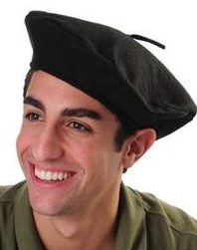

“Mr. Jackson. Congratulations.” A young man wearing a dark brown beret with a thick French accent said as he approached the Pop star and shook his hand. “I am Jacques. Your main photographer for today. Please follow me.”
“Thank you.”
“Get a load of his Frenchie accent.” Mac whispered in Michael’s ear. “Jasmine must have picked him up from Dorks R Us.”
“Hey!” Michael whispered back. “Don’t insult the people of France. My daughter is named after their capital city.”
“Oh right.” Mac said feeling bad. “Oops.”
The groomsmen walked towards Jacques where his equipment was set up with Michael walking safely in the center of everyone fully protected from the sun (due to his skin conditions) with a large black umbrella. Luckily, the park was full of shade making Michael feel more at ease about his appearance and sensitivity to sunlight. Jacques took several photos of Michael by himself then took several more with his groomsmen and best man together as group photos. The Jackson brothers did a few silly poses putting rabbit ears behind their beloved brother’s head and placed their arms around his neck as if they were trying to choke him.
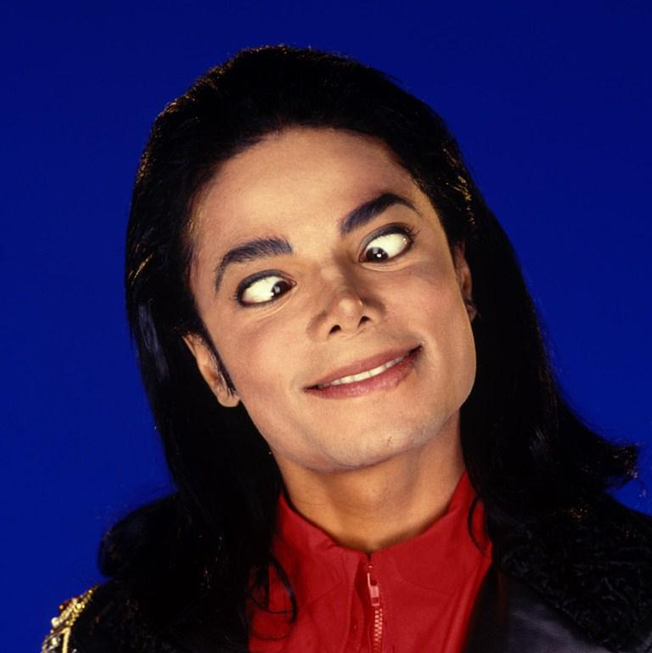
Javon and Mac held their fists in the air looking like they were about to hit their boss and best friend. Michael made goofy faces with his wedding party and Jacques loved every second of it. He captured Michael and his men from every angle in many different poses not wanting to miss a second of the Pop star’s photogenic nature. After two hours of nonstop clicking, Jermaine casually turned around and noticed Diana’s wedding party was having their own photo sessions in the distance.

“LOOK!” Jermaine yelled. “The ladies are way over there!”

Excited, Michael quickly turned his head to catch a glimpse of his beautiful bride but whimpered as he noticed several large fences and white boards were set up around the entire park blocking everyone’s view of Diana.

“I love you tea flower.” Michael said under his breath smiling at the fact that Jasmine did a good job keeping with the marriage traditions.

“Tres bien!” Jacques yelled clicking his camera at the groomsmen one more time. “These are fantastic photos! You all look smashing, bravo!”

Mac couldn’t help but laugh at Jacques words and funny sounding accent. Brad immediately caught on and started imitating the photographer making Mac and the others crack up laughing. Not realizing that he was the subject of their laughter, Jacques became very camera happy and snapped a few more shots of everyone in their natural state. Michael admired his family and friends in that moment and couldn’t help but thank God for his many blessings.

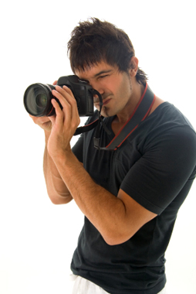
“BEAUTIFUL! VERY BEAUTIFUL!” Diana’s handsome Italian photographer Raphael said clicking his camera every two seconds capturing the bride’s flawless beauty. “Your dress is perfection, Bella.”
“Um, thank you.”
“He likes you.” Jasmine whispered while posing next to me. “I wonder if he’s single.”
“You won’t ever stop that, Jasmine.”
“I don’t mean for me, silly.”
“He looks taken to me.” I said without breaking my smile. “And he looks like he’s in his mid-thirties.”

“Now, everyone please join the bride!” Raphael said in his unique Italian accent gesturing the entire female wedding party to stand around me.
“You are stunning.” Liz said as she and Katherine took their places next to me.

“Thank you, Liz. I only wish I could look as gorgeous as you.”
“Oh, dear you do.” She said jokingly. “But I must say, my beauty is eternal.”
“I agree! Katherine said in her adorable purple skirt and blazer. “Inside and out.”
“SHH! NO TALKING!” Raphael said taking his work way too seriously. “I need smiles, lots of smiles. And pretty poses! Talking ruins everything.”
“Jeez!” Janet said. “He’s uptight.”
“He’s the best photographer in Italy.” Jasmine said trying to keep a straight face.
“He does know what he’s doing.” Rebbie said. “He’s got some expensive looking equipment.
“Ok, all done for now!” Raphael said. “You girls can breathe and take five. I need to change the film in my camera and reposition some boards for some new lighting techniques.

“Look girls!” Jasmine said peeking her head out through one of the white boards. “I can see the guys! They look like they’re having a blast.”
“Is that Michael in his fedora?” I asked trying to sneak behind Jasmine and take a look.
“HEY!” Jasmine yelled pulling the board back in its place. “No looking at the groom for you, young lady!”
“She’s right.” Angela said while fixing her dark brown curly hair. “I accidentally saw Mr. Harper the day of our wedding and some really bad luck came my way.”
“Really?” I asked. “What happened?”
“She ended up marrying me.” John said humorously making all of us laugh.

“OK, BELLAS! JUST A FEW MORE!” Raphael said holding his camera with a large lens strapped to the front. “Let’s move to the water bridge. Quickly before the men do!”
Everyone marched over towards the bridge built over a beautiful landscape of greenery and a pond of shimmering clear water. Jasmine and the others took some serious photos before becoming silly and made funny faces and gestures with their hands. Raphael couldn’t help but laugh at everyone and admired how close all of us were. Katherine and Liz took some serious photos with me and we concluded the session with everyone facing inwards with me in the middle with a large bouquet of purple roses Jasmine had custom made for me.
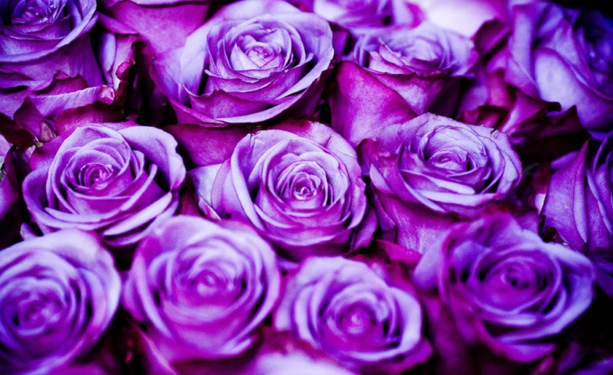
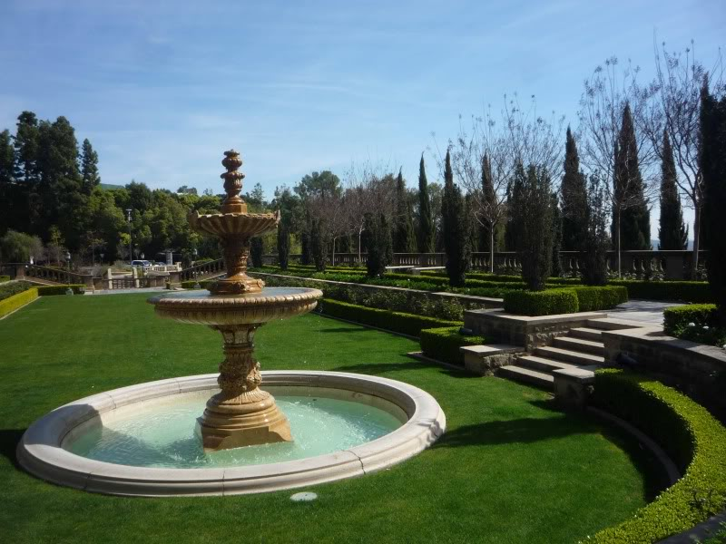
“That was fun!” La Toya said.
“Can we take some more pictures later today?” Ashley asked.
“But of course, Bella!” Raphael said. “This is just the beginning. You have me all day and night to take as many pictures as you’d like!”
“Yaay!” She screamed like a child.

“We have one more session to do quickly, Raphael.” Jasmine said confusing everyone.
“Oh, yes! I forgot about her, Bella.”
“Huh?” I asked confused. “Who?”
Jasmine smiled brightly as she turned her head and yelled for someone to come out of hiding. Angela and John stood behind me covering my eyes as the sound of high heels clicking against the pavement became louder and louder in my ears.

“What are you all doing to me now?” I asked with impatience dripping from my voice.
“Giving you our wedding present, sweetheart.” John whispered as he and Angela removed their hands from my face.

I opened my eyes and watched Jasmine as she stepped aside and left me face to face with my estranged best friend wearing a ravishing baby pink lace chiffon dress.
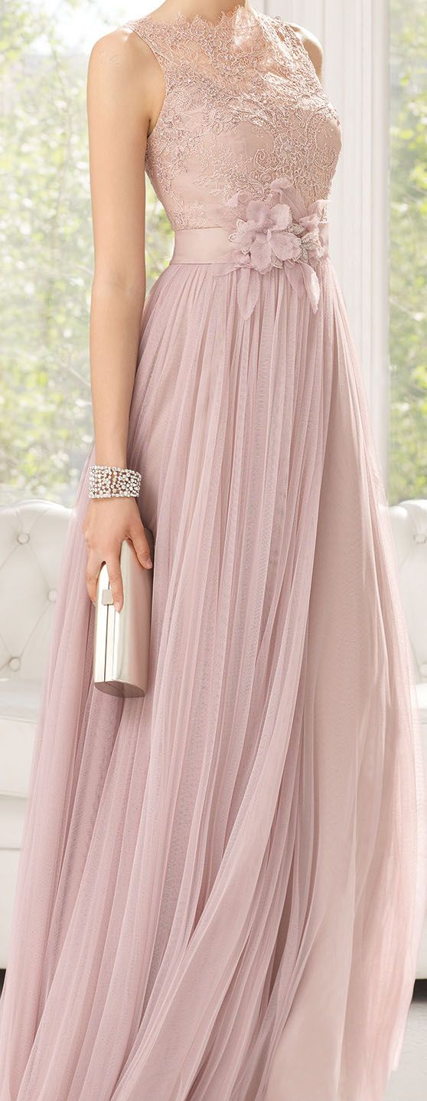
“MARIE!” I yelled running towards her and wrapping her tightly in my arms. “YOU’RE HERE!”
“Congratulations, Diana.” She whispered as she kissed my cheek softly. “You look incredible.”
“Oh Lord there goes my two hour makeup job.” Jasmine said rolling her eyes.
“Got it covered.” Janet said handing Jasmine a small makeup kit that she brought with her just in case I was to get emotional for any reason.

“I can’t believe what I’m seeing!”
“It’s really me.”
“How did you get here? You look sensational in your dress! Why didn’t you—“
“Jasmine planned everything.” Marie said interrupting me. “She and I have been talking secretly for weeks. I changed my number so Mac couldn’t find me because I knew if he did he wouldn’t keep it a secret. My parents were the only ones who knew where I was.”

“They did?” I asked turning around to face them.
“Of course.” Angela said. “She’s our daughter. She’d never abandon her family.”
“Except for when she moved here to be close to you.” John added.
“I can’t believe you all.” I said trying to preserve my eye makeup. “I’m so happy I can’t even speak words. Marie, you have no idea how glad I am to know that you’re ok. I’m sorry for everything that happened between us.”

“That’s all in the past now, Diana.” Marie said smiling.
“So you’ve forgiven me?”
“Would I be here if I hadn’t?”
“Same old Marie.”

“It’s so good to see you again, dear.” Katherine said hugging her daughter in law’s friend.
“It really is.” Liz said also hugging her. “Welcome back.”

“BELLAS! WE MUST CONTINUE!” Raphael said being his bossy self. “We need to move to phase two very soon. In position, everyone!”

Jasmine quickly touched up my face and hair again. She and I took a few photos with the newest addition to my bridal party and the others followed immediately afterwards. Raphael was very happy with his work and said it was time to pack up and head to the house. His assistants helped disassemble his equipment and lights. Within minutes, the extremely professional and handsome Italian photographer and his camera crew left to meet us all at Neverland.

“Ok, we got to go!” Jasmine said eyeing her watch. “We need to get you in outfit number two and re-do your hair and makeup.”
“Wait Jasmine.” I said while the others jumped into the limos. “Does Michael know Marie is back?”
“Not yet.” She explained. “Marie will surprise him at the house.”
“Oh Lord! I hope he doesn’t pass out when he sees her.”
“I’m sure he won’t.” Marie said. “But if he does, I know CPR!”
“MARIE!”
“Just kidding!” She said being her usual adorable self.
“OK, LET’S ROLL!” Jasmine yelled shoving us into our beautiful ivory colored limousine.

NEVERLAND
9AM

Diana and Michael’s separate photo session was a complete success. With the wonderful addition of Marie added to the bridal party, the beautiful bride was on cloud nine. Jasmine was doing a splendid job as the matron of honor making sure her best friend, boss and woman of the hour was doing okay and always looked as perfect as possible.

Michael’s groomsmen were having the time of their lives enjoying champagne in their limo and making dirty jokes. Mac kept sticking his head out of the sunroof whistling at the girls in other cars and on the sidewalks (knowing his fiancé was on her way to Neverland to attend the wedding) screaming loudly that his best friend was getting married. The Jackson brothers kept a close eye on their brother making sure he was feeling ok and not overwhelmed while Brad did his job making sure his brother in law was well hydrated and drank his protein smoothie that Kai packed for him in a small thermos.

Prince and Paris were at Neverland with their new nanny, Grace. Michael adored the mocha skinned woman. She had years of experience looking after children and like Kai and Bev, Grace successfully passed every test the Pop star threw her way. For their safety, Michael and Diana agreed to keep their little ones at home and not have them out in the public for the photo sessions but would definitely include them in the next set of photo takings at Neverland.

Diana’s party returned home to Neverland safely with Michael’s procession not too far behind. Not wanting Diana or Marie to be seen by anyone, Jasmine and the others made sure those two entered the main house as quickly as possible. Prince jumped into his mommy’s arms and Grace came down the grand staircase with Paris in her arms.

“My babies!” I yelled kissing my son and daughter.
“Wow, he’s grown a lot.” Marie said seeing her best friend’s children after such a long time. “Prince, you look very handsome.”
“Thank you, aunty M.” Prince said hugging Marie affectionately. “I missed you.”
“We all did.” I added.
“I missed you too. And look at this little princess!” She said scooping Paris into her arms and kissing her forehead. “She is so big now!”
“Seven months.” Jasmine said. “Diana, we need to get you upstairs!”
“The guests have already started to arrive.” Liz said opening the entrance door seeing several limousines and fancy cars driving through the main entrance gate.
“Oh Lord, they’re here early!” Jasmine yelled.
“No, dear. I don’t think so.” Katherine said glancing at her watch. “Doesn’t the meet and greet at 9:30?”
“OH MY GOD IT’S ALREADY 9AM?” Jasmine yelled looking at the grandfather clock in the foyer. “Diana, we need to get you changed NOW!”
“I’ll help!” Marie said.
“Great, let’s go!”

Grace and the others left the main house to welcome all of the guests and to help with the seating arrangements. Kai, Bev, Ashley, Jasmine and Marie helped me upstairs and into the master bedroom to get me into wardrobe number two. All I could do in that moment was think about Michael. How was he feeling? Did he eat anything? Jasmine told me about Kai packing him a smoothie and Brad promising to keep a close eye on him which gave me a huge amount of relief. Seeing Marie in her pretty dress made me the happiest woman on earth. I always knew in my heart that my best friend wouldn’t miss the biggest day of mine and Michael’s life. I thanked God for answering my prayer and for returning one of my most precious treasures.

“We made it!” Teddy said as everyone burst through Michael’s largest cottage farthest away from the main house. “Time for outfit number two!”
“Oh man!” Mac said looking out of the cottage bedroom window. “Everyone in Hollywood is coming to this wedding! Jasmine certainly knew what she was doing.”

Dozens of famous celebrities dressed in designer brand, elaborate clothing stepped out of their limousines, Ferrari’s and other exotic vehicles landing directly onto the lavish red velvet carpet Jasmine had set up for the event leading the guests straight towards Michael’s veranda for the pre-wedding meet and greet. Mac didn’t see any sign of Rachel anywhere but didn’t think anything of it. Knowing whose wedding it was, the child star knew his fiancé wanted to look extra sharp since she would officially be known as the future bride of Macaulay Culkin.

“Mike, we need to get you changed into number two so that you can greet all of your guests.” Javon said. “We’ll be outside if you need us.”
“Thank you.” Michael said as he headed towards his walk in closet to wear his next scheduled wardrobe.

Minutes after Michael changed into a more casual, relaxed outfit, Karen knocked on the bedroom door asking if he needed a touch up. The Pop star quickly pulled himself together and let his friend inside barely opening the door so that the others wouldn’t see him a second before they were supposed to. Karen giggled seeing her friend and client dressed differently than usual. For the first time, Michael didn’t wear a sparkling jacket with military style inspiration. Instead, he wore a simple navy blue jacket with gold tassels on his shoulders and gold buttons running along the cuffs of each sleeve supported by burgundy colored fabric lining. He chose not to wear a fedora or sunglasses revealing his dark, chestnut colored eyes and raven dark hair with a few curls resting perfectly against his right eye.
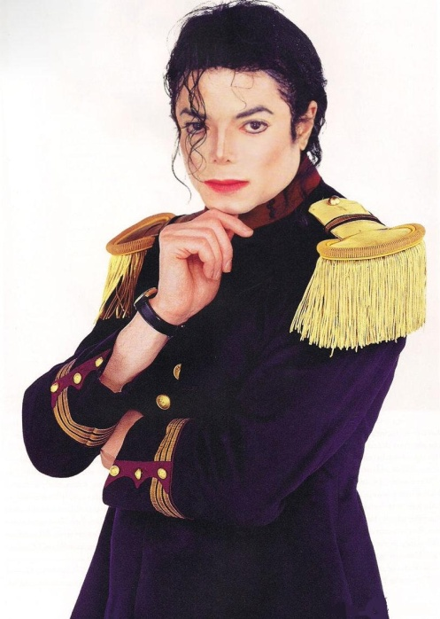
“What?” Michael asked innocently. “Do I look stupid?”
“Of course not!” Karen replied. “I’ve just never seen you look so…normal.”
“Is that bad?”
“Michael, why do you always assume the worst?”
“I’m nervous, Karen.”
“And why is that?”
“Because I’m getting married today.”

“AWWWW! MICHAEL!” Karen said girlishly making Michael blush all shades of red. “You have no reason to be nervous. Diana is so happy today. And she looks absolutely stunning.”
“You’ve already seen her?”
“Of course. I went gave her a small touch up before coming back here to see you.”
“Karen, you little sneak!”
“Yes, that’s me. Now, let’s get you ready for phase two of the Jackson wedding.”

The two of them spent the next hour making sure Michael looked and felt his best with his new set of clothing. Like always, Michael wanted to wear a fedora to protect him from the sun but also to keep his iconic style intact. Karen admired her finished product once again and hugged the Gloved One congratulating him on the happiest day of his life.

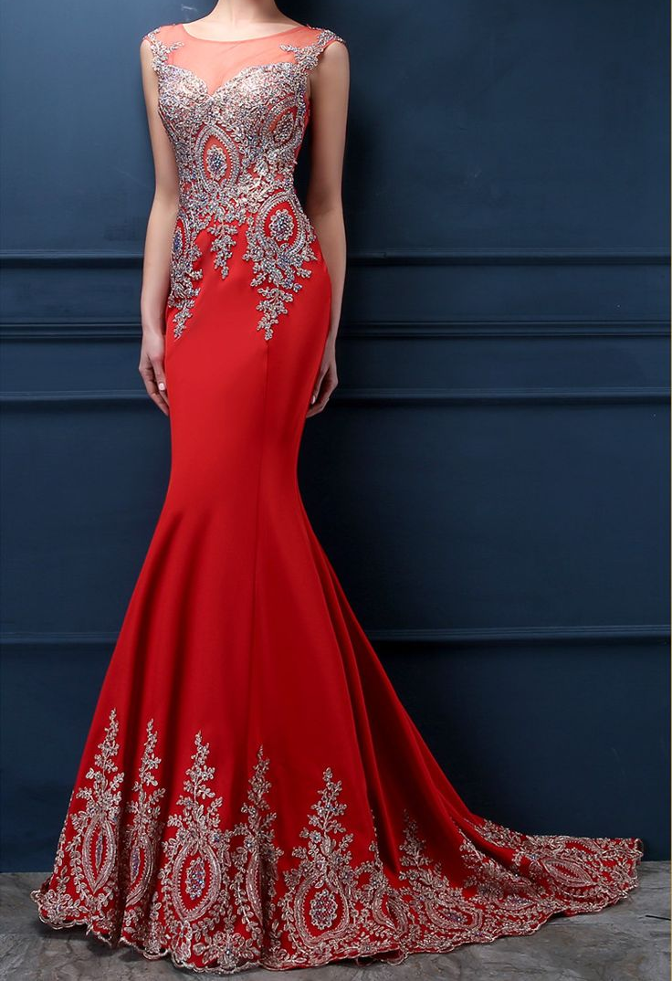
“Another fabulous piece of work.” Jasmine said admiring hers and Karen’s work in the full length mirror. “You really should have taken up modeling instead of music, Diana.”
“I second that.” Marie added.
“Stop it, you two. You all look lovely in your second outfits too. Are you sure this dress looks ok for the meet and greet?”
“Yes! It’s perfect.” Kai said helping me pin my hair up into a bun. “I just need to curl these last few parts of your hair and we’ll be all set.”
“We can’t forget your shoes!” Bev added placing a large black shoebox on the bed. “I really love these! I’m glad you took my advice and bought them.”

“Me too.” Jasmine said. “I bought the same ones in red.”
“OO I like!” Marie said examining them closely. “Will you be changing shoes again later?”
“Of course.”
“She better!” Kai said. “The ceremony shoes are crucial! And I bought them for her!”
“Really?” Bev asked.
“Yes and they are the perfect shoes for today!” Bev added. “Cinderella had nothing on you, Diana Jackson!”
In honor of my future husband’s fashion trend, Jasmine ordered me a pair of silver high heels with rhinestones all over them symbolizing Michael’s iconic silver glove. My ruby red mermaid dress was also filled with hand woven silver patterns making it the perfect ensemble to represent me as the King of Pop’s bride.

“You all are way too kind.” I said blushing. “Thank you so much. I’m still going to be a Dean for a few more hours.”
“I can’t believe this day has finally come.” Marie said looking at my veil hung up on the closet door. “You and Michael make such a lovely couple.”

Jasmine was blown away by her friend’s comment. Kai and Bev smiled and felt proud of Marie for having the courage to let go of her grudge and accept defeat of losing her childhood crush to her best friend. Diana hugged her best friend lovingly thanking her former assistant for giving her blessing. Not being able to resist, Jasmine and the others joined in forming a huge bridal party group hug.

“Ok, enough with the sappy stuff.” Ashley said. “We need to get this gorgeous looking woman out there.”
“What if Michael sees me?”
“Not gonna happen.” Jasmine explained. “He’s meeting the guests first outside. You’re meeting them second right here in the house. Javon is guiding everyone into the dining room where snacks and beverages are set up. Not to mention some of Kai’s organic goodies that Mac is probably going to devour.”
“How did you manage to do all this by yourself?”
“Who said I did all of it myself?” Jasmine asked confusing me.

“Everyone had a hand in your wedding, Diana.” Kai said.
“Even me.”
“You, Marie?”
“Of course. Who do you think gave Jasmine the idea of hiring French and Italian photographers and decorators?”
“In memory of us all being in Europe.” Jasmine replied. “We thought you’d pick up on that right away.”
“I’ve been so distracted with everything that I didn’t even think about that. But thank you for keeping our fondest memories a part of this day.”
“LET’S GO MISS BRIDE TO BE!” Tina yelled from outside the bedroom door. “The guests have started coming in the house and we’re all dying to see you!”
“Oh gosh, things are moving rather quickly today.” Jasmine said. “Ok, let’s finish you up and get ready for your big entrance.”
“I’m nervous, Jas.”
“Don’t be.” Marie added. “This is your day. Embrace it.”
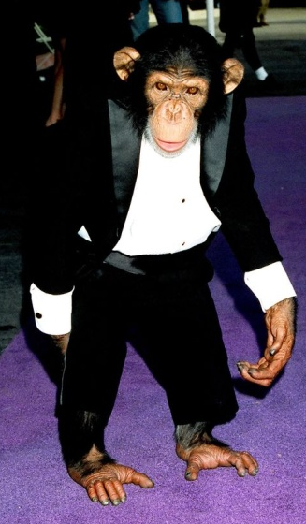
Kai and Bev took their positions in front of the room and opened the door. When Jasmine gave the signal to open it, both women exited with Ashley and Marie right behind them. Jasmine stood in front of me as I took a few deep breaths and followed my bridal party out of Michael’s room. Soft, classical music started playing on the stereo in the living room. Grace stood at the bottom of the grand staircase with Prince, Paris and Bubbles who was also dressed in a black tuxedo. I giggled seeing the chimp look so handsome as I slowly made my way down each step.

“You look beautiful.” Grace said placing my daughter in my arms. “She missed you.”
“I love you princess.” I whispered seeing her giggle and hold my pinky finger tightly.
“Mommy, you are pretty.”
“Thank you, baby. Did you see daddy?”
“Yes, he looks nice too.”
“I’m glad he does.”
“I love you mommy.”
“I love you more, sweetie.”

“Ready to meet a few guests?” Jasmine asked.
“Do I know them?”
Marie scoffed in a good way.

“You’ve seen them on TV.”
“Oh gosh, they’re all famous?”
“Uhh, yeah!” Jasmine said. “Have you forgotten who your groom is?”
“No, I most certainly haven’t.”

“Come on, let’s go!” Kai said tugging at us to keep moving.
“I hope I don’t get anxiety or something.”
“You won’t Ana.” Marie said.
“Ana…I haven’t heard that name in so long.”
“You’ll always be my Ana.”
“I love you, Marie.”
“I love you too.”

“Let’s get in there!” Jasmine said. “It’s rude to keep everyone waiting.”
“I have my two best friends and the best staff workers by my side.” I said confidently with my head held high. “I’m not nervous anymore. Let’s go rub elbows with the rest of Hollywood!”

Michael was enjoying himself mingling with so many people he hadn’t seen in years. Some of his early bird guests included Quincy, Vincent, Waleed, John, “Dita” and Siedah. Several more were on their way with all of the groomsmen excitedly watching as they greeted every single famous person who walked onto their brother’s exquisitely decorated veranda filled with multicolored lights, an assortment of fresh white carnation flowers and large pillar candles on every table.

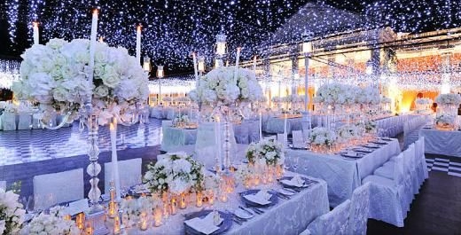

“You ok, Mike?” Brad asked noticing his brother in law was looking a little pale.
“I’m fine.”
“Are you sure?”
“Yes, I’m ok.”
“Ok. Just say the word if you need anything.”
“I want to see your sister so badly.”

“We all do.” Brad said sipping on a glass of orange juice. “I can’t even imagine how stunning she must look right now.”
“Me too. I can’t wait to take it all off later.”
“AHEM.” Brad yelled. “Uh, yeah that’s something I didn’t need to hear.”

Michael laughed as he continued shaking his guest’s hands standing upright looking as if he were a commanding officer in an army. Not being able to make the photo session due to his work commitments, David finally arrived in his three piece black suit.

“Sorry, I’m late.” He said hugging the groom. “Congratulations, man.”
“Thank you David.” Michael said humbly. “I’m so glad you made it.”
“Is the photographer still around?”
“Oh yeah, Jacques is over there taking photos of the guests and the food.” Brad said.
“Jacques?”
“Don’t ask.” Michael said.
“Hope you like Frenchies!” Mac said as he casually walked by.
“Hmm… this could get interesting.” David said as he and the other groomsmen went to have their photos taken together.

“Congratulations, Michael.” A familiar voice said.

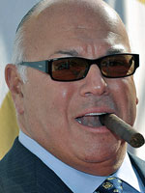
Michael turned around and gasped seeing his former manager puffing on a cigar.
“FRANK DILEO!”
“Yeah, that’s me. Thanks for remembering!”
“You silly man!” Michael said hugging his friend and former business partner. “Thank you for coming.”
“My pleasure. I’m off to see your bride.”
“You might want to get rid of the cigar first.” Michael said. “She can’t stand second hand smoke.”
“You definitely caught the right woman, Mike.”
“I know.” He said giggling. “I’m so happy you’re here.”
“I wouldn’t have missed this for the world.”

Emmanuel sat in the backseat of his black stretch limo in his fully tailored, finely cut Italian Hugo Boss grey suit. He graciously accepted Jasmine’s offer to keep him along with several other out of town wedding guests at the Hilton and checked in a few days ago with no problems. In his right hand was a large white envelope with a letter and very generous monetary gift for his friend and future bride. The child star could not stop smiling as he felt the warm California sun fall on his face and the wind blowing in his fuzzy black hair.

“I’m coming, Michael.” He said as he rolled up his car window.

