Chapter Twenty Seven
Born as Two, United as One

Michael & Diana’s Wedding Day

PART II

NOVEMBER 14, 1998

NEVERLAND
10:00AM

The meet and greet was coming along perfectly. Michael’s guests were arriving by the dozen in their glamorous cars and outfits excited to meet their Pop star friend and mentor on his special day. After meeting with the early bird attendees, the ladies quickly took the bride upstairs to change into wardrobe number three – her wedding gown.

“Diana, you’re going to look absolutely incredible!” La Toya said helping her soon to be sister in law up the grand staircase.
“I’m anxious to see the dress!” Jasmine said.
“Me too!” Christy and Tina both said.
“In time, ladies.” I said smiling brightly.

Janet helped bring the large garment out of Michael’s fully mirrored walk in closet in his room and placed it on his giant wooden sleigh bed. Being careful not to fall (because it was so huge and heavy) Jasmine helped the baby Jackson and gasped seeing how large the dresses’ protective bag was. Not wanting to ruin the surprise, everyone except Jasmine left the soon to be bride in her room to change while they waited impatiently to help with her hair, makeup, jewelry and shoes.

“Diana, your dress looks massive!”
“That’s because it is.”
“I can’t even imagine how long your train is.”
“You’re about to find out.”

Katherine, Elizabeth, and Grace joined the festivities on the veranda keeping a close eye on their son and friend. Being the center of attention was something Michael had grown accustomed to but today, he felt extremely apprehensive as if something was not right. Trying his hardest not to think much of it, Michael continued to smile and greet all of his visitors at his home not leaving a trace of uncertainty in his aura.

“You’re still doing ok?” Brad asked his perplexed looking soon to be brother in law.
“I think so.”
“Mike, you can’t hide it from me. I can tell something is bothering you.”
“Brad, can you cover for me?”
“Where are you going?” Diana’s brother asked worried.
“I just need to be alone for a few minutes. I’ll be right—“
“MIKE!” Mac yelled running up to his friend. “It’s almost time. You need to get changed into number three.”
“NOW?” Michael asked not realizing how much time had already elapsed.
“Yes, NOW!” Mac explained. “The ceremony is in an hour. Karen asked me to get you and take you to the cottage house.”
“Oh god…”

“What’s wrong?” Mac asked.
“I just need some time alone.”
“Are you having second thoughts?” Brad asked afraid to hear the answer to his question.
“Of course not!” Michael replied. “I just need to get away from everyone. I’ll be right back.”
“Mike, it’s your wedding day!” Mac said trying not to alarm the guests.
“I know!” The Pop star replied. “Just give me a minute. I’ll meet you both at the cottage house.”

Michael walked away discreetly and ran towards his amusement park. Mac and Brad stood in awe wondering what was going on with their friend and soon to be brother in law and hoped that whatever it was, it would soon disappear. Not wanting to cause a scene, the two boys continued mingling with the guests and enjoyed the wonderful appetizers made by Kai and the caterers. Javon witnessed the entire incident from afar and felt bad for his boss. Wanting to know what was really going on, he followed his employer making sure he didn’t stray too far.

Michael sat on a bench near his grand clock and sighed deeply. He tried his hardest to be strong but for some reason, his heart felt heavy. He had always dreamed of marrying Diana and now that his dream was just an hour away from coming true, he couldn’t help but wonder if bringing the beautiful CEO and his two young children into his world of whirlwind, chaos and fame would end up destroying them. He also missed Marie terribly and wished for nothing but his favorite fan in the world to be by his side on his special day. Suddenly, a gust of wind circled around the Pop star’s entire frame and whispered in his ear.

“Don’t second guess yourself….”

Michael gasped and quickly turned his head every direction. No one was around him. The wedding guests were acres away from him and no one was in sight for miles.

“She is your soul mate, Michael. Be brave.”
“Who are you? Why do you keep haunting me?”
“You will find out soon. She is closer to you than you think…”

Michael thought he may have been hallucinating again. He scratched his head in confusion wondering who or what this spirit was and why it would always come to him in an unknown form never wanting to reveal itself.

“You must change now…” the wind howled again.

“Please, whoever you are. Just go away.”
“I will…after today.”

Michael was more confused than ever. He stood up from the bench and screamed as he felt a small tug on his right arm.

“Jeez, Mike!” Mac said jumping two feet back. “What’s gotten into you?”
“Nothing, Mac.” The Pop star replied shaking off his fear. “What are you doing here?”
“Uh, I’m your best man!” Mac said reminding his friend of his matrimonial duty. “I have to get you to the cottage house NOW. The ceremony is in half an hour.”
“Diana is getting ready?”
“According to Jasmine – yes. Now, let’s go!”

“Mac…” Michael grabbed his child star friend’s arm as tears filled his eyes.
“Michael, what’s wrong?”
“I’m getting married, Mac.”
“I know you are.”
“I can’t believe it. I never thought I’d ever have a wife or become someone’s husband. I’ve wanted this all my life. I watched my brothers and sisters get married and prayed that one day I’d have my chance and now it’s here. It’s finally here, Mac…”
“Michael, you deserve it.” Mac said hugging his groom friend. “This is YOUR day. I know you’ve struggled with being alone but you won’t feel that way ever again after today.”

“Do you really think she will stay with me?”
“She came back to you didn’t she?”
“Yes, but Diana is so beautiful and intelligent. She can have anyone she wants.”
“And who she wants is YOU, Michael.”
“But why?”
“Because you’re the one she loves.”

Michael wiped his tear stained face and sat back down the bench. Knowing they were pressed for time, Mac almost told his friend that he needed to get changed again but after seeing his distressed look, it was obvious that Michael needed to talk to someone. Being the good friend he was, Mac forgot about the wedding for a moment and focused on Michael who clearly needed someone to listen to him. He joined his friend on the bench and the two had a heartfelt man to man talk.

“When did you know Rachel was the one, Mac?”
“Mike, I’m only 18. You’re 40. I should be asking YOU that question.”
“Aren’t you the one who always says that age is just a number?”
“Weren’t you always the one telling me that age has nothing to do with love?”

The two friends laughed childishly.

“Seriously, Mike…” Mac continued. “You and Diana belong together. She needs you just as much as you need her. You’re like a tree trunk and Diana is your biggest branch. Prince and Paris are your leaves. Without branches and leaves, the tree just isn’t a tree.”
“Looks like I’ve taught you well, Macaulay.” Michael said smiling.
“You sure did, Peter Pan. Now let’s show everyone how you and Wendy can fly.”
“You got the rings?”

“I sure do and I can’t wait to see both of your faces when you see how they will be presented.”
“Mac, you’re the best.”
“You learn from the best in order to become the best, Mike. Now, let’s get the King of Pop married, shall we?

The two men stood up from the bench and headed towards the large cottage house. Michael noticed his screaming fans from a distance and waved to them making them scream even louder with excitement. Wanting to shake their hands and thank them personally, the Pop star quickly ran to the new fence that was installed near his main entrance gate and grazed his hand along the edges thanking his admirers and even took a few photos for the paparazzi. One fan in particular caught his eye and Michael could not resist seeing her up close. She had a young child with her who could not stop crying making the Gloved One feel even more loved and appreciated.

Knowing it was his wedding day and how pressed for time he was, the soon to be married star asked Mac to wait a few minutes while he approached the gate as close as he could while dozens of guards hovered over him for safety. The young lady with the child was trying so hard to console the young one but nothing she did seemed to work. Michael felt concerned for the child and wanted to know if he could say or do anything to help.

“What’s your name?” Michael asked as he bent down and reached for the little girl’s hand from the gate and kissed it.
“Tori.” The child said while sniffling.
“You are beautiful. What’s wrong?”
“I love you. I want to be with you today.”

Michael’s heart was breaking. How could an innocent little girl feel sad on the happiest day of his life right outside his home?

“I’ve been a fan of yours ever since I was her age.” The older girl said. “She’s my three year old daughter. We drove all the way from San Francisco to be here. She loves you and your music.”
Michael rose to his feet and tried talking to the young lady some more but urging fans stopped him from having any sort of conversation with her. His guards were telling him repeatedly to step away from the gate as his fans were becoming too hostile. The Pop star requested the young lady and Tori to be allowed onto his property. Mac helped push a few fans out of the way as the guards slightly opened the rod iron, gold embedded gate fully decorated with flowers and a monogram of Michael and Diana’s names.

The guards closed the gates immediately gently pushing Tori and her mother onto the property. Mac glanced at his watch and reminded Michael that time was running out and he had to get dressed. Javon called Mac’s cell phone every two minutes wondering where his boss was and what he was doing near his entrance gate. The child star explained that everything was ok and Michael just wanted to greet his loving fans before getting dressed for his own ceremony.

“What is your name?” Michael asked the young lady.
“LaShea.”
“It’s nice to meet you.” He said hugging his adoring fan.
“Everyone calls me Shea for short.” She explained. “Tori’s real name is Tanisha.”

Michael looked down at the three year old and picked her up kissing her cheek.

“You are so cute.”
“Thank you.”
“I love you.”
“I love you too.”
“Would you like to stay with me?”
“CAN I?” The young girl asked with excitement dripping from her innocent voice.
“Of course. You and mommy can stay for my wedding.”

“We don’t want to impose—“
“Don’t be silly!” Mac said interfering. “It’s our pleasure. I’ll call one of Mike’s workers who will escort you both to the ceremony.”

“You really ARE a very kind soul.” Shea said Michael as he put her daughter down. “Your fiancé is very lucky.”
“Thank you so much.” Michael said with flushed cheeks. “Thank you for coming to my home. I hope you enjoy yourself.”

“OH.MY.GOD.” Jasmine said looking at her best friend come out of the bathroom with her wedding dress on. “Diana…”
“You like it?”
The beautiful right hand assistant could not help but cry at the sight of the CEO’ dress. The color, pattern, design and overall presentation were nothing short of spectacular.

“Michael is definitely going to faint.”
“I HOPE NOT!”
“You know what I mean!” Jasmine said wiping her tears. “You look like a goddess.”
“You think so?”
“Oh stop it! Let’s get you ready!”

Jasmine opened the bedroom door allowing the other wedding party members in to help the bride with her hair and makeup.

“WOOOOW!” Kai, Bev and Marie said in unison.
“Now THAT’S what I call a wedding dress!” Kai said. “Absolutely stunning!”
“You girls really like it?
“LIKE? LIKE?” Marie asked. “Diana, you look better than the queen did on her wedding day!”
“I wouldn’t go that far.”
“I certainly would!” Bev said. “Now, enough chatter. The ceremony is just thirty minutes away. We need to get you accessorized and ready to go!”

The ladies changed into their dresses one at a time in the bathroom making sure they were taken care of and out of the way before spending the remainder of their time getting the bride dolled up for her special day. All Diana could do was think about Michael and what he would be wearing for the most important day in their lives.

Michael made sure Shea and Tori were ok and enjoying themselves at his grand event. Javon and the others welcomed the chocolate skinned woman and her angelic three year old daughter by giving her a quick tour of Michael’s beloved home before walking them to their seats where the ceremony was set up. Karen helped her friend and client look his best again for the most important part of the day. The Pop star put on his ceremonial attire and checked himself out in his full length mirror making sure there were no wrinkles or flaws of any kind on his custom made wardrobe.

Teddy and the others were having a great time mingling with Michael’s ‘single lady’ guests making sure they were ‘well taken care of’ and not feeling too emotional. Rodney tried hitting on a few guests and surprisingly even got a few phone numbers. Teddy bet his producer friend that he could get more numbers than Rodney by the end of the day. The two talented producers accepted the challenge and felt confident that one would definitely beat the other.

“You look fabulous, Mike.” Mac said helping his friend and mentor put on his diamond encrusted brooch on his collar. “I thought you were going to wear something a lot more extravagant.”
“I don’t want to steal attention away from Diana.” Michael explained. “The entire world will be watching us today. Everyone is expecting me to wear something that I usually wear. What better day to show them that I too can look just like everyone else sometimes?”
“Well, you look great.” Jermaine said helping his brother put his shoes on. “I can’t imagine what Diana must be looking like right now.”
“Did you book the hotel room?” Mac asked.
“Um, EW!” Brad said sounding disgusted. “I don’t want to know!”
“Yes, Jasmine took care of that too.” Michael said giggling.

“So you gonna wear boxers for her, Mike?” Mac asked.
“UM, HELLO! BROTHER IN THE ROOM!” Brad yelled.
“So, leave!” Mac joked.
“Like I always say…” Michael continued. “I’m a gentleman. A gentleman doesn’t kiss and tell.”
“COME ONNNN!!!” Mac whined. “The great Michael Jackson won’t share his story with his own groomsmen!”
“NO!” The Pop star yelled while smiling brightly. “It’s a secret. You all have your own sex lives to worry about.”
“Shoot, not me.” Javon said. “I hadn’t gotten laid in months before Lola came around.”
“LOLA? THE STRIPPER?” Everyone asked in unison.
“UHH…CONGRATULATIONS SIR!” Javon said desperately wanting to change the subject.
“I WANT DETAILS!” Mac yelled excited.
“ME TOO!” Brad added. “Don’t leave ANYTHING out!”

“GUYS!” Tito yelled. “This is Michael’s wedding day! So, Javon you’re going to fill us all in later right?
“Oh god…” Michael said rolling his eyes. “I have the sickest friends and family in the world.”
“But you love us to death.” Brad said hugging his soon to be brother in law.
“Yes, I most certainly do.”

The entire gang of men helped Michael with his attire while Karen helped with his hair and makeup. The Gloved One wanted to look simple but elegant for his special day with nothing but his beautiful bride in mind. His jet black blazer was custom made by Italian designer Gianni Versace, the same designer who created the Pop star’s gold wardrobe for his HIStory tour. His pants were also black made from acrylic and silk – the perfect material for his sensitive skin. A large diamond embedded brooch rested perfectly in the middle of his collar and his curly hair was teased and ruffled resting perfectly on the right side of his wonderfully chiseled face.

“You are gorgeous, Mr. Groom.” Karen said kissing her client’s cheek.
“Thank you so much.” Michael replied. “I’m so glad you’re here. You look lovely too, Karen.”
The beautiful makeup artist wore a pink and white dress with a pink flower barrette on the right side of her flowy blonde hair.

“This is it, Mike.” Michael’s brother Randy said. “No turning back now.”
“I know.”
“Ready to go?” Jermaine asked.
“I think so.”
“Do you have your vows written down, Michael?” Karen asked.
“MAC!”
‘Right here.” The best man said pulling out a folded white sheet of paper from his back pocket. “Jeez, will you chillax? I got this.”

“Guys!” Javon yelled bursting into the room. “Two things! First, Mike there’s someone here who wants to see you. Second, the minister just arrived.”
“Oh boy.” Michael said under his breath. “This is really happening today.”
“It sure is!” Karen said happily.
“Who wants to see him?” Mac asked curiously.
“It’s a surprise.”
“Send them in please.” Michael said anxious to see his mystery visitor.
“Close your eyes.”

The Pop star did as he was told and turned his back towards the bedroom door. Marie quickly slipped in and stood at the door surprising everyone including Mac.

“OH MY GOD! RIE—“
“SHHHHH!” Javon yelled covering the child star’s mouth.

Marie walked up to her idol and placed her hands on top of his eyes. Michael’s heart immediately skipped a beat. He gasped lightly to himself. This was all too familiar to him. He knew that touch. He knew that perfume. He knew that person.

“Remember me?” Marie whispered in Michael’s left ear.

Not saying a word, Marie felt her inner palms become wet from Michael’s forming tears. He knew exactly whose hands were on his face and politely asked the others to leave the room while he welcomed his estranged friend and fan in private. Marie removed her hands from her idol’s face and spun her childhood crush around. Thin lines of black streamed from Michael’s eyes like rain falling from a glass window. Marie wiped the Pop star’s tears away and hugged him tightly not wanting to let go of him.

“You have no idea how much I’ve missed you.” Michael said wrapping his arms around his favorite fan. “I prayed to God every single day begging Him to bring you back to me.”
“I missed you too.” Marie said pulling away from the Pop star.
“You are more beautiful than I remember.”
“Stop it, Michael.”
“It’s true.”
“I can’t believe how handsome you look.”

“Stop it, Marie.”
“It’s true.”
“How are you?”
“Just fine.”
“I’m sorry.”
“For what?”
“Not choosing you. If I had met you first--”
“Michael, I’ve loved you since birth.” Marie explained. “I was fortunate to meet and get to know you in person. I traveled to Europe with you. I helped raise your son. I’ve stayed in your home and most of all, I gained your friendship. Believe me - You DID choose me.”

“I love you, teddy bear.”
“I love you more, Mikey.”
“How does Diana look?”
“Like your bride.”
“Really?”
“Yes, Michael. You and Diana are made for each other. I wish you two nothing but the best.”
“I’m glad you’re here.”
“Thank you. So am I.”
“Don’t you ever leave me like that again!”
“Is that a threat?”
“YES!”
Marie laughed and kissed her friend’s cheek.

“I won’t go anywhere ever again unless it’s with you and Diana.”
“Promise?”
“Yes.”
“Say it.”
“I promise.”
“You promise what?”
“Michael, stop being a baby!”
The Pop star tickled his fan until she could no longer stand still. Not wanting to accept defeat, Marie refused to give into her idol thinking he would eventually stop tickling her and give up on his own since it was his wedding day.

“OK! OK!” She yelled. “STOP IT!”
“Not until you say something nice about me!”
“You look very handsome today!”
“TODAY? You mean I wasn’t handsome before?”
“YOU’VE ALWAYS BEEN HANDSOME!”
“And?”
“You’re the greatest entertainer in the world!”
“AND?”
“You’re the best dancer on earth!”

“AND?”
“Today is your wedding day!”
“AND?”
“Prince and Paris are adorable!”
“AND?”
“Oh god, Michael! What else is there?”
“Who’s my number one fan?”
“ME!”
“Who isn’t going to leave me ever again?”
“ME!”

“Who will always stay by my side?”
“ME!”
“Who will—“
“ME! ME! ME!” Marie yelled wanting her idol to stop tickling her before she had an accident.
“MICHAEL! PLEASE STOP TICKLING ME NOW!”

The Pop star did as he was told and helped Marie compose herself. She playfully nudged Michael’s shoulder and he caught her as she fell into his arms.

“I love you, Marie.”
“I love you too, Michael.”
“Welcome back.”
“Thank you.”
“You will always have a piece of my heart.”
“Really?”
“Yes.”
“Promise?”
“I promise.”

The two of them hugged for what seemed like hours. The King of Pop kissed his fan’s forehead and thanked her for being at his and her best friend’s wedding. After a brief talk, Marie wished the groom luck as she left to tend to the bride and to make sure her duties were taken care of before the ceremony began. Not being able to control himself, Mac excitedly ran into the room and hugged his long lost friend feeling so happy to see her again.

“I need a minute alone please.” Michael said to everyone as they returned to the room. “I’ll be right out.”
“Don’t take too long.” Javon said. “Jasmine called and said 98% of the guest list has arrived.”
“Including Rachel?” Mac asked.
“Yeah. She arrived about an hour ago. Bill escorted her to her seat.”
“I won’t take long.” Michael said as the gang made their way out of the cottage bedroom.

Mac and Marie both walked out together. Michael called out to his fan one more time.

“Marie!”
She turned around and faced him.

“Does she really look sensational?”
“Wait till you see her.” Marie said as she winked at her idol before leaving his cottage house with his best man.

“Where have you been, Rie-Rie?” Mac asked as the two of them headed towards the ceremony.
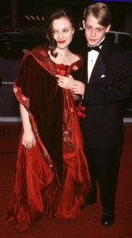
“I went into hiding.” Marie explained. “I stayed with my parents for about a week then at a hotel for a while. I needed to clear my head. “
“Well, I’m glad you’re back.” Mac said hugging his friend. “You look beautiful in your sparkly dress. The gang really missed you.”
“Including you?”
“I think you know the answer to that.”
“Yes, but I’d love to hear you say it.”

Mac smiled as he grabbed Marie’s right hand kissing the back of it gently.

“I really missed you, Marie Ann Harper. You have no idea how happy I am that you’re back. This wedding wouldn’t have been the same without you.”
“Thank you, Mac.” She said squeezing her friend’s hand lightly.

“Here you are!” Rachel said running towards her fiancé. “I’ve been looking all over for you!”
“My bad.” Mac said letting go of Marie’s hand. “I was helping Mike get ready. This is Michael’s number one fan and my good friend, Marie. Marie, this is Rachel. My fiancé.”

Marie gasped to herself but kept her composure. She shook the brunette haired beauty’s hand admiring her stunning red dress and fur inspired shawl around her shoulders. Rachel’s handshake was anything but friendly. Marie felt her unwelcoming aura almost immediately and excused herself as she left to check on her best friend and bride.

“So, she’s the one you told me about?” Rachel asked Mac as they both headed towards the ceremonial lawn.
“Yeah. She just came back.”
“I see.”

Rachel had a strong feeling of resentment towards her fiancé’s friend. Marie’s temporary disappearance resulted in Mac spending countless days and nights trying to find her in New York much to the young actress’s disliking. Rachel felt a large sense of insecurity and wondered what it was about Michael’s number one fan that intrigued her fiancé towards the young fan. Not wanting to cause a scene, Rachel ignored her feelings and sat in her seat next to her intended waiting for the ceremony to begin.

Michael sat at his vanity in his cottage house bedroom. He carefully examined himself in the mirror and for the first time in years actually liked the result of what was looking back at him. He smiled as he carefully placed a few strands of hair in front of his right eye symbolizing his usual, adorable shyness.

As he stood up from his vanity stool, a large beam of white appeared from behind the mirror forcing the Pop star to turn around and see what was forming behind him. To his surprise, a tall blonde haired woman wearing a white dress and a halo above her head flew down from the ceiling. Michael rubbed his eyes with his fingers making sure he wasn’t dreaming and that the image he was seeing was actually there.

“I am so proud of you, my friend.” The lady in white said standing in front of the Pop star groom. “This can’t be…” Michael said to himself. “Diana?”
“Oh my word.” She replied smiling. “You remember my name.”
“I can’t exactly forget it.” Michael said giggling. “My wife has the same one.”
“I love that you regard her as your wife already, Michael.”
“Why are you here? How can you—“
“I am your guardian angel.” The spirit explained. “I have been watching over you since the day I took my last breath.”

Michael was amazed. He had heard of similar things happening in books and on TV shows but never once thought it could ever happen to him.

“I have been guiding you ever since you returned from Europe.”
“Oh my god! Yes, you have.” Michael said thinking back to all the moments in his life when the phantom wind spoke to him. “It was you all along.”
“It was, indeed.”

“You warned me about everything.” Michael explained. “Cameron, Prince, the message on my notebook in the studio, the letters ‘POW’ on my bedroom wall. It was all—“
“Princess of Wales.” The spirit admitted. “Yes, Michael. It was me.”
“Thank you, Diana.” The Pop star said as he stood up and offered his hand to the spirit. “I miss you very much.”
“And I you, my friend.”

“Please don’t ever leave me.”
“I will do no such thing, Michael. But I must warn you that you will never see me again after today.”
“Why not?”
“A guardian angel can only reveal themselves once to the one they are protecting.”
“Does that mean I won’t know when you are around me?”
“You will always feel my presence in the wind, Michael.” The spirit said as it slowly started to fade.
“Diana, please don’t leave.”
“Congratulations, Michael. You have found your soul mate.”
“Diana, NO!”
“I shall always be with you…”

The spirit suddenly dissipated into thin air. Michael was left standing awestruck with his mouth open wondering what just happened and if what he saw was real. He turned to his mirror and saw a fog appearing on the glass with a picture of a little boy with the words ‘he is here’ at the bottom. Michael’s heart suddenly felt content. The spirit WAS Princess Diana and her message to him was crystal clear.

“I love you, Diana.” Michael said as he watched the fog disappear from the mirror.

THE CEREMONY
11AM

Dozens of helicopters roamed the sky hovering over Michael’s enchanted home trying to catch a glimpse of the biggest wedding of the century. News reporters were setting up their video equipment outside the main entrance gate excited to report any piece of information they could get their hands on. Every radio station, TV channel and internet webpage was interrupted with breaking news announcing that the King of Pop was just minutes away from saying his vows to the luckiest woman on earth. His beautiful CEO bride.
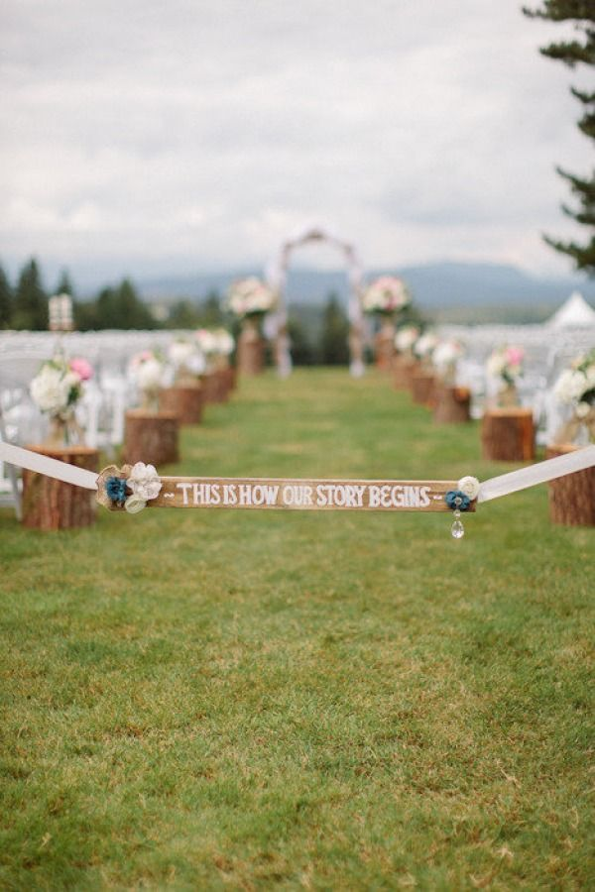
The groomsmen were ready. The bridal party was ready. The guests were overly excited as they were ushered to their seats. Everything was going according to schedule and the two imported photographers, Jacques and Raphael were having a blast snapping pictures of everything in sight. Javon quickly entered the ceremony area before all of the guests sat down in their white plush seats and placed a ‘reserved’ sign on two chairs at the front of the VIP area next to Katherine.

She and Liz were assigned to sit together and wondered who would be sitting next to them since the seating chart did not have names on those two specific seats. Bill stood at the podium and thanked everyone for attending the highly anticipated event before handing the microphones over to the emcees for the wedding – Quincy Jones and Berry Gordy.

“Thank you.” Both men said as they gestured for everyone to take their seats. “We are both very thrilled to be here. No pun intended.” Quincy joked making everyone laugh.

“Quincy and I are very honored to be a part of this wonderful occasion.” Berry said. “We hope that you all enjoy yourselves and the ceremony. Thank you.”

Just then, Michael and Diana’s entire bridal party made their way into the ceremonial area one by one with Quincy and Berry taking turns announcing their names:

- Jasmine and Macaulay – Matron of Honor and Best Man
- Ashley and Bradley Dean - Bridesmaid and Groomsmen
- Marie and Jackie – Bridesmaid and Groomsmen
- Kai and Tito – Bridesmaid and Groomsmen
- Beverly and Jermaine – Bridesmaid and Groomsmen

Jacques and Raphael went crazy with their cameras clicking away every two seconds pushing themselves out of each other’s way. Everyone smiled and posed for pictures before taking their positions at the front of the podium. All 500 guests turned their heads and waited eagerly to see the groom who was seconds away from making his grand entrance. Javon, Bill, Marlon and Randy stood across the ceremony passage waiting for their cue from Mac as he gave an eye signal for them to walk in.

Michael took a deep breath as his two employees and brothers formed a circle around him and walked across the fully decorated lawn towards the podium. Jasmine looked behind her and waved her hand signaling the legendary Etta James to enter from behind one of the large white pillars near the corner of the ceremonial area. She appeared in a dazzling black sequined gown and sang “At Last”, her most iconic song startling the guests as they all clapped in delight seeing the greatest entertainer in the world enter his own wedding ceremony.

Diana waited on the lawn away from view with John and Angela at her side ready to give her away. She could hear the wailing of helicopters above her head, fans screaming in the distance and Etta’s magical voice singing her most cherished song that she once told Michael was one of her favorites. A small tear ran down the CEO’s face as she remembered all of the trials and tribulations she and her soon to be husband faced as she stood in her white and silver dress feeling euphoric.
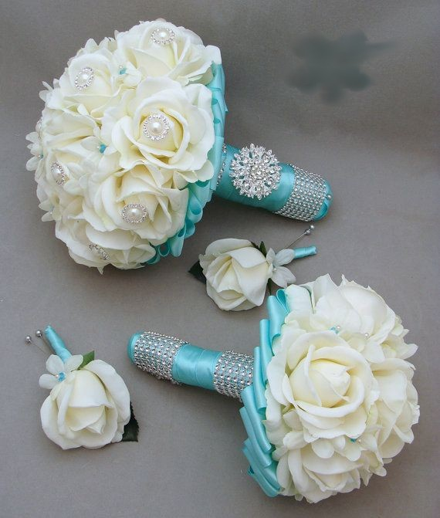
She thought back to earlier in the morning when everyone returned from the photo shoot. Katherine, Liz and Jasmine sat with the future bride in Michael’s room and gave her wonderful advice on how to be a good wife, a good mother and what to expect from Michael. In keeping with the wedding traditions, after the talk was over, the three of them gave Diana an assortment of gifts in honor of the special event.

For something ‘new’, Elizabeth gave her best friend’s fiancé an impeccable diamond necklace from her favorite jeweler – Harry Winston. For something ‘old’, Katherine gave her new daughter in law a gold bangle that her mother gave her on her own wedding day. Diana wore both as her way thanking the two special women for their never ending love and blessings. For something ‘blue’, Marie had baby blue ribbons tied around the bridal party’s bouquets. Finally, for something ‘borrowed’, Jasmine gave her best friend her very own garter belt that she wore on her wedding day reminding Diana that Michael would have the privilege of removing it from her leg and throwing it in the air in front of every bachelor at the wedding for them to try and catch.

As Etta’s song came to an end, butterflies suddenly invaded my stomach. I had no second thoughts about getting married but the fact that I was just minutes away from becoming Mrs. Michael Jackson was more than I could bear in that moment. Marie’s parents noticed my anguish and immediately questioned me with looks of worry in their eyes.

“Are you alright, honey?” Angela asked.
“Yes, I’m fine.”
“You are one beautiful bride.” John said kissing his acquired daughter’s forehead. “I am so glad to be giving you away today.”
“Thank you.”

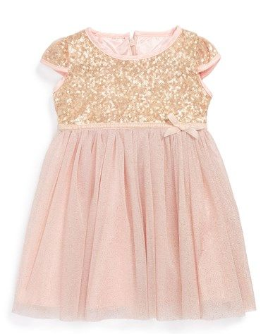
Grace snuck over to where I was standing and quickly showed me my daughter revealing her adorable daddy inspired baby dress with sparkles with one small glove on her right hand. I kissed her nose as she lay in her nanny’s arms fast asleep. Grace then took her position with Prince and the others as we straightened ourselves out preparing to make our grand entrance. I took deep breaths and tried to relax as thoughts of Michael waiting for me at the podium looking as handsome as ever danced in my mind. Prince was smiling the entire time giving me all of the strength and inspiration I desperately needed. We all had been waiting to see this day for years and there wasn’t anything that anyone could say or do that was going to ruin my day or this historic moment.

Michael kindly greeted the legendary singer thanking her for her beautiful number before taking his position at the podium. Javon politely escorted Etta to her seat and also took his position. The time had finally come for Diana to make her grand entrance. Marie quickly grabbed a large frame that was turned upside down leaning against the side of the ceremonial stage and walked over to one of the seats that Javon had marked ‘reserved’. She removed the tag from the seat and placed the frame directly on top of it positioning it upright for everyone to see. Michael’s eyes filled instantly when he saw that the subject in the frame was none other than his guardian angel.

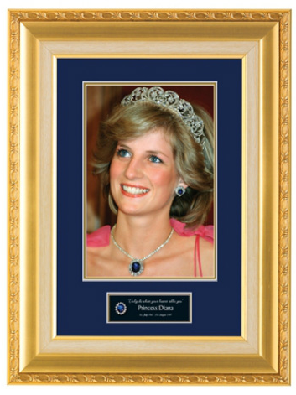
“Beautiful.” Katherine said.
“Our favorite guest.” Liz said trying to hold back tears.
“She was the first person to know about Michael’s wedding.” Marie explained. “Jasmine sent an invitation to her final resting place on Michael’s behalf. I know that she is with us in spirit today.”

Marie then requested everyone to join her and the others in a moment of silence in honor of the Princess of Wales and her tragic passing. Michael released a few tears before closing his eyes and lowered his head thanking his friend in silence for their private talk earlier and also thanked his favorite fan for the wonderful gesture of including his late friend as a guest at his wedding. Jasmine then looked straight ahead and noticed her surprise gift for Michael was also ready. She asked to borrow Quincy’s microphone and walked towards the groom.

“Michael, there is one more surprise for you before we bring out your bride.”

The Pop star stood silent with a straight face as he waited patiently for what was coming his way. Jasmine looked straight ahead and waved her hand signaling her surprise to come in. Michael gasped loudly and almost fell to the ground upon the sight of his father heading straight towards him. Katherine and the other Jackson children were just as shocked as the groom was to see the Jackson patriarch at his son’s wedding – the wedding he never wanted to attend.

Joseph approached his seventh child and hugged him tenderly. Michael tried to hug his father back but was too appalled at his presence to say or do anything. Mac and Brad both stood next to their friend for support as Joseph pulled away from his son and congratulated him. All of the guests clapped again seeing the wonderful father and son moment.

“Joseph…” Michael said with tears pouring down his face.
“Not today.” Joseph replied looking down and sighing deeply. “Not today, Michael.”
“What are you doing—“
“I’m the groom’s father.” Joseph said interrupting his son. “This is where I’m supposed to be.”
“But you always—“
“I’m here now.” He said. “That’s what matters.”
“Thank you, Joseph.”

Being the unemotional person he was, Joseph then told his son abruptly to stop crying and simply walked away sitting at his assigned seat next to his wife which was the reason for the other ‘reserved’ sign. Katherine kissed her husband’s cheek happily and held his hand as they waited for the ceremony to begin. Michael approached Jasmine and kissed her forehead thanking her for such a wonderful surprise.

“How did you get him here?”
“I have my ways.”
“I love you, tea flower.”
“I love you too.”

“Ahem!” David said while sitting in his VIP seat near the podium. “She’s taken!”
“I know she is.” Michael said giggling. “I am too!”
“Let’s get on it!” Mac said. “I wanna party!”
“He just wants Lola.” Jermaine whispered in Beverly’s ear making her crack up laughing.

Michael quickly took his position next to Mac again. Jasmine looked to her right and smiled as she saw a large white sheet that was covering another one of her surprises being lifted by the wedding ushers she hired for the event. The guests oohed and aahed with joy as they saw a beautiful black grand piano unveiled from underneath the massive white cloth. The ushers then did as they were instructed and lifted the sheet up in the air covering the musical instrument from all sides.

“What are they doing?” Marie asked.
“You’ll see.” Jasmine replied.

Mac looked across the pathway to John who gave a thumbs up saying the bride was ready to make her entrance. Quincy and Berry asked all of the guests to stand up as the piano started to play. Jasmine smiled as the ushers walked away one by one with the white sheet in their hands slowly exposing to all that the mystery piano player was none other than the one and only legendary singer Stevie Wonder.

