Chapter Twenty Eight
Born as Two, United as One

Michael & Diana’s Wedding Day

PART III

NOVEMBER 14, 1998

NEVERLAND
11:30AM

“OH MY GOD!” Everyone yelled as they clapped their hands hearing the legendary performer play harmonious music on his beautiful, black grand piano. Mr. Wonder’s smile was beaming as his magical fingers tickled the ivories on his keyboard. Michael’s facial expression was priceless as he discreetly thanked his tea flower for choosing one of his closest friends and a remarkable artist to play at his special event.

“Here we go.” John said taking his position next to the lovely bride.
“You ready, Diana?” Angela asked.
“As ready as I’ll ever be.” I said taking a deep breath.
“You look so beautiful.” John said admiring my cream colored laced dress with white sparkly high heels with the words ‘I DO’ written on the bottom.
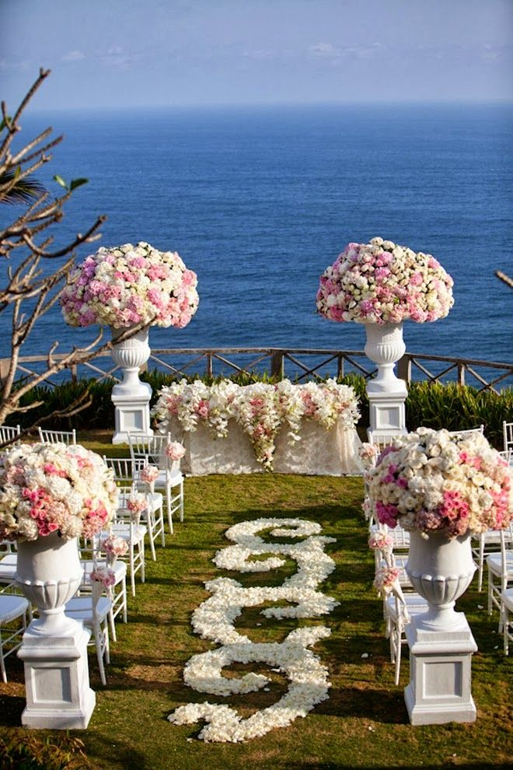
I continued breathing deeply as I admired my beautiful looking wedding full of fancy decorum, flowers and guests. There was nothing but clear blue water before me and a beautiful sun filled sky above me. Michael smiled from ear to ear as he thought about his bride entering her own wedding. Steve’s voice echoed throughout the entire ranch thanks to the wonderful surround sound speakers Javon and Bill installed for Michael’s fans and reporters to hear from outside the gate. The videographer, Jacques and Raphael were busy capturing every second of the historic moment as the beautiful CEO stood in the distance waiting for her cue.

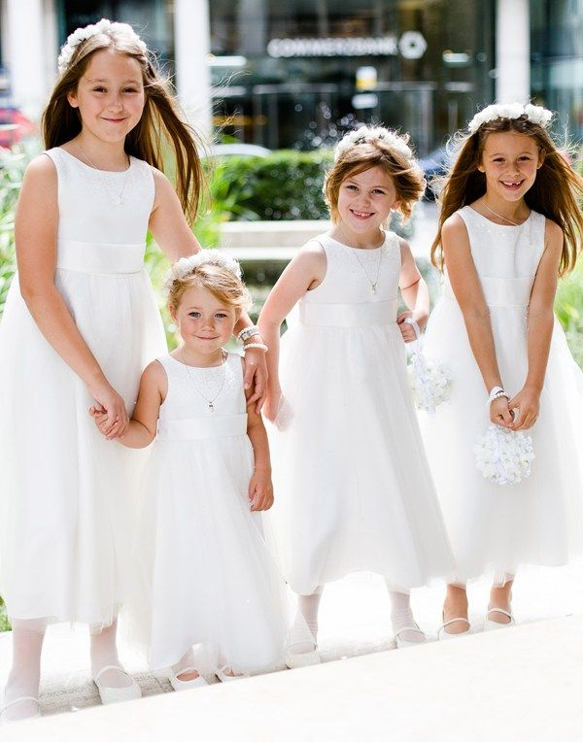
Michael gasped as he watched his bride’s four flower girls: Abby, Beth, Paige and Angela (the little girl he met in Germany) dressed in white dresses walk down the aisle in pairs dropping red, pink and purple rose petals all over the red carpet while Stevie continued his instrumental piece in the background. The Pop star attempted to run towards his little angels wanting to snatch all of them into his loving arms but knew he’d have his chance to later on.

Once the little bundles of joy finished their flower girl duties, Michael hugged and kissed each of them as they stood in two’s next to the bridesmaids and matron of honor. With the guests still standing, Javon stood next to Stevie and whispered in his ear that the bride was about to make her grand entrance. Stevie smiled and with a sway of his head, his melodic tune quickly changed from a beautiful instrumental to one of Diana’s most favorite songs by the legend himself: “Isn’t she lovely?”

“Oh God…” I said under my breath. “I guess it’s too late to elope.”
“Why would you want to?” Angela asked.
“I don’t. I just know I can’t even if I wanted to.”
“You are doing the right thing.” John said as he and Angela gently placed my white sheer veil over my head. “We love you, honey.”
“And Michael does too.” Angela added.
“I love him too.” I said taking my last breath as the three of us stepped forward.

As I slowly walked towards the front of the podium, I saw Jasmine, Marie, Ashley, Kai and Bev looking absolutely radiant in their sparkly champagne colored bridesmaid dresses holding their bouquets and admiring me with such pretty smiles that oozed of nothing but pure warmth and sincere happiness.

Stevie’s wondrous voice continued singing with poise and passion as the beautiful bride continued strolling down the aisle with everyone’s adorning eyes on her. Mac, Brad and Michael’s brothers nudged the groom playfully as he blushed 100 shades of red and pink watching his breathtaking bride walk towards him on their day of union in the most stunning looking dress he had ever seen in his entire life.

“I can’t believe she’s mine.” Michael thought to himself.
“I can’t believe he’s mine.” Diana thought to herself.

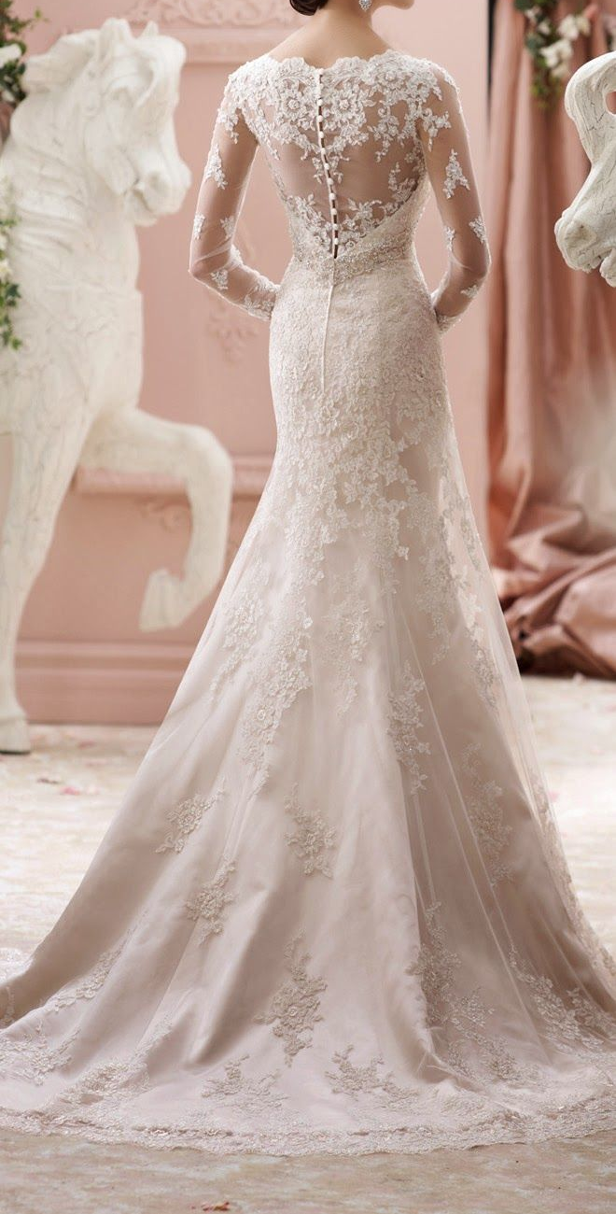

Jasmine smiled. Marie cried. Ashley cheered. Brad hollered. Katherine and Liz wiped their eyes with tissues. I turned my head to the left and to the right and smiled seeing all of the guests that attended my event: Diana Ross, Tatum O’Neal, Tatiana Thumbtzen, Ola Ray, Eddie Murphy and Imaan were just a few. Jasmine had a jumbo size, big screen TV installed at the very top of the wedding pillar centerpiece to allow live footage of our day for Michael’s fans and for the general public to see and enjoy from the outside gates and in the comfort of their homes.

“BEAUTIFUL! SO VERY BEAUTIFUL BELLA!” Raphael yelled as he happily took photos of me walking towards my soon to be husband.
“TRES BIEN! MAGNIFIQUE! MWAAAH!” Jacque yelled kissing me with his fingers making me giggle as he pushed Raphael out of his way to take pictures too.

My heart pounded. All I could do was look straight ahead at my fiancé. I had never seen him look so shy yet so unbelievably happy at the same time. His entire demeanor almost made me lose my balance. His stunning, curly black hair, pearl white skin glistening in the California sun, his hypnotic eyes meeting mine underneath my veil and his million dollar smile gave me all the reassurance I needed that he and I were definitely made for each other and that we were both doing the right thing.
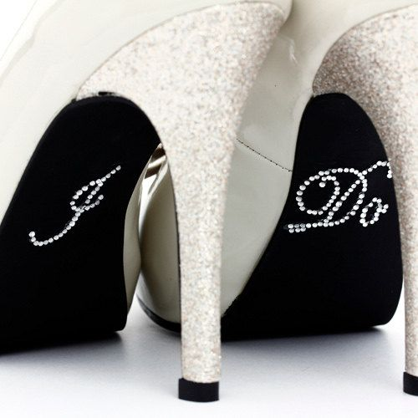

“Isn’t she lovely?”
“Isn’t she wonderful?
“Isn’t she precious?”
“Isn’t she pretty?”
“Truly the angel’s best”
“Boy, I’m so happy”
“We have been heaven blessed”
“I can’t believe what God has done”
“Isn’t she lovely?”

Michael’s smile grew bigger and bigger by the second. He giggled loudly while blushing and looking down at his feet. Mac couldn’t help himself and hugged his best friend giving him his full blessing and reminding him that his bride was only his. For the first time since the birth of his children, Michael felt proud of himself for conquering one of his deepest fears: not being able to find that special someone to share his life with.

Once Diana made her way to the front of the podium, Jasmine turned to Javon who whispered to the legendary signer on the piano that she had made her entrance and was now standing at the podium. Stevie then stopped playing and Michael’s guard along with Bill escorted him to his VIP seat. Several guests took photos of the ravishing bride dripping with anxiety and happiness as they waited for the wedding of the century to begin. Jasmine then signaled Quincy and Berry to announce the minister who would be conducting the special event.

“Ladies and gentlemen, Reverend Al Sharpton.”

The famous churchman stood at the front of the podium in his minister attire complete with white robe and his program binder firmly in his hands. As he placed the microphone perfectly in front of him on the stand, Jasmine and the others made sure the TV was on and the videographers could get a clear view of the event which was now just seconds away from taking place.

“You may be seated.” Al said to the guests. He then continued:

"Marriage itself a blessing. But doubly blessed is the couple who comes to the marriage altar with the approval and love of their families and friends. Who has the honor of presenting this woman to be married to this man?

"We do.” John and Angela both said in unison. “On behalf of her venerated parents who are no longer with us, Eric and Rebecca Dean, along with her loving friend Jasmine and our wonderful daughter Marie, we, John and Angela Harper give our acquired daughter, Diana Elizabeth Dean to the greatest human being and entertainer ever to grace this earth, Michael Joseph Jackson.”

Diana whimpered. She never imagined Marie’s father would come up with his own special vow while giving her away. Michael’s face lit up with pride. He touched his heart humbly as John let go of my arm and happily embraced his new son in law.
Angela kissed my veil gently and also gave Michael a hug and kiss before both parents sat in their seats next to the Jacksons. Mac raised his eyebrows mischievously grinning like he just pulled off the greatest scheme in history. I snickered quietly as Michael took his position next to me standing with more poise and attention than I’d ever seen before. My smile did not leave my face as I watched Al open his program ready to begin the ceremony.

“You look handsome.” I whispered making Michael blush. He giggled adorably and looked down too shy to respond. “I love you, baby.”

“I love you more.” The Pop star whispered shaking his head and smiling feeling incredibly lost for words. Jasmine and Marie were giggling like little girls watching the two of us stand in front of Al and God just seconds away from becoming husband and wife.

“How do I look?” I whispered not turning my head to face the man next to me.
“I’ll tell you later.” Michael replied with incredibly flushed cheeks.
“I look bad?”
“NO!” Michael yelled making everyone gasp thinking he changed his mind about getting married.

“Mike, what’s wrong?” Mac asked running towards him.
“Nothing, I’m fine.”
“What did you yell for?”
“It was her!”

“She didn’t do anything!” Jasmine said. “Now can we go on with the ceremony please?”
“Yes, that would be a good idea considering I do charge by the minute.” Al joked making everyone laugh.

Mac went back to his position shaking his head thinking is friend was a goof ball but also the luckiest person in the world. Wanting to see him smile and laugh on his special day, Diana teased her fiancé repeatedly as he stood next to her anxious and nervous.

“Do I look nice?”
“Not now!” Michael whispered. “You got me in trouble!”
“Is that a no?”
“Diana!”
“Michael!”

The reverend then cleared his throat and double checked his microphone making sure it was adjusted to the right level and volume before starting off the grand event with his traditional, ceremonial words.

“Dearly beloveds, we are gathered here together in the sight of God and in the presence of these witnesses to join together this man and this woman in Holy matrimony which is an honorable estate, institute of God and signifying to us all the mystical union that exists between Christ and His church. It is therefore not to be entered into unadvisedly but reverently and discreetly and in the fear of God into this Holy estate these two persons come now to be joined. If there is anyone here who feels these two should not be joined together in Holy matrimony, let them speak now or forever hold your peace.”

Joseph scoffed lightly under his breath. Michael knew he would do an unpleasant gesture as his way of saying he still did not approve of his decision to marry Diana but the Pop star couldn’t have cared less. He then looked discreetly at Marie who lightly shook her head ‘no’ and winked at her idol making him smile and believe that his favorite fan truly did give her blessing to him and her best friend.

“Michael please tell me!” I whispered. “Do I look pretty?”
“Diana, stop it.”
“Do you love me?”
“Do you not see me standing here?”

I giggled. I loved seeing Michael so happy and knew now was the perfect time to put him on the spot and show him that I too could be just as bratty as him, even on our wedding day.

“Michael and Diana, today is your day. This is the day you prayed for, waited for and worked for and now God has brought it upon you. He has given you the desire of your heart. I charge you both as you stand in the presence of God to remember that love and loyalty alone will prevail as a foundation of a happy home. Secondly, I charge the two of you to love each other from the depths of your heart. Love out of strength, not out of weakness. To love knowing that you have much to give and in marriage we discover what is it we have to give. Let not the sun go down with your mate wondering or the sun come up with your mate confused or concerned about where they stand in your life. Thirdly, I charge you to be considerate of each other. You both come from two separate walks of life. It will take you time to learn about each other, to understand each other. Do not worry or be afraid of each other. In the learning process, be mindful and be considerate. Walk together with tender touch on the soft soil of each other’s emotions. Lastly, I charge you to always be and stay humble and affectionate towards each other and those whom you keep in contact with every day. You are both very successful and independent and sometimes throughout the course of life we tend to feel proud or arrogant about our success. Do not let your achievements destroy your humility for it is this that can bring anguish and indifference in this sacred institution known as marriage.”

“Yeah, Michael.” I whispered jokingly. “Don’t brag about how great you are anymore.”
Michael bit his bottom lip and smiled beautifully inserting butterflies in my stomach.

“You are so going to get it.”
“I hope so. I’m wearing something really sexy for you underneath this dress.”

Michael shook his head. His cheeks were beet red and his smile was so bright it added more light to the already brightly lit ceremony.

“Let us pray.” Al said as everyone bowed their heads respectfully.

“Eternal God, Creator and Preserver of all life, author of salvation and giver of all grace, bless and sanctify with your holy spirit Michael and Diana who come now to join in marriage. Grant that they may give their vows to each other in the steadfast strength of your love. Enable them to grow and love in peace with you and with one another all their days. In God’s name. Amen.”

Al then whispered for Michael and I to turn and face each other holding our right hands together. The almost wed King of Pop continued smiling with flushed cheeks and shaky hands. I squeezed it gently letting him know him that I loved him and he had no reason to feel flustered.

“Do you Michael Joseph Jackson take Diana Elizabeth Dean to be your lawfully wedded wife to have and to hold from this day forward for better or for worse, for richer or for poorer, in sickness and in health as long as you both shall live?”

“I do.”

A single tear fell from my eye.

“And do you Diana Elizabeth Dean take Michael Joseph Jackson to be your lawfully wedded husband to have and to hold from this day forward for better or for worse, for richer or poorer, in sickness and in health as long as you both shall live?”

Silence.

“Diana?” Al asked.

Silence.

“Diana…” Michael whispered with tear filled eyes.

Silence.

Just then, he rolled his eyes knowing exactly what he had to say next.

“Yes, you do look pretty.”

“I DO!”

“Praise the Lord! Hallelujah!” Mac yelled.

“May I have the rings please?” Al asked.

Michael and I both turned our heads to look at Jasmine and Mac but were pleasantly surprised as they pointed us towards the front of the aisle where we saw our son walk happily down the aisle in his black tuxedo with the little boy who now had a brand new life because of the man I was minutes away from calling my husband.
“Bela!” Michael said wanting to hug the little one.

I squeezed his hand reminding him of where we were and that he could see his friend later after the ceremony. Prince was smiling brighter than his daddy (if that was even possible) as he held one of Michael’s jeweled ‘Billie Jean’ gloves with his ring for me on the wedding finger of the glove.
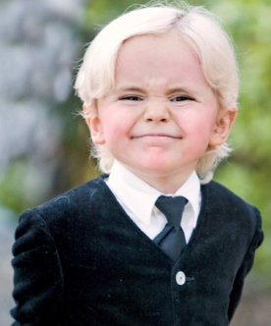
Bela also held a sparkly glove with Michael’s ring from me on the wedding finger. We both laughed and looked over at Jasmine who gave us a thumbs up feeling proud of her creative idea. Michael thanked his dear friend the beautiful Princess of Wales in his head for the photo of Bela that she showed him in his mirror. He knew it was because of her Bela had been given a new life and was more grateful than ever that she gave him a sign that the two of them would soon meet again.

Prince and Bela stood next to Michael and Diana as Al continued with his ceremonial duty.

“The wedding ring is the outward and the visible sign of the inward and spiritual grace and love between Michael and Diana. It signifies to us all the uniting of them in Holy matrimony.”

Mac then came over and stood next to our son helping him remove my ring from the glove finger. Prince gave the ring to his daddy and kissed his cheek making Michael blush even more. He thanked his son as Al continued.

“Michael, please place the ring at the top of Diana’s third finger on her left hand and repeat after me…”

Michael kept on smiling as he looked happily into my eyes with a rose gold and diamond wedding ring similar to the first ring he gave me in New York.

“In token and pledge of our constant faith and abiding love, with this ring I thee wed.”

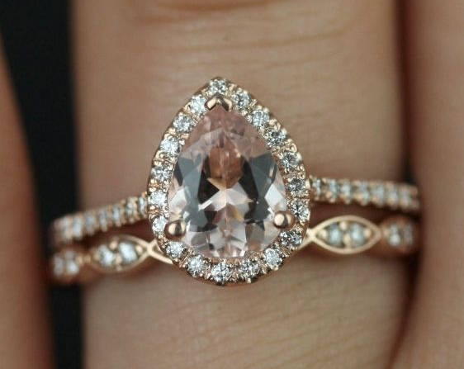

He then slipped the ring onto my perfectly French manicured left finger kissing it gently. We stood there frozen in time for a moment as Jacques and Raphael took pictures of the historic gesture. Mac returned to his place near the podium. Jasmine then came over and stood next to Bela who had my ring for Michael. The beautiful matron of honor helped the little one remove it and placed it in his hand as he gave it to me. I thanked him as I placed the gold, name engraved band in my hand waiting for my turn.

“Diana, please place the ring at the top of Michael’s third finger on his left hand and repeat after me…”

“In token and pledge of our constant faith and abiding love, with his ring I thee wed.”
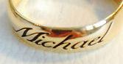

“And now, the bride and groom have a few words of their own that they wish to say to each other.” Al announced.

Mac and Jasmine both opened our hand written vows and placed them in our hands one at a time then returned to the positions near the podium. Michael read his vows first.

“Diana, my love, my best friend and the mother of my children:

From the first moment I laid eyes on you, I knew you were the one. Your intelligence, charm and captivating beauty struck me like a bolt of lightning which still carries a severe effect on me to this day. As I stand here next to you, in front of God, our family, friends and the reverend I want you to know that I am honored to be your husband and I look forward to spending the rest of my life with you and our children. I love you.”

Tears poured down mine and several guest’s faces. Marie, Mac, Ashley and Brad were also sniffling at Michael’s heart wrenching words. As always, Jasmine came to my rescue trying to fix my face. I quickly pulled myself together and smiled again hearing the reverend announce that it was now my turn to speak.

“Michael, my guiding light, companion and father of my children:

I can’t believe this day has finally come. It seems like yesterday when we first met at the museum in Manhattan. I can still remember how shy and lovable you were within the first few seconds of us meeting each other and that was one of many things that drew me towards you. Your smile made me forget reality. Your eyes took me to a whole new dimension – one that I never wanted to leave. You showed me the meaning of love and the effect it can have on a person. But most of all, you showed me that I too am worthy to be loved. Thank you, Michael. I look forward to being your wife. I love you very much.”

The Pop star was so touched. Tears of black ran down his face as he carefully wiped them with a Kleenex Mac had given him. Katherine also wept from happiness and Liz was quickly re-applying her eye liner. Not one person had a dry eye and Michael and I couldn’t have been happier to make everyone in the room happy on our joyous occasion. Reverend Sharpton then announced he would be reading a scripture from the Bible before ending the ceremony. Michael and I stood facing each other smiling while Al opened his Holy bible which surprisingly looked awfully familiar to Michael.

“Love is patient, love is kind. It does not envy, it does not boast, it is not proud. It is not rude, it is not self-seeking and it is not easily angered. It keeps no record of wrongs. Love does not delight in evil but rejoices with the truth. It always protects, always trusts, always hopes and always perseveres…”

“Love never fails.” Michael said out loud as he finished the beautiful Corinthian verse.

“You know that scripture?”

Without answering, Michael turned to his mother. He remembered the loving matriarch used to read that particular verse to him as a child every night before bed and realized that the Bible reverend Al Sharpton has in his hand was hers.

“I love you.” Katherine mouthed to her baby boy who had tears in his eyes again as she sat next to her husband in her pretty sky blue dress with matching jacket.
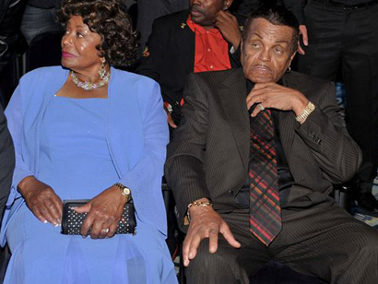
Michael winked as his way of saying the words back to her. Finally, Al made his final ceremonial announcement. The one every person in the world, including the bride and groom were aching to hear.

“Michael and Diana have consented together in Holy wedlock and thereto have pledged their faith and love for each other with the exchanging of rings. And now, by the power vested in me, I know pronounce you husband and wife.

What God has joined together may no man put asunder. Michael, you may now kiss your beautiful bride.”

Michael’s smile never left him. As he slowly lifted my veil, he looked down at his wedding band and lightly brushed my cheek with his ring finger. As he came in closer towards me, our eyes met and he immediately felt unbelievably shy.

“WILL YOU DO IT ALREADY?!” Mac yelled.

Michael giggled adorably making all of the guests swoon over his innocence.

“What’s wrong?” I asked. “You don’t want to?”
“I’m so shy.” He whispered as he came closer to me. “My entire family is here. My fans are watching. I’m feeling so embarrassed.”
“Just think of it as another performance.”
“This is a different, Diana.”
“Shut up and kiss me, Moonwalker.”

It was then that Michael forgot about his nervousness and pressed his lips against mine.

“YAAAAAAAAY!!!!” Everyone yelled as the entire guest list rose to their feet clapping in a roaring thunder.

Michael saw his fans on TV and his parents in front of him and couldn’t believe what he just did. He was no longer just the greatest entertainer or the greatest humanitarian. He now had a new title to add to his glorious name – the husband of Diana Dean Jackson. All 500 guests cheered as the entire VIP section threw rice and rose petals on the newlyweds congratulating Michael and Diana on their union. Jasmine, Marie and Ashley came to hug the couple while all the groomsmen shook Michael’s hand and hugged him lovingly.

Raphael and Jacques were going camera crazy and everyone announced that we had just made world history all over again. Reverend Sharpton was not able to stay for the reception due to other commitments but thanked us for including him in our special day. Michael shook his hand and made sure Bill and Javon escorted him out of the Neverland and that he exited his property safely.

The girls reminded me that I still had one more outfit to change into and Mac also reminded Michael of the same. Quincy and Berry announced that the reception would be taking place on the other side of the ranch next to Michael’s iconic grand clock in a few hours and to enjoy each other’s company along with cocktails and appetizers. Several golf carts were rented and ready to transfer the guests over from the ceremonial ground to the reception area. Mac and Jasmine both suggested all of the guests enjoy the refreshments and each other’s company as Michael and I dressed for the final part of our special day.

Stevie returned to the piano and played the bridal march while Michael and Diana held hands and walked down the aisle with rice and roses being thrown all over them. The entire bridal party followed them out with Bill, Javon and a few ushers escorting all 500 happy and excited guests over to the reception area. Jasmine and the others also had to change from their bridesmaids dresses into their evening gowns while the two photographers captured every moment with their lenses.

The videographer packed up his things and headed towards the reception area and a few more ushers turned off the jumbo screen. Everything was going according to plan and in just a matter of hours, Michael and Diana would be walking into their own reception for the first time as husband and wife.

“You did it, Mike! You did it!” Mac said hugging his friend as he and the other groomsmen entered the cottage house to get into their final outfits for the reception.
“He sure did. He was a pro out there!” Teddy said.
“Yeah, Mike you were the man!” Rodney added.
“Thank you so much.” The Pop star said. “I never would have made it without all of you.”
“We’re proud of you.” Jermaine said hugging his younger brother. “It may not seem like it, but I know Joseph is too.”
“Is he staying for the reception?”
“We’re assuming so.” Tito said. “He never said he wasn’t.”
“I have a feeling he’ll make up some excuse and leave.”
“Well, who cares about that?” Randy said. “The important thing is, the hard part’s over and now we can PARTAAAY!”
“He said the magic word!” Mac yelled. “I’m calling Lola!”
“HELL YEAH!” Teddy yelled making Michael roll his eyes.

“GUYS!” Michael yelled. “Can we not do that again? I’m married now.”
“OOOOO listen to him!” Jackie said. “Mike’s ‘a married man’ now!”
“I guess he told us!” Rodney said jokingly.
“That’s not what I meant.” Michael said. “I have to get changed now. Leave. All of you!”
“Well, fine then!” Brad said immaturely. “Who does he think he is?”
“I’M MICHAEL!” He yelled making the others laugh.

“Mr. History Maker wants us to leave him alone.” Jermaine said as Karen came into the cottage house to get her friend ready for his final fitting.
“Guys! I didn’t mean it that way.”
“Yeah, uh huh!” Mac said. “Kidding. We’ll meet you outside.”
Karen hugged her client and congratulated him on the greatest day of his life as she helped him put on his casual V-neck white shirt, black blazer, fedora and a single white rose on his left lapel next to his heart.

“You were amazing out there.”
“Stop it.”
“I’m serious!”
“I was so nervous.”
“But it didn’t show.”
“Really?”
“I swear it didn’t. You were wonderful. And that bride of yours looked like a real peach!”
“Thanks, Turkle.” Michael said calling his friend by her nickname.

“Hey! I haven’t heard that in a while!”
“I save it for special occasions.”
“Michael, in all the years I have known you I have NEVER seen you this happy. You are glowing today.”

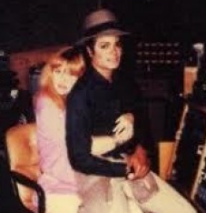
“Karen?”
“Yeah?”
“I’m married now.”
“Yes, Michael you are.”

“Me. Michael Jackson. Married. Can you believe it?”
“Yes, I sure can. And I’m very happy for you.”
“I’m married. I’m married!”
“You are so cute.”
“Karen…I’M MARRIIIEEEEEEED!!!”

The King of Pop danced around the room childishly doing his signature moves including his famous crotch grab. Karen stood back and laughed uncontrollably at her friend thinking he may be on something. Michael was soaring above the clouds. Karen was right – Michael WAS extremely happy. More than he ever had been in years. And he owed it all to one person – his new wife, Mrs. Diana Jackson.

“You did it, Ana!” Marie said as we all got back to the house and in the master bedroom. “You’re married to Michael Jackson!”
“I know, Marie.”
“It’s about darn time!” Jasmine said as she brought out my dress covered in its protective plastic sheet. “Jeez, Diana. Dragging your dresses around is a full time job!”
“If you recall, I did the same thing at YOUR wedding!”
“Ahh…yes…my wedding…”

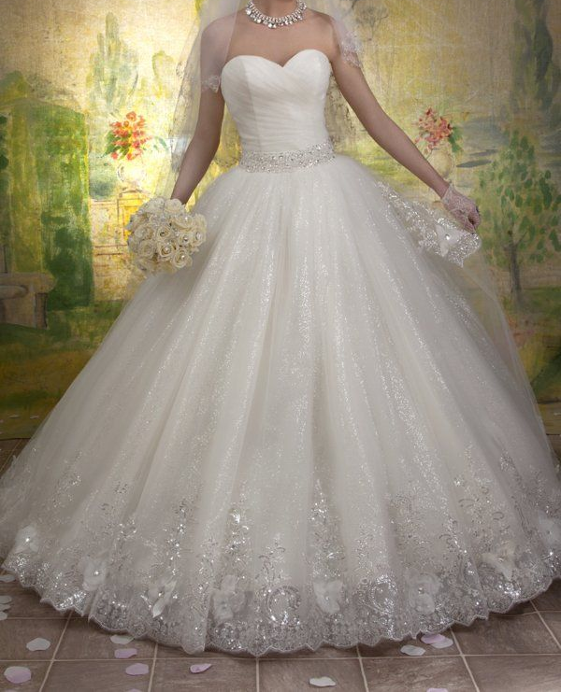
“Oh Lord here we go again.” Marie said rolling her eyes.
“You liked my wedding, M!”
“Yeah, but I don’t like hearing about it every time we go to another wedding.”
“Tell us about it, Jasmine!” Janet said curiously.
“Yeah, what was your dress like?” Christy asked.
“I only wore one dress.” Jasmine explained. “Diana picked it out. She had it custom made from the same designer that did her dresses. David wore a black tux with tails. He looked very handsome…”

“And they exchanged vows, said ‘I do’ put on their rings, ate some cake and that was it. THE END.” Marie said not wanting to hear the repetitive story.
“Come on, I want to hear all about it!” La Toya said.
“Me too!” Rebbie added.

“You all can hear about Jasmine’s wedding while Marie helps me get into my last dress in the bathroom.”
“Sounds good!” Jasmine said as she sat in the middle of mine and Michael’s bed with her audience surrounding her in a circle.

Grace quickly peeked her head into the room and showed me Paris before getting ready to change her diaper. Prince was already changed and with his daddy in the cottage house not wanting to see me at all. He was lucky he was cute! Paris changed into a red dress with sparkles and Grace put adorable gold barrettes in her hair. Marie cooed seeing my little princess and totally forgot about helping me.

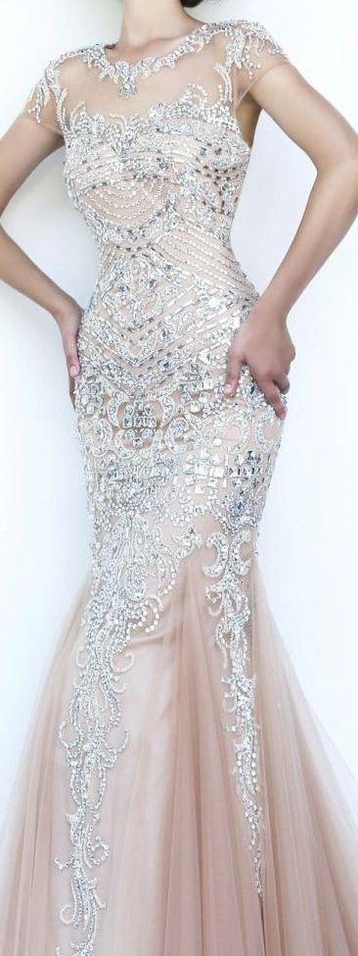
“Um, hello? Marie! Bride needs your help.”
“Not now!” Marie spat back. “I’m busy with Paris.”
“Marie! She needs her diaper changed. Wanna do it?”
“EW! NO WAY!” Marie said making a sour face and giving my little girl back to her nanny. “Grace can handle that part.”
“Congratulations, Diana.” Grace said as she took Paris from Marie. “I’ll get her changed and we’ll see you at the reception.”
“Thanks Grace.”

“She seems nice.” Marie said as Grace left the room.
“Yeah, so far so good.”
“Michael hired her?”
“Yes. Katherine recommended her.”
“Nice! Now let’s get you ready, shall we?”
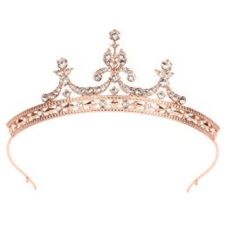

Jasmine was still sharing her love story with her audience while Marie helped me remove my veil and enormous wedding dress. She carefully placed my rose gold ‘queen’ tiara over my hair and re-pinned the veil in the back of my head after helping me into my pink rhinestone embedded gown. I was so relieved that I wouldn’t have to wear anymore outfits. Marie then helped me touch up my hair and makeup and took a picture of the two of us making kissing faces with her camera she kept in her purse.

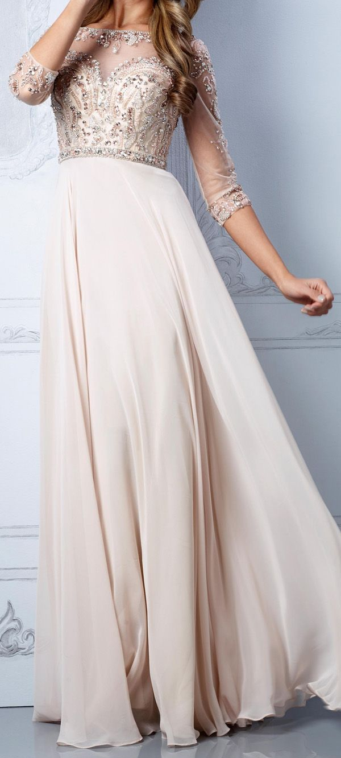
“I remember that camera.” I said seeing her initials on it. “You brought that with you to Europe!”
“Yes, I did.”
“We’ve come a long way since then, Marie.”
“Yeah. We have.”
“You’ve matured quite a bit.”
“I was immature before?”
“Yes, but in a good way.”
“I guess losing Michael made me realize I was no longer a kid.” She explained. “I learned how to grow up and deal with real adult issues when I left you all behind. Being alone made me realize how tough yours and Michael’s relationship really was.”
“I’m just glad those storms have come and gone.”
“Me too.”
“I can’t wait to see you become a bride, Marie.”
She scoffed and rolled her eyes.

“I don’t think that’s going to happen, Diana.”
“Why do you think that? You look amazing in formal dresses. I love this one you have on.” I said admiring her beautiful beige chiffon beaded dress.

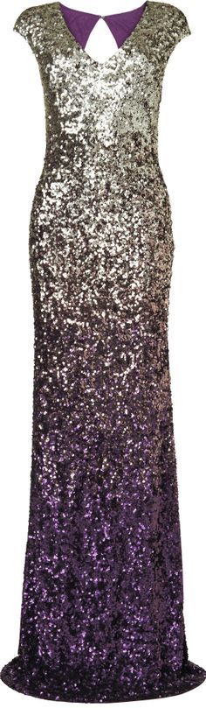
“Thank you but not everyone gets to have a fairy tale love story and wedding like you.”
“Believe me, Marie. Our story may look like Cinderella’s but it was more like Romeo & Juliet except we didn’t die in the end.”
“I’m glad it didn’t turn out that way.”
“So am I.”

“Hey, you two!” Jasmine said opening the bathroom door. “The guests are already at the reception waiting. We need to move!”
“Are you finishing telling your story?” Marie asked.
“Yes, I am. And we’ve already changed in our final outfits. You like?”
“I SURE DO!” I yelled seeing my matron of honor wear a stunning gold and purple ombre dress covered in gold sequins.

“You like mixing your colors, don’t you Jas?” Marie asked.
“It’s my trademark.” Jasmine said confidently. “No one rocks it like I do!”
“Amen to that.” I said applying a bit of pink to my cheeks.
“Hey! Away from that makeup, missy!” Jasmine said. “Getting the bride ready is MY JOB!”
“You help Ana, I’ll help the others.” Marie said as she left the bathroom.

Jasmine helped me look absolutely perfect making sure my hair, makeup and jewelry were all in place. She then gave me a brief explanation as to what to expect at the reception such as the speeches, performances and the food but kept most of the major details a secret. She also said she had a special announcement to make after the reception was over. Curious, I tried pumping her for information but she said it was top secret and something I had to wait to find out. I asked if Marie knew and she said no one did, not even David. A few ideas came to mind but I didn’t want to ruin the excitement so I stopped thinking about it and focused on the last part of my special day and what my husband would be wearing to it.

“Do I look ok?”
“Yes, Michael.” Karen said eyeing her friend in his full length mirror. “You look like a King.”
“Daddy, you are cute.”
“No, son.” Michael said kissing the top of his little boy’s head. “That would be YOU.”
“Daddy looks handsome, Prince.” Karen said trying to teach the little Jackson junior.
“Hamburger!”
“No, Prince.” Michael said. “HAND-SOME.”
“Hamburger!”

“He does that all the time.” Michael said laughing. “Just keeps on saying the wrong thing.”
“He is his father’s child.”
“That he is.”
“I’ll see you out there.”
“Thank you Turkle.”
“Michael, stop calling me that!”
“No way.” Michael explained. “I love calling you that.”
“One little mistake.” Karen said shaking her head. “I swear I meant to say TURTLE!”
“Right.” Michael said. “Whatever you say- Turkle!”
“You are such a brat.”
“But you love me.”
“I sure do. Congratulations, handsome!”

Karen left the room and informed the others that the groom was ready. Mac came in to check on his friend and made sure his ‘best man’ duties were all fulfilled. Michael’s final wardrobe was his own iconic, white military inspired jacket fully encrusted with pearls and sequins along with his black trousers, penny loafers, single glove and sparkly socks.

“Are you going to change again for the after party?” Mac said.
“Yeah, I guess so. Wait…WHAT AFTER PARTY??”
“The one after the reception.”
“I wasn’t told about that!”
“Surprise!” Mac yelled.
“Why didn’t you tell me!”
“It was Javon’s idea.”

“Oh Lord, don’t tell me it’s going to be bachelor party the sequel.”
“You’ll have to ask Lola about that.”
“MAC!”

The child star laughed as he helped his groom friend with his hair and pants.

“Don’t worry.” Mac explained. “It’s just us guys hanging out here when all of the guests are gone. You and Diana will be at the hotel. We’ll need something to do while you two are gone for the night.”
“I have a feeling we’ll be sleeping in tomorrow.” Michael said turning red. “I’ll be really busy tonight, Mac.”
“You are SO going to tell me about it tomorrow!”
“Mac, I don’t---“
“Kiss and tell I know.” The best man replied. “But I don’t care! You’re breaking that rule with me tomorrow.”
“We’ll see, Macaulay.”

THE JACKSON WEDDING RECEPTION

NEVERLAND
6PM
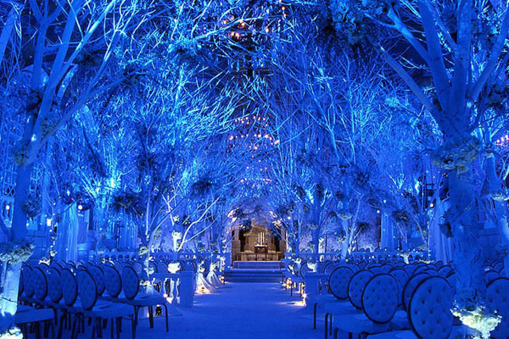

“Ladies and gentlemen…” Berry said as he and Quincy stood center stage at the outside reception. “We hope that you’ve enjoyed mingling, snacking and photo taking but the time has come to get the party started. So without future delay, it is my honor to present to you for the first time – Mr. and Mrs. Jackson!”

Everyone stood from their seats and clapped as Michael and I entered the reception holding hands with our bridal party one more time. Angela and Bela were by our side and sat with us at our head table along with Dr. Amberg and Dr. Evans from Germany who were now married to each other. Jasmine called them about the wedding and the two specialists couldn’t turn down her gracious offer to fly in for the event. Angela and Bela were excited to hear about their two older friends and jumped at the chance to not only attend but also to participate in their idol’s day of nuptials.
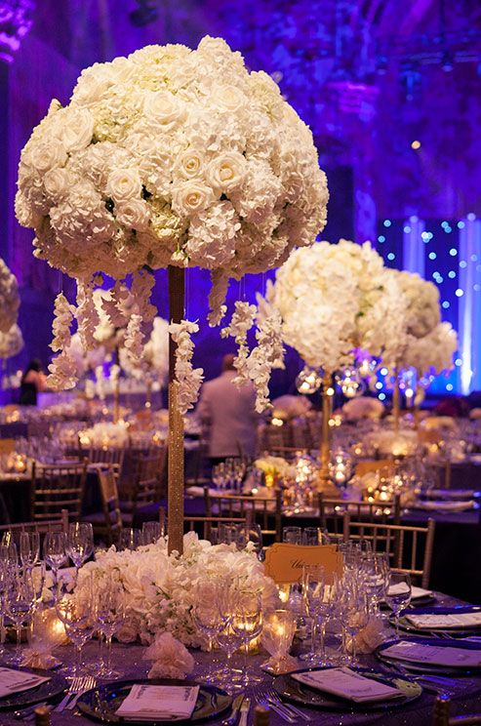
The newlyweds sat at their head table fully decorated with elegantly designed white rose centerpieces, candles and the finest glassware in the world. Many guests gave heartfelt speeches including Jasmine, Marie, Brad, Katherine and Michael’s sisters. When Ashley’s turn to speak came, she reminded us all that she brought a date with her to the wedding – and it was someone Michael knew very well.

“Ladies and gentlemen, I’d like to introduce you all to my date and one of my brother in law’s oldest friends – the adorable Emmanuel Lewis!”

“OH MY GOD! MANNY!” Michael yelled as he gasped loudly and stood from his seat as he saw his ‘little’ friend approaching the stage in his finely cut suit. Not able to hold himself back, the Pop star ran towards the ‘Webster’ star and hugged him tightly not wanting to let him go.

Emmanuel’s eyes filled as moments of his childhood came flashing back to him instantly. Michael stood next to him the entire time he was on stage expressing his love for his Pop star friend and wishing him and his bride a bright future ahead.

“How do you know him?” Brad whispered in his sister’s ear.
“We went to school together.” Ashley explained. “Remember when I transferred to Berkeley.”
“HE went to Berkeley?”
“Yeah, what’s wrong with that?”
“I couldn’t even get into that school.”
“Well, yeah because you’re a dumb ass!”
“SHUT UP, SMURF!” Brad said messing up his baby sister’s hair.

After Emmanuel’s speech was over, Michael and Diana thanked him and gave one of their own speeches as a special gesture:

“I know Michael is always very shy when it comes to speaking in public and since he’s passed the microphone to me I guess that means I have to do the talking for both of us.”

The guests laughed as they enjoyed seeing Michael and I interact together for the first time as a married couple.

“We’d like to thank all of you being here today.” Michael said sharing the microphone with me. “Diana and I are very grateful that you could all be here to share this day with us. We hope that you will stay and enjoy yourselves.”

Wanting to keep things brief so the guests could have fun, Michael and I went back to our seats and heard several guests clanking on their wine and champagne glasses. Michael had no idea what that meant and feared something was wrong.

“What is that?” He asked me.
“They want us to kiss.”
“AGAIN?” Michael asked nervously.
“KISS! KISS! KISS!” The guests chanted making Michael turn one hundred shades of red and pink again.
“What do you say, hubby?”
“Come here, girl.”
“OOOOOH!” Everyone yelled as we heard Jacques and Raphael clicking away with their cameras.
“Take it off!” Mac yelled jokingly.

Michael’s brothers smacked the best man lovingly as he smirked next to his fiancé. Katherine sat at the head table with her son and new daughter in law while Joseph spent all of his time talking business with several other guests and didn’t pay attention to the actual festivities around him.

Once all of the speeches were over, Quincy announced that dinner was ready to be served. Knowing 500 guests rushing to the buffet tables at once would cause chaos, Jasmine thought ahead and hired professional waiters and servers to bring dinner to each table for the guests instead of giving them the trouble of getting it themselves. Michael loved the idea and thanked his tea flower for being so proactive in planning his and Diana’s special day.

Kai loved the fact that the caterers allowed her to make several different organic appetizers and specific entrees specially cooked for Michael and his children since the beloved chef was afraid that her boss and his children would run the risk of getting sick by eating unknown food catered from an outside company. Jasmine created a dinner menu based on the newlywed’s favorite foods: fried chicken, popcorn shrimp, beef kebabs, grilled vegetables, dinner rolls, roasted baby red potatoes, baked salmon, lobster tails, lasagna and a massive salad bar with more than a dozen dressings and sauces.

Jasmine devoured her plate of food and asked for seconds before Marie and the others could finish their first serving. Mac also finished his share and asked for seconds right away. Teddy and Rodney were next followed by Liz, Katherine and Brad. Michael’s sisters were very light eaters and saved room for dessert which was another huge selection of sweet, savory treats imported from Europe ON TOP of the wedding cake which was next on the Jackson wedding agenda.

In lieu of a band, Jasmine decided on live entertainment by a string of guests who volunteered to sing at their friend’s wedding during dinner including Diana Ross and Lionel Ritchie who sang their classic ballad “Endless Love” followed by Whitney Houston singing her famous cover of Dolly Parton’s classic “I Will Always Love You.” Stevie Wonder returned to the stage and sang “I Just Called to Say I Love You” as the final number. The groom stood up in respect for his entertainment and thanked them humbly for their wonderful performances.

Once the plates were cleared and to allow some time for the wonderful cuisine to be digested, it was time for the married couple’s first slow dance. Not knowing what song to expect, Michael took his wife by the hand and led her onto the dance floor. Jasmine gave the DJ (recommended by Teddy and Rodney) the signal to turn on the requested song. Diana shook her head and giggled. Michael’s song of choice was none other than his very own “Liberian Girl.”

“I can’t believe you, Michael.”
“I had to.” The Pop star replied as he took me onto the dance floor. “It’s our song.”
“I love you.”
“I love you more.”

My husband and I danced center stage in the spotlight with nothing but the evening star filled sky above us. As I looked up to admire it, a shooting star quickly flew by. I closed my eyes and clutched the back of Michael’s neck as I made a wish never to lose my significant other no matter what. Prince came in between us and stood on my toes wanting to dance with his mommy and daddy. Michael gladly let his son cut in and within a matter of minutes, Katherine and Joseph, Mac and Rachel, Jasmine and David, and John and Angela all joined in dancing with their significant others while enjoying one of Michael’s most heartfelt songs.

While the dancing was happening, Michael and I took several photos with and without guests taking full advantage of Jasmine’s imported photographers while the dance floor was heavily occupied. Michael and I tried our best to go around to each of the guest’s tables thanking them all personally for attending our event and each table took their time shaking our hands and congratulating us with tons of affectionate hugs and kisses.

Jasmine assigned everyone’s seats accordingly. Michael giggled seeing so many people from his past at his wedding trying his hardest to hold back tears of joy as dozens of close friends approached him taking pictures and offering their blessing to him and Diana. One table in particular made Michael’s heart jump for joy – the Cascio table.
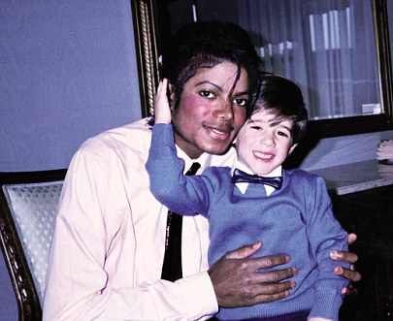

“FRANK!” Michael yelled as the young boy stood up to hug his mentor and longtime friend. “It’s been so long. How are you?”
“Fine, butthead.” Frank replied. “Thanks for forgetting about us!”
“I could never forget about you and your family.” Michael said being his humble self. “Dominic! Eddie! Marie Nicole! Thank you so much for coming!”

The Pop star spent valuable time with his longtime friends while I tried to get the ball rolling and moved onto other tables not wanting to be rude or keep the other guests waiting. The sports table was next with basketball superstars, Shaquille O’Neal, Kobe Bryant and Earvin “Magic” Johnson. Wanting to feel important around fancy people, Marie joined in on the fun greeting everyone with me as we walked from one table to the next.

Vincent Price, Madonna, Mariah Carey, Luther Vandross, Usher and Michael’s guitarist Slash were next. I greeted everyone quickly but courteously as Marie and I continued with the next table. Michael was trying to catch up with me but kept on getting held up by other guests. Smokey Robinson, Paul McCartney, Sheryl Crow and Siedah were next. Once that table was finished, the “Royal” table was not too far behind: Princess Stephanie of Monaco, Princess Diana (in sprit by picture frame), Prince Waleed and the godfather of soul, legendary singer James Brown were all next to be greeted.

Michael excitedly met his childhood role model and embraced him for a long time as he collected advice from one of his most cherished mentors. “Dita” hugged and kissed her friend congratulating him and introduced her daughter Lourdes to the Pop star who then introduced Prince to the little girl.

When Michael, Marie and I reached the last table, we were more than relieved. Brooke Shields, Oprah Winfrey, Suzanne De Passe, John Branca and Beatles singer Paul McCartney were all who were left to be greeted. Michael and Brooke shared a hug and spoke for a very long time in private. Knowing Brooke was part of Michael’s past, I was fully aware that my husband no longer had feelings for the former model due to her breaking his heart years ago. Still, as a woman I felt a small sense of insecurity seeing the two of them together so up close and personal.
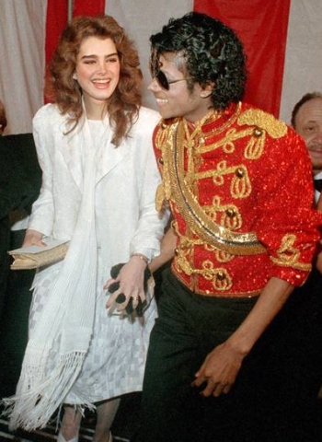
“Don’t worry about them.” Mac said coming up to me. “He no longer has feelings for her.”
“I know, Mac. I’m just—“
“He loves YOU, Diana.” Mac said interrupting me. “Standing here right now proves it. End of story.”
“Mac, you’re so
awesome.”
“So is your husband.”
He then walked away smiling brightly leaving me with all the confidence in the world. Once the slow ballads were over, Berry announced that it was time to cut the cake. Michael and I stood at the corner of the stage where two different cakes were lined up wowing us all with their beautiful looking designs.
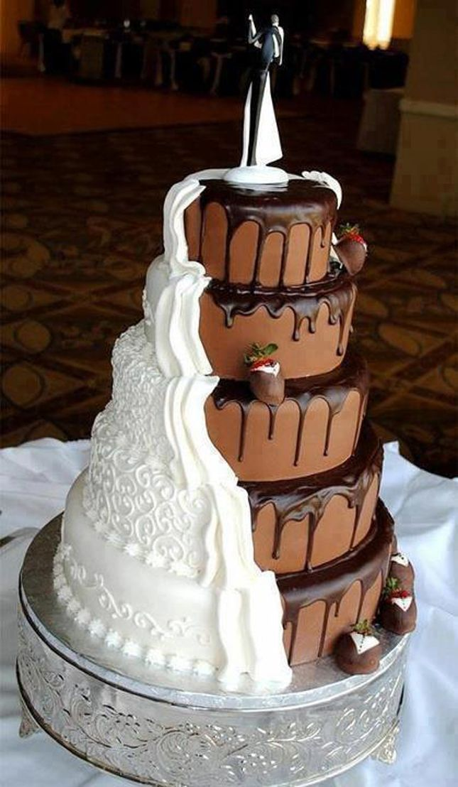
“TWO CAKES?” Michael asked surprised.
“Of course!” Jasmine explained. “Did you really think one cake was going to feed 500 guests?”
“Who hoo! More for us!” Mac said greedily. His fiancé Rachel laughed on his arm.

Michael and I stood in front of cake one which was a chocolate and vanilla split cake representing Michael’s song “Black or White.” The Pop star giggled seeing the creative concoction and held Diana’s hand and she cut through the delicious treat using a knife with a sparkly pink ribbon wrapped around it. The couple fed themselves with small pieces and posed for photos with Jacques and Raphael before moving onto cake number two which was a large, multi-tiered structure surrounded by edible flowers, iced piping and small pieces of white chocolate pearls. Michael and I cut a small piece from its edge and fed each other posing again for pictures. The servers then cut the mouthwatering confection and placed them onto small porcelain china plates with elegant silver forks and passed them to each guest at their tables.

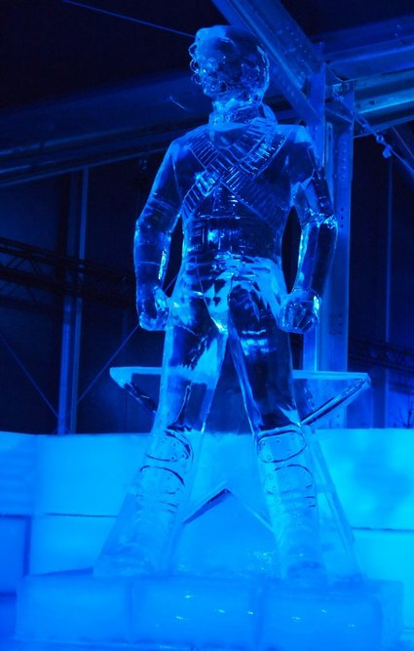
To make the event look as regal as possible, Jasmine ordered a few ‘sample only’ cakes and had them on display at the dessert table for guests to admire and take pictures. Her last wedding surprise was a large ice sculpture shaped as Michael during his ‘Dangerous’ tour symbolizing the year that he and I first met. The King of Pop couldn’t have been more grateful and kissed his tea flower’s forehead thanking her for such a heartfelt, wonderful gift. Marie’s gift was more personal – she decorated our hotel room for us to enjoy after the wedding was over.

Later, to everyone’s surprise, Jasmine took the gang away from the festivities for a moment and announced that she was pregnant. David nearly fell over from shock but was so happy he cried. Michael and I hugged the Aversons and congratulated them on their new found happiness.
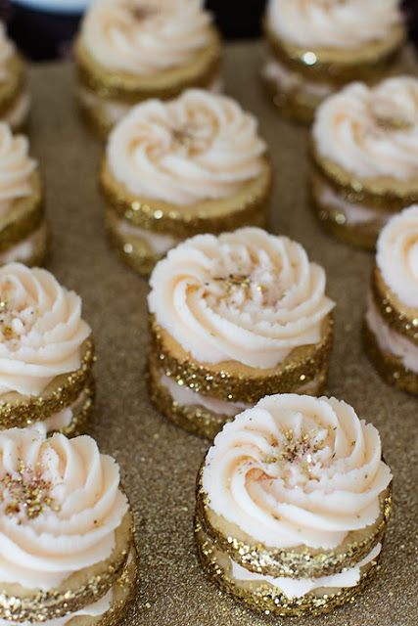

Speeches were read. Our first husband and wife slow dance was over. Dinner had been served. Our cakes had been cut and served with desserts such as brownies, cupcakes, mini cheesecakes wrapped in gold colored glitter (to represent the groom) and lemon tarts along with coffee and tea.

Quincy and Berry performed a toast before the evening was over congratulating us one more time on our special day. David’s gift to us was an adorable bride and groom champagne glass set that we used for the special celebratory moment. Just when we thought things had come to an end, Michael suddenly stood up from his seat at the head table and walked center stage.
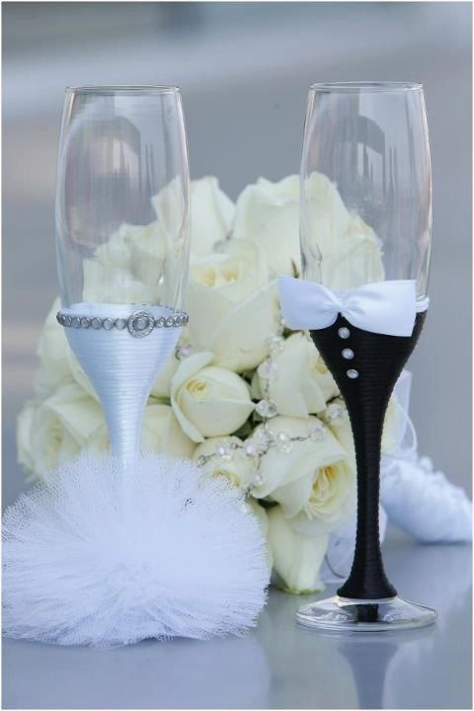

“Before this wonderful evening comes to an end, I’d like to make one final announcement.”

All 500 guests gave the Pop star their full, undivided attention.

“As you all know, it’s been a few years since I’ve released a new album and while there has been a lot of speculation in the media, I want to make it official tonight that the rumors are true and I do have a new project that I have been working very extensively on.”

Everyone cheered in excitement hearing the wonderful news.

“I don’t have an exact time as to when it will be released yet.” Michael continued. “My two right hand producers, Teddy Riley and Rodney Jerkins have been working diligently trying to negotiate contacts and obtain licenses to make things go as smoothly as possible for me but there are a few hurdles that we must pass before release dates can be made public. What I can tell you is that this album will consist of all new material that has been heavily inspired by my new wife and two children as well as all of the children of the world including my precious angels Abby, Beth, Paige, Bela and Angela and of course, my friends and family. As time goes on, I will be sure to keep you all informed as to what the next step will be. Thank you and please be safe on your way home.”

“Michael, what is the new album going to be called?” Brad asked excitedly.

Michael smiled brightly as he slowly turned his head towards his favorite fan and looked into beautiful dark brown her eyes winking just before his response.

“Invincible.”

THE END!

Please click on the link below to view Michael & Diana’s guestbook:

http://www.mixbook.com/photo-books/interests/michael-and-diana-s-guestbook-11771744?vk=mK4wXkUjgU

