CHAPTER 11:
Witnessing the Unexpected

I couldn’t believe who was in my boardroom. My body was shaking and I heard my voice crack as I asked Jasmine to leave the room. He told the other two men that were with him to wait outside while he and I had a talk alone. When the others left, I felt extremely nervous as my eyes gazed upon who was in the same room as me. I tried to maintain my composure as he spoke in a very harsh manner.

“What are you doing in his life again?”
“Sir, he came to me. I certainly wasn’t expecting to see him again.”
“I’m here to tell you to stay away from him.”
“I’m sorry, I can’t do that.”
“You WILL do that.”
“I have legal obligations to represent him. Releasing him from my production company can result in legal action against me.”
“That’s not my problem. You do as I say and LEAVE HIM.”
“No disrespect to you but this is MY office and MY business. You don’t control me or my life. As a matter of fact, you don’t even control HIS life anymore. If Michael chooses to be with me, that’s between the two of us.”
“You don’t know who I am and what I can to you if you don’t get out of his life.”
“I know all that I need to know, sir. You don’t scare me and you sure as hell don’t scare him anymore. He’s not that young, defenseless child you once knew.”
“You are one smart lady.”
“I’m glad you know that.”
“You just couldn’t wait to sweep him up now that he’s divorced and vulnerable. You knew this would be the perfect time for you to get him back and take what you think is yours.”
“Sir, I don’t want or need Michael’s money. As you can see I have my own. I’m not nearly as rich as he is and I honestly don’t care. I’m not after his fortune and he knows that.”
“Save it. No one cares about that boy. Everyone wants his assets and from what I’ve heard, you’ve already gotten your dirty hands on his.”
“If you’re referring to our personal relationship, that’s something I keep to myself. What Michael and I do or say behind closed doors is not up for discussion with anyone.”
“I’m not here to waste my time arguing with you. I’m here to tell you to go away and release him from your company or you’ll deal with me again.”
“I respect who you are and I appreciate you coming here to see me but I have no idea why you despise me and I don’t care to know. You can threaten me if you want to, but unless Michael tells me to, I’m not leaving his side.”
“You are nothing but trouble. I will not allow you to ruin his life any more than you already have. You might think you outsmarted him but you can’t fool me. I know more about life than you do, little girl.”
“The only person that has ever ruined Michael’s life is YOU. I have nothing against you but for some reason, you’ve always put your guard up against me. It’s just sad to see how oblivious you are to what’s always been in front of you.”

He then became angry and walked up to me forcing me to lean against the wall.

“STAY AWAY FROM MY SON.”
“I’m not intimidated by you, Joseph. I will never leave Michael.”
“You will be hearing from me again.”
“I look forward to it.”

He stormed out of the boardroom and the other men that came with him followed as he went in the elevator. Feeling angry, I ran to Marie’s desk.

“Why didn’t you tell me he was here?”
“I had no idea it was him. He had an over coat on and those other guys were covering him. I’m sorry, Ana.”
“It’s ok. I didn’t mean to shout at you. Has he called yet?”
“No. I’ve been watching the phones all morning.”
“Please let me know when he does. If I’m with the investors, please ask him to call back after three this afternoon.”
“Will do.”

I went to my office to try and calm myself down. Seeing and hearing Joseph threaten me in my own office made me livid. As much as I love his son, I know there is a zone I can never cross with him as he is still Michael’s father. Jasmine ran into my office worried out of her mind about what happened.

“Diana, are you ok?”
“I’m fine.”
“What did he want?”
“Me to stay away from Michael.”
“WHY?”
“I have no idea, Jas. He pulled the same thing five years ago at Neverland. Michael told him what happened between us and he lost his mind. Joseph is crazy. I’m afraid he’s going to hurt him. I can’t go through this again, Jas. This is exactly why I never wanted to see him again. I can’t lose him. I don’t know what to do…”

She came over to me and put her hand on my shoulder.

“Ana, please calm down. You know that won’t happen.”
“Jasmine the man hates me and more importantly he hates his own children.”
“He’s just like that. There’s nothing anyone can do. I’m sure he won’t harm him this time.”
“You don’t know him, Jas. You didn’t see him that day.”
“Was it really that bad?”
“Jasmine, the man threw his own child against a mirror and it shattered to pieces.”
“Poor Michael. Was he badly hurt?”
“He was, emotionally.”
“I wonder if he knew he was coming here.”
“I think if he did he would’ve warned me about it.”
“So, what now?”
“The show must go on, Jas. We can’t back out now. Michael and I both signed legal documents. If I release him, I’ll be in litigation with Kingdom International.”
“I know. I have a feeling Michael will be really mad when he finds out about this.”
“I know, Jas.”
“Do you know where he is today?”
“He’s visiting children then going home to rehearse.”
“Will you see him again soon?”
“I wasn’t planning to but I have to now.”
“I think you should tell him about this in person. If you say it over the phone we both know how he’ll react and you won’t be able to stop him from doing something stupid.”
“You’re right, Jas. Thank you.”

*** MARIE’S POINT OF VIEW LATER THAT DAY ***

“TSG Productions, Marie speaking.”
“How’s my favorite fan?”
“AAAAHH!! OH MY GOD!! *ahem* I mean um, I’m doing great. How are you sir?”
“Please don’t call me that. I really hate it.”
“Sorry. I’ll try and stop. How are you?”
“I’m fine now that I’ve heard your voice.”
“You are too sweet.”
“I miss you.”
“I miss you too!”
“Where is that beautiful boss of yours?”
“She’s in a business meeting. She said to tell you to call back after three.”

He then started to giggle like a little boy.

“Michael, I love your laugh.”
“Thank you. I have an idea.”
“What is it?”
“Let’s have some fun with her.”
“OK!”
“Is there a way you can page her?”
“Yes, but the red light is on the switchboard for the boardroom which means I am not allowed to disturb her.”
“Page her for me.”
“I can’t. She will kill me.”
“Don’t worry, she won’t.”
“I really can’t.”
“She won’t get mad at you. I promise.”
“You don’t know Ana. She really gets furious if we interrupt her business meetings.”
“Please? For me?”
“I shouldn’t. She will really lose it on me.”
“I love you, Marie.”
“OH GOD. I’ve waited my entire life to hear you say that. You’re going to make me faint.”
“I know you love me too.”
“More than anything.”
“Please?”
“Ok, but only because you charmed me into it.”
“By the way I’ve sent all of you some gifts.”
“YOU DID?”
“It should arrive later today.”
“You are the sweetest man in the world.”
“I’m just giving back some of the love you’ve all given me for so many years.”
“I don’t need to be rewarded for it. Seeing you makes me happy.”
“I’m honored you feel that way.”
“I’d really love to see you again.”
“You will soon.”
“Yay! I’ll put you through to Ana now.”
“Tell her it’s her invader calling.”
“Huh?”
“She’ll know what you mean.”

*** DIANA’S POINT OF VIEW ***

The intercom in the boardroom rang and I reluctantly answered.

“Marie, I’m in a meeting.”
“I know. Your invader is on the phone.”
“EXCUSE ME?”
“He said you’d know what that meant.”
“Tell him to call back in 30 minutes.”

“Michael?”
“Yes?”
“She said to call back in 30 minutes.”
“Page her again and say spaceman really wants to orbit her galaxy.”
“What are you talking about?”
“It’s an inside joke between me and her.”
“Marie, STOP CALLING ME.”
“Spaceman wants to orbit your galaxy.”
“OH MY GOD! He is so bad. He’s doing that on purpose.”
“What is he talking about?”
“Nothing, Marie. Just tell him to please call back and it’s important he does.”
“What galaxy is he talking about?”
“It’s NOTHING, Marie. I don’t have time for games I’m in a meeting with his investors. Tell him to call back.”
“Yes, boss.”

“She’s mad now. She asked me to stop calling her and for you to call back. She also said she really needs to talk to you.”
“I thought she’d laugh at that.”
“She has a lot on her mind. Something happened earlier today.”
“Please tell me she’s ok.”
“She is! It’s not like that.”
“What is it then?”
“I shouldn’t be the one to tell you. Just please call back ok?”
“I will. I hope you like what I’ve sent you.”
“I’m sure I will. We’ll talk later.”

*** AN HOUR LATER ***

Jasmine wanted to go out for lunch and enjoy the weather. When we arrived back at the office we noticed a few things had been delivered. Marie and Jasmine’s names were written on their items and the two of them couldn’t stop screaming and jumping up and down. There was a large framed poster of Michael with his autograph hung on the wall and a large cardboard cutout of him in the lounge addressed to Marie saying:

“To my favorite fan in the world, I love you very much. MJ.”

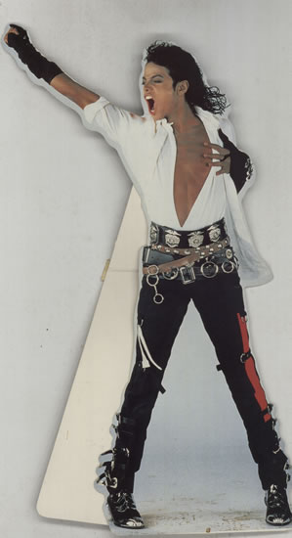

He gave Jasmine a mini version of his own personalized statue from the History promo with his autograph on the back.

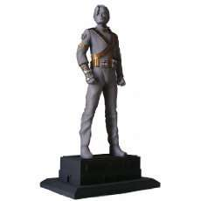

I was surprised that he didn’t give me anything but was taken aback as soon as I went to my office and saw several dozen multi colored roses placed around my entire office in beautiful arrangements. There was a card on my desk from him.

“Thank you for coming back and showing me the colors of love. I can’t wait to see you again.
Your Spaceship Invader.”

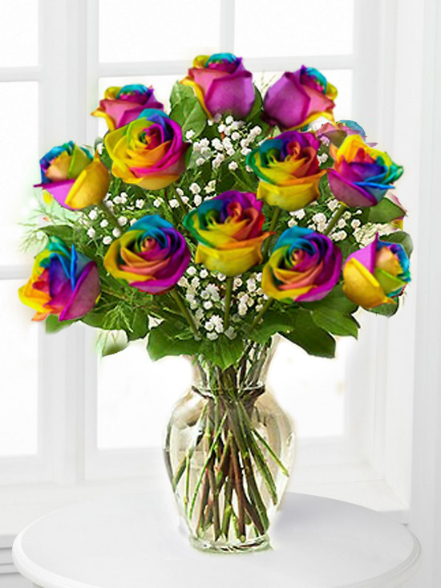

I almost cried at the sight of his words but also knew being with him again wasn’t going to be as easy as I thought it would be. Now that all of the details concerning Michael’s tour were finalized I had to tell him about Joseph. I knew in my heart that he’d be worth the fight but I didn’t want to come in between him and his father. I still couldn’t figure out why he hated me but I stopped obsessing about it when I realized he hated everyone. If his own children couldn’t get through to him, there was no way I ever could.

*** TWO HOURS LATER ***

“Ana, Michael is on the phone. I’ll put him through.”
“Thanks Marie.”

“Hi, baby.”
“How are you Liberian girl?”
“I’m alright.”
“I miss you very much.”
“I miss you too!”
“Did you get my gifts?”
“YES. Thank you so much.”
“Your roses are the same colors that we used in the canvas room.”
“I noticed that. You are so creative and brilliant.”
“I’m just your man.”
“I’ve never heard you say that before.”
“It’s the truth.”
“Indeed, it is.”
“I tried to make you laugh earlier today.”
“I KNOW. You are such a brat. I was with your investors at the time.”
“I know, that’s why I did it.”
“You are so cute.”

He noticed I wasn’t being responsive when he was telling me about his day and how it felt being around children at the hospitals and orphanages.
“Diana, what’s wrong?”
“Michael, I need to talk to you in person.”
“You’re scaring me.”
“It’s nothing to do with us.”
“What happened?”
“I can’t tell you like this. I need to see you.”
“I want to see you too but the media knows I’ve signed with you for my tour. Reporters are following me everywhere and are scouring Neverland trying to get inside information. They might even start coming to your office.”
“This is really important.”
“I love you.”
“I love you too, Michael.”
“Please tell me what’s bothering you.”
“I really want to see you.”
“I’ll come there.”
“We both know that’s not a good idea.”
“I’ll go crazy if you don’t tell me. I can feel it’s important.”
“It really is. I’ll send Jasmine to explain the situation. Is that ok?”
“Yes, of course. Tell her to meet me at London West. I’ll be there in an hour.”
“Ok, I will. Thank you, baby.”
“Diana, whatever it is we’ll work it out.”
“I hope so.”
“I won’t lose you again.”
“I needed to hear that.”
“Marry me?”
“Invade me?”
He laughed for the longest time which made me feel so much better.

“Will you?”
“Of course. Anytime.”
“Can I see you tomorrow?”
“London West is reserved for me until we leave in May. I’ll let you know when I’m there and you can meet me after your work is done.”
“I love you baby.”
“I love you more.”
“I’m giving you a big hug right now.”
“I got it, thank you.”
“Call me later tonight.”
“What do I get?”
“Your galaxy.”
“Girl, I’ll call you every hour.”
“MICHAEL! You’re so silly.”
“I love you, girl.”
“Love you too. Call me later.”
“I will.”

I hung up with him and went to Jasmine’s office to tell her the news and also gave her a few more documents for Michael to review and sign. She happily agreed to see him for me but of course, Marie wasn’t too thrilled about it.

“How come SHE gets to go?”
“Because she’s NOT YOU.”
“What is that supposed to mean?”
“Marie, you’re too big a fan of his to ever take things seriously.”
“I am NOT.”
“This is business, Marie. You’d be too busy drooling over him to tell him anything. Our business could be going up in flames and the second he appears in front of you you’d forget to tell him that.”
“She’s right, Marie.”
“I guess you do have a point. Please tell him I said hi.”
“I will for sure.”

The phone rang at Marie’s desk and she left to answer it. I was trying so hard not to let Joseph bother me but I couldn’t get his words out of my head.

“Don’t worry, Diana. It’s going to be fine.”
“Jas, I don’t want to come in between them.”
“He’s not going to let that happen.”
“Why does he hate me, Jas? I never did anything to him.”
“Diana he hates his own children who never did anything to him either.”
“I know. I just wish I could get through to him somehow.”
“Michael tried for years and failed and if there’s something Michael Jackson can’t do, we all know no one else can either.”
“You’re right again, Jas. Thanks for understanding.”
“I’ll go see him and tell him what happened and he can deal with Joseph on his own. It’s his father, he knows him better than all of us. Leave it in his hands, Diana.”
“Please tell him I love him?”
“You know I will.”

She gave me the warmest hug then left to see him. Once she was gone, I went into work mode to get my mind off Joseph. I ended up catching up on everything I had to do and decided to take the rest of the day off and go to the spa and asked Marie to join me. She happily agreed and the two of us spent the rest of the day getting pampered. I felt reassured knowing that everything would be fine between us and that nothing could ever come between us again.

*** JASMINE’S POINT OF VIEW AN HOUR LATER ***

She meets Michael at the hotel and he invites her inside the suite.

“I can’t stay too long. I have a lot of work to catch up on.”
“Thank you for coming. How are you?”
“I’m well. I need to fill you in on what’s going on.”
“I hope no one followed you here.”
“I’m not really that well known. Ana is the one who’s always in the spotlight. Even if someone saw me they wouldn’t know who I was.”
“You are so lucky to have privacy in your life.”
“I’m sorry. I forgot who I was talking to.”
“It’s ok. I’m used to it.”
“I wish I could give you back those years you lost.”
“It was meant for me to have this life. I wouldn’t trade it for anything.”
“I’m glad you don’t have regrets.”
“If I wasn’t who I am, I never would have meet Diana.”
“That’s sweet. By the way, Marie said hi and Ana said she loves you.”
“I love her more. She really has no idea how much she means to me.”
“I’m sure she’d love to be reminded.”
“I’ll never stop telling her. So, what happened today?”
“Oh right. Before I get into that, Ana sent some more documents for you to review and sign. They’re from the investors. We need your signature approving their proposal and the budget that they have provided.”

Michael carefully reviewed the financial details of his tour and signed the documents with confidence. He was so happy that things went according to plan. “Now that the budget is done and the investors are ready with the funds, you can let Prince Waleed know that Marie will be faxing the papers to him overseas so he can meet us in Europe for your press conference announcing the tour dates and city locations.”

“Diana really knows what she is doing.”
“Indeed. She’s the best.”
“Now that this is taken care of, what happened to her today?”
“I don’t really know how to tell you so I’ll just come right out with it.”

Michael looked worried. Jasmine sensed he was about to get emotional.

“What happened to my sweet girl?”
“Nothing, Michael. It’s not like that.”
“Then what is it?”
“Someone came to see her today.”
“Who?”
She stalled as she could tell he suddenly became extremely tense.

“Please don’t get upset.”
“Who was it?”
“We were expecting the investors this morning but then he suddenly showed up.”
“Who?”
“Michael….don’t get angry please.”
“Who was it, Jasmine?”
“Your father.”

Hearing those words infuriated him. His eyes flared as he stood up and walked away.

“Michael, where are you going?”
“Stay there. I’ll be right back.”

Feeling concerned, Jasmine got up and started following him. He noticed as she tried to find out what he was going to do.
“Jasmine, go back and sit down. I’ll be right back.”
“Please just tell me where you’re going.”
“I need to make a phone call.”
“Ok. I’ll be in the living room.”

She waited over an hour for him while he was still in another section of the suite talking on the phone. Not wanting to be rude, she didn’t over hear anything but could see Michael’s body language and slightly heard him screaming at whoever he was talking to. She waited patiently for him then he finally came out the room and went to stand outside on the patio an hour later. Jasmine went to join him.

“Are you alright?”
“I wish he’d leave me alone.”
“I know it must be tough on you.”
“He doesn’t care about anyone except himself.”
“Has he always been that way?”
“For as long as I can remember. He was the reason I moved out and did my own thing.”
“I don’t mean to make matters worse but he threatened Diana today.”
“I know, he told me.”
“You were speaking to him?”
He shook his head yes and Jasmine saw tears coming out of his eyes.

“Michael, please don’t cry.”
“I tried so hard to please that man and he never cared. He’s always hated me. I just don’t understand him at all.”
“No one does. That’s the way he is, Michael. I told Ana the same thing. I can’t really say much about him because I don’t know him that well but based on what I do know and what Marie has told me, he’s just a difficult person and it’s not your fault.”
“I can’t believe he went to see her today. I wasn’t expecting him to do that.”
“He told Diana to leave you and release her name from your tour.”
“I know. She refused because of me.”
“She will never let you go, Michael. She really loves you.”
“I know. I love her too.”
“You both have been through a lot. There is NO WAY she will allow you to slip away from her this time, especially now that you’re going on tour. That is something Joseph is going to have to deal with and eventually accept.”
“I don’t care even if he doesn’t. It’s MY Life, not his.”
“THAT’S the Michael Jackson I know.”
“Thank you. Now I know why Diana calls you her best friend.”
“I can also see why she loves you so much.”

They both hugged each other and Michael told her he felt a lot better.

“I love you, girl.”
“Me too.”

*** DIANA’S POINT OF VIEW ***

As the two of them let go of each other, their eyes met and suddenly Michael kissed Jasmine’s lips. What he didn’t realize was that Marie and I were standing in the living room just as it happened.

