CHAPTER 13:
The Unwise Decision

As soon as I saw who it was, I was overcome with happiness. I couldn’t hold myself back as I ran and hugged her.

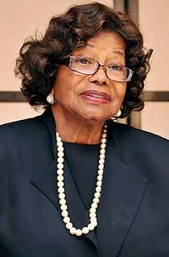
“It’s been too long, Diana.”
“It sure has. I’ve missed you so much.”
“How are you?”
“I’m well. How are you?”
“Better now that you’ve returned.”
“I wanted to ask Michael about you but we’ve been so caught up with things I never got the chance to.”
“It’s ok. I’ve been busy myself.”
“You look just as beautiful as I remember.”
“Thank you, Mrs. J. So do you.”

The girls came in and Marie gave Katherine cookies and tea. The two of them were so happy and excited to meet the famous woman who carried Michael and brought him into the world.

“Why didn’t you tell me she was here?”
“She wanted to surprise you.”
“That she did. I jumped across the room when she closed that door.”
“I’m sorry. I didn’t mean to scare you.”
“Don’t apologize. I’m so glad to see you.”

The girls and I sat with her for the longest time talking and catching up on things. She knew Joseph came to see me and wasn’t happy about the things he said. She assured me that he wouldn’t bother me again since Michael told Katherine he didn’t want to hear about his father coming near me or him again.

“I wish I understood him.”
“Joe has always been very difficult. His upbringing wasn’t exactly normal.”
“I know, Michael told me. I just wish I could get him to like me somehow.”
“Give him time. He’ll grow into it.”
“You think so?”
“I’m hopeful about it.”

I asked her to stay with me at the office and she agreed. The girls and I made sure she was comfortable and I went over Michael’s tour details with her and she was glad I was going to Europe to take care of him and his tour.

“Michael called me last week and he was screaming like a little boy.”
“Really?”
“Yes. He said MOTHER! MOTHER! I have something to tell you. I said what is it Michael and he said you’ll never guess who I saw! I knew he was talking about you.”
“It was a complete twist of fate. I really wasn’t expecting to see him.”
“I’m glad you did though. I can see you’re doing well.”
“I just needed a reason to let go of him but at the same time, I wanted to be closer to him too.”
“I’m glad you are back in his life. You have no idea how lonely he was when you two separated. I don’t know what really happened but all that matters is that you’ve worked it out.”
“That won’t happen again, Mrs. J. I love him and can’t live without him.”

She smiled and hugged me as I showed her how my business operated and the different types of projects we all did on a daily basis. She laughed when she saw all of Michael’s pictures and short films everywhere. She then asked me about the baby.

“I heard what happened. Michael told me. From one mother to another, I understand what you felt that day. It also happened to me.”
“I’m sorry and thank you. I was devastated but it was for the best at that time.”
“I’m sure you two can try again.”
“Definitely. I know he really wants children.”
“He does and I’m sure he’d enjoy the process.”

I laughed at her words and couldn’t help but notice how much Michael still resembled his mother. It was so lovely to be around her again. For a second, it seemed as if she had filled the void of me not having my own parents. I felt relieved knowing I had a motherly figure I could count on again. She stayed with me the entire morning then left in the afternoon to take care of some important business. I asked her to come back and visit and Marie walked her downstairs to the main entrance.

*** LATER THAT AFTERNOON ***

“Ana, Michael is on the phone.”
“Can you talk to him for a few minutes? I’m just finishing something.”
“SURE!”
“Behave, Marie.”
“I always do!”

“She asked me to talk to you while she finishes her work.”
“Does she ever take a break?”
“Do you?”
“I do now. I never did before.”
“She picked up your bad habit.”
“I’m working on fixing it.”
“Good. We can’t have anything bad happen to you.”
“I’m a soldier with the strength of ten men.”
“I can tell.”
“Is Jasmine there?”
“She is. Would you like to speak to her?”
“Yes, please.”

“Jas, Michael wants to talk to you.”
“Put him through.”

“Hi, Michael!”
“Jasmine, I wanted to apologize.”
“For?”
“What happened between us.”
“Don’t worry about it. I know you were thinking of Diana.”
“I hope your husband didn’t get mad.”
“He actually laughed it off.”
“He did?”
“Yeah, he said I was the luckiest girl in the world. Even though it was an accident, he said so many girls would kill to have that mistake happen to them.”
“He seems like a nice person.”
“He is and he’s a fan of yours.”
“What is your son like?”
“He’s quite the little terror.”
“I’d love to meet him one day.”
“I’ll introduce you to him when we come back to LA.”

“Marie, are you still talking to him?”
“No, Jasmine is. I’ll tell her you’re free now.”
“No, let them talk. Just tell her to put him through to me when she’s done.”

I went over all of the fine points of Michael’s tour details including the flight and hotel arrangements and was so excited to be done early. I couldn’t wait to tell him the good news.

“Ana! They’ve finished talking. Is it ok to transfer him now?”
“Sure, thank you.”

“Hi space man.”
“Hee hee.”
“OH MY GOD! THAT IS THE CUTEST THING EVER!”
“Thank you. I’m so happy.”
“Why is that?”
“Because I can hear your voice.”
“How sweet.”
“I wanted to ask why you came to the hotel yesterday.”
“Marie and I finished work early and went to the spa. I was missing you and she wanted to see you as well so we both thought we’d surprise you.”
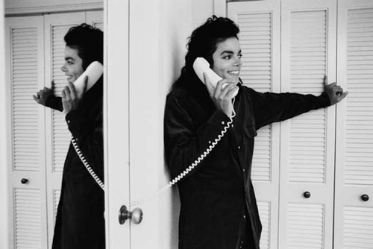
“I’m sorry it wasn’t a pleasant surprise.”
“Don’t worry. Like I said I’m over it.”
“I still feel bad.”
“You’ll feel better when I see you.”
“REALLY?”
“Yes, I promise.”
“I’m excited now.”
“I’ll let your imagination tell you the rest.”
“It tells me a lot of things, Diana.”
“Like?”
“How lovely your cupcake is.”
“OH MY GOD!! STOP IT!”
“How big and beautiful your galaxy is—“
“STOP!”
“How loud you scream when I’m going inside of you—“
“MICHAEL!!!”
“Ok, ok. I’m sorry.”
“NO, please don’t stop!”
“You like saying that.”
“Only with you.”
“Please come see me, Diana.”
“No, Michael. We need to spend time apart.”
“PLEASE?!”
“It’s not a good idea.”
“Girl, I’m begging you.”
“You know I would but if I start seeing you every day you will get distracted and so will I.”
“I’m distracted even when we’re not together.”
“I am too. But we need to focus on the tour. It’s important, baby.”
“I know. You’re right.”
“I’ll see you again very soon. Now, let’s talk about something else.”
“Mother told me she came to see you today.”
“SHE DID. I almost cried when I saw her.”
“I knew you’d enjoy her company.”
“Thank you for sending her to me. I wanted to ask you about her so many times.”
“She’s so happy you are back in my life.”
“Are you?”
“You have to ask?”
“I like hearing you say it.”
“Yes, Diana. I’m very happy.”
“About?”
“DIANA!”
“MICHAEL!”
“Girl, you know how shy I am!”
“I know and I love that about you.”
“I’m happy that you’re back in my life.”
“See? That wasn’t difficult.”
“I love you.”
“I love you too. By the way, you’ll be delighted to know that the tour is completely set up from our end. It’s all about getting on the plane now.”
“Will you three be travelling together?”
“Yes, of course. That reminds me you still have to send me yours and your staff’s itinerary.”
“I forgot about that. I’ll send it after I get in touch with Waleed.”
“Sounds good.”
“I really want to see you.”
“Michael, you need to stop asking.”
“I can’t go a day without you.”
“You went five years without me.”
“Only because I had to.”
“I don’t want to come in between your work. I know you have tons of things to do.”
“Nothing is more important to me than you.”
“You are such a cupcake.”
“I enjoyed yours.”
“OH GOD! Please STOP IT.”
“Girl, you weren’t saying stop last night.”
“ENOUGH!”
“HEE HEE!”
“Why do you ALWAYS do that?”
“Because it’s fun.”
“You’re silly.”
“Only with you.”
“I’ll be thinking of you all day.”
“Me too. Don’t work too hard.”
“I’ll try not to.”
“Be sure to take breaks and remember to eat.”
“I will now that I have a reason to.”
“And if you’re a good boy, I just might reward you.”
“YOU WILL?”
“I MIGHT.”
“I’m looking forward to it.”
“Call me before bed?”
“Of course. I love you so, so much.”
“I know, Michael. I love you too.”
“I can’t wait to have you in Europe.”
“EXCUSE ME?”
“I mean SEE you in Europe.”
“Boy, you’re crazy. Enjoy your rehearsals.”

I couldn’t stop smiling the entire day. I felt bad for refusing to see him but I knew it was for the best. I thought we’d appreciate our time together a lot more if we didn’t see each other all the time. Being away from him was definitely a difficult task. One that required serious effort but I knew once the tour started, I’d see him every single day and there was no way I could escape from him then.

*** FOUR MONTHS LATER ***

We are now two days away from leaving LA to go to Europe. The girls and I spent the last few months taking care of other projects, shopping, going to the salon, making sure we had enough money for everything we needed and wanted and of course, preparing the staff and crew to Michael’s standards. He and I haven’t seen each other in two months as we’ve both been on the go and haven’t talked much on the phone but he called at least once a week to make sure me and the girls were doing ok. Time has flown by so quickly. It was hard for all of us to believe that we were about to join the greatest entertainer in the world on his international tour.

“GIRLS!!We’re going to Europe! Who’s excited?”
“Obviously you are, Marie.”
“Aren’t you?”
“I’m excited but not too thrilled about leaving David and little man for 5 months.”
“I know that’s going to be tough, Jas. But you can always call them as often as you want.”
“Ana, have you talked to Michael?”
“Not really. He hasn’t called me this week and when he does, he just says hi and asks how you two are doing.”
“He must be going crazy and feeling stressed out.”
“I know. I can’t imagine what’s going through his mind right now.”

Just then, Marie heard his name on TV. “LOOK! HE’S ON!” She quickly turned the volume up and turned off the office switchboard. We stood in the lounge and heard on the news that he was officially announcing his leave for the second leg of his tour in Europe. To my surprise, he looked noticeably different.
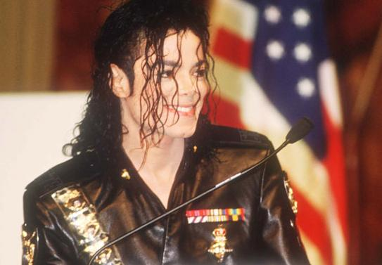
“HE LOOKS SO HOT!” Marie yelled.
“YES, HE DOES! Doesn’t he Ana?”
“He always looks handsome to me.”
“HE CHANGED HIS HAIR!”
“I know, Marie. I can see that.”
“When did you see him last?”
“About two months ago.”
“IT’S BEEN THAT LONG?”
“Yeah, he wanted my insight on wardrobe and hairstyles. That was the last time I saw him and we’ve barely said ten words to each other since then. I’m glad he took my advice and had his beautiful hair styled that way.” The girls couldn’t take their eyes off him as he spoke at a press conference in front of thousands of fans and reporters.

“Ana, did you know he was going to do this?”
“No, but he’s allowed to as long as he doesn’t reveal specific information about his dates and locations. He knows he can’t do that until he arrives in Germany.”
“I can’t believe how GORGEOUS he looks!”

I also couldn’t stop myself from staring at him. I smiled as I heard him speak so proudly about the second part of his world tour. He seemed genuinely happy and prepared to show his fans overseas what he was truly made of.

“Ana, I don’t know what you did but Michael is glowing.”
“I know. I’m so happy and very impressed that he’s doing well. I think having you two in his life has also made a huge difference. I’m glad he’s been keeping his promises and taking care of himself too. Marie, don’t forget to confirm our check in at the airport and get our flight times.”
“Got it!”

“I’m all set. David and little man are going camping so it’s all good from my end.”
“I think I’m good to go too. I just have one last thing to take care of.”
“What’s that?”
“I need to buy something.”
“What is it?”
“Lingerie.”
The girls started with their usual oohing and aahing as they heard me say the magic word.
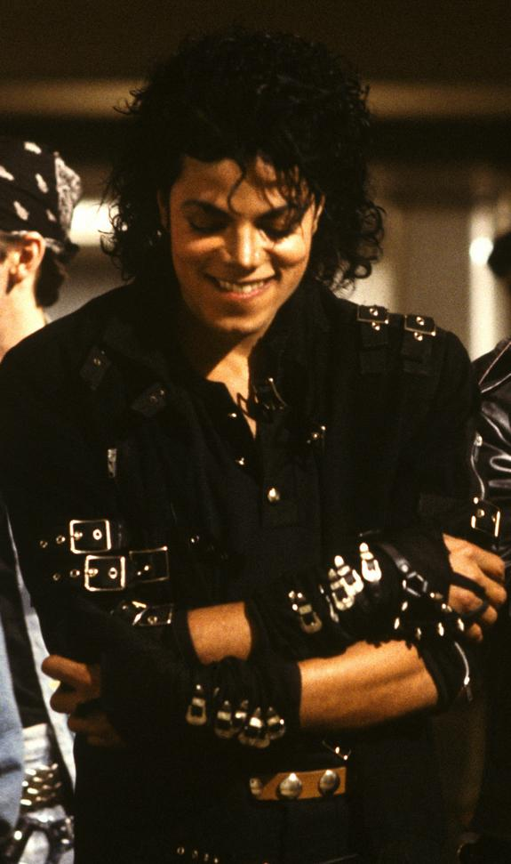
“Ana and Michael sitting in a tree...”
“Well, that is the one place we haven’t done it yet.”
“YET?! ANA! I can’t believe you.”
“I’m kidding. We’re not that freaky.”
“Yet!”
“SHUTUP! You two are just as bad as he is!”
“No one is more bad than Michael. He’s even got the song and the black outfit to prove it.”
“I wonder if he still has it.”
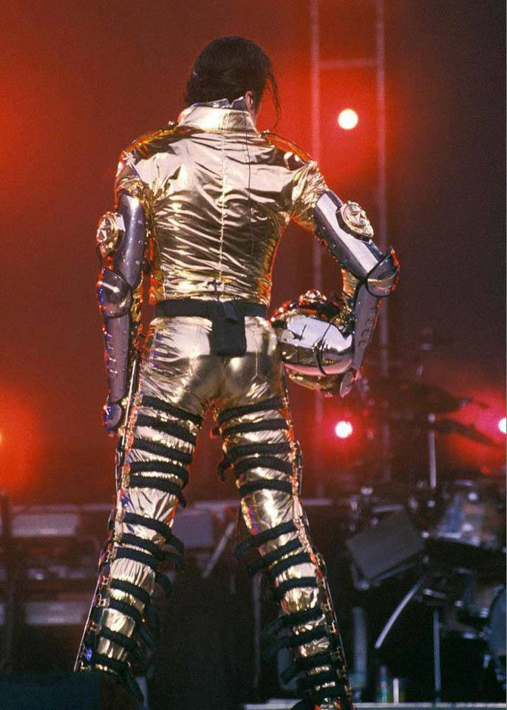
“There’s only one way to find out.”
“STOP IT. I was just curious.”
“Well, for now you can keep yourself occupied by unwrapping his gold card.”
“JASMINE! YOU ARE TERRIBLE!”
“Or better yet, his gold nuggets!”
“THAT’S ENOUGH! I’m still your boss and I can drop you two from his tour!”
“You can’t because you know Michael would have a fit.”
“True, but he gets disoriented every time he sees me without clothes on.”
“Does that happen often?”
“That topic is not for discussion.”
“For NOW.”
“FOR EVER.”

Jasmine offered to go shopping with me. She said she wanted to make sure I had just the right outfit and the right color. Marie stayed at the office saying she didn’t want to miss Michael and would tell him to call my cell if she heard from him. His conference was on every TV channel and radio station in the city. I knew he would have a hard time at the airport now that the world knew he was about to leave the United States. Jasmine was kind enough to hire additional security for his own protection as well as ours just in case someone was to chase us down or try to harm him in any way.

*** LATER THAT DAY ***

Jasmine and I went to Victoria’s Secret in Beverly Hills to look at negligees and night gowns. She and I couldn’t choose just one so we picked several different things we thought Michael would like to see on me. Jasmine was so enticed by them she decided to buy a few for herself.

“And who are you going to show these to in Europe, Jas?”
“You never know. Michael might have some hot guys in his crew!”
“JAS! You’re married!”
“I KNOW. Jeez, can’t a married girl make a joke once in a while?”
“Not when it comes to cheating!”
“Relax, Ana. I’d never do that to David. Even if I did he’d find the guy and cut his pickle off.”
“His PICKLE? I’ve never heard that term before.”
“What do you call Michael’s pickle?”
“JAS! Why do you ALWAYS set me up like that?”
“Because I WANT TO KNOW!”
“I don’t call it anything. I don’t even look at it.”
“WHAT? You have no idea what it looks like?!”
“I do know and I am NOT telling you.”
“Does it look nice?”
“JAS, SHUT UP!”
“Ok, ok sorry. But does it?”
“YES and that’s all I’m telling you.”
“Ok, I won’t ask you again.”
“GOOD.”
“So, how does it feel?”
“THAT’S IT!”

Like two kids, we ran around the department store with lingerie in our hands causing a scene in front of other customers. When I finally got a hold of Jasmine I tackled her to the ground and started tickling her just like Michael always does to me. She couldn’t stop laughing then got up and hugged me.

“I’m happy for you, Ana.”
“Thank you.”
“I don’t mean to be nosy. I just want to make sure he takes good care of you.”
“He does, Jas. I love him.”
“He loves you more.”
“I know and he never lets me forget it.”
“We should buy our things and go. I have to finish packing and Michael might call you later.”
“I forgot about that. I don’t want him knowing we are in here.”
“You HAVE to tell me what it feels like when you undress him from that gold wardrobe.”
“WHY?”
“Because it’s HOT!”
“Jas, if I tell you then I’d have to tell Marie.”
“You can tell her too. Just be more graphically intense with me!”
“You are just awful, Jasmine.”
“But you love me.”
“Yes, of course I do.”

We both decided on what to buy then went to the cashier to pay for them. While we were waiting in line, I felt a change in me. I tried fighting it thinking it was nothing serious but it suddenly became very strong.

“Ana, are you ok?”
“Oh my god. Not again.”
“What’s wrong?”
“Jas….I feel sick.”

