CHAPTER 14
Impulse, Interrupted

“Oh my god, Ana. Not AGAIN!”
“Wait here, Jas.”

I ran to the ladies room and threw up. I was shaking so bad. The thought of being pregnant again made me hysterical. I hoped it wasn’t true but also knew there was no other explanation for unexpectedly getting sick. I stayed in the bathroom for a few minutes just in case it happened again but luckily it didn’t. I went back to Jasmine, paid for my things and we both went to a drug store to get a few pregnancy tests.

“Ana, I can’t believe you! How could you be so STUPID?”
“Jas, getting pregnant isn’t stupid.”
“It is when you’re two days away from going to EUROPE FOR 5 MONTHS!”
“I know. It’s my own fault.”
“Well, DUH!”
“I mean besides the obvious. Michael wanted to use protection. I turned it down.”
“WHY?”
“Because I got caught up in the moment again, Jas. It wouldn’t have been the same and I wanted to rekindle that special feeling.”
“Ana, you are way too sentimental when it comes to him. He immensely clouds your judgment.”
“Why do you think I limit myself from seeing him? What am I going to do? There’s no way he will allow me to travel if I am expecting.”
“He can’t cancel the tour either. Marie and I also can’t back out. Now that I think of it, NONE of us can.”
“Knowing Michael, he’ll be thrilled at first but then be worried half to death. He was the one who kept telling me not to do it unprotected. I felt optimistic thinking this wouldn’t happen to me again.”
“Let’s find out for sure before we start going off the deep end.”

We went to an all-night pharmacy and grabbed a few different brands of tests. I went home and used each of them and sure enough, they all had the same result.

“Looks like I have a baby coming, Jas.”
“I’m happy for you but also really concerned.”
“That makes two of us.”
“If you tell him, it will distract him big time. He’ll postpone the tour and that’s going to cost us and Kingdom International millions of dollars. Not to mention the investors will hit the roof.”
“I know, Jas. That’s why he can’t find out.”

We both sat and talked about what the next best thing would be.

“Ana, you have to tell him.”
“He’s going to freak out.”
“Would you rather go to Europe and tell him there?”
“That might work.”
“Oh, yeah that’ll go over big. “Hi Michael, it’s so nice to see you. I’m having your baby. So where do we set things up?”
“Shut up Jas!”
“Seriously, what are you going to do?”
“We all have travel and medical insurance. I’ll find out for sure in Europe.”
“Ana, you took three different tests – how sure do you need to be?”
“I need to tell him before I leave, don’t I?”
“YES, DIANA!”
“Maybe I should get checked out by a doctor first.”
“You are NOT getting rid of it.”
“OF COURSE NOT! I’d never do anything that stupid. Even if I wanted to Michael would NEVER allow it and I know he’d leave me if I did it behind his back.”

“Whatever the case may be, I know Michael will be happy. His mother might get the shock of her life though seeing as how you two just met again and you’re already expecting.”
“I’m sure she will understand.”
“I better go. I have to finish packing and I promised the squirt I’d read him a story since he and David are leaving in the morning.”
“Did you show him what Michael gave you?”
“Yes and he loved it. He keeps it next to his standing toe lamp.”
“That’s so cute.”
“He’ll have a little brother or sister to play with.”
“That’s sweet, Jas. Your support means the world to me.”
“Get some rest. I’ll call you in the morning and we’ll take it from there.”
“Ok, goodnight.”

She hugged me then left. I was feeling really tired so I went to my room to change and lie down. Ten minutes later, my phone rang.

“Hi, baby.”
“How are you?”
“Better now that you called.”
“I miss you.”
“Me too. I saw you on TV.”
“I think everyone did.”
“Marie was glued to you like always.”
“Did I look ok?”
“Michael, you ALWAYS look ok.”
“No, I don’t.”
“YES, you do!”
“I’m just me, Diana.”
“And who you are, is absolutely beautiful.”
“You’re sweet. Thank you.”

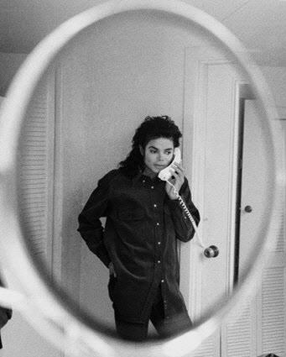
“How was your day?”
“Busy as always. I can’t believe I’m leaving in two days.”
“Are you ready to go to Europe?”
“I guess so.”
“You don’t sound happy about it.”
“I am. But going on tour stresses me.”
“I bet it does. You must get so exhausted and restless travelling from one place to another.”
“Girl, you have NO idea.”
“At least this time I’ll be there to help you get through it.”
“I know. I’m so grateful to have you.”
“Me too.”
“Come see me tomorrow?”
“I don’t want to get in your way.”
“You won’t. I have to see you before I leave.”

As much as I wanted to see him, I feared what would happen between us and me not being able to say no. I had to think of a way to not let that happen without telling him why.

“I really want to see you too. I wish we weren’t taking separate flights.”
“It’s a security thing.”
“I know. I understand. Call me when you wake up. I’ll be there.”
“I miss your cupcake.”

I couldn’t help but laugh.
“Michael, we can’t do that.”
“Why?”
“I don’t want you losing focus.”
“Diana, my focus will be gone as soon as I see you.”
“I know, but I don’t want that to happen.”
“Is something wrong?”
“Not at all. I just want to spend time with you without being intimate if that’s ok.”
“Of course. I wasn’t really thinking about that.”
“Right.”
“I’m serious. I wasn’t.”
“I believe you, silly. How are you feeling?”
“Better. I’m doing my best to take breaks and eat on time.”
“Good boy. I noticed you look so much better now.”
“I looked horrible before?”
“OF COURSE NOT! Why would you think that?”
“I’m teasing you, girl.”
“Please don’t joke about that. I work so hard to make you feel good about yourself.”
“I know you do. I’m sorry.”
“It’s ok – and yes, you ALWAYS look amazing but I noticed you seem a lot happier and determined to start the second leg of your tour.”
“It’s all because of you, cupcake.”
“That is the cutest name in the world.”
“It’s yours.”
“No, Michael. It’s YOURS.”

He giggled. I could hear the shyness in his laugh.

“You really want it, don’t you?”
“If only you knew how badly.”
“You can have it in Germany.”
“Really?”
“If there’s time.”
“Girl, I’ll MAKE time.”
I laughed so hard.

“Baby, you’re so cute.”
“I can’t believe it’s been two months since we’ve seen each other.”
“I KNOW. Time flew by and we’ve both been on the go.”
“It’ll be worth it when I see you next to me in Europe.”
“Aww, thank you. I feel the same way.”
“I need to rehearse again, Diana.”
“Ok. I’m going to bed. Thank you for calling.”
“I told you I will always make time for you.”
“I appreciate it.”
“I love you, Diana.”
“I love you too. Please don’t over work yourself.”
“I’ll try not to. I promise.”
“Call me when you wake up?”
“I will.”
“Go to bed early?”
“I will.”
“Take your medicine?”
“I will.”
“Marry me?”
He suddenly didn’t say a word.

“Did I scare you?”
“YES! Why didn’t you answer me?”
“I wanted you to think I’d say no.”
“Does that mean you won’t?”
“NO, DIANA!”
“I know, I know. I’m kidding.”
“I asked YOU, remember?”
“Yes, I do. So will you?”
“Yes.”
“Yes, what?”
“Please don’t do that to me.”
“Do what?”
“Why do you always make me say things?”
“Because I like hearing them.”
“I’m so shy.”
“I know. Please, Michael?”
“Yes, Diana. I’ll marry you.”
“See? I knew you could do it.”
“I showed you I could.”
“MICHAEL!”
“I love you, cupcake. Goodnight.”
“Goodnight, baby.”

*** THE NEXT DAY ***

“Diana, WAKE UP!”
“Jas, what are you doing in my house?”
“You gave me a key a long time ago. It’s almost noon.”
“IT IS?!”
I looked at my alarm clock and she was right. I checked my phone and noticed I had over a dozen missed calls.

“OH MY GOD! I was supposed to meet Michael this morning.”
“I know, he told me.”
“He called?”
“The office like twenty times.”
“I can’t believe I slept in.”
“Did he call last night?”
“Yeah. We talked for a while and he told me to see him today. I have to get to London West.”
“You want me to take you?”
“No, I can go. Can you take care of things at the office today?”
“Of course. Please tell him I said hi. Oh, and this is for him.”

She gave me a large piece of paper with a drawing on it:

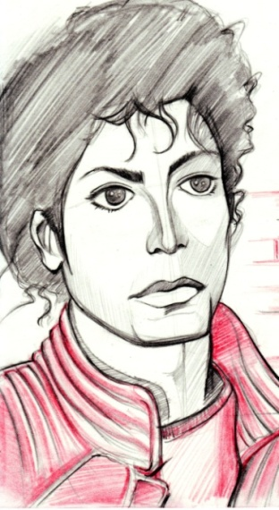

“This is from David and little man. Can you please give it to him?”
“Jas, this is amazing. Did they make this?”
“David drew the picture and squirt colored it.”
“It’s beautiful. Michael will love it. I’ll gladly give it to him.”
“Thanks. How are you feeling?”
“I’m fine. I didn’t get sick again which is good.”
“I’ll let you get dressed and head over there. Call if you need me.”
“I will, thanks. Please make sure Marie does everything she’s supposed to.”
“Don’t worry, I will. And the others know what they have to do for the next 5 months until we get back.”
“I owe you my life, Jasmine.”
“Just make me your maid of honor and we’ll call it even.”
“I’ll probably have two of everything since I can’t choose between you and Marie. I also have a feeling his sisters will obviously want a huge part in the wedding.”
“We’ll discuss all of that when the time comes.”
“For sure. I just hope I’m not some fat ass bride.”
“YOU WON’T BE! Now get ready and go see the man. If he calls the office again Marie and I will tell him you’re on your way.”

I arrived at London West and the entire hotel property was packed with people. Thousands of fans and reporters were aching to see the man who was about to leave Los Angeles for 5 months. As his guard escorted me through the crowd and up to his room, I could hear so many people chanting his name and screaming as they waiting anxiously to catch a glimpse of the man they loved. I started thinking that I must have done something incredible to deserve such an immense reward like Michael’s affection. Coming from someone who was never a fan of his, I had never been more appreciative of having him in my life then at that moment.
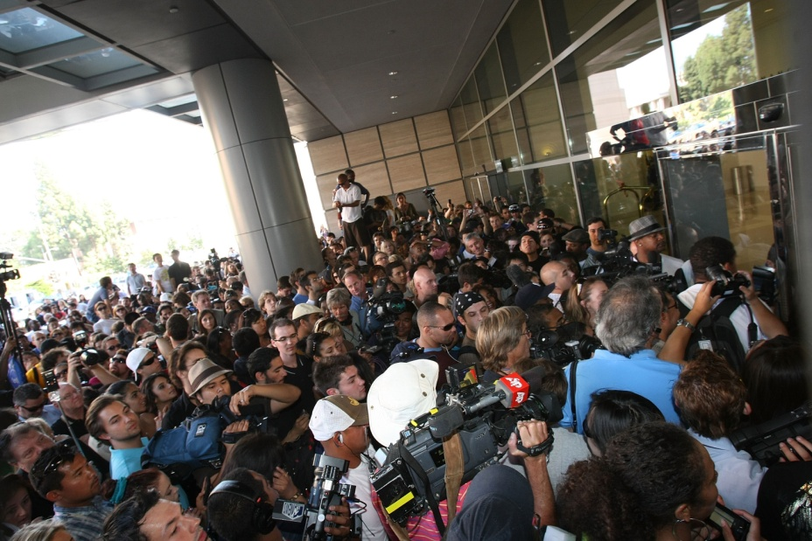

When I got to his suite, his guard let me in and said Michael was expecting me. I went inside and saw him on the patio waving to his fans. I didn’t want the public to see me so I waited for him in the living room out of view. I also didn’t want to interrupt him so I let him do his thing and watched as he smiled and blew kisses to his fans from the balcony. It was so beautiful to see someone who struggled with loneliness light up at the sight of his admirers. I knew Michael had strong, special feelings about his fans. It made me feel a bit possessive but I knew if I was going to be with him, I’d have to be willing to share him with the rest of the world on a permanent basis.

He turned his head and saw me standing in the living room. He smiled so beautifully and winked at me. I told him to take his time and not worry about me but he couldn’t help himself as he ran and held me in his arms.

“I’m so glad you’re here. I missed you so much.”
“I missed you too, baby. It seems like your fans are keeping you company.”
“They are. They’ve been here since last night.”
“Go see them. I can wait.”
“Are you sure?”
“Yes, of course.”
“I don’t want to keep you waiting for me.”
“Michael, those are your FANS. They are here because they won’t see you for 5 months. I’ll be with you every day. Take your time. I don’t mind at all.”
“You really are my sweet girl.”
“And your cupcake.”
“Yes, that too.”
He kissed my lips then went back to the patio. He signed the hotel’s pillows and several pictures of himself and threw them over the balcony for his fans to grab. I could see from Michael’s bedroom window that his fans were happy and so amazed to see him up close. I realized I’d have to get used to his kind of lifestyle if I was going to marry him. A lifestyle that would require me to constantly be in the spotlight with him. And if I were to have his baby, that would also be all over the news and media not allowing a single moment of privacy. I suddenly remembered why I chose to let Michael go five years ago. I was starting to have doubts about myself and wondered if I could really handle all of this or not.

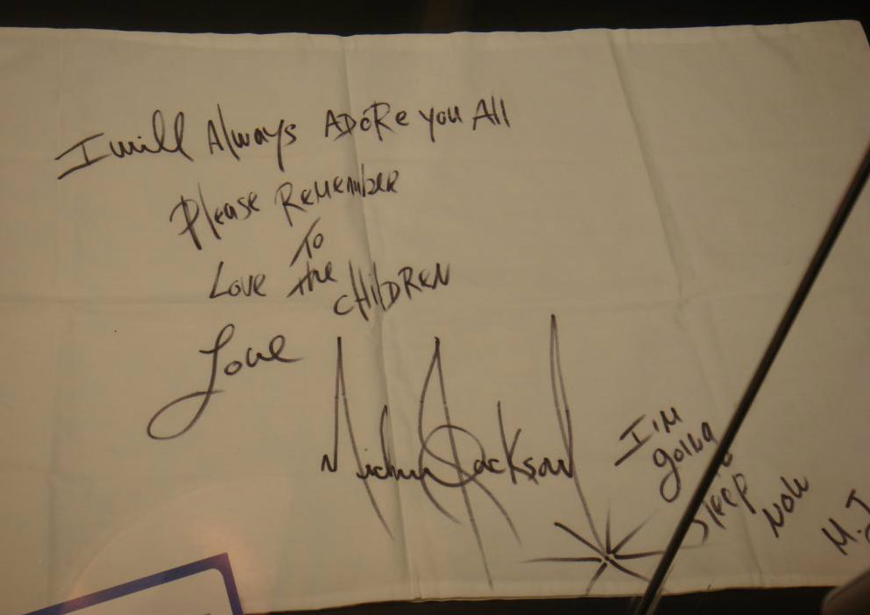
I went to the bed to lie down and put my hand on my stomach wondering if this was the best choice for me. I knew I wanted to be with him, but just couldn’t get the thought of not having a normal life out of my head. I knew he would be worth it but how long would I be able to keep up? I wasn’t sure why but seeing Michael with his fans suddenly made me second guess my entire relationship with him. I pondered for the longest time while he was on the patio.

*** AN HOUR LATER ***

“Diana, wake up!”
“I had no idea I fell asleep.”
“It’s ok. You seem tired.”
“I don’t know why. I over slept this morning which is why I missed your calls.”
“I’m glad you’re ok. I was worried about you.”
“I’m sorry. I’m just worn out from setting up your tour.”
“I didn’t mean to exhaust you.”
“You didn’t. It’s part of my job. I’ve just never executed a project this extreme before. Did the people outside leave?”
“Security and police escorted everyone off the property. That always happens eventually. I know the same thing will happen at the airport.”
“I was thinking that too. Jasmine hired additional security for you.”
“I know, she told me. You all are so considerate of me.”
“We love you.”
“I love you more.”

He lay down next to me. I pulled him on top of me and started playing with his hair. My previous thoughts entered my mind again. I was feeling afraid of what my future with him was going to be like. What amazed me the most was the fact that Michael sensed that and immediately questioned me about it.

“Something really serious is on your mind.”
“How did you know?”
“Your energy is different. You are never like this around me.”
“Like what?”
“You are really tense and confused.”
“I’m just nervous about going to Europe.”
“You’ve been there before, haven’t you?”
“Yes, but not with someone as famous as you.”
“I know it seems scary but once we start and end the first show you’ll see how routine it really is.”
“You’re right.”
“But that’s not all that’s bothering you.”
“Michael, you are SO intuitive.”
“You have to be in this business, Diana.”
“Believe me, I know.”
Michael put his head on my stomach making me feel awkward. I placed my hand on top of his head and ran my fingers down the side of his face. The feel of his soft, luscious skin made me feel happy. He put my finger in his mouth and bit it gently making me feel somewhat aroused. He then kissed my hand and put it on his chest next to his heart. Being with him felt so serene but my fear kept overshadowing my mind.

“You are so quiet, girl. It’s not like you.”
“I’m sorry, baby. I just have a lot on my mind.”
“Please tell me?”
“I will but not now. I don’t want to distract you.”
“Is it about me?”
“Sort of.”
“Something I said?”
“No.”
“Something I did?”
“No. I really don’t want to talk about it now. I just want to be with you like this.”
“I can’t lose you again, Diana.”
“You won’t. It’s nothing like that.”
“I won’t force you to tell me. But whatever it is, I’ll help you get through it.”
“You will?”
“Yes. I’ll be your protective shield.”

Hearing him say those words suddenly sparked something in me. I knew it was the perfect time. I gently pushed him off me and sat up on the bed. I took his hand and placed it against my stomach.
“You will be OUR protective shield.”

His eyes flickered. I could tell he seemed confused at first. He then looked up at me and I winked at him. He then knew exactly what I meant.

“Diana, are you telling me...”
“Michael…I’m pregnant again.”

He gasped gently to himself then lay me down on the bed. He lifted my shirt and gently kissed my stomach. I could feel his tears dropping onto my skin as he lay there on top of me pressing his beautiful face against me. All I could do was place my arms on top of him and ask him not to lose focus or get too emotional.

“You have NO idea how happy I am. When did you find out?”
“Last night.”
“Do you know how far along you are?”
“Not yet. I took a few tests last night and they were all positive. I’ll get checked out by a doctor in Germany when we get there.”
He then realized we were about to leave and of course, he started to worry.

“Diana, you can’t fly alone. You’re coming with me.”
“I won’t be alone. The girls and entire tour crew will be with me.”
“Diana, you HAVE to go with ME.”
“I can’t. Kingdom International has a legal contract that we had to agree with which says we cannot travel with you because it’s against their safety standards.”
“You think I give a damn what they say?”
“MICHAEL! You have to give a damn. You’ll go to jail if you don’t.”
“You’re carrying my baby.”

Hearing him say that brought tears to my eyes.

“There is NO WAY you will travel 12 hours on a plane without me.”
“Michael, you have to understand—“
“NO!”

He was starting to get angry. I kept quiet not wanting to make matters worse. As always, he felt horrible for yelling and hugged me.

“I’m sorry. I just don’t want anything bad to happen again.”
“It’s ok, baby. I will have everything I need with me on the plane. The girls will take care of me. I promise I’ll be fine.”
“I wish you could be with me. I’d take care of you.”
“I know but it’s just one flight. I’ll be with you 24 hours a day once we land.”
“You promise?”
“Of course.”

He felt better and kept hugging my stomach and kissing it. He then started talking to it as if it were a real person.

“I’m your daddy. You are my baby.”
“WHAT ARE YOU DOING?”
“I’m talking to him.”
“What if it’s a girl?”
“Then I’m talking to her.”
“You’re silly.”

I pulled him on top of me and we kissed passionately. He then became paranoid and kept moving to the side not wanting to be against me.

“I can’t lie on you. It will hurt him.”
“It will not and it could be A HER!”
“Ok fine, IT.”
“You’re calling our baby IT?”
“Can we name her cupcake?”
“CUPCAKE JACKSON?”
“I LOVE THAT.”
“THAT SOUNDS RIDICULOUS!”
“Ok, fine. How about space man if it’s a boy?”
“ARE YOU INSANE?”
“I’m kidding, girl. We have plenty of time.”
“Yes, we do.”
“You make me so happy, Diana.”
“You make me happier.”
“Marry me?”
“Ask cupcake.”

He laughed then whispered to my stomach that he would marry ‘its’ mother. We then spent so much time holding each other and coming up with silly names for our children. I suddenly remembered the gift Jasmine gave me.

“I completely forgot! I have something for you.”
“You do?”
“Yeah, I’ll get it.”

I ran to the living room where my purse was and pulled out the drawing. I ran back to the room and handed it to Michael, face down.

“Jasmine’s husband and little man made this for you.”

He turned it over and couldn’t believe his eyes. I could tell he was so moved. A single tear fell from his eye and I lovingly wiped it away for him, kissing the top of his head.

“It’s beautiful. I love it.”
“I told her you would.”
“I’ll take it with me to Europe. Is she at the office?”
“Yes, they both are.”
“I’ll call and thank her. Do you mind?”
“Of course not. Go ahead. I’ll be in the living room.”
“Have you eaten yet?”
“Now that I think of it, no. Have you?”
“I was waiting for you to get here.”

I knew that was his way of telling me he felt hungry.

“I’ll take care of it.”
“There’s a menu by the phone in the living room. You can look through it and when I’m done we’ll get something for the both of us.”
“You mean the THREE of us.”
He smiled and blushed like a little boy.

“Aww, is Michael happy about becoming a daddy?”
“Yes. I can’t wait until my little cupcake or space man gets here.”
“You are SO cute. I’ll be outside.”
“By the way, I have something to tell you later.”
“Ok, I’m looking forward to it.”

I left the room and sat on the couch in the living room with the menu in my hand. As I was looking at the different options, I couldn’t help but wonder if Michael had ever eaten anything ‘bad’ like a French fry or a piece of cake. I didn’t want to ask him but knew I’d have to spoil him once we got to Europe. He came out the room a few minutes later wearing different clothing.

“Do you see something you like?”
“I’m looking at it right now.”

He smiled and looked down.

“Come sit next to me.”
“What do I get?”
“Cupcake?”
He started to laugh as he made his way over to me. I could tell he was very happy.

“I don’t think I’ve ever seen you smile so much.”
“I’m just so happy. You’ve given me so much joy.”
“I’m glad. I hope you always smile.”
“Thank you. I wish the same for you.”
“I think space man will need singing and dancing lessons.”
“Oh god, I don’t know if I want him to be an entertainer.”
“I’m sure it’ll be fine if that’s what he wants.”
“And if cupcake wants to be one?”
“I’ll send her to Janet.”

We laughed as he put his head on my shoulder and looked at the menu with me.

“Michael, do you always eat so light and healthy?”
“I have to. Otherwise I’ll get sick.”
“I’ll help you with it once we get back from the tour.”
“You’ll help me by eating everything once you get further along.”
“SHUTUP! I am not going to be a fat pregnant woman.”
“You will always look lovely to me, Diana.”
“I feel the same way about you.”

We kissed then Michael reminded me he had something to tell me.

“Right, what is it?”
“Not yet. After we eat.”
“Can I share something with you?”
“Of course. I know just what to get.”

He got up from the couch and called the hotel staff to bring us room service. I went outside on the patio to get some fresh air and clear my mind. He followed me minutes later and the two of us stood there holding each other with our hands on my stomach. He tilted my face towards his and we kissed each other for the longest time. We both wanted to do more but knew we had to stop ourselves from going too far. He gently massaged my stomach asking me if I felt any pain or discomfort.

“I’m fine, baby. Thank you for being so caring.”
“Of course. I love you.”
“I love you too, senior moonwalker.”
“Oh god. I’ll have to teach him that too.”
“Does that worry you?”
“No, but everyone wants to learn that.”
“You don’t like teaching it?”
“I do, but I wish people would notice more about me than that.”
“THEY DO! But the moonwalk is your trademark, Michael. Everyone loves it.”
“It’s not that great.”
“Why don’t you EVER give yourself credit for the wonderful things you do?”
“Because it’s not me, it’s God’s work.”
“I love how humble you are.”
We kissed again then the doorbell rang. Michael asked me to sit on the couch while he allowed the staff in to set up the food. They were sad to know that he was leaving and asked for his autograph and picture. Being the wonderful, generous man he was he gave them all hugs and so many pictures of him with his autograph that they could hang up on the hotel walls. His love for people and desire to be kind astounded me. I knew at that moment that Michael would make a great father, one that his children would definitely be proud to have.

Seeing him so full of love made me emotional. I stood and watched him as he lovingly gave his heart to everyone he came in contact with. As happy as he seemed, I could still see his loneliness. I knew all he wanted was to feel like he mattered to someone and having his baby would be the best way to convince him. Once the staff left, he came over to the couch and noticed I had been crying and pulled me towards him.

“What’s wrong? Did I do something to hurt you?”
“No. You are just so full of love. It makes me cry.”
“All my love is for you, Diana.”
“And for the world too.”
“I just want everyone to love each other, it’s important.”
“I know. You don’t want anyone to feel the way you do.”
“The way I DID before I met you.”
“You don’t feel lonely anymore?”
“Only when I’m not with you but it’s nothing like it used to be.”
“You’ll never feel that way again. I promise.”
“I know, especially with space man or cupcake on the way.”
“You are too cute. I can’t wait to see their face when they grow up and hear you call them that.”
“You will too, won’t you?”
“Maybe. If I’m not too busy disciplining you two for being bad.”
“I think I’d enjoy it.”
“STOP IT!”

We both ate all kinds of snacks. Michael fed me this time. He even put a piece of watermelon on my stomach and ate it.
“MICHAEL, that’s gross!”
“No, it’s not. I’m feeding my baby.”
“You are so silly!”
“But you love me anyway.”
“Yes. Very much.”

When we finished, my phone rang. Marie and Jasmine both did a conference call.

“Ana, give Michael the phone.”
“Hi to you too!”
“Sorry, hi. Give the phone to Michael.”
“You two are MEAN!”
“We are not. We just don’t care about you right now. Give the phone to Michael!”
“You two are terrible. I’m going to put you both on speaker so I can hear EVERYTHING you say.”

I turned it on and put my phone on the coffee table.

“We can both hear you two now.”

The girls spoke at the same time and sounded like they were reading a letter out loud:

“We just wanted to tell you that you are the greatest entertainer and human being ever to grace this earth. Thank you for coming back into our lives and making us the happiest girls in the world. We wish you a safe and happy flight to Germany and can’t wait to see you perform live on stage. We love you, Michael.”

I looked over at him and noticed he was teary eyed. I comforted him and told him he would always be loved by them. He was so touched by their words he couldn’t even thank them.

“He heard you both and thanks you for your kind words.”
“Why isn’t he saying anything?”
“He’s emotional.”
“Don’t cry, Michael. You will make us cry too.”
I told them he was ok but they wanted to be absolutely sure. I took them off speaker and handed my phone to him and the three of them had a conversation for the longest time. I tickled him as he continued talking trying to bring his beautiful laughter back. Seeing him happy was truly an amazing sight to see. I prayed at that moment hoping that Michael would always have something to smile about, even in his darkest days.

“You two are so sweet.” He said as they continued their conversation. “I really don’t know what I’d do without you.” Desperate for his attention, I kept distracting him. He was so good at ignoring me, I decided to take things to another level and grab his attention another way.

I stood in front of him and started to undress. His eyes widened as he stared at me. I removed all of my clothes and sat right on his lap kissing his neck. He was making noises to himself as I was pleasing him not realizing the girls were still on the phone. I could hear them calling his name wondering what happened to him. Michael was so stimulated he almost dropped my phone on the floor.

“He’s a little busy now. I’ll call you both later.”
“Diana, you know you can’t do that!”
“I’m not doing anything. Bye!”

I hung up with them and before I could put my phone away, Michael grabbed my hand and put it on his package.
“See what you did to me?”
“That wasn’t me.”
“Of course it was!”
“I didn’t do anything. I’m an innocent girl.”
“You were trying to excite me.”
“I was NOT. I just wanted your attention

and you were ignoring me.”
“I’m sorry. I didn’t mean to.”
“I’m kidding. I’m just a little possessive of you.”
“I can see that but it makes me feel special. Like someone really cares about me.”
“You know I do.”
“Yes, of course.”

I started squeezing my hand trying to excite him. I knew we couldn’t do what we both wanted but the tension was definitely rising between us.

“Diana, we can’t.”
“I know but I really, really want to.”
“Girl, you think I don’t?”
“I miss your body, Michael.”
“Why don’t we just cuddle each other? I love doing that with you.”
“Here?”
“In the bed.”
“OK! I’d love to.”

I went to grab my dress but Michael stopped me and asked me not to put it back on.

“I didn’t say with our clothes on.”
“OOH! I like the way you think, baby.”
“I’ll do the same. It will feel like we did it in the end.”
“You are SO smart. I’ll race you to the room.”
“Girl, I’m a dancer. I will beat you before you start.”
“You think so?”
Without answering me, he headed for the bedroom. We both ran so fast but ended up jumping in the bed at the same time.

“I BEAT YOU!”
“You did NOT. It was a tie!”
“There is no win or lose in love, Diana.”
“You’re just saying that because you don’t want me to feel bad.”
“No, I’m saying that because you LOST.”
“You are such a smart ass!”

He removed his clothes then we both got under the covers and cuddled as close as we could. He kept touching my stomach making sure nothing would hit it and put a pillow in between us so that he wouldn’t kick me accidentally.

“Now, how are we supposed to cuddle with this thing in the middle of us?”
“It’s not very big. I just don’t want to hurt cupcake or space man.”
“You are adorable. I know you’ll make an amazing daddy.”
“You think so?”
“Yes. But PLEASE don’t put a glittery diaper on our kids.”
He burst out laughing and couldn’t stop himself. His laughter truly was the beat to my heart.

“I think I might moonwalk my kids to school.”
“Oh god, I’ll be sure not to be there.”
“But seriously, can you believe we’re going to be parents in a matter of months?”
“I really can’t. I don’t know how difficult it’s going to be in Europe. I’m hoping I don’t get too sick.”
“If you do, you need to tell me.”
“I will and I know the girls will take care of me.”
“They know?”
“Jas does, not sure if she told Marie yet.”
“Make sure you include her too.”
“I definitely will. Now, what was it you wanted to tell me before?”
“I forgot about that. I wanted to surprise you.”
“I hope it’s nothing bad.”
“No, it’s not. I think you will be really happy.”
“TELL ME! TELL ME!”
“I wrote something.”
“A song?”
“Yes. For you.”
“MICHAEL! You wrote A SONG FOR ME?”

He covered his face with his hands and giggled. I was melting at his reaction but also flattered that he did something so gracious just for me.

“I WANT TO HEAR IT!”
“Really?”
“OH MY GOD! OF COURSE! PLEASE? PLEASE? PLEEEEASE?”
“Do you mind if we cuddle first?”
“Sure. You want to get into singing mode?”
“If that’s ok.”
“Absolutely. Good things are worth waiting for.”
“I think that makes us both good people then.”
“Indeed, it does.”

We lay on the bed together cuddling and telling each other silly stories. After a while, we both didn’t say a word to each other and just enjoyed the peace and quiet. I didn’t want the night to end but knew it had to. Michael had an early flight to Germany and I knew I couldn’t stay much longer with him as he needed to go to bed early and be fully alert in the morning to meet and greet his fans and media reporters at the airport.

*** TWO HOURS LATER ***

My eyes opened and I felt Michael asleep in my arms. I tried to wake him but I noticed how tired he was and how badly he needed to rest. I felt so much tension in his body as I gently rubbed his shoulders. He then opened his beautiful eyes and asked me not to stop.
“That feels amazing, Diana. Thank you so much.”
“You’re welcome. I could tell you needed a massage.”
“I do. I’m really stiff.”
“I know. I can feel it.”

I massaged his entire body kissing every inch of him as I continued. I touched his feet and kissed his soles making him flinch from being ticklish. I ran my fingers down each foot and rubbed them. As I finished, I whispered to myself:

“May God keep these beautiful and magical feet dancing gracefully on every stage in the world for many more years to come. Amen.”

I was hoping Michael wouldn’t hear me as I didn’t want him to think I was strange but he did. He got up and gave me his hand to hold. He held me close to him thanking me for what I had said. I felt his gentle touch on my back and the ends of his hair moving swiftly across my shoulders. We both didn’t want to let go of each other but knew the time was near for me to leave. He placed his hand on the back of my head and began to sing:

“I was alone in the dark when I met you
You took my hand and you told me you loved me

I was alone, there was no love in my life
I was afraid of life and you came in time
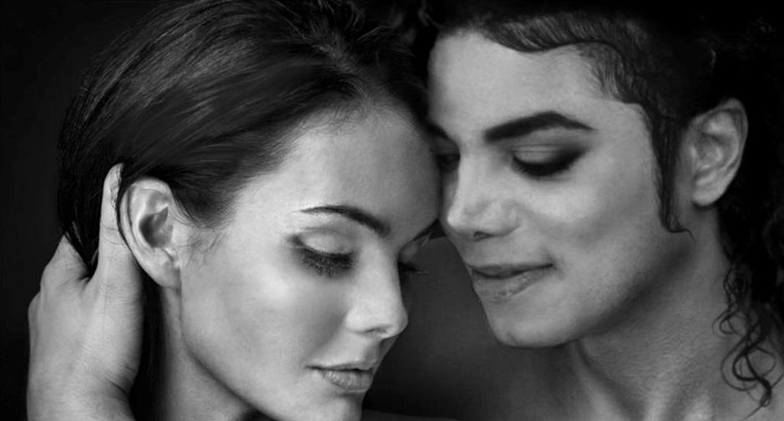
You took my hand and we kissed in the moonlight

I like the way how you holding me
I like the way you’re loving me
I like the way how you are touching me
I like the way how you’re kissing me
You’ll see

It won’t be long ‘till we make vows I bet you
I thank the heavens above that I met you

I was alone there was no love in my life
I was afraid of life and you came in time
You took my hand and we kissed in the moonlight

I like the way how you’re loving me
I like the way how you’re holding me
I like the way how you’re touching me
I like the way how you’re kissing me

The world’s a better place ‘cause you came in time
You took away the rain and brought the sunshine
I was afraid ‘cause I was hurt the last time

I like the way how you’re loving me
I like the way how you’re holding me
I like the way how you’re touching me
I like the way how you’re kissing me
You see.”

All I could do was fall to his feet crying. I grabbed onto his leg and felt his gentle touch on my head and he bent down and lifted me up. He wiped my tears and told me repeatedly he loved me more than anything. Just when I thought I couldn’t take anymore, he surprised me once again.

“Diana, marry me please?”

He had a ring in his hand. One that I had never seen before in my life.
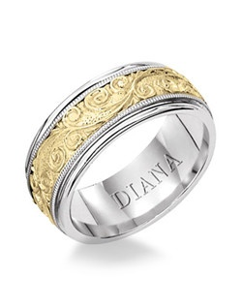

I was lost for words. My breathing felt like it had stopped. I froze in time as he sat me down on the bed and asked me again.

“YES, Michael. I’ll marry you. But I’m already wearing your ring.”

He removed the older one, placed it on my other hand and slipped the new one on my ring finger.

“Now everyone will know that you are REALLY taken.”
“It’s beautiful, thank you.”

I stood up to kiss him and started to cry tears of happiness again as I jumped into his arms.

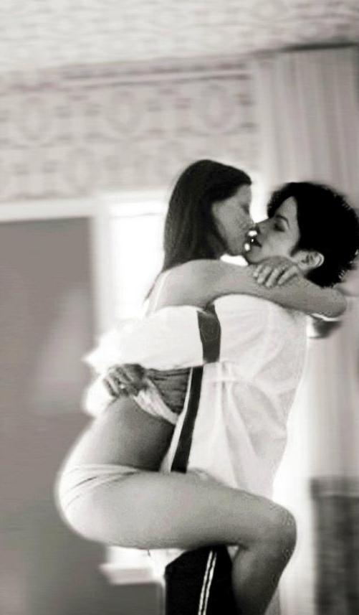
“I can’t believe this is really happening. I feel like I’m dreaming”
“I feel the same way.”
“If I could, I’d marry you right now.”
“Would you, really?”
“I wouldn’t think twice about it.”

He ran his hand through my hair and smiled at me.

“Why don’t you then, Diana?”
“What do you mean?”
“Let’s do it now.”
“WHAT? HOW?”
“I will call a minister.”
“HERE?”
“Why not? No one will find out.”
“Of course they will. Everyone knows you’re staying here tonight. There are probably reporters and all kinds of sleazy people creeping around trying to find out what you are doing.”
“Then why did you come here?”
“Because the media knows you’ve signed with my production company. According to the world, everything is strictly business between us.”
“Is that the only reason?”
“You’re doubting me now?”
“Of course not.”
“Why would you ask me that?”
“I was trying to get you to say it.”
“You’re playing my own game against me now?”
“Yes, for once.”
“In that case, NO that wasn’t the only reason I came here.”
“Why did you?”
“Because I love you.”
“I love you more, Diana.”
“Is that what you wanted to hear?”
“Yes. I hope I didn’t make you mad.”
“No, silly. I could never get mad at you.”

He then got down on his knees and sat in front of me running his beautiful hand down my face.

“Be my wife tonight, Diana.”
“Are you serious?”
“Yes.”
“You really want to get married now?”
“I do.”

He winked and smiled at me as he said those words. It was then that I knew he really was being serious.

“I do too, Michael.”
“Will you do it?”
“Do what?”
“DIANA!”
“MICHAEL!”
“Please, don’t do that to me again.”
“Do what to you?”
“Girl, you drive me crazy.”
“Do you love me?”
“More and more every day.”
“Do you want to get married?”
“Yes.”
“Then tell me that.”
He laid me on the bed and asked me to close my eyes. I did as I was told and I felt his presence up close.

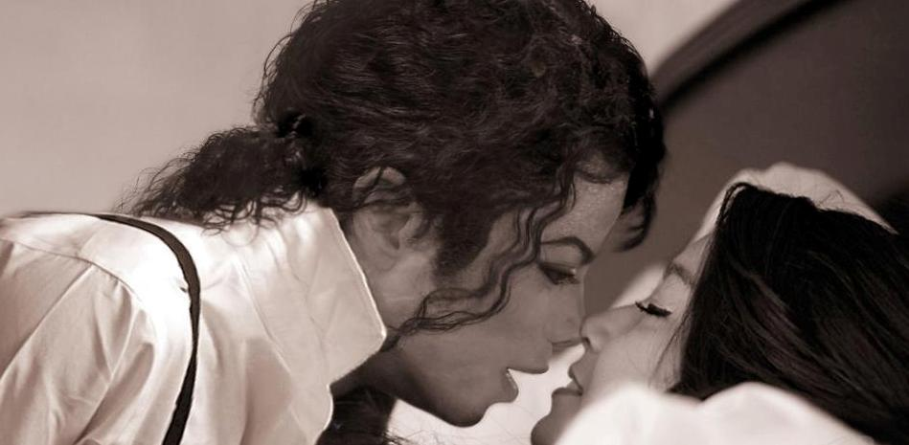

“Diana, I want to be your husband. Marry me tonight?”

I smiled as I opened my eyes.

“I will.”
“You’ll do it?”
“Yes.”
“Really?”
“Yes!”
“You’re sure?”
“YES!”
“Then tell me that.”
“I will marry you right now.”
“Who are you marrying?”
“YOU!”
“What’s my name?”
“Oh my god, you are insane.”
“What is it?”
“MICHAEL JACKSON!”

He jumped on top of me and started screaming in his high pitched voice. He kissed my entire face and said he was so overcome with happiness.

“I’m sorry I forgot that you—“
“It’s ok. You didn’t hit cupcake or space man.”
“I’ll go talk to my security. They will set everything up anonymously so no one will find out it’s for me.”
“Can I go with you?”
“Sure. If you want to.”

We both got dressed and headed for the suite door. As soon as Michael opened it, the one person we were not expecting stood directly in front of us….

