CHAPTER 15
Making Things Official before Takeoff

“What are you doing here?”
“What is SHE doing here?”

My heart was racing. I had no idea what was about to happen. Michael squeezed my hand and we both walked backwards as the person we weren’t expecting to see entered the room. He was pressing my hand so hard it was turning blue. I felt the agonizing fear and anxiety in his energy as he held onto me for support.

“Diana, go to the bedroom.”
“I won’t leave you.”
“Please, go.”
“I can’t leave your side.”
“Please, just GO. I’m serious.”
“He will hurt you.”
“I promise, he won’t.”

I couldn’t stop myself from crying. The thought of Michael being alone in a room with his father terrified me. I didn’t want what happened five years ago to happen again. I wasn’t trying to be stubborn, but also knew I should do what he asked and respect his wishes.

“Go. I’ll come and get you when I’m done.”
“He’s going to hurt you, I know he will.”
“He WON’T. I won’t let him this time.”
“I can’t lose you.”
He kissed my forehead and kept asking me to leave. I looked at Joseph and he gave me the most evil look I had ever seen in my life. His eyes were fierce and full of so much hatred and anger. I didn’t understand how a father could be one way and his son could be another. I let go of Michael’s hand, slowly made my way to the room and closed the door. I sat on the edge of the bed hoping nothing would escalate between the two of them.

*** MICHAEL’S POINT OF VIEW ***

“What do you want NOW, Joseph?”
“Why are you still hanging around her?”
“Because I want to. Why do you care?”
“She is BAD NEWS, boy. You don’t know how women work.”
“Actually, I do. I was married to one.”
“WAS being the key word.”
“Leave me alone, Joseph. I’m not a toy that you can play with whenever you want then throw away when something else comes along to pass your time with.”
“Out of my all kids, YOU always give me the most grief.”
“There must be a reason for that.”
“LEAVE THAT GIRL.”
“Or what?”
“I will destroy her.”
“How? By having her killed?”
“If I have to.”
“You will go through me first.”

Joseph comes closer to Michael cornering him into a wall as always.

“Don’t you see that girl is after your money?”
“She’s not like you, Joseph.”
“Boy, don’t you talk to me like that. You would be NOTHING if it weren’t for me.”
“Here we go again.”
“I didn’t come here to fight like a bunch of kids. I came here to tell you that she is not the one just like that other tramp you were with.”
“I don’t need your advice especially when it comes to my personal life.”
“Don’t you ever THINK boy?”
“Yes and I think you should leave.”

*** DIANA’S POINT OF VIEW ***

I sat on the bed shaking wondering if Michael was ok. I knew I wouldn’t be able to stay in the room much longer. The entire situation was making me nauseas and started to rattle me. I took a few deep breaths and tried to calm myself down but it wasn’t helping. Suddenly, I heard Joseph screaming.
“WHERE WAS SHE WHEN YOU WERE FACING CHARGES IN COURT? WHERE WAS SHE WHEN YOU WERE GOING THROUGH YOUR DIVORCE? WHERE WAS SHE WHEN YOU WERE CRAWLING AROUND THE FLOOR HIGH AS A KITE ON DRUGS LIKE SOME CRAZY DOG TRYING TO FORGET ABOUT WHAT WAS HAPPENING TO YOU?”

I couldn’t stand it anymore. I opened the bedroom door as quietly as possible and stood at the far end of the hallway hoping they wouldn’t see me. I heard Michael laugh which infuriated Joseph even more.

“YOU THINK THIS IS FUNNY, BOY?”
“You have no idea how hypocritical you sound right now.”
“What the hell are you talking about?”
“You asked me where was she during the worst time of my life…”
“Why don’t you find out the answers before you put yourself in financial ruin over some whore who just wants to take your money and run?”
I saw Michael push his own father slightly away from him and walked away from the wall he was cornered into.

“Don’t you EVER call her that again.”
“You think you’re so tough.”
“I KNOW I AM, Joseph. SHE was the one who got me through my days in court. WHERE THE HELL WHERE YOU? SHE was the reason I got divorced in the first place. I wanted to be WITH HER. WHERE THE HELL WHERE YOU WHEN I SIGNED MY DIVORCE PAPERS? When I was medicating myself to forget about her, WHERE THE HELL WHERE YOU? Why didn’t YOU comfort me? Why did I have to resort to a bottle full of pills every night when YOU COULD HAVE BEEN THERE FOR ME LIKE A REAL FATHER SHOULD HAVE BEEN?!”

I didn’t like the way he was treating him. I understood his anger but didn’t want Michael to treat the man who helped bring him into this world with such rudeness. I ran over to him and held him from behind.

“Baby, please don’t talk to him that way.”
“Go back in the room.”
“No, I won’t let you disrespect him like that.”
“He doesn’t care.”
“I DO!”

“I don’t need you to stand up for me, little girl. I can handle my kids myself.”
“Sir, I don’t know why you see so much negativity in me. I would never say or do anything bad to anyone in your family.”
“Save the speech. I’ve heard it all before. I warned you to stay away from him and you didn’t listen.”
“I told you, I love Michael more than anything. He’s all I have in this world. I don’t have parents and I don’t need his money. I have my own. You’ve seen my business and how it operates. I don’t need someone else’s assets to make me feel complete. I’m not insecure about anything and if you would just take the time to get to know me—“
“SHUT THE HELL UP!”

Joseph yelled so loud he petrified me. I felt my stomach turn as his piercing scream echoed in my ear. Michael was furious. He dragged me into the room by my arm and slammed the door shut telling Joseph he wanted him gone by the time he returned to the living room.

“STAY IN HERE, DIANA.”
“Michael, please let me stand by you.”
“I don’t want you or my child around him.”
“I know that. I’m just trying to reason with him.”
“Don’t waste your time or energy. He doesn’t care. He never has and he never will.”
“I’m not giving up. I promised your mother I’d give him a chance.”
“My mother put up with him because she was afraid of being alone with 9 children. She was cowardly for thinking she couldn’t survive without him.”
“Michael, don’t say that about her. You weren’t in her position back then.”
“Stay here, please.”
“Baby, you’re not listening to me.”
“I’ve heard enough.”
“You are SO stubborn!”
“I’m my father’s son.”

Hearing his harsh tone made me feel incredibly sad. I had to cry and let my emotions out. I wasn’t trying to seek his attention but wanted him to know and see how badly his feelings towards his father were affecting me. He came over to me and held me on the bed.

“I wasn’t raised the way you were. I know he wasn’t the best father to you but speaking as an orphan a child only has one father and one mother. And Michael once they are gone, they are GONE. You can’t get them back. Trust me, it’s not worth it for you to hold onto your anger anymore. Please just let it go.”

I knew he was listening. I could feel his embrace becoming tighter and tighter. His heart was beating faster than the speed of light. It seemed like I was actually getting through to him.

“I know you don’t understand things about him and you’re confused, scared and really mad. All I’m saying is he’s your father. He is part of the reason why you are here and why we are here. If you can find some contentment in that I know it will make you feel better. And if that isn’t for you, come to me and cry on my shoulder. That’s what it’s there for. I will be your shield as much as you will be mine.”
“You are so wonderful to me, girl.”

I grabbed his arm and put his hand on my stomach.
“You also have a chance to be the father you never had with cupcake.”
“Or space man.”
“Exactly. You have to show him or her that they are special to you. It will be like a second chance for you to re-create that childhood magic you never had. I know ‘it’ will have a wonderful time exploring things with you, especially in a fun filled place like Neverland.”
“Diana, you are the greatest woman in the world.”
“I’m just me, Michael.”
“I love you.”
“I love you too.”
He kissed me then realized Joseph could still be in the living room. He ran back to the living room and noticed the front door was open. His guard told him Joseph had left and wanted to make sure we were ok. Michael told him we were and that Joseph was never allowed to see either of us again and if he was to come back to not let him in. I had no reason to worry since Michael and I were leaving for Europe anyway. After dealing with so much drama, my sickness returned.

“Oh my god. It’s back.”
“What is?”
I ran to the bathroom and threw up again. It came so suddenly that I couldn’t even stand up. I sat on the bathroom floor with my feet curled up and my head against the wall. Michael was so worried, he knocked on the door begging me to let him in.

“It’s open, baby.”

He came in and sat on the floor next to me pulling me towards him so he could cradle me like a baby. I always loved his affection towards me and never wanted it to end.

“What happened to my sweet girl?”
“I got sick. I get like that once in a while.”
“Is it like morning sickness?”
“Same type of thing, yes. But it happens throughout the day.”
“Now I’m going to be thinking about you even more tomorrow.”
“I’ll be fine. I might get motion sickness on the plane though.”
“I get that as well.”
“Really?”
“Every single time. I struggle so much with flying. I get very sick and really fatigued.”
“I wish we weren’t taking separate flights. I really need you.”
“I need you too. We should be together.”
“I know we can’t travel together going there but maybe on the way back we can work something out.”
“I’ll see what I can do when the time comes ok?”
“Thank you, baby.”
I suddenly remembered where we were and felt awkward about it.

“I think we should leave the bathroom now.”

We both laughed as he helped me up and carried me to the bedroom.

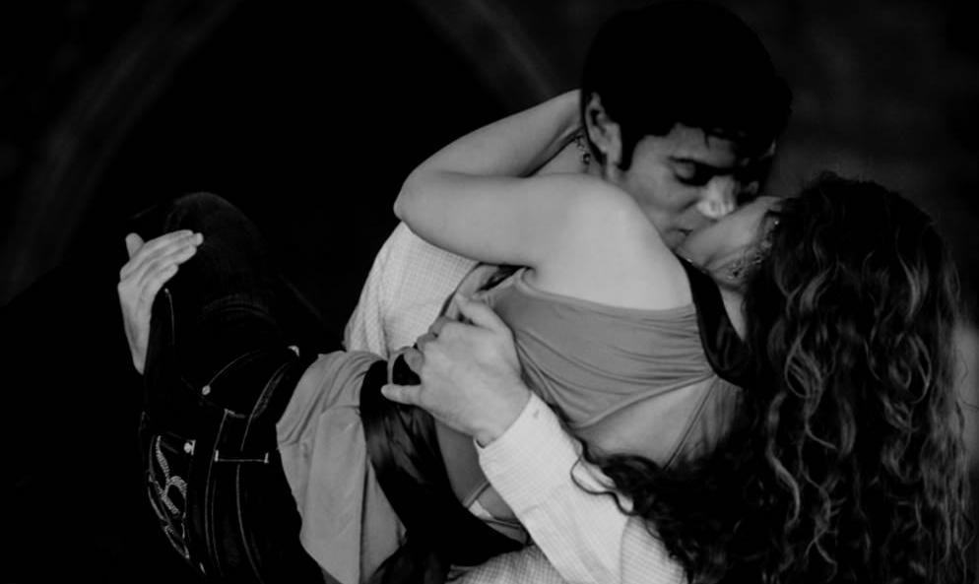

“You really ARE a king, Michael.”
“You think so?”
“I KNOW so!”
“That makes you my queen.”
“Queen Diana Jackson. I like the sound of that.”
“It has a nice ring to it.”
“Indeed.”

We both lay in bed together and Michael put his hand against my stomach being careful not to hit me. I put my hand on top of his and we held each other with our free hands and looked into each other’s eyes for the longest time. It was mind blowing to know our silence towards each other was so loud that we always knew exactly what the other person was thinking. In Michael’s eyes, I could see love, passion, awareness and intelligence. He told me he saw fear, confusion, shock, sincerity and comfort in mine. He then grabbed my leg and placed it on top of his. I knew that was his way of telling me to come closer to him. Our faces were touching and I stroked his beautiful hair making him blush adorably.

“I love how you still react that way every time I touch your hair.”
“What way is that?”
“The same way you did when we first met.”
“I always think about that day.”
“So do I.”
“Do you regret it?”
“The only regret I have is not meeting you sooner.”
“Really?”
“But I do feel like I don’t deserve you sometimes.”
“Because you weren’t a fan?”
“That and also because I used to think you were strange.”
“In what way?”
“In EVERY way. I never thought of you as a normal person. I have no idea why. I guess because Marie was always so fascinated by you. She would always tell me things about you that she saw or heard or liked and it drove me crazy.”
“I think you appreciate me on a different level.”
“Compared to your fans?”
“Yes. You didn’t like anything about me but something captured your heart and mine.”
“You are so right and I have NO IDEA what that was.”
“I have an idea…”
He took my hand and tried to put it somewhere specific.

“Boy, don’t you start that again!”
“Please?”
“We can’t!”
“Why?”
“Um, cupcake baking in the oven?”
“We don’t have to go that far.”
“But we both know we won’t stop until it does.”
“Diana, if it happens, it happens remember?”
“Do you always remember everything I say?”
“I try, but it’s not easy.”
“Because you have so much on your mind?”
“Because you ALWAYS give me something new about you to remember.”

His words were so loving. He kept on putting his ear to my stomach saying the most adorable things to the baby. I felt like he was more happy to be a parent then I was.

“Can you imagine if the baby is born in Europe?”
“Don’t even joke about that. I’m hoping I don’t go into premature labor.”
“I’ll be there if you do.”
“I know but that’s not a good thing. I’m going to try and be as stress free as possible. But working with someone like you is really going to be a challenge for me. I’m going to need all the help I can get.”
“Me and the girls will make sure you are ok every step of the way.”
“I know and thank you.”
“He or she will start dancing as soon as they hear me on stage.”
“You think so?”
“Of course. It’s a Jackson thing. We can never be still whenever a beat comes on.”
Just then, a funny but adorable thought came to mind.

“Michael, if we have a girl I will name her.”
“Too late, I already did.”
“We are NOT naming her cupcake!”
“WHY NOT?”
“MICHAEL, ARE YOU SERIOUS?”
“It doesn’t have to be her first name.”
“It won’t be ANY name!”
“Ok fine, what name were you thinking about?”
“Promise you won’t laugh?”
“I won’t.”
“You’ll keep an open mind?”
“Of course.”
“Billie Jean.”
“OH, HELL NO!”
“WHY?”
“I am NOT naming my child after a song.”
“Michael, it’s YOUR SONG!”
“I know that, Diana.”
“Please?!”
“FORGET IT!”
“You’d rather have cupcake?”
He placed himself on top of me and put his hand underneath my dress.

“I most certainly would.”
“OH MY GOD, YOU ARE SO BAD!”
“I need it, girl.”
“NO!”
“Please?”
“Will she be Billie Jean?”
“Diana! That’s not fair.”
“Will she?”
“The kid is not my son.”
“ HA HA VERY FUNNY AND IN THIS CASE YES, IT IS!”
“Not with that name it isn’t.”
Having him on top of me made me feel sensual. I took his lovely hand and slid it right inside of me, pushing it past my undergarment and inserting his fingers deeper as they made their way around my slippery walls.

“What will her name be, Michael?”
“Cupcake!”
I took my free hand and slipped it underneath his pants and rubbed his glands repeatedly feeling the chills that ran down his entire body. I knew he was feeling incredibly sedated and wanted more.

“What will it be?”
“Space man!”

I pushed his hand further into me making him gasp directly into my ear. I felt his hair cling to me as his face was pressed up against mine. He whispered my name over and over again asking me to go further. I wanted to make sure he knew who was in control.

I played with his anatomy rubbing it up and down hearing his shriek go higher and higher. His voice was so appealing. I wanted to hear him all night long. The sounds and noises coming out of his precious mouth gave me just as much satisfaction as his body. Michael was truly a full package filled with many hidden gifts. I wanted him so badly that I could no longer resist his strong aura of lust. I knew I just had to have him.

We switched positions and our hands pulled out of each other’s body. Without giving it a second thought, the rest of our clothing came off and fell onto the floor. I knew what I was about to do may not have been the best thing, but it was what we both needed and I wanted to remind Michael of the fact that I loved him more than anything and would gladly put my own life at risk just to see him smile and be happy from the heart.

“I don’t think we should—“
“SHH! HUSH, BOY.”
“I love when you take control over me.”
“I’m a bad girl, Michael.”
“Really?”
“Yes, I’m bad just like you.”
“Will you show me that you are?”
“Would you like that?”

Without answering, he sat up and placed me on top of him. I could feel his skin against mine as the most intimate parts of our bodies were touching each other. The next thing I knew, Michael raised himself into me and we were making love with me sitting directly on him. The feel of sitting enticed me to the point where I could no longer remember my own name. He held onto me like a gentleman making sure I wouldn’t fall or hurt myself in any way.

After a while, he was concerned about me feeling too much pressure and laid me on the bed.

“Just relax.” He whispered in my ear as he rubbed my body from one side to another. His feel of touch was inflaming me with craze. I had no idea what he was going to do to me but what I did know was that I was more than ready to enjoy it. He pressed his body against my back and slipped himself into my backside. I shuddered at the first sensation of his impact and he continued going deeper. I grabbed onto the sheets and bellowed as he dominated me. There wasn’t a part of my body that his lips did not fall upon. His hands quickly followed making me believe they were infused on me.

“You feel so good, baby.” I said as he continued.

He gently turned me over and finished inside of me. Neither one of us knew how many times it had happened nor did we care to. I was so gratified by his love that I didn’t want him to leave me on the bed alone. He held me close to him and seized me in his arms not wanting to let go. I looked at the time and realized it was already past midnight. Just like in a fairy tale story, the clock was ticking and my time with the prince was about to run out.

“Michael, it’s time for me to go.”
“Don’t leave me please.”
“I don’t want to but I have to.”
“I can’t do this.”
“Do what?”
“I don’t see you for so long then when I do, this happens and then we separate again.”
“I’m sorry. But it won’t be like this forever.”
“Stay with me until I fall asleep?”
“Michael, I can’t do that. Your guards will get angry.”
“They won’t say anything. Please?”
“I don’t know if I should. You have to rest and I feel like the longer I stay, the more distracted you will be.”
“Diana, I can sleep on the plane. It’s a 12 hour flight.”
“I know that but you need to be fully prepared for the fans and media at the airport too.”
“I won’t force you to stay. But I’d really love it if you did.”
“Now how am I supposed to say no after you just said that?”
“You’re not, that’s the point.”
“You are so delightful, baby.”
“So are you, cupcake.”
“I love that name.”
“I love it too.”
“Now close your eyes and try to sleep.”
I suddenly remembered he had to take medication before bed. I asked him about it and he said he already did which made me feel relieved. I was glad that he was starting to take care of himself without me having to remind him. Watching him sleep put me in a sense of tranquility. I stroked his hair gently and saw him smile. I kissed his ear and wished him goodnight as he took my hand in his and placed it under his cheek on the pillow. I figured that was his way of telling me not to leave yet.

I lay next to him for a while and eventually noticed he was falling asleep. I removed my hand from underneath him and slowly tried to get up. As soon as I did, he woke up again asking me not to leave.

“I have to. It’s two in the morning now.”
“I almost fell asleep just before you got up. I know I will get there soon. Please stay.”
“Ok, but if you don’t fall asleep soon I will leave.”
“Goodnight, Liberian girl.”
“Goodnight, baby.”

I sat up on the bed and watched him again. I noticed he seemed troubled. I pulled his hair away from his face and placed the blanket closely on him making him feel more comfortable. I heard a loud noise coming from the living room so I went to see what it could be. Rain was falling on the windows and patio doors. The stars were shining brightly and the rippled water falling onto the panes were incredibly beautiful to look at. I could hear thunder and quick strikes of lightning. I went to the window and wrote the first thing that came to my mind:

I went to the patio and stood on the balcony feeling the rain as it dripped onto my skin. I stood there with my eyes closed thinking how wonderful it would be if Michael came and joined me. Seconds later, I felt a touch on my back. He kissed the side of my face and turned me around. We then started to dance in the rain together like a couple in love in a movie.

Being with him made me forget about reality. Michael and I had our own world that we never escaped from once we were together. I loved it and so did he.

When the thunder hit, Michael felt scared and held onto me like a child.

“What’s wrong?”
“I’m terrified of thunderstorms.”
“Are you really?”
“Yes, ever since I was a child.”
“I know what will help you.”

I pulled him towards me and held him close right there in the rain storm. He was so appreciative of my affection he asked me to continue holding him and not let go. Feeling his embrace in the rain was beyond words. I never wanted anything to come between us and I knew I would fight the world to stay with him if I had to.

Michael was my friend, my love, my soul mate, and soon to be husband and father of my child. There was nothing else that I could have possibly asked for.

“You are so the one for me.”
“Am I?”
“Definitely.”

He took my hand and walked me back to the patio door. As we went inside to change and dry off, and idea came to my mind:

“Michael, can you describe me using just one word?”
“Of course I can.”
“What is it?”
He glanced at the window behind me.

“Come here.”

He walked towards it and started to write something. I smiled brightly when I read it and couldn’t help but kiss his gorgeous, wet lips.

“Why are you so wonderful to me?”
“Because you saved me.”
“From?”
“Everything, Diana. This world, this crazy life, my loneliness, my despair. Everything.”
“I didn’t even know I did all that for you.”
“That and so much more.”

As we kissed each other, he picked me up in his arms again and caressed me against him. It seemed like our love for each other was growing by the second. I suddenly saw a ray of light appear on the back of Michael’s shirt. I looked outside the window and noticed the sun was starting to rise.

“OH MY GOD! MICHAEL, IT’S 5AM!”
“IT IS?”
“I have to go NOW.”
“I have to rehearse in an hour.”
“WHAT?”
“My flight’s at 10. I leave here at 8 and I need to get one more rehearsal in.”
“You haven’t even slept yet.”
“I know, I can’t now.”
“MICHAEL! You have to sleep!”
“I will on the plane.”
“I will not let you do that to yourself anymore.”
“Diana, I’ll be fine. I promise.”
“You’ve barely had any rest.”
“You helped me though.”
“How?”
“You massaged me, you laid next to me, I fell asleep for a little while. I’m restored now.”
“Are you sure?”
“Yes, I can do it. I’ll get plenty of sleep on the plane.”
“Will you dream of me?”
“I always do.”
“Will you call me before you leave for the airport?”
“I’ll try my best. If I don’t it means I ran out of time.”
“I understand.”
“But I’ll call you as soon as I land in Germany.”
“I’ll see you there in two days.”
“I know. I can’t wait.”
“Me too. I wish you a safe and great flight.”
“I had so much fun with you.”
“Me too. I enjoyed dancing in the rain.”
“I’ve never done that before.”
“Me neither. Maybe we can do it again.”
“I’d love to.”

We held each other for the last time and didn’t want to let each other go again. Michael became so emotional and refused to let me leave.

“I can’t do this.”
“I will see you again soon.”
“I will worry about you two on the plane.”
“We’ll be fine. Space man is a strong boy. He’ll protect his mommy.”
“And cupcake?”
“She’s too sweet to ever put me in any danger.”
“Maybe one day she will let me lick her mother’s icing.”
“I’M LEAVING NOW!”

He kissed my lips repeatedly saying me he loved me in between each one. It felt like Michael wasn’t leaving to go on tour but off to war. I tickled him quickly one last time just to hear his beautiful laughter, ran my fingers through his hair and he watched me from the door as I made my way to the elevator. I looked over at him and saw he was wiping tears from his eyes.

“Michael?”
“Yes?”
“I like the way you love me.”
I winked at him as I entered the elevator. His smile was the last thing I saw before the doors closed. As I walked to my car, I noticed the sun had completely come up and I headed home to change and catch up on my sleep.

*** A FEW HOURS LATER ***

“Ana, wake up!”
“You’re here AGAIN, Jas?”
“Why the heck are you sleeping so much?”
“Two reasons, Jas. I’m pregnant and I was up all night with Michael.”
“REALLY?”
“Don’t get any ideas.”
“Did you do it?”
“WHY DO YOU ALWAYS ASK ME THAT?”
“Because I need to know these things!”
“You are so nosy.”
“Did you?”
“Maybe.”
“OH MY GOD! So did you tell him?”
“Yes and he’s fine with it.”
“HE IS?”
“Yeah, thankfully.”
“And he’s ok with the tour still going on?”
“Yes, everything is ok.”
“Thank goodness. I was worried all day. Anyway, come downstairs. He’s about to board the plane.”
“WHAT?”

I looked at the time and it was almost ten.

“DAMN! I missed him again. Jas, did he call the office?”
“No, why?”
“I guess he wasn’t able to. I asked him to call before he left the hotel but he said he might not get the chance.”
“I’m sure he will when he lands.”
“That’s what he said.”
“Hurry up and come downstairs. Marie is waiting too.”
“I’ll be right there.”

I quickly got dressed and met the girls in the living room. Every channel was showing thousands of fans at the airport. The aniticpation was unbearable. I couldn’t contain myself as I waited to see him. I needed to make sure he arrived and boarded his plane safely for my own peace of mind.

“LOOK, THERE HE IS! HE MADE IT!” The girls said jumping up and down.
“GIRLS! He’s going to Germany. He’s not on some game show about to win a prize!”
“We’re so happy for him.”
“I know, I am too.”
“Doesn’t he make you feel excited?”
“In more ways then one.”
“PLEASE DO TELL!”
“Shutup, Jas.”
“SHH!! I’m trying to watch!”

We watched the news as they annouced Michael had arrived at the LAX airport and was just minutes from boarding. We saw him get out of his town car and just as he did, my stomach muscles were turning. It seemed like the baby was kicking me as if it recognized who was on the screen. I put my hand on my stomach and laughed to myself.

“Ana, are you ok?”
“Yeah, it’s moving.”
“I told Marie this morning.”
“I’m happy for you two.”
“Thank you. I hope you’re not upset.”
“Not at all. I’m thankful that I got to meet him, hug him, get so many gifts, kiss him and now go on tour with him. I’m set for life.”
“She’s set for a million lifetimes now.”
“Jas, you’re not being nice.”
“I love picking on her. She knows it’s harmless.”
We continued watching him and heard so many people scream and holler for him making me feel even more happy for him. I knew he loved the attention, especially now that he was going to bring his amazing talent back on stage and share it with the world overseas.

“OH MY GOD, HE LOOKS SOOOO GORGEOUS!”
“He does, indeed.”
“Meh, he’s ok.”
“DIANA!!”
“I’m kidding. He looks stunning as always.”

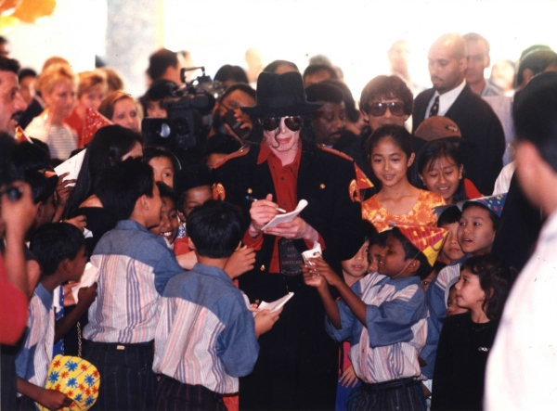

The news showed full coverage of him leaving.

“I wish we could have been there to see him.”
“We’ll see him in two days, Marie.”
“I know, but it’s not the same. I wish we were all going together.”
“That’s what I said too. But Kingdom didn’t allow it.”
“I understand that. I mean they are trying to protect him.”
“We talked about that yesterday. Maybe on the way back we’ll be able to fly together.”
“REALLY?”
“We’ll see what he can do. I’ll definitely be showing by then and pretty much half way through. He doesn’t want me travelling without him.”
“He must’ve hit the roof when you told him.”
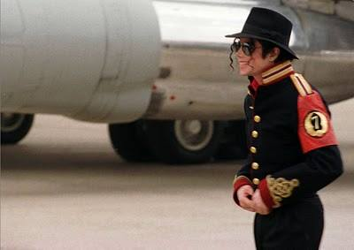
“He did at first but I charmed him into forgetting about it.”
“I don’t want to know.”
“I SURE DO!”
“Be quiet, Jas.”

We saw Michael walking along the runway towards his plane. My heart trembled and tears were rolling down my face as I saw him about to leave the city and soar through the sky. The girls noticed and both hugged me.

“My baby is leaving.”
“You’ll see him again in two sleeps.”
“I know. We had a really special night. I didn’t get home until 5 this morning. We were so swept away by each other. I swear it was so magical.”
“That’s so romantic.”

Just before he boarded, a news reporter interviewed Michael briefly.

“TURN IT UP! HE’S ABOUT TO SAY SOMETHING!”

“I miss my three girls very much. Especially one in particular. I hope she sees this and looks after space man or cupcake for me. At least, until I can orbit there again.”

“OH MY GOD! HE DID NOT SAY THAT ON TV!”
“What the heck is he talking about?”
“Nothing, it’s an inside joke. I am SO going to let him have it!”
“Um, I think you already did that.”
“SHUT UP! That’s not what I mean. I can’t believe him!”
“Why is he so obessed with space and orbiting?”
“Marie, please feel free to ask him when we see him again. I’d love to know his response.”

After saying goodbye to his fans and the rest of this side of the world, Michael boarded and the plane door closed. As I watched him take off into the sky, I closed my eyes and prayed that he would fall asleep. Since the girls and I were finished with work, the two of them spent the afternoon with me.

“Marie, we can tell her now.”
“Tell me what?”
“Michael asked us to spend the night with you to make sure you’d be ok.”
“When did you two talk to him?”
“This morning. He told us to wait until he boarded the plane to tell you.”
“Even when he’s in distress all he does is think of me.”
“What do you mean?”
“He didn’t sleep at all. When I left he said he had to rehearse then get ready to leave.”
“He’s so sweet.”
“I know, Marie but that worries me. I don’t want him running on empty anymore.”
“I’m sure he will rest now. What else will he do for the next 12 hours?”
“True. I hope he eats too.”
“You two worry so much about each other, it’s cute.”
“I guess we just want to make sure we are both okay when we’re not together.”

*** AN HOUR LATER ***

The girls and I made our own pizzas, popcorn and sundaes. I was so afraid of gaining weight all I could eat was the popcorn.

“Ana, you can’t starve yourself. You’re eating for two now.”
“I know but I don’t want to get fat.”
“You will NOT GET FAT, NOW EAT!”

I had the smallest piece of pizza and ate more popcorn. We started watching a movie on pay per view when the doorbell rang. I got up to answer it and a postman was standing at the door step.

“Miss Dean?”
“Yes?”
“I have a registered letter for you. I need you to sign it and give it back to me.”
“What is it?”
“It’s addressed to you as strictly confidential. I’m not aware of its contents.”

He handed me a large brown envelope with my name on the front. I opened it and saw a faded brown document with a gold seal.

I gasped as I read the title of it:

Then screamed from shock when my eyes saw whose name was at the bottom making it official.

