CHAPTER 18
The Calm after the Storm

The look on Michael’s face was priceless. I couldn’t take my eyes off him as he glared at my signature. I could tell he was happy but also completely appalled.

“Michael, are you ok?”
He didn’t say a word as he took the document from my hand. His eyes filled as he touched my name. I didn’t know what to say or do so I stayed quiet allowing him time to absorb what he was feeling.

“I’m…I’m...shocked.”
“Is that a good thing?”
“I can’t believe you signed this.”
“Why wouldn’t I?”
“You told me you didn’t want to.”
“I’m full of surprises.”
“What made you change your mind?”
“You did.”
“I hope you don’t regret this one day.”
“Will you ever give me a reason to?”
“NEVER, Diana. At least not on purpose.”
“Michael, you didn’t just talk me into this. I did it on my own. It’s what I want to do.”
“I love you, girl.”
“I love you too, Moonwalker.”
He wrapped his arms around me and let out his tears. I held him close and whispered in his ear that he was the only one for me and there was no way I would let him get away. His body was still shaking. He was very unstable from what happened to him.

“Baby, you feel really cold.”
“I’m out of shape, Diana.”
“Meaning?”
“I haven’t eaten or slept in two days. All I’ve been doing is thinking of you and rehearsing like crazy.”
I pulled him in front of me and felt his forehead. Sure enough, Michael appeared to be pale and his body temperature was dropping significantly by the minute.

“I think you’re dehydrated and overly exhausted again. You have to eat and rest.”
“I will now that you’re here. Stay with me tonight.”
“That’s why I came here, silly.”
The girls knocked on the door and came in the room. Michael saw them and gave them both a hug. I told the girls I’d stay with him and that everything was ok. Jasmine saw Michael’s condition and almost screamed at how ill he looked. I told her not to worry and that I would take care of him.

“Chris told us we could stay here at the hotel. We’d really love to stay close to you two if that’s ok. We’ll both be in Michael’s suite across the hall.”
“I don’t want anyone staying there.” He said with a crack in his voice.
“The chambermaid was just in there. Chris called room service and told them to change the sheets and make everything brand new for us. There’s no trace of…well you know.”
Michael was still hesitant to allow the girls to sleep there for their safety as well as his own. I assured him they would be fine and after much pleading, he finally gave in. I wanted to make everyone happy and lift the tension away with some joy so I asked Michael and the girls to sit on the couch next to me. Michael sat on the couch closest to the window since he wanted to have some air on him to help cool him down.

“We have something important to share with you both.”
Michael smiled and looked down as he sat on the couch across from everyone and giggled to himself. I extended my hand to him and he lovingly took it and stood next to me holding me gently from behind.

“Michael sent me something before we left LA. I wasn’t sure if I wanted to go through with it at first but after giving it some serious thought, I feel I have made the right decision.”

I showed the girls our marriage certificate and they both jumped up and grabbed us both in their arms.

“ANA, YOU SIGNED IT! YOU SIGNED IT! YOU SIGNED IT!” Jasmine screamed.
“Yes, Jas. I did.”
“OH MY GOD! YOU TWO ARE MARRIED NOW?!” Marie asked.
“Technically, yes.” Michael explained. “This is just the first step. We still have to do all of the formalities. But now that this is signed by both of us it will go into a legal registry. If we decide we don’t want to go through with it, we can withdraw this and get it annulled. That’s why I took this step first. I had to make sure Diana didn’t have second thoughts about being with me.”
“That’s NEVER going to happen!” Jasmine said.
“No it’s not! I’ll make sure of it.”

The girls squeezed us with so much force Michael and I couldn’t breathe. They were happy but also knew they had to keep quiet about it. We all heard sniffling noises then looked across the room and saw Chris standing near the door. Michael went over to him and they shared a hug. The three of us had tears in our eyes and Chris told him he had never been happier for him.

“I’m glad your wish finally came true, sir.”
“It was your wish too. I knew you were always praying for her to come back.”
“I just wanted you to be happy again.”
“Thank you.”

“OH MY GOD! This is so amazing!” Jasmine said jumping up and down.
“We have SO much planning to do! LOTS and LOTS of planning!”
“Marie, we have to book our hair and nail appointments NOW and go dress shopping and oh my god the cake and flowers.”
“Not to mention the first song to their slow dance. I need to lose ten pounds too!”
“GIRLS! It’s not happening anytime soon. We still have to go on with the tour. NO ONE can know about this.”
“So THAT’S where you got the other ring from!” Marie said touching my finger.
“He gave it to me the other night.”
“It’s beautiful.”

I gave the document to Michael and he said he had the perfect place to keep it. The suite had a built in safe somewhere that no one knew about. Michael was the only one who did and didn’t tell anyone, not even me to make sure it stayed safe. He went to put it away and Chris left to help the hotel staff move Michael’s belongings into his suite and Chris and the girls would stay in the other suites across the hall.

“Ana, you need to tell him about the baby.” Jasmine whispered.
“I know but I don’t know if he’ll be able to handle it.”
“We’ll be right here with you.” Marie said.
“I don’t think he’ll want you two to see him break down again.”
“We’ll play it by ear.” Jasmine said. “If we notice him getting angry or upset, we’ll leave.”
“That might work.”

Michael returned and told us he wanted to change and look presentable. We told him it wasn’t necessary but as always, he always wanted to look and feel his best. While he was doing that, the girls and I had a long talk.

“Ana, I think he should know right away.”
“I don’t think it’s a good idea.”
“You know, I really hate my name now.”
“Why?”
“That’s HER name too. I bet he hates me now.”
“MARIE! Michael could NEVER hate you!”
“He won’t ever call me that now because of what she did to him.”
“You are being ridiculous. Besides, that’s not her ONLY name.”
“She’s right, Marie. Don’t worry about it. He doesn’t see things or judge that way.”
“Now, getting back on topic. He hasn’t slept in two days. If I tell him now, he won’t sleep at all. It’s been a rough few days for everyone. Maybe I should wait until tomorrow?”
“The longer you put it off, the harder it’s going to be. Besides, he might get angry at you for not saying anything sooner. Especially since you signed the certificate.”
“Jas, you know you’re always right.”
“Of course. I’m the wise one of the group.”
“What am I?” Marie asked.
“The crazy, obsessed fan!”
“GREAT! I’ll take it.”
She made me laugh as I tried to find the strength to tell Michael. I sighed deeply not knowing what his reaction would be like. He already had so much on his mind. Adding this to it seemed like the wrong thing to do.

“I wonder what’s going to happen to her now.”
“Who cares about that bitch?!”
“SHH! Michael might hear us.”
“I don’t care. She should go to jail.”
“Knowing her, she’ll make it seem like Michael did it and of course, the world will take her side.”
“If it ever goes to the media, I will defend him till the end.”
“So will I.”

“You girls are the reason why I love what I do.” Michael said as he came out of the room wearing black and red. They both went over to him and expressed their undying love and concern for him as he smiled and felt so much better being in our company.

“You look amazing, baby.”

He came and sat close to me on the couch placing my hand in his.

“How are you feeling?”
“I’m ok. The flight was so incredibly long. Do you feel alright?”
“Yes, now that you’re here with me.”
“I mean, don’t you think you should see a doctor?”
“I don’t need to. Whatever she gave me must’ve lost its effect by now.”
“Please let me know if you feel sick?”
“Of course. I’m so happy you all made it here safely. Did you meet Dr. Klein?”
“Yes and he was very helpful.”
“I’m glad he took care of you when I couldn’t.”
“Why are you so thoughtful?”
“Ask my heart. It always takes action over my brain when it comes to you.”
“Speaking of action…”
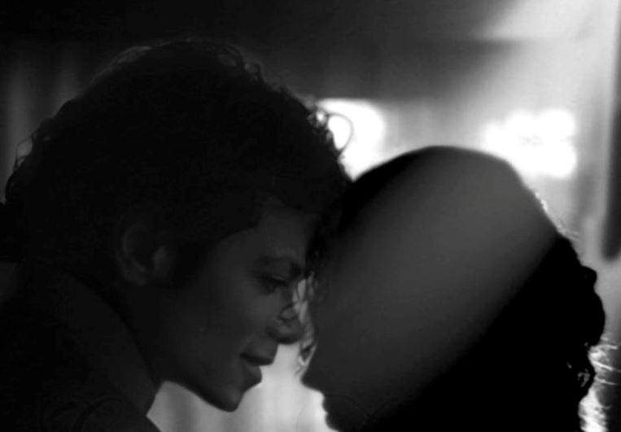
He giggled and buried his head on my shoulder.

“AHEM! We’re still in the room you know!” Marie said.
“I don’t mind watching!!” Jasmine said.
Michael laughed as we sat up straight.

“On a serious note, Michael there is something else I need to tell you.”
The entire room became silent. I put my head down in agony wondering how to come up with the right words to tell him the heartbreaking news. The girls came to my side and put their hands on my shoulders.

“It’s ok, Ana. We’re here with you. Tell him.”
“I can’t do this!” I said with tears rolling down my face.
“What’s wrong?” He asked wiping my tears away.
“He’s going to break down, I just know he is!”

Michael knew at that moment it had to do with the baby. He let go of my hand and put it on my stomach as a way of telling me he knew something wasn’t right and what it was about.

“Diana…”

We both looked in each other’s eyes. I put my hand on top of his and he just knew from my silence that he was no longer going to become a father. He immediately stood up and started to shout as loud as he could.
“I KNEW YOU SHOULD HAVE COME WITH ME! WHY DIDN’T YOU? WHY DIDN’T YOU FLY WITH ME? I KNEW SOMETHING WOULD HAPPEN TO YOU! I ALWAYS LOSE SOMETHING WHEN YOU AREN’T NEAR ME! WHY DIDN’T YOU LISTEN TO ME? WHY?”

“Michael, please calm down. You will make yourself sick.” Jasmine said as she went over to him and gently touched his back.
“I’M ALREADY SICK!”
“Please, just sit down with her. It’s really not what it seems like.”
“I can’t deal with this now. I need to be alone.”
“Michael, we’re all here for you.”
“I need to rehearse.”
“You need to rest, Michael.” Marie said.
“No, I don’t. I need to be alone.”
“Michael, you don’t understand—“
“GET OUT!”

Hearing him angry made the girls upset. Marie cried as she made her way to the door. Jasmine was so lost for words all she wanted to do was be as far away from him as possible. As the girls helped me up from the couch, Michael grabbed my arm.
“YOU STAY HERE!” He shouted.

“Ana, we’ll be across the hall if you need us.” Marie said as she and Jasmine opened the door and left. Michael put me back on the couch and sat down next to me. I could tell he was furious and wanted to know exactly what happened.

“What did you do?”
“I didn’t do anything.”
“Did you get rid of it?”
“HOW CAN YOU ASK ME THAT?”
“Did you?”
“OF COURSE NOT!”
“Then how did it happen?”
“NOTHING happened, Michael. That’s the problem.”
“What are you talking about?”
“I was NEVER pregnant.”
He looked at me with nothing but confusion in his eyes.
“I had a hysterical pregnancy. The baby was never there to begin with.”
“Is that possible?”
“Apparently, yes. You coming back into my life brought a lot of tension and stress which caused physical issues making me believe I was pregnant again.”
“I don’t believe this.”
“I took three different tests and they all had the same result. I was getting sick all the time just like before but according to the doctor, it was all in my mind and nothing but hormonal imbalances.”
“I’m so confused. I don’t know if I should be happy or sad.”
“Neither do I. Jasmine told me I should think of it as a premonition for what’s to come in the future.”
“I feel horrible for what I said to them. Can you call them for me please?”
“They’ll understand.”
“I have to apologize.”
“You’re not angry anymore?”
He walked towards the foggy bay window near the patio doors and started writing. My eyes filled as I read his message to his unborn child:

I went over to him and held his body from behind.

“I’m sorry, baby.”
“Is it possible to lose something you never had?”
“I wish I knew.”
“How can a person love something that never existed?”
“Just because it’s not in front of you doesn’t mean it doesn’t exist, Michael.”

He turned around and fell to his knees putting his head against my stomach.

“My little cupcake….”

I closed my eyes trying so hard not to shatter in front of him. I knew he wouldn’t take the news lightly.

“My space man…”

“Michael, they will be there one day. I promise.”

He squeezed my stomach trying to find comfort in his loss. I stroked his hair gently hoping it would make him feel better. I heard him breathe lightly against me as he lifted my shirt and kissed me from one end to the other. I pulled him up gently and he led me to the couch and laid me down on it placing himself on top of me. I couldn’t bear to see him so destroyed. As much as I wanted to wait, I realized the only way to make him happy again would be to tell him the one secret I was keeping from the world for the past five years.

“Baby, there’s something else…”
“What else could there possibly be?”
He sat up and I did the same. I took a deep breath and held his hand.

“This is really going to shock you. Probably even more than what I just told you.”
“Diana, you have a secret.”
“How did you know?”
“It’s in your energy. It’s something very deep.”
“HOW DO YOU DO THAT?”
“I’m Michael.”
I smiled brightly.
“I haven’t heard you say that in a long time.”
“I know it’s not bad.”
“You don’t think so?”
“If it was, I would have felt it like I did about the baby.”
“Michael, this is huge.”
“I’ve heard you say that before.”
“MICHAEL!”
“Come here, girl.”
He pulled me towards him and kissed me lustfully for the longest time. Having Michael’s lips pressed against mine felt even more beautiful than before. Our hands were travelling and I could feel him ‘getting excited’.
“Michael, wait.”
“What is it?”
“I still haven’t told you.”
“I don’t want to know.”
“You DON’T?”
“I know it’s nothing serious and that makes me happy.”
“But, Michael I still have to tell you.”
“You can tell me when you are ready to. You are just trying to make me feel better right now.”
“Boy, how do you know these things?”
“I can read you like a book, my sweet girl.”
“I love you.”
“Do you?”
“You have the certificate don’t you?”
“That’s just a piece of paper. Show me.”
“You first.”

He stood up and started to undress. I felt so excited. Seeing him take his clothes off turned me on in a flash. I licked my lips and moaned as I watched him reveal his beautiful body to me one part at a time. I couldn’t help but run my hand down my own body as I watched him come closer to me with nothing but a smile on his divinely handsome face. Once he finished, he came over to me and stripped me down leaving me completely open and bare.

“I missed this gorgeous body.” He said as he ran his hands down my entire frame.
“It missed you so much more.”
He giggled as he touched my tattoo.

“What?”
“I was just thinking.”
“About?”
“If you weren’t pregnant before, you definitely will be after this.”
“There’s only one way to find out.”

I winked at him as I asked for what I had been craving for days.

“How badly do you want it?”
“Want what?”
“NO, DIANA.”
“Tell me.”
“No!”
“Please?”
“Girl, why do you do that?”
“You know how much I love hearing you talk.”
I touched his large and lovely package desperately wanting to have it in my most favorite spot.

“Something is waiting for you, baby.”
I put two of his fingers inside me kissing his desirable lips as they made their way through. I held his face in my hands as he pushed himself deeper inside kissing my neck and shoulders as he gasped louder and louder.

“I know you want it.” I whispered as I kissed and nibbled on his right ear.
“You really have no idea how much.”
I gently grabbed his head and looked him in his eyes.

“Show me then.”
“Are you sure you can do this?”
“Of course. Can you?”
“I know I can.”
“Do you want to?”
“You know I do.”
“What is it you want to do?”
“DIANA!”
“MICHAEL!”
“Don’t do that.”
“Do what?”

Feeling irritated, he picked me up and carried me to a Persian rug directly underneath the bay window. I felt the cold sensation of the floor on my bottom as he put me down and placed himself on top of me.
“I love you with all my heart, Diana. You are what’s keeping me alive. I hope and pray that we never lose each other for any reason. I can’t wait to be your husband so I can proudly show you as my wife to the world. But for now, there’s nothing more I would like than to make love to you if you let me.”

My eyes popped out of their sockets. He definitely caught me off guard with his words.

“Michael, that was very sweet. Thank you.”
“Will you take the next step in marrying me?”
“Yes.”
“Really?”
“Yes!”
“You promise?”
“Michael, if you don’t stop doubting me I won’t do it.”
He pinned my arms down on the floor and brought his face closer to me.

“You wouldn’t DARE leave me now.”
“You don’t think so?”
“You think I’d be stupid enough to let you?”
I noticed a spark of silver in his eyes.
“Michael, your eyes…”
“They have you in them.”
“I can see that.”
“You make me so happy.”
“So do you.”

I suddenly remembered my most terrible mistake and felt the need to apologize.

“I’m sorry for hitting you.” I said as I ran my hand gently across his cheek.
“You had every right to.”
“No, I didn’t. I lost my senses and wasn’t thinking clearly.”
“It hurt more on the inside, Diana.”
“I’ll never do that again.”
“It’s ok. I actually forgot about it.”

As I kissed his lips, he pushed his body against mine making me feel every inch of his limbs from his feet all the way up to his incredibly strong shoulders.

“You feel better and better every time you are on me.”
“I can’t wait to do this every night with you.”
“EVERY NIGHT?”
“Of course.”
“How will you find the energy after singing and dancing constantly for hours?”
“I’ll always make time for you, Diana.”
“You are the sweetest man.”
“Soon to be your husband.”
“You already ARE, Michael.”

Hearing me say that brought tears to his eyes. I kissed them away and without wasting any more time, our first round of love making in Europe began. I adored the ambience surrounding us. I looked at the dark blue sky from the bay window and admired the beautiful splashes of water being thrown onto the glass. Michael’s message was still visible. As he made his entrance, I threw my head back in passion trying to take in every second of his affection towards me.

We didn’t say a word to each other the entire time. His sounds and mine were the only sources of voice in the entire suite. I could still feel the cold sensation from the floor underneath the rug. Michael was so gratified, his hands wouldn’t stop fidgeting as he tried to grab a hold of something to help release his sexual pleasure. All I could do was smile and softly kiss his neck while asking him not to stop as he carried on with his husbandly duties. He released multiple times in me but refused to stop. I told him he had to but he chose to ignore me.
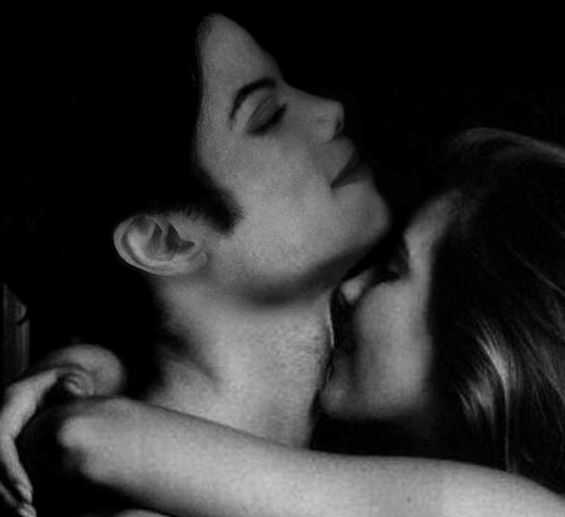

“You have to STOP, baby.”
“I can’t.”
“I don’t want you draining yourself before you grace the stage.”
“I’ll be fine. I have the body of a god.”
“YES, YOU DO!”
“I knew you’d agree with me.”
“You little sneaky devil.”
“Diana?”
“Yes?”
“Do you love me?”
“OH MY GOD. REALLY, MICHAEL?”
“Please tell me.”
“Are you still unsure about my feelings for you?”
“No, it’s not that.”
“Then why do you keep asking?”
“You really want to know?”
“Yes, please tell me.”
He exited from me and laid his beautiful head against my chest. He placed my hand on top of his head which I knew meant he wanted me to stroke his hair. He then started to confide in me.

“Diana, I’ve never known what it’s like to be loved.”
“I know, Michael.”
“Every woman I ever tried to get close to left or deceived me somehow. I’ve developed a serious paranoia about being alone. If it seems like I’m being excessive, it’s only because I need to be reminded that I am loved by someone who won’t leave me one day.”
“I never knew you felt that way.”
“I’m sorry if that annoys you.”
“It doesn’t. I misunderstood your feelings but I’m glad you know that I would never leave you.”
“Promise?”
“Yes, I promise.”
“Ever?”
“Ever.”
“No matter what?”
“No, Michael. Where would I go?”
“You wouldn’t take my child away from me?”
“ARE YOU CRAZY? Why would I do something like that?”
“I just want to have my own family someday. A family I can come home to and not have to look over my shoulder with all the time like I’m forced to do with my own.”
“You won’t have to worry about that with me. I promise I won’t leave you for any reason. Even if you asked me to, I still wouldn’t. And if by some chance we had to separate, I would leave our child with you.”
“You would?”
“I wouldn’t be able to live with myself knowing that I took something so precious away from you.”
“You really ARE the one for me.”
“I hope so.”
“You don’t feel the same way?”
“Would I be lying on a hotel room floor with you in Germany if I didn’t?”

He laughed and kissed my forehead.

“I missed you, Diana.”
“I missed you more.”
“I just want to lay here with you all night.”
“You can. I’m not going anywhere.”
“I have to rehearse.”
“Tonight?”
“Yes. But not here, at the studio.”
“Baby, you need to rest.”
“I know but my first concert is in two days.”
“Can’t you start first thing in the morning?”
“I can’t lose any more time. Every minute is important.”
“Please don’t rehearse today. I want to be with you.”
“I’ll stay with you for a while, then go later ok?”
“Will you cuddle with me until you leave?”
“Yes.”
“Will you eat?”
“Yes.”
“Good boy. I’m fine with it now.”
“You’re a silly girl.”
“Who loves her silly man.”

He and I both got up from the floor and like always, Michael wanted to change and straighten himself out. He remembered we were still in Chris’s suite and his clothing was across the hall. I told him I’d get them but he insisted on going back himself. I reminded him that the girls were there and they could help with moving his things from one suite to the other. I quickly splashed some water on my face, put my clothes on and went across the hall with him.

“You’re sure you can handle going in there?”
“I’ll be fine as long as you’re with me.”
“I love you.”
“I love you too.”
Marie came to the door and let us in. Michael apologized to her for screaming and kissed her forehead as he ran straight to the room and saw Jasmine asleep. Without waking her, he snuck into the closet, grabbed as many items as he could and went back to the other suite across the hall. His guards were standing at every door watching him and offered to help move a few of his things. The thought of touching Michael’s clothes excited Marie and she happily volunteered to help as well. Once we moved everything, Jasmine woke up and wondered what was going on. As soon as she did, Michael apologized and kissed her forehead too.

“Were you planning on leaving me here?”
“She caught us, Diana.”
“Caught what?”
“We’re flying to another city. My tour has been canceled here but since you were sleeping we didn’t want to disturb you. We thought you’d be fine alone in Germany.”
“WHAT? DIANA, HOW COULD YOU AGREE TO THAT?”
“HE’S KIDDING!”

Marie burst out laughing as Jasmine threw one of her pillows at us.

“She wants to fight with me now!” Michael said.

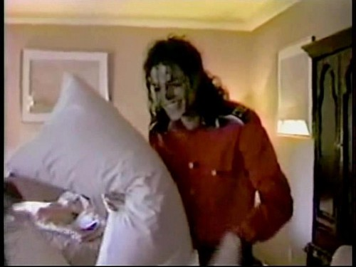
He picked up a few pillows and Marie and I grabbed some from the other bedrooms and living room. We all joined forces and had a massive pillow fight tearing a few of them as the feathers inside flew across the room. I knew Jasmine’s intention was to bring some sort of positivity into Michael’s life from that room so that he’d be able to forget the horrific experience he had. I thanked her in private for her great idea and she hugged me saying she was just looking out for him.

“Now, I look like a bird!” Michael said as he removed several feathers from his hair.
“Bird’s the word!” Marie yelled.
“What the heck does that mean?”
“I don’t know. I’m just being silly. That was so much fun!”
“Indeed but the fun is now over and Michael needs to rest.”
“I agree. We all should. We have a busy day tomorrow and have to get to the stadium on time to make sure the crew members are completing their assignments correctly.”
“I’m sooo excited! I can’t believe we’re going to watch you perform LIVE!”
“I’ll be so happy to see you there.”
“Ok, girls. We’re going to bed.”
“WE?” Jasmine asked being her usual nosy self.
“Don’t even think about it.”
“Too late.”
“What is she talking about?”
“Video camera, Diana!!!”
“SHUT UP!”
“She wants us to film something?”
“NEVERMIND. Let’s go.”
“OOO, Diana and Michael are going to do it!!”
“That already happened.”
“MICHAEL!”
“I’m sorry. I didn’t know that was a secret.”
“DETAILS!!! GIVE…ME…DETAILS!”
“GOODNIGHT YOU TWO!”

I grabbed most of my items and Marie helped me move to the other suite. We both checked on Chris who was asleep across the hall and Michael’s security guards were standing in place ready to protect him if necessary. For once, it seemed like nothing could go wrong until the unexpected gong show started. Thousands of people and reporters surrounded the main lobby downstairs. He asked me if I had told anyone where he was staying and I told him none of us did. Chris barged into the suite minutes later saying he was told a reporter was lurking in the bushes and saw Lisa Marie leaving earlier which in turn tipped the press into knowing where Michael was.
“Oh, no. They will start coming here every single day.” He said with his palm on his face.
“It’s ok. They love you and really want to see you.”
“I know. I love them more. But I want to be with you today.”
“Go see them on the balcony. I’ll meet you in the bedroom afterwards.”
“Are you sure it’s ok?”
“Of course. Don’t leave them like that. They want to see their King of Pop.”
“I won’t be long.”
“Michael, I’m not going anywhere. Take your time.”
“Do me a favor?”
“Sure.”
“There’s a red bag on the bed. Can you get it for me please?”
“Of course, be right back.”

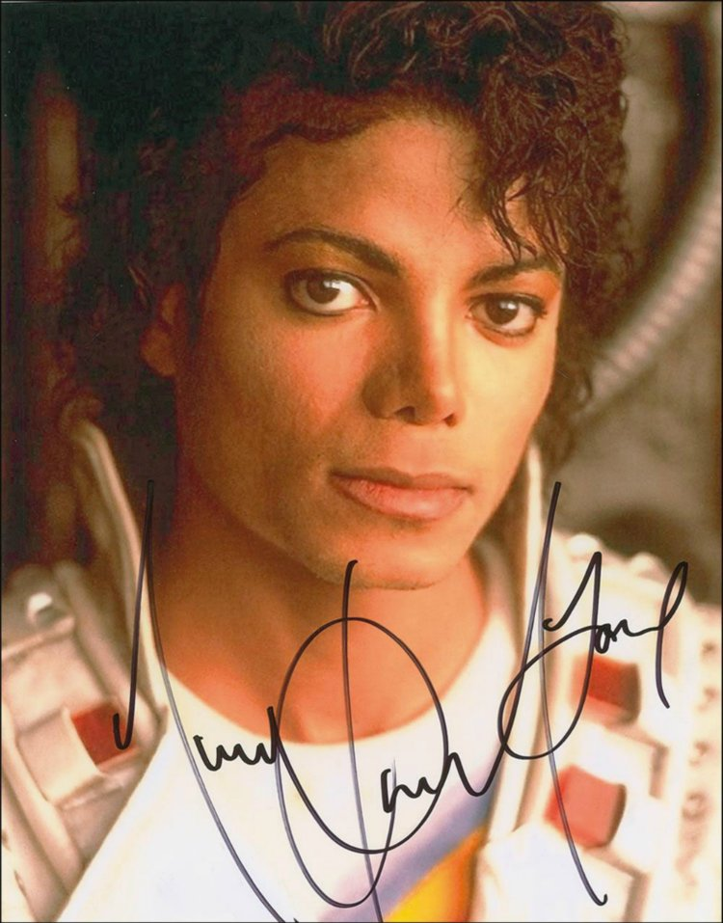
I ran to the room to get what he asked for and could hear the screams and echoes of his German fans outside the hotel. I heard them speaking in their native language as I walked back to Michael and handed him his bag. As he opened it, I saw dozens of black felts and photos of him inside. It was Michael’s ‘fan bag’ that he loved to carry around.

“You really do love your fans.”
“Of course. They are the reason I am who I am today.”
“I don’t think any other celebrity carries around pens and photos of themselves to give to their admirers.”
“They give me so much love. It’s my job to give some of it back.”
He kissed me then asked if I wanted to join him on the patio. I told him it was best if he greeted them alone for now. I started noticing the time difference and wanted to lie down as my body was starting to weaken. I told him I’d wait for him in the bed as I left. The noises from outside kept me awake but I didn’t mind. I knew this was the beginning of my ‘fame’ with my future husband and had to start training myself to be someone that Michael could and would be proud to call his wife.

*** TWO HOURS LATER ***

I smelled Michael’s sweet cologne as he crawled into bed and held me from behind. I was on my side and felt the warmth of his loving hand as he gently slipped it underneath my waist and pulled me towards him. He assumed I was asleep since I didn’t make any sudden movements and my eyes were closed. I felt his lips against my hair and then my neck as he started whispering to me.

“I don’t know what I’d do without you. You are the greatest thing to ever happen to me. I was so lonely and miserable before I met you…”

It seemed like Michael wanted to purposely share his feelings with me when he thought I wasn’t awake. I loved hearing his graceful and magnificent voice as he continued speaking.

“I will wait for the day when I see you as my bride wearing in a pretty white dress. I will take you away somewhere so far and we’ll have a beautiful honeymoon where no one will find us. I’m looking forward to putting a large part of his life behind me and starting a new one with you, my ideal wife.”

I was holding back tears as hard as I could as he went on.

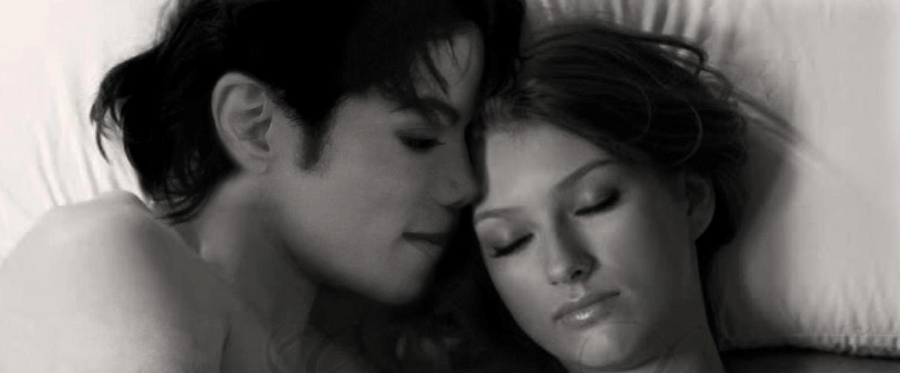

“I don’t know what I did to deserve someone like you but whatever it was I’m glad I did it. You complete me, Diana. Without you, there is NO Michael Jackson.”

He then placed his hand gently on my stomach.

“I can’t wait to have a baby with you someday. I hope when that day comes I’ll be strong enough to handle it and not cry in front of everyone so they don’t call me the cry baby.” He giggled making me flinch slightly.

He noticed my sudden shrug but thought I was still asleep. His words were giving me so much enjoyment that I didn’t want him to stop. I stayed in the same position being as still as possible hoping his lovely words would continue flowing from his mouth.

“There’s only thing one I’d ever ask from you, Diana…”

His hand was still on my stomach. I felt butterflies and a cold shiver run through my veins like a sharp incision made by a needle.

“I promise to always be honest with you. I will never hide anything from you and I hope that you will do the same. I really don’t like secrets…”

