CHAPTER 19:
HIStory: The Beginning

I felt another cold chill run down my spine. Hearing Michael say those words made me shudder. I tried to remain calm as I opened my eyes informing him that I was awake. He gently wrapped his arms underneath me and smiled as I moved closer towards him.

“I’m sorry I woke you up.”
“You didn’t. I was going in and out.”
“Did you hear what I was saying?”
“Here and there. Was it important?”
“Not really. I was just expressing myself.”
“Do tell.”
He giggled as I ran my hand down his cheek. Seeing Michael smile was always so incredibly beautiful to me.

“It wasn’t anything you don’t already know.”
“You know how much I love hearing you talk.”
“It’s nothing worth repeating.”

Not wanting to make him suspicious, I decided to let it go and change the subject.
“You haven’t eaten.”
“I know but it’s too late now.”
“It’s NEVER too late, Michael. Starving yourself is extremely dangerous.”
“I won’t do it again.”
“I don’t understand how you can go days without eating anything.”
“I’m used to it.”
“That doesn’t make it safe.”
“I know. I’m sorry. I will eat before I leave in the morning.”
“Promise?”
“Yes. Of course.”

I could still hear his fans outside the window screaming and chanting his name. Michael was so immune to it he easily blocked it out from his mind and ears.

“How do you handle this every day?”
“I’ve been handling it my entire life, Diana.”
“It doesn’t bother you?”
“Never. I love my fans. I’d be nothing without them.”
“Did you sign and give them your photos?”
“A few, yes.”
“I understand their feelings. You are so unbelievably wonderful. It’s extremely difficult not to love you.”
“Really?”
“Absolutely. You are a very lovable person, Michael.”
“Thank you.”
“You’re welcome. Goodnight.”
Before he could respond, Michael’s eyes closed and he became as still as water. I watched him as his breathing became steady and his lips quivered slightly. I touched them with my thumb and he kissed it lightly telling me he was still awake. I whispered in his ear as he slowly drifted into his dreams.

“I love you, Michael. I can’t wait to be your wife.”

He smiled and shook his head agreeing with me. I knew at that moment he was more than tired and it was time for both of us to catch up on our sleep. I tucked his hand underneath me as I crept over to him and closed my eyes. Being in his arms always made me feel safe. The comfort he gave me was indescribable. Being with him in that moment was the most beautiful experience. I realized that I never wanted to wake up or go another day without him. It was perfect. It was us. It was definitely meant to be.

*** TWO DAYS LATER ***

I woke up to the sounds of birds chirping and loud buses honking their horns outside. Michael’s first concert was scheduled for tonight at the Weserstadion in Bremen. The two of us spent yesterday morning with the girls then Michael spent the remainder of his day rehearsing. I got out of the bed and to no surprise, Michael was already gone. I put on my plush robe given to us by the hotel and washed up when I heard faint voices coming from the living room. I opened the large, double bedroom doors and saw the girls watching TV and eating an assortment of breakfast foods that made my mouth instantly water.

“Good afternoon sleepy head!” Jasmine said.
“How did you sleep?”
“Really well. I needed that sleep. Where is Michael?”
“At rehearsal like always.”
“I haven’t seen him since yesterday morning. I hope he isn’t overworking himself.”
“SOO, how was it?” Jasmine asked.
“How was what?” I asked heading for the breakfast table grabbing a muffin and a glass of orange juice.
“Your first night in Europe with him!”
“Jas, you are WAY too nosy.”
“Oh come on! Did you videotape it?”
“JAS!”
“Ok, ok sorry…but did you?”
“NO, I did not tape it and it’s none of your business, you pervert!”

Marie burst out laughing. As crazy as she was about Michael, I loved how she always respected my privacy with him.

“Did he say when he’d be back?”
“No, but according to Chris he’ll be gone all day.”
“What time do we have to be at the venue to set up?”
“We don’t.”
“Huh?”
“Marie and I went there this morning with Michael. Everything is set and ready to go.”
“I WAS SUPPOSED TO BE THERE! Why didn’t you two wake me up?”
“Michael asked us not to. He said you needed to rest.”

He’s always thinking of me. I thought to myself. I started missing him in that moment wondering if he was feeling ok and when he would be back.

“Girls, do you know if he ate anything?”
“We all ate together this morning.”
“I’m so glad you two were with him. Did he eat enough?”
“I’d say so. You know Michael’s not a big eater.”
“I know but he’s been running on empty for a few days.”
“He’ll be fine, Diana. He’s a strong man.”
Hearing those words gave me a bit of comfort but I was still worried. I couldn’t shake the feeling that Michael would be in some kind of danger again, especially after what Lisa Marie did to him.

*** MICHAEL’S POINT OF VIEW ***

TELDEX STUDIO, BERLIN GERMANY

Michael’s rehearsals were four hours away located in a different city from the hotel in Bremen. For his own protection, Prince Waleed and his entourage decided it would be best to keep Michael away from the city where his first concert was to be held in order to avoid contact with the press and unnecessary paparazzi. He rehearsed his most famous dance steps several times without stopping when his muse suddenly fell out of place.

“I need to speak to Diana. Please call her for me, Chris.”
“Sir, you only have two hours left to rehearse before we leave.”
“I know, but I can’t do this anymore. My muse is gone and she’s the only one who can bring it back.”
“I think you are being hard on yourself again, sir. Please just relax and take it one step at a time.”
“Chris, I need her. She is the only one who can jump start these feet.”
“Very well. I’ll arrange to get her on the phone.”
“Thank you.”

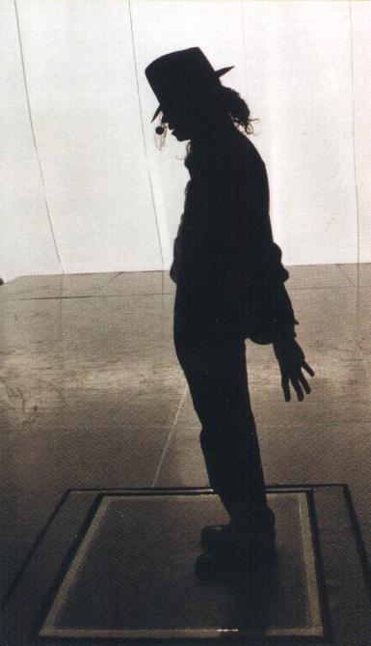

*** DIANA’S POINT OF VIEW ***

The phone rang in our suite. Marie and Jasmine were unsure about answering as they were afraid it might be someone from the media or an obsessed fan trying to get information. Neither one of them answered. Fifteen minutes later, it rang again.

“Marie, answer it!”
“I don’t know if I should. This is Chris and Michael’s suite.”
“It might be Michael himself calling!”
“YOU answer it then!”
“No way! He’ll get mad at me.”
“So, you’d rather I get in trouble?”
“Well, yeah. He’ll like me so much more if he doesn’t like you.”

I stormed into the living room wondering what was going on.
“GIRLS! Why are you not answering the phone?”
“We don’t want to get in trouble!”
“Oh for god’s sake! I’ll get it!”

“Chris’s suite.”
“Diana?”
“Michael?”
The girls ran over to me and started pulling on the phone cord.

“LET ME TALK TO HIM! LET ME TALK TO HIM!”
“Will you STOP pulling on the cord?!”
“I WANT TO SAY HI!”
“STOP!” I yelled pushing them both away.

Michael giggled feeling flattered that the girls wanted to hear from him.

“It’s ok. I’ll talk to them.”
“No, me first!”
“Why didn’t any of you answer before?”
“The girls were afraid they’d get in trouble since this isn’t our suite.”
“I guess I should have told them it would be ok.”
“We know that now. How are you?”
“I’m well. Did you sleep ok?”
“I guess so, but you know I hate waking up alone, Mr. Jackson.”
“I’m sorry. I had to leave at 4.”
“4AM?”
“Yes.”
“Why?”
“The studio is four hours away from the hotel.”
“WHAT?”
“It’s a Kingdom International thing – for my security.”
“Please don’t over work yourself. You need to be well rested for tonight.”
“I needed to hear your voice before I continued.”
“I love you.”
“I love you more.”
Marie came over begging to talk to Michael. Feeling annoyed by her constant nagging, I gave the phone to her.

“Michael? I miss you SOOO much!”
“I miss you more, beautiful.”
“When are you coming back? We want to see you before you leave for the venue.”
“I have two more hours of rehearsal plus the drive back.”
“That’s 6 hours!”
“I know. I’m sorry but I won’t be coming back there.”
“It’s ok. I guess the next time we see you will be backstage?”
“Yes, exactly.”
“Jasmine and I are rooting for you. We can’t wait to see your magic in person.”
“I love you, Marie.”
“YOU DO?”
“Do you really have to ask?”
“No, I just wanted to make sure.”
“You’re my girl in the next life.”
“REALLY?”
“Shhh, don’t tell Diana.”
“I won’t.”
“I’m running out of time. Can I speak to Jasmine now?”
“Of course. I’ll see you in a few hours.”
“Yes, you will.”
“Michael?”
“Yes?”
“You are the GREATEST entertainer in the world.”
“Stop it.”
“You KNOW it’s true!”

He giggled beautifully making Marie giggle too.

“What are you two talking about?” I asked feeling jealous.
“Nothing – inside joke.”
“MMM HMM. You tell that man to behave! I have ears everywhere.”
“She must be an alien.” Michael said.

Marie burst out laughing.

“What is so funny?”
“Michael called you—“
“NO! She will kill me.”
“Called me what?”
“Michael, can I please tell her?”
“NO!”

I grabbed the phone from Marie’s hand.

“What did you call me boy?”
“My beautiful wife.”
“Don’t lie to me!”
“You said you have ears everywhere so I called you an alien.”
“I’M AN ALIEN? YOU’RE the one with the space suit!”
“I miss your galaxy, Diana.”
“JAS! Michael wants to talk to you!”
“That big, beautiful galaxy filled with so much—“
“JAS!”
“I can’t wait to touch it again. So tight, so full of pleasure, so incredibly wet--”
“JASMINE!!”
“I’m coming.”
“That’s what you’ll be saying too.”
“OH MY GOD! I’ll see you later. Goodbye, Michael!”

He spoke briefly to Jasmine and again to Marie before hanging up. We wished him the very best and the girls and I chose our outfits for the concert. Chris was kind enough to have a few of Michael’s guards escort us around town and show us some of the best places for hair, makeup, nails and spa treatments. The girls and I had a few hours to kill before it was time to get ready for the concert. To mine and Jasmine’s surprise, Marie met a young, handsome man named Gerwin at a coffee shop and became very friendly with him. She took his number and wanted to invite him to the concert but to her surprise, he mentioned he was already going. She knew she was not allowed to reveal anything about Michael or his tour so she said she too would be attending and would try to meet him there if possible.
*** TWO HOURS LATER ***

“Are you girls ready yet?” I yelled from across my bedroom.
“Almost. Beauty takes time, Ana.”
“I’m fully aware of that. I’m still not ready either.”
Chris knocked on the door a few minutes later asking if we were ready to leave. As he stood in the living room, he couldn’t help but stare at Marie as she came out the room first:

“You look beautiful, Miss Marie.”
“Thank you. Do you think it’s too simple for a TSG employee?”
“Not at all. Mr. Jackson loves the simple look on his three favorite girls.”
“I guess I better go change then!” Jasmine said as she came out next:

“You look just as beautiful as Miss Marie.”
“Thank you. I hope David doesn’t see me on TV and get the wrong idea.”
“What do you mean?”
“He bought me this dress as a wedding gift. I don’t want him thinking I’m wearing it to attract other men.”
“David is not that insecure, Jas.” Marie said.
“You’re right. Besides, I love to flaunt what others can’t have.” She said smirking.

After hours of pampering, I was finally ready. As I made my way out of my room, the girls didn’t notice me until I walked under a beautiful antique chandelier that was sparkling above me. Marie’s jaw flew open so wide a fly could have gone into it. Jasmine was also lost for words as she came over to me saying she had never seen a more beautiful woman in her life.

“Michael is going to be swept away.” She said as she touched up my hair.
“Ana, you are so beautiful. Michael is a lucky man.” Chris said.
Hearing their words made me emotional. Jasmine noticed and wiped my tears from the corners of my eyes worried that my makeup would smear. The venue was an hour away from the hotel and we knew we had to leave within minutes to see Michael before his grand entrance.

We gathered our things and headed out the door. As we made our way through the main lobby, dozens of cameras were flickering in our eyes as security tried to push us through the large crowds of fans and people trying to get a story out of one of us. Marie and Jasmine basked in the glory as their pictures were taken. I hid behind Chris as he took me to the limousine. Marie made kissing faces to the cameras and Jasmine was posing as if she was the next Marilyn Monroe. As much as I hated what they were doing, I adored their confidence and watched them from the dark, tinted window as they were slowly making their way to the vehicle.

“THAT WAS INCREDIBLE!” Jasmine said as she stepped inside with Marie.
“I have never felt so famous! I love hanging out with Michael’s crew!” Marie said jumping into her seat.
“I’m glad you two are having fun acting like Hollywood celebrities, but we have to keep a low profile for Michael’s sake.”
“Right…LET’S DO IT AGAIN, MARIE!” Jasmine said.
“GIRLS!”

They both hopped out of the vehicle and took more photos for the reporters and fans. I yanked them both in the limo and told Chris to leave immediately before we got swarmed with more people from all directions.

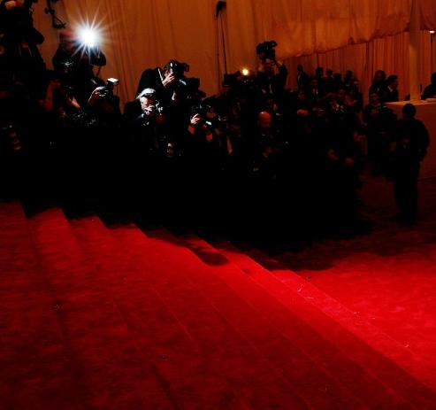
“That was unnecessary, you two!”
“Sorry, Ana. But it was SO much fun!”
“We can have fun after this first concert is over. We need to stay professional.”
“Ana, you know he won’t mind.”
“I know HE won’t mind, but Kingdom will. They have very high standards. If we don’t comply with them, they could release us from the tour making us lose MILLIONS of dollars.”
“She’s right, Marie. We need to behave…for now.”
The girls maintained their composure as we left for the venue. The echoing and chanting of Michael’s fans were in our ears the entire time and the three of us couldn’t help but feel more and more excited as the time came closer to seeing Michael before he graced the stage with his wonderful presence.

*** AN HOUR LATER ***

Michael didn’t return to the hotel since he ran out of time and arranged to have his wardrobes and makeup artist arrive directly at the venue. He was able to freshen up and get changed on time while he waited impatiently for his wife to be and her two best friends to arrive. He drank his trademark solution of ricola cough drops dissolved in warm water to help ease the tension in his throat and voice and anxiously paced back and forth in his dressing room wondering if they would make it on time. After what seemed like an eternity to him, his heart felt at ease when he was told the limousine had arrived at the back entrance doors. He wished to see his favorite person in the whole world and couldn’t wait another second to rest his eyes on his beloved.

“Sir, the girls have arrived.”
“Did they come with Chris?”
“Yes, sir.”
“Thank god. Bring them in please.”

As soon as the door to his dressing room opened, Michael ran to the girls and gave them the biggest hug in the world while I stood out in the hall waiting for the perfect time to surprise him.

“Where’s Diana?”
“She’ll be here.”
“Didn’t she come with you two?”
“She did but she had to take care of a few things with the crew.”
“I can’t believe she didn’t want to see me first!”
Feeling disappointed, he turned his back towards the girls facing his makeup table when I came in and stood directly behind him. The girls walked backwards and slowly left the room leaving Michael and I alone.

“Now, why would I do something stupid like that?”

He turned his back and saw me standing at the far end of the room. I kicked the door closed with my foot locking it without turning. Michael smiled brightly and ran towards me faster than the speed of light carrying me all the way to his dressing room table. His lips touched mine and within seconds, the two of us were locked in an airtight embrace.

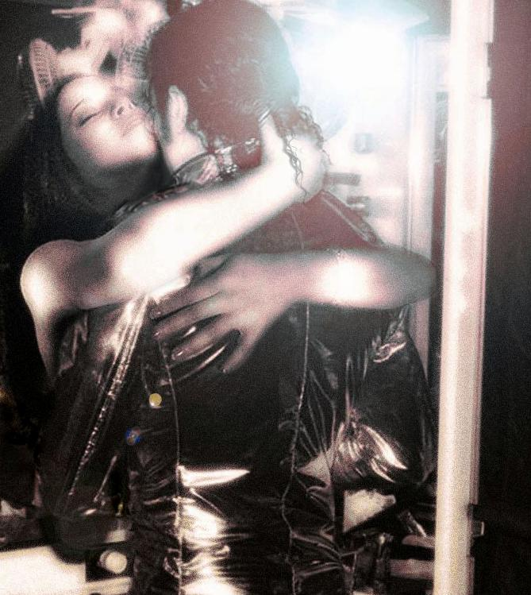

“I missed you so much, girl.” He whispered in my ear.
“I missed you too, baby.”
“I’m so happy you’re here.”
“I wouldn’t miss my husband’s first show in Germany for anything.”
“I love when you call me that.”
“Call you what?”
“No, Diana. Not again.”
“Call you what, Michael?”
“Your…your...”
“My…”
“Your spouse.”
“Also known as?”
“Partner.”
“And?”
“Soul mate.”
“And?”
“Bed friend?”
“MICHAEL!”

He laughed as I nudged his shoulder gently.

“Your husband, Diana.”
“It’s not difficult to say.”
“It’s more difficult to believe.”
“Not for me. You look amazing senior space man.”
“You like my gold?”
“I do! Do you have the helmet?”
“Of course. I can’t go on stage without it.”
“How much time do you have?”
“About fifteen minutes.”
“Nervous?”
“Not at all. The stage is where I feel most comfortable.”
“I remember you telling me that at the museum.”
“I still can’t believe it’s been five years since then.”
“I KNOW. Time has really flown by.”
Michael’s makeup artist, Karen Faye entered the room to touch up his hair and makeup. He looked just as angelic in that moment as the first day I met him. I noticed Michael refused to look at his reflection in the mirror and kept his back towards it the entire time Karen was enhancing his beautiful features. I felt uncomfortable with it but knew I couldn’t bring it up as I didn’t want him to feel uncomfortable minutes before going on stage in front of 100,000 people.

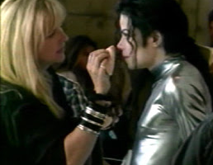
“All done, Michael.” Karen said as she put her makeup kit away. “Just have to put on your eyeliner.”
“I’d love for Diana to do it.”
“ME?”
“Yes. Please?”
“Michael I don’t know how to put it on another person. Besides, Karen is a professional. She knows what she is doing.”
“Karen, can you do one side and she can do the other?”
“I don’t see a problem with that.”
“No, Michael. I can’t.”
“Please?”
“I don’t want to ruin your beautiful eyes. Your makeup is smudge proof and water resistant. If I mess up, it won’t come off easily.”
“I’ll show you how, Diana. It’s really not that difficult.”

Michael grabbed my hand and pulled me towards his side.

“Please, Diana?”
“Why me?”
“It’s something very personal to me. I want you to be a part of it.”
“Are you sure about this?”
“Of course.”
“Michael, I don’t want to ruin your look. My hands aren’t exactly steady.”
“They are with me.”
“MICHAEL!”
Karen giggled as she heard what he said.

“You embarrass me.”
“So, will you do it?”
“I’ll show you how I do it, Diana. You’ll be fine.”
“Show her with my right eye, please. I’d like her to put it on the left one.”
“Why is that?”
“That’s where my heart is.” He said as he winked his eye.
I could feel my flushed cheeks turn fifty shades of red and heard Karen giggle again. I watched her closely as she slowly applied a very thin layer of black liquid along Michael’s lower eyelid. With a firm stroke of the brush, she was done and it looked incredibly natural on him.

“Your turn.” She said handing me the applicator.
“I really don’t know if I can do this.”
“I won’t force you, but I’d really love it if you did.”
I didn’t want to break Michael’s heart. Feeling incredibly nervous, I agreed and gave it a try. I pumped the brush gently in its applicator and stood as close as I could to Michael’s face. He lightly kissed my lips as they came in contact with his and told me not to worry. I had never seen Michael so closely before. His skin was so creamy and unique and his eyes were truly deeper than any ocean in the entire world. It didn’t take long for me to get lost in the midst of them.

I leaned forward and he gently wrapped his arms around my waist. My hand trembled as I made my way over to his eye breathing deeply hoping not to ruin what, to me, was already a magnificent piece of work.

“I love you, cupcake.” He whispered.
“I love you too. Please don’t get mad at me if I screw this up.”
“I won’t and you’ll be fine.”

I began to gently apply the liner to his eye. Karen put her hand on top of mine to stop my fingers from shaking and with a swift stroke, it was on perfectly and Michael looked lavishly impressive.

“I did it!”
“Yes, you did and you did a fantastic job.” Karen said.

She placed a handheld mirror in front of Michael and he briefly saw his eyes then looked away. Him not wanting to see himself properly was the equivalent to throwing daggers into my heart. I knew I had to stay silent but also wanted him to know I was not comfortable with the way he ignored his appearance.

“Michael, I don’t like when you do that.”
“Do what?”
“You know what I’m talking about.”
“No, I don’t.”
“When you look away from yourself.”
“I didn’t look away, I saw myself.”
“Barely.”
“It’s not a big deal, Diana. I know what I look like.”
I didn’t want to probe further since we were not alone and he was minutes away from performing. As much as I disliked his bad habit, I knew now wasn’t the right time to argue with him about it.

“Good luck, Michael.” Karen said as she hugged him on her way out. “I know you’ll be great as always.”

He thanked her and I walked her to the door. Michael’s entourage came in a few minutes later and told him he had five minutes before the entire crew would meet for their huddle.
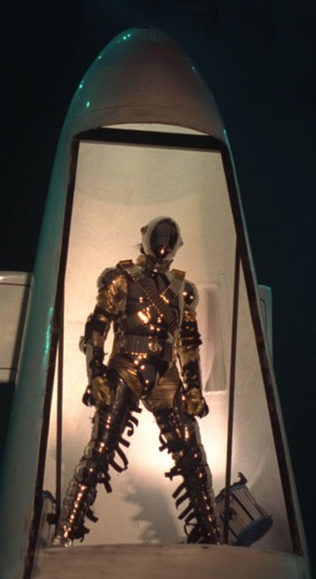
“Crew huddle?”
“We all come together before we go on stage. You and the girls will join us.”
“Really?”
“Of course. You’re a part of our family now.”
“That’s sweet. I better go find the girls and let you get yourself together. Will the huddle be here?”
“No, it’s in the main hall next to the stage.”
“I’ll meet you there if that’s ok?”
“Sure.”
I hugged him tightly and gently kissed his cheek.

“Diana?”
“Yes?”
“Will you walk me to the stage?”
“I’d love to. But won’t your fans see me?”
“Not right away. I’ll be in my space ship.”
“YOU HAVE YOUR OWN SPACE SHIP?!”
“Yes.”
“CAN I SEE IT?”
“You can see one of them now.”
“YOU HAVE MORE THAN ONE?”

He grabbed my hand and placed it in his favorite spot.
“This one belongs to you.”
“MICHAEL! You are horrible.”
“I wanted to make you laugh.”
“You’re silly!”
“I love you.”
“I love you too. So, where is this space ship of yours?”
“It’s a surprise. You’ll see.”

He then ran his hands through my long, flowing hair. Michael always loved it when I left it open for him.

“You look so beautiful tonight.”
“Really?”
“Yes. I love your dress.”
“You don’t think it’s too formal?”
“That’s your style though, isn’t it?”
“It is, but I didn’t want to seem like I was going to a prom. I just wanted to look pretty for you.”
“You ALWAYS look pretty to me, Diana.”
“Thank you. You know I feel the same way about you.”

One of Michael’s backup singers came in the room informing him the huddle was about to start. Since we were pressed for time, Michael decided to have it in his dressing room. Jasmine and Marie followed along with several of Michael’s entourage members, backup dancers and production workers. We all joined hands in a circle with Michael leading the group. He introduced me and the girls to the members we hadn’t met before and one of his backup dancers said a prayer blessing Michael and his career and all of us wishing for a good show and a great time in Europe.

When the huddle was completed, everyone immediately left to attend to their duties and stations. Michael had to wait for his signal before leaving his room to enter the stage area. He held my hand firmly saying he was excited to be in front of his fans again and wanted so badly to present me as his wife.

“In time, baby. In time.”
“I wish I could do it tonight.”
“You can for your next tour.”
“Will you be next to me?”
“With cupcake in my arms.”

He smiled and kissed me passionately and we held each other. The girls ooed and aahed as they saw Michael expressing his love to me. Prince Waleed arrived and we all greeted him courteously. He informed Michael that it was time for him to take his place. It was then that Michael told us the big moment was just minutes away. He asked the three of us to walk him to the final point of the stage before he separated from us. Marie and Jasmine were honored and we walked with him and his guards as he led the way towards the main hall.

The constant screaming and chants of 100,000 people made Michael feel like he was indeed a true king. The smile he had on his face was gleaming and I had never been happier for him then in that moment.

“I am SOOO excited!” Marie said jumping up and down.
“Me too! You’re going to be awesome. Our eyes will be glued to you!”
“I love you girls.” Michael said as they shared a group hug.

We reached the final point of the stage where his entourage waited to supervise him as he went underneath the entire stage above his head.

“I guess this is it.”
“I love you, Diana.”
“I love you too. Have a GREAT show.”
“I will now that you’re here. Will you watch me?”
“What else am I going to do for the next 3 hours?”
“I could think of a few things.”
“MICHAEL, YOU ARE DISGUSTING!”
“I wasn’t thinking that at all.”
“Right.”

I kissed his lips and touched his hair gently, giving him the perfect look.

“I love your eyes.”
“They look so much better today.”
“You noticed a difference?”
“Yes. I have your magic touch on me. I know I will be amazing on that stage now.”
“You are always so sweet to me.”
“You deserve it.”

I took his hand and led him underneath the stage until I couldn’t follow him any longer. Michael had to crawl underneath a cave like section of the stage surrounded by poles and cloths where he would be hiding in safety before he entered a space ship type structure.

“MICHAEL! IS THAT YOUR SPACE SHIP?”
“Hey! You’re not supposed to see that yet!”
“I can see it through the cloth!”
“Don’t look! You have to wait like everyone else.”

He covered my eyes and kissed my forehead.

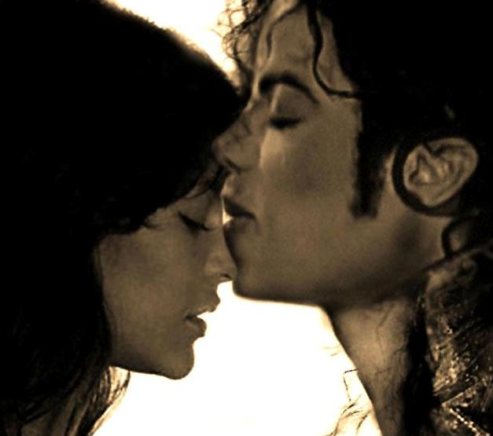

“Please do the moonwalk for me?”
“You know I will.”
“I’ll be right over your shoulder.”
“I hope you stay there forever.”
“I will if you let me.”
“I love you.”
“I love you too.”
“Prepare to be amazed.”
“I’m looking forward to it.”

We kissed one final time and I watched him as he walked towards the underground section of the stage and gently crawled underneath. When Michael was no longer visible, his entourage told me I had to leave that area and go directly towards the upper level backstage where the girls were so that I wouldn’t miss his grand entrance. I ran as fast as I could with the sounds of my heels clicking on the hard pavement. When I reached the girls, they had smiles on their faces and nothing but true excitement in their eyes. Within minutes, the entire venue’s lights went dim and a large picture of Michael appeared on the jumbo screen at the very top of the front stage area. Thousands of fans cheered and screamed frantically as they saw their idol on screen and were thrilled to know they were just seconds away from seeing him in person. The anticipation of his arrival made everyone impatient, even me but I smiled knowing I had the one thing no one else would ever have – his heart.

