CHAPTER 20:
Everyday Create Your History

To My Beloved Readers:

This chapter is entirely about Michael’s first concert in Germany during the History tour on May 31, 1997. There isn’t much of a ‘storyline’ but I felt it was important to describe the experience of such a remarkable event through the eyes of Diana, Marie and Jasmine. I hope you all don’t get bored and enjoy the amazing journey of this magnificent tour. I truly did my best to describe Michael and recapture his amazing magical craft on stage. I hope that by reading this chapter, you all get a sense of what it would have been like to be there that night. I watched the entire concert online while writing this chapter from start to finish trying to get an accurate grasp on every single historic and special moment that occurred. I know Michael would be proud of me as my eyes were literally glued to him the entire time. There are, of course a few surprises (especially one in particular near the end) that obviously did not happen that night but, for the sake of this story I added them for your enjoyment.

The crowd continued cheering as Michael’s voice and image sitting inside a space ship appeared on the screen. Marie and Jasmine watched in delight as they watched him ‘fly’ through a virtual terminal making it seem like he was travelling on a roller coaster.

“HOW DOES HE DO THAT?” Marie asked.
“Who cares? He’s a friggin’ genius!” Jasmine yelled.

Yes, he is. And he’s all mine. I said to myself.

After a few minutes of showing him on the screen, a countdown had started and Michael was seconds away from appearing live and in person. My heart raced and Marie was so excited she thought she was going to pee herself. Jasmine was so lost for words she could barely stand up as her nerves were completely shot through her system. Within seconds, gold fireworks and large puffs of smoke erupted and a space ship broke through the bottom of the stage.
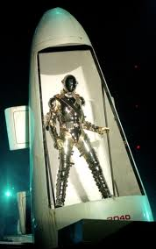

“HE REALLY DOES HAVE A SPACE SHIP?!” I yelled without thinking.

The girls were amazed but remarkably calm as the crowd continued to cheer and scream for the man dressed in gold to appear. He stayed inside the structure for what seemed like forever to his fans as they continued hollering and shouting for him. He then kicked the door open and appeared in front of the venue wearing his entire gold wardrobe including his helmet and leg pads. It was then that everyone in the entire venue and both Marie and Jasmine lost their minds and screamed as if they had just seen God himself. Surprisingly, I was calm as if my voice had suddenly disappeared in the back of my throat. Once Michael stepped out of his space ship, it lowered itself underground and an announcement was made informing his fans that he was now ready to dance.

Michael took a step back and the beat to his song ‘Scream’ began to play. He quickly removed his chest plate and turned around. Jasmine and Marie kept a close eye on him as he was just several feet away from us. He slowly removed his helmet and quickly glanced over his right shoulder where he saw the three of us. I noticed him discreetly wink his eye and smile in our direction just before turning around gently tossing his helmet directly in front of him.

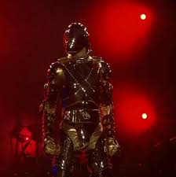

“ANA! DID YOU SEE THAT?”
“Yes, Marie. He wanted to make sure we were watching him.”
“HE LOOKS SO DAMN HOT IN GOLD!” Jasmine yelled.
“Hey! That’s my husband you’re talking about.”
“Not if I can help it.”
“JAS! Does the name DAVID ring a bell?”
“WHO?”
“JASMINE!”
“I’m kidding. He’s all yours. I can at least look at him, can’t I?”
“SHUTUP! HE’S PERFORMING!” Marie yelled.

Michael’s face suddenly became serious and his feet moved in their most famous ways. It was then that Marie and Jasmine lost her minds with the fans started dancing like he was.

“HE’S AMAZING! I LOVE HIM TO DEATH!!” Marie yelled.
“I can’t believe we’re watching this LIVE!”
“Believe it girls. There are still 40 concerts left. I’m sure you will get sick of seeing the same routine after a while.”
“ARE YOU KIDDING? I could see this a BILLION TIMES and NEVER get sick of it!
“ME NEITHER. He’s so magical.”

I shook my head in disbelief and continued watching Michael perform. So many thoughts were running through my mind while seeing his various remarkable talents. As amazing as he was, I could immediately feel his desperation for love and acceptance and finally understood why it was so important for him to give his fans the best show he possibly could – he simply wanted to make the world happy, one fan at a time. Several fireworks exploded next to him as his dancers jumped on stage from underground. He then orchestrated a military style procedure in which his ‘soldiers’ moved according to his commands.

“He’s so sexy when he’s in charge.” I whispered.
“I’d sell my kidney to take all that gold off him.”
‘MARIE!”
“Sorry. I can’t help it. He does things to me.”
“TOO MUCH INFORMATION!” Jasmine yelled.

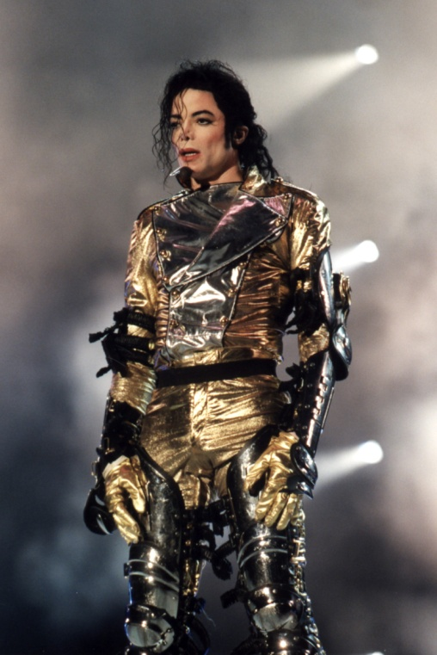
He then began to sing and dance to “They Don’t Care About Us.”

“I LOVE THIS SONG!” Jasmine yelled.

We watched trying our hardest not to lose our composure. Of course, that didn’t last long with the girls as Michael continued to grace the stage with his amazing dance steps and soprano styled voice. It was obvious that Michael truly enjoyed being on stage and felt most comfortable being there.

“I don’t think I’ve ever seen him smile so much!” The girls said.
“He’s in his happy place right now. Nothing matters to him except his fans and his performance.”

He then continued with “In the Closet.”

“MY SONG!!” Marie yelled.
“Oh god, Marie. EVERY song of his is ‘yours’.”
“HE’S AMAZING!”
“Yes, he is.”

After introducing the song, Michael spoke driving his fans absolutely crazy:

“One thing in life you must understand. The truth of lust woman to man. So open the door and you will see, there are no secrets. Make your move, set me free.”

“HE TALKED! HE TALKED!”
“Yes, Marie. Singers have a tendency to do that!”
“Shut up, Jas.”

He danced in the most erotic way making my insides rage with fire.

“Oh god, he’s sexy.”
“Calm down, Ana. You can have him later.”
‘SHUTUP! I’m not even thinking about that.”
“RIIIIGHT!”
“Will you two stop and let me watch the man?”

I noticed Michael continuously looked over his shoulder making sure we were still watching him. I couldn’t tell if he wanted to tell me something or if he was just making sure I was alright.
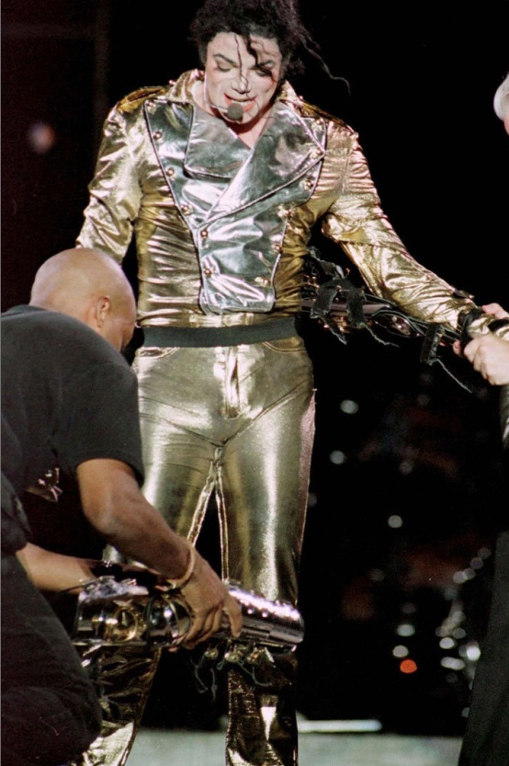
“Ana, he misses you.”
“I know. I can tell.”
“I think he wants to make sure that our eyes are still on him.”

Once the song finished, a few of Michael’s crew members appeared on stage and removed his leg pads and arm braces. He looked at the crowd from all directions and told them he loved them making their screams even louder than before. I couldn’t help but admire the glow on his face as he smiled and looked towards his fans. They truly were his inspiration and reason for living.

After hollering back at his fans, he continued with “Wanna Be Startin’ Something.”

“OH MY GOD!”
“We know, Marie.”
“He’s certainly starting something with those pants of his!”
“JAS! You need to quit.”
“Sorry. I just can’t help it.”
“Ana, it’s only natural for every woman to fantasize about him.”
“Not when they are my best friends!”
“You will always have him. The rest of the world can only dream.”

Jasmine was right. I couldn’t stop every single woman from loving him in their own ways, including my own friends. I decided to let them have their ‘way’ with him and not be so over protective.

“I’m defensive when it comes to Michael. He’s been through a lot and I don’t like people saying unnecessary things about him. He gets enough of that from the media on a daily basis.”
“You know we’d never say anything to hurt him.”
“I know but I’m also a bit possessive and he knows that.”
“A BIT?” Marie asked.
“OK OK! I’m VERY possessive of him. But, can you blame me?”
“RIGHT NOW I CAN! I’M TRYING TO WATCH!” Marie yelled.

Watching Michael perform was definitely the most indescribable experience. I had been to many concerts and promoted many tours, but NOTHING compared to Michael on stage. His energy, aura and overall presence was so strong that he could easily make everyone forget their own name.

“He’s brilliant!” Jasmine yelled as the song came to an end. Marie blew him kisses as he quickly glanced in our direction again when the song re-played. Michael, by force of habit, would constantly look in my direction during one particular moment – whenever he would sway his hips and twirl his finger at the same time.

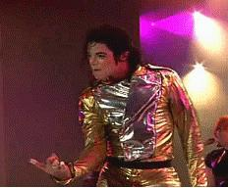

“SWEET JESUS! THAT’S SEXY!” Marie yelled.
“It sure is.” Jasmine said. She then put her own finger in her mouth as if she was enticed by his action.
“JASMINE! WHAT ARE YOU DOING?”
“Nothing! I was just…umm…NEVERMIND!”

Marie and I burst out laughing as we continued watching. Once the song ended, the lights became dim and Michael opened his gold vest revealing a white shirt underneath making his fans scream and holler again.

“IS HE GOING TO STRIP?” Marie asked feeling excited.
“LET’S HOPE SO!”
“GIRLS! I can’t believe you two! He’s just taking off the vest!”
“Too bad.” Jasmine said.

I couldn’t help but shove her lovingly as “Stranger in Moscow” played. The audience became quiet and watched Michael closely as he gracefully danced away to the beat of the song. Almost every single fan in the audience held lights in the air as a way to show their love. The three of us also lit our own as we watched him dance away against the beautiful blue backdrop stage lighting.

“WE LOVE YOU, BABY!” I yelled as he smiled and looked down.
“I think he heard you.” Marie said.
“I think so too. I want to keep him motivated.”

He continued dancing in his most iconic way capturing every single audience member’s eye. He giggled to himself and put his head down as if he were telling himself something. To my surprise, he started doing a few of his trademark robotic steps then briefly did the moonwalk looking directly at me just before spinning, pointing twice and spinning one last time before the music and lights turned off at his command by directing his hands down in front of him.

“THAT WAS SLICK!” Marie said looking at me. “Did you see how he did that without the audience noticing?”
I couldn’t help but blush as I heard the girls saying he much they could see his affection for me on stage.

“He’s drawing too much attention to me. I don’t want Waleed to suspect anything.”
“He won’t. Just relax. Michael knows what he’s doing.”
“I know but we all need to keep a level head. One wrong move and it could cost me my entire business.”
“Michael won’t let anything happen to any of us.”
“Let’s forget about it for now and watch.”

Moments later, a few of Michael’s male dancers dressed in black suits with white stripes and black hats appeared on stage with two women. One was wearing a red dress and the other was in a green one with a large feather type fan in her hand.

“What song is this?” Jasmine asked looking confused.
“I have no idea.”
“Neither do I.” Marie said.
“YOU don’t know a Michael Jackson song?”
“No, Ana. This is different.”

Seconds later, our inquiry was answered when we heard the famous “Are you ok, Annie?” question being asked in the background seconds before seeing Michael appear with a gun ‘shooting’ at the top of the stage illuminating a large white cloth against it.
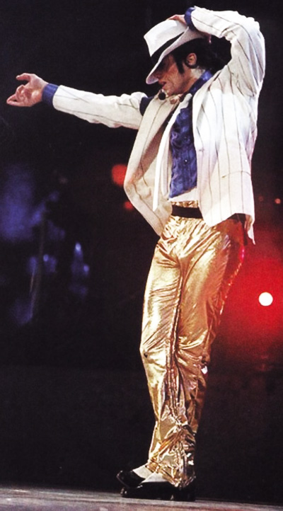
SMOOTH CRIMINAL!” Marie yelled.
“THIS IS MY SONG!” Jasmine said jumping up and down like a little girl.

He appeared as a large, shadow type silhouette throwing his gun aside while his dancers looked towards him on stage with their back towards the fans. Michael then brought his signature dance moves to life by gliding and moving his entire body to the snap of his own fingers.

“That’s one of my favorite things he does!” Marie said.
“Me too! It’s so illusion like.”

Moments later, two of Michael’s dancers appeared against the backdrop and the beat to “Smooth Criminal” began alarming the entire audience making them happy and overly excited. Marie and Jasmine also screamed with joy as the backdrop slowly disappeared against a large display of fireworks at the side of the stage.

By this time, Michael’s wardrobe changed slightly. He wore his trademark outfit from the short film including the jacket, white hat and white tie. As he continued his routine, a few bright lights appeared and he did his iconic anti-gravity lean leaving all of his adoring viewers shocked and completely blown away.

“I still can’t figure out how he does that.” I said.
“It’s actually very simple.”
“Marie, Michael would NEVER reveal his secrets.”
“It’s not a secret. It’s his shoes and the way the floor is set up.”
“DO TELL!”

“I don’t know all of the specifics. You’d have to ask him.”
“How do you even know that much?”
“He told me.”
“HE DID?”
“Yes, but like you said he never reveals everything.”
“I’m sure I can charm it out of him.”
“PLEASE VIDEO TAPE IT THIS TIME!”

I scoffed as I heard Jasmine’s usual and ridiculous comment.

Once the song was over, Michael turned his back towards the audience and ‘walked away’ as if he were leaving.

“HE’S NOT FINISHED, IS HE?!” Marie asked.
“HE CAN’T BE!”

Just then, the beat to one of Michael’s most recent songs played making me feel emotional but angry at the same time due to the person who was in the short film with him.

“Umm, this is awkward for me.” Marie said wanting to leave.
“For me too. I think we better get some fresh air or something.”
“DON’T MOVE!” Jasmine said holding our arms. “That would be rude and you know Michael would get upset.”
“Jas, he wrote this song for ME and filmed it with his ex-wife. Do you really think I want to stay here and listen to it?”
“And she has my name too!” Marie added.
“There’s obviously a reason why he added this song to the concert list. Ana, like you said, he wrote this song for YOU. And Marie, he probably thought of you in a good way and wanted you to see it live.”
“I don’t think that’s it, Jas.”
“Just don’t leave. If he looks over and sees you two aren’t here he will go crazy and you know it. If you don’t want to draw unnecessary attention, stay and let the song go by.”

Marie and I both sighed. We knew Jasmine had a valid point but hearing that song did nothing for Marie and I except make us cringe and hate Lisa Marie Presley even more than we already did. We looked at the audience as the lights went dim and a beautiful, blue light appeared on stage with Michael singing in the background. He wasn’t on stage right away which had me concerned.

Seconds later, he appeared wearing a white shirt with a thin, long sleeved black shirt over it. It looked awfully familiar.
“DIANA! Isn’t that YOUR shirt?”
“OH MY GOD IT IS!”
“Why is he wearing a GIRL’S shirt?”
“Why did he wear his mother’s jacket for Billie Jean at Motown 25? WHO CARES? IT LOOKS GOOD ON HIM!”
“Marie, you scare me sometimes.”

Seeing him perform “You Are Not Alone” wearing my shirt made me feel even more uncomfortable. I had no idea where he got it from but in a way it was flattering to know that he wanted a piece of me on stage with him. Suddenly, Michael turned towards Marie as if he were signaling her.

“Marie? You want Marie?” Jasmine asked him.
Michael shook his head in agreement.
“WHAT? WHY?” Marie yelled not knowing what to do. A guard came from behind saying Michael had requested Marie go on stage with him.
“ME? HOW? NO WAY!”
“MARIE! He’s calling you!”
“ARE YOU KIDDING? I WILL FAINT IN FRONT OF ALL THOSE PEOPLE!”

Meanwhile, Michael was still eyeing Marie asking her without being obvious to stand next to him.

“MARIE! He’s calling you! GO NOW!”
“FORGET IT!’

Jasmine and I pushed her on stage so that Michael could reach for her at a reasonable distance. Once we did, he ran towards her taking her hand gracefully on stage for all of his fans to see.
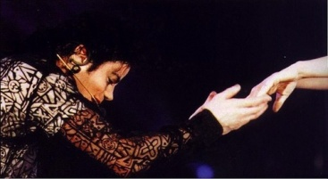

“I can’t believe he did that. She is NEVER going to forget this moment.” Jasmine said.
“I know.”
“I hope you’re not upset that he didn’t ask you to join him on stage.”
“He knows he couldn’t have. We’re business partners. The world can’t know about our personal relationship yet. Besides, Kingdom would’ve hit the roof if they saw me and him doing that together on stage. He also couldn’t choose you because of what happened and of course, because of David making Marie his next choice.”
“He’s the sweetest man ever. Diana, you have NO idea how lucky you are.”
“I know, Jas. I know.”

Michael got down on one knee and sang the remainder of the song directly to Marie making his audience grow more and more excited. Minutes later, one of his guards came and removed her from the stage just after she kissed his hand. She came back and joined us not knowing what to say or how to feel.
“Are you alright?”
“Umm…umm…I…I…”
“Marie? MARIE?” Jasmine kept shaking her but she couldn’t say a word.
“He…he…we…”
“She’s in shock!”
“She’ll get over it.”
“I can’t believe he just did that.” She repeated to herself.
“Are you happy?”
“He…we…in front of 100,000 people.”
“Marie, come on back to earth!” Jasmine said handing her a bottle of water.
“I’m fine. I’m fine. I’m ok.”
“Did you like it?”
“Yeah, but it was…scary.”
“How so?”
“So many eyes, so many screams, so many arms. I don’t know how he does it.”
“He’s used to it. It was sweet of him to do that for you.”
“I think I’ve fallen in love with him all over again.”
“Marie, you will always love Michael and he’ll always love you back.”

Meanwhile, Michael had finished singing and spoke to his audience again saying he loved them and wanted to see them by having his production team turn on the lights in the entire venue. It was so remarkable to see the connection he had with his fans while he slipped on a black jacket with a bright yellow stripe going across his broad shoulders.

“I want to thank the band, the dancers, the crew and all the technical people who make this empire, this industry we have here, this giant circus a possibility. “

The crowd cheered louder hearing his sweet voice vibrate across the entire venue through a single microphone.

“Or should I say, this bow is for you.”

I stood amazed and melted internally as Michael lower his head humbly in front of his fans.
“He loves them so much.” Jasmine said.
“Indeed, and they love him too.”
“You know how I feel about you. From the deepest, from the abyss of my soul and my heart, I thank you and I love you very much.”

“I’M DYING!” Jasmine yelled. “He’s SO sweet!”

Michael then made us all laugh when he noticed a bug on stage and asked Wayne, one of his entourage members to remove it without killing it.

“Did he just say he saw A BUG?”
“YES! That’s hilarious!” Marie said as she burst out laughing.
“He’s so silly.”
“But so cute!”

He spoke a few more words to his fans as they continued to cheer and yell his name making Michael smile and feel their love within him. He continued the concert performing to “I Want You Back” “The Love You Save” and “I’ll Be There” with pictures of himself when he was a child displayed on the screen behind him.
“I don’t know where he gets his energy from!”
“That makes three of us.”
“It’s all part of his disciplined life.”
“And how do you know that, Marie?”
“He told me.”
“You and him talk a lot!” Jasmine said.
“We’re friends. Friends talk to each other all the time.”
“I’m glad you two are so close. He thinks very highly of you, Marie.”
“HE DOES?”
“Yes. If Michael allows you in his world, it’s because he trusts you.”
“Hey! He doesn’t see me that way!” Jasmine said feeling left out.
I laughed as I heard Michael sing in the background.

“He loves you differently, Jasmine. I think he’s still a bit uncomfortable around you because of what happened.”
“I keep telling him not to be but I can understand that.”
“He does like you though. If he didn’t, you wouldn’t be here.”

As Michael continued to sing, we noticed him getting sentimental during the end of “I’ll Be There.” I wanted to comfort him as he lowered his head a few times on stage before standing with open arms allowing his fans to cheer and scream.

“You can tell he got emotional just now.” Jasmine said.
“I know. I wish I could hold him.”
“He’ll be fine. Just watch.” Marie said.

She was right as we saw him jump up and down and sing happily before the lights became dark again.

“How did you know he was going to do that, Marie?”
“He does that all the time. He feels sad at first but then fights it off by dancing around and ending the song quickly before it gets to be too much for him. He then moves to his next act.”
“Act? What act?”
“You’ll see. It’ll be for you.”
“FOR ME?”
“MARIE! That was supposed to be a secret!”
I gasped and took two steps back trying to regain my stability.

“WHAT DO YOU TWO KNOW?!”
“Nothing. We know nothing!”
“You two better tell me NOW!”
“We don’t know what you’re talking about!”
“DON’T GIVE ME THAT! TELL ME!”

Suddenly, Michael was heard walking across the stage wearing his signature black pants, loafers and white sparkly socks. He held a briefcase in his hand and walked towards the center of the stage placing it on top of a stool.

“We weren’t allowed to tell you until the right time….” Marie said.
“Tell me WHAT?”
“You’ll see.”

Feeling agitated and extremely nervous, I waited and watched Michael’s every move hoping he wouldn’t say or do anything to embarrass me. As he opened his briefcase, he took out his signature black jacket and wore it seconds before turning around and reaching for his glove.

“This is for you, my TSG girls.” He said as he looked over his shoulder and winked at us.

“HE DID NOT JUST SAY THAT!” I screamed.
“Keep watching!” Jasmine said.
“Wait, you two KNEW about this?”
“WELL, DUH!” Marie said.
“YOU LITTLE SNEAKS!”
“SHH!!! Keep your eyes on him!” Jasmine yelled.

I pushed myself in front of them so I could get a better view of what he was doing. Chris suddenly appeared and stood next to us.

“This is my favorite part of the show!” He said.

Once Michael had his black fedora in his hand, he closed his briefcase and took center stage.

“What the heck is he doing?” I asked myself not having a clue.

With a snap of his finger, a spotlight appeared and he quickly ran to the center of it placing his fedora perfectly on his head and the beat to “Billie Jean” began to play.

“OH MY GOD! I can’t believe him.” I yelled putting my head down in embarrassment.
“He knew you’d like it!” Marie said as she removed my hands from my face.

We all stood in complete silence as he sang and performed one of his most beautiful and legendary songs of all time.

“She was more like a beauty queen from a movie scene...”

“He’s talking about you, Diana.” Jasmine said.
“Stop. He is not.”
“Oh, yes he is!” Chris said.
“REALLY?”
He kept quiet and glued his eyes to his boss as multi colored lights appeared from all directions making Michael look like a walking shadow. The crowd stood in shock and complete astonishment as they observed him sing and dance to his heart’s delight.

“I’m going to name our daughter that.” I said to the girls.
“BILLIE JEAN?” Marie said looking puzzled.
“What’s wrong with that?”
“Um, is he ok with it?”
“Not really but he’ll get used to it.”
Michael must have known I still had that on my mind as he subtly sang the words I wasn’t expecting to hear.

“Billie Jean is NOT my daughter!”

“WHAT THE—“
“He knew you would say that.”
“He is the biggest brat in the world. I swear I would tickle him right now if he wasn’t in front of so many people.”

“There’s more to come.” Chris said.
“THERE IS?”
“Oh yeah. This is just the halfway mark of Michael’s concert.”
“And there’s another surprise for you too, Diana.”
“Oh god. What else is he going to do to me?”
“It’s not what he will do – it’s what he will SAY.”
“MARIE!” Jasmine yelled. “Zip it!”
“She’ll never guess.”
“I don’t like this, girls. Not one bit.”
“She really has no clue!” Chris said.
“YOU’RE in on this, too?!”
“Well, duh!”
“I cannot believe you all ganged up on me.”
“It was Michael’s idea!” Marie said.
“And you went along with it?”
“We thought it was sweet and you of all people should know he doesn’t take NO for an answer.”
“Apparently not!”
“Don’t get angry, Ana. You will love it. Trust us.”

I didn’t respond and continued watching Michael as the time came for his solo ‘after Billie Jean’ performance where he would free style his dance technique creating an illusion type shadow reflecting from his own image.

“I LOVE THIS PART!” Marie yelled as she stood in front of us trying to get a better view.

I stood proudly watching my future husband dance his feet away in front of 100.000 people wondering what magic he had inside of him to bring such genius type art to life form. He briefly glanced in my direction again before reaching down to grab his fedora next to him on the stage floor.

“Love you, baby!” I mouthed the words to him as he smiled and quickly looked away not wanting suspicion to arise. Once he placed his fedora on his head, the lights dimmed and the spell of Michael’s dance was cast upon everyone.

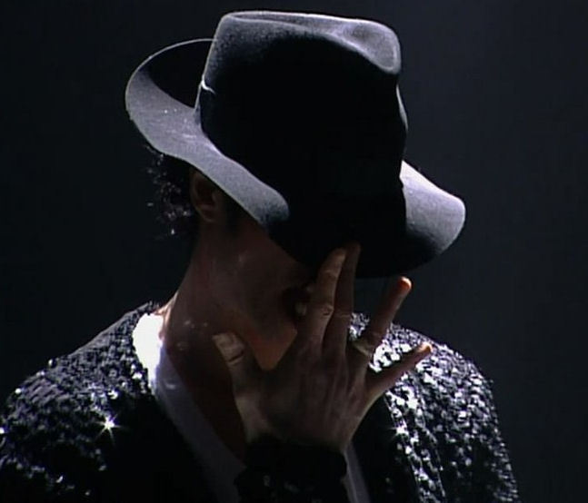

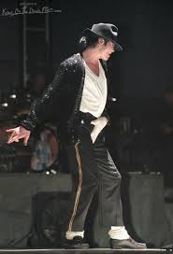
“Gotta love the crotch grab!” Jasmine said as she examined his every move.
“I actually don’t like when he does that.”
“YOU DON’T?”
“No, it draws too much attention to the wrong part of him.”
“THAT’S THE POINT!” Marie said.
“I know but I wish he’d stop doing that sometimes.”
“Why?”
“Because of all he’s been through. It makes him an easy target.”
“Diana, the man could grab his knee and the world would STILL make him an easy target.”
“I guess I’m just overly paranoid again.”
“Michael’s a smart man – he knows what he’s doing.” Chris said as he watched Michael’s performance then began to walk away.
“Where are you going?”
“I need to get behind the stage.”
“For what?”
“His next act – you’ll see.”

He left quickly making us question what he was referring to. Not thinking anything of it, we continued watching as Michael brought “Thriller” to life on stage next.

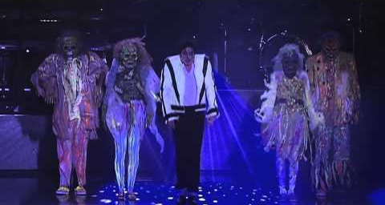

“He is just so fantastic. I love this song!” Marie said.
“It definitely helped his solo career and opened so many doors for other artists along the way.” Jasmine said.

While the girls were discussing Michael’s ‘career path’, his dancers were dressed in scary costumes similar to the ones worn in the short film. Michael also wore his famous werewolf mask and did a magic trick on stage showing his audience he had ‘disappeared’ creating a clever diversion allowing himself enough time to prepare for “Beat It.”

“THAT’S CHRIS!” Marie said.
“How do you know that?”
“Why else did he leave so quickly?”
“I think you’re right, Marie!”
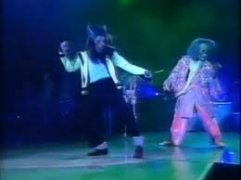
“I guess that’s what he was talking about when he said he had to help him with his act.”

Once “Beat It” began, Michael was standing on a large cherry picker gleaming towards his audience wearing a long black robe with fabric resting against his entire body. He then stepped down wearing a red jacket similar to the one worn in the short film. His guitarist also joined him on stage adding a touch of originality to the song.

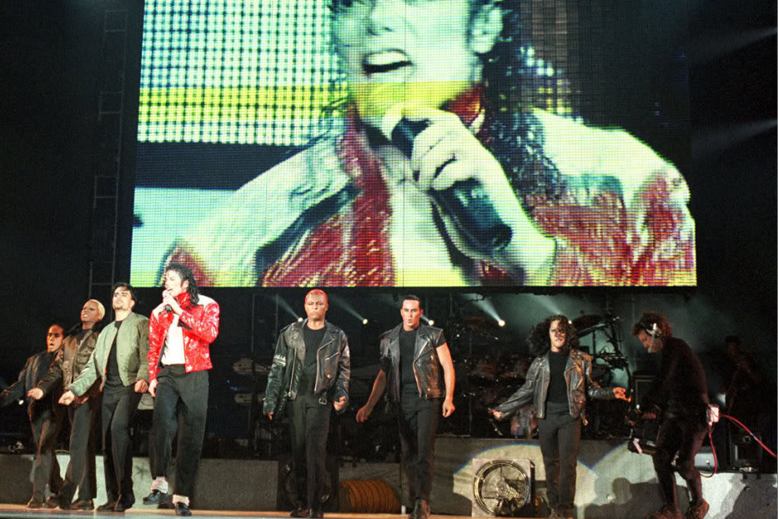
“He’s about to dance again!” Marie yelled as the song slowed down allowing Michael to stop for a few minutes behind the stage while his dancers performed the signature ‘anti-violence’ style dance from the short film. Once Michael took the lead, the crowd was ecstatic again until the song came to a complete stop and played again at the command of Michael’s every jump.

“What is he doing?” Jasmine asked.
“He’s trying to get the crowd hyped. He can tell by their energy when they become restless.”
“Marie, do you and him talk in private about his performing styles?”
“No. I’ve read every single thing written about him. I know why he does the things he does and why he sings the songs he sings.”
“Marie is ultimately THE biggest Michael Jackson fan!” Jasmine said making her feel extremely proud of herself.

Once the song came to an end, Michael surprised us again by performing a song that wasn’t on the concert list.

“BLOOD ON THE DANCE FLOOR?! HE TOLD ME HE WASN’T PERFORMING THAT ONE!” Marie yelled while jumping up and down.

As soon as the beat played, Michael’s face lit up as he glanced over at Marie and winked at her.

“HE TRICKED ME!” She yelled.
“He did?”
“YES! I told him I loved this song and he said he wouldn’t have time to perform it! HE’S THE BEST!”
“That’s the beauty of Michael – always surprising people.”
“I think Diana’s surprise will be the best.” Jasmine said.
“WHAT surprise?”
“You’ll see!”

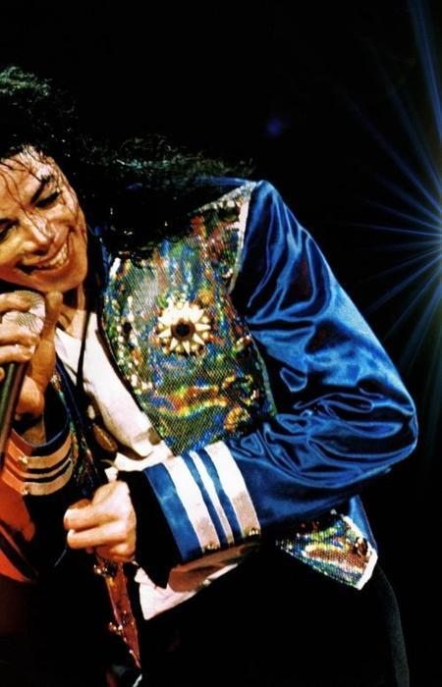
Not paying attention to them, I went back to watching my senior space man as red lights glistened around his beautiful, shiny blue jacket until the song stopped making his feet stop moving.

“Jas, it’s time.”
“Oh right. Diana, this one is for you too.”
“Huh?”
“The next song!”

Fireworks exploded again and Michael’s male dancers were dressed in black suits again wearing red gloves. Michael ‘shot out’ from behind one of his dancers wearing the same attire except he did not have a glove on.
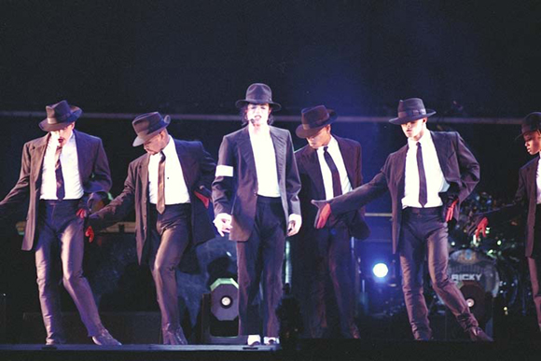

“HE TOLD ME HE WASN’T PERFORMING DANGEROUS!”

The girls laughed at me as if I had said the funniest thing in the world.

“Michael hid certain things from each of you on purpose.” Prince Waleed said as he came from behind us. “He didn’t want any of you to know all of his secrets about the History tour which is why he gave Marie a ‘false’ presentation.”
“THAT LITTLE DEVIL! I should have known!” She said.
“He never ceases to amaze me!” Jasmine said as we all watched him perform one of our most favorite songs.

He surprised me yet again when he looked at me during the chorus winking his eye. He then included an audio clip of my own voice as part of his routine:
“You know you want me!”
I gasped so hard the girls heard me.
“THAT WAS ME! THAT WAS MY VOICE!”
“That was the surprise!” Jasmine said.
“But I just said that to him less than two days ago. How did he record it?”
“He’s Michael!” Marie said.
“Thanks for the reminder.” I said as I covered my face with my own hands.

He also included a small part of “Smooth Criminal” as well as his sister Janet’s voice near the end of his routine before ending the act with one hand on the back of his head and the other lovingly pointing towards his audience with his fedora against his face making his dancers fall behind him at the same time.

“That was smooth!” Jasmine said as she stood next to me completely dazzled.
“I love that routine!” Marie said. “He is so good at imitating the greats.”

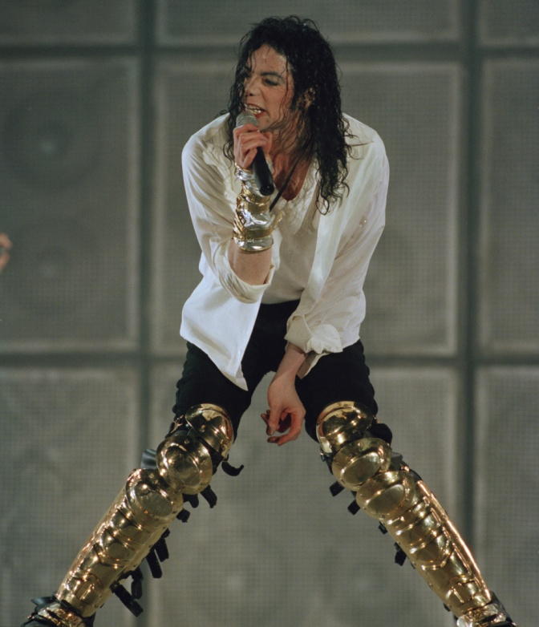
Michael’s next performance was “Black or White”. The short film played on the large screen giving Michael time to change into a new wardrobe again.

“That man will NEVER stop changing his clothes!” I said as I watched Macaulay Culkin jump up and down on his bed on the screen.
“He likes to look his best, Ana. You know that.”
“I do, but I wish he’d stop doing it so often. He always looks amazing and it wouldn’t be the end of the world if he wore something twice.”
“Diana, unless he’s performing, Michael NEVER does anything twice.”
“Except his wife!” Marie said.
“SHUT UP!”

Michael appeared on stage with white lights behind him wearing a white t shirt, a longer white shirt and his signature black pants with his gold pads on top of them.

“I love his hair.” I said wanting to run my fingers through it.
“I love his gold pads!”
“I’d love to remove those for him.”
“JAS! You are horrible. I would’ve expected Marie to say that.”
“Marie says things that are worse. She just doesn’t say them in front of you.”
“Don’t you think there’s a reason for that?”
“She’s scared of you. I’m not.”
“You’re impossible.”
“But you love me anyway.”
“I’M TRYING TO HEAR THE MAN SING!” Marie yelled.

As the song continued, Michael stood near his guitarist and a large, smoke blowing fan was placed directly beneath him. He loved to share his spotlight with his band members and was never one to be greedy or selfish about anything, especially his own fame. The crowd stayed excited as a large square shaped wall crumbled on stage causing a small explosion and excessive smoke to permeate the air.

“That’s incredible. I wonder how he did that on stage.”
“He has his ways.”

The sound of a helicopter and police sirens raided the entire venue as the crowed waited anxiously for “Earth Song” to begin. A revolving planet earth appeared on the screen causing the entire venue to become dark. Lights from all of Michael’s fans were lit up again as the song played in the background before Michael appeared wearing black and red.

“This song always makes me cry!” Jasmine said.
“Me too.”
“I have to admit – I’ve never heard this one.”
“Listen to it, Diana. It’s one of his best that he’s ever created.”

I cried constant tears while listening to his beautiful lyrics and watched him bring the song to life on stage with beautiful visuals. Michael sang wholeheartedly on the cherry picker again followed by an emotional plea at the end with a large army tank, a soldier with a gun and a young child putting an end to war and destruction to the planet while holding a daisy in her hand.

“He is so passionate about people and nature.” I said as I wiped my tears.

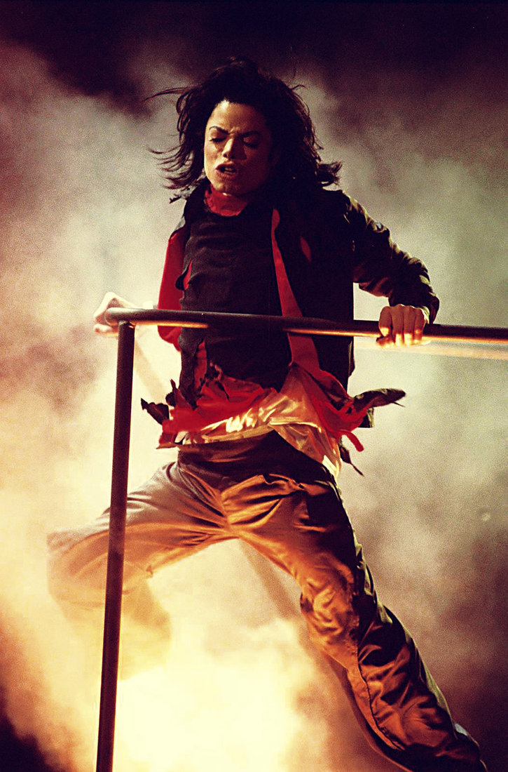
“Indeed. He wants the world to know that we need to love the planet as much as we love each other.” Marie said.
“What a great message.”

Everyone in the audience was silent as Michael concluded the song holding onto the soldier with several other people behind him supporting his idea to preserve the planet and everyone on it. He then had several pictures of adults and young children from all over the world on the screen for the audience to see as he again left the stage to change.

An instrumental version of “We Are the World” began to play followed by “Heal the World.”

“He is so beautiful.” I said to myself.
“Diana, don’t you feel lucky?”
“I do. I just hope people will take his message seriously.”
“I think they will. All it takes is one person to make a difference. Michael definitely is that person.” Jasmine said.
“Jas, you always know what to say.”

Michael’s fans swayed their hands from left to right in unison as he sang beautifully wearing a black jacket with holographic blue stripes on each side going down his arms. He then had several children join him on stage as he held hands with them forming a circle in front of his fans. Seeing this made Jasmine feel emotional as it reminded her of her own family back home.

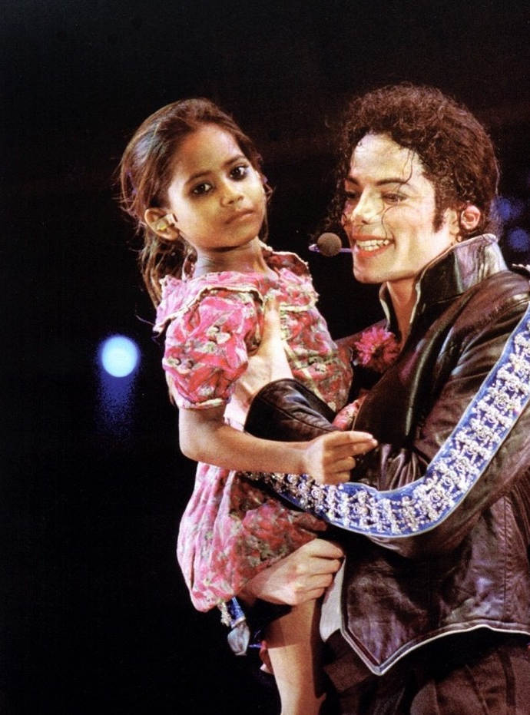

“It’s ok Jas. You can call home when we get back to the hotel.”
“He and David are gone for a few more days.”
“I miss him too, Jas. But he knows we love him.”

We continued watching Michael as he told his fans he loved them and carried a few children in his arms and led them off stage before performing his title song.

“We’re almost at the end.” Marie said.
“Not quite.”
“What do you mean, Jas?”
“This is where MY surprise comes in.”
“Huh?”
“He told me he had a surprise for Diana too. I have a feeling it’s after this since it’s not on the concert list.”
“Oh god. Could there possibly be anything else he could say or do to embarrass me?”
“We’re about to find out.”
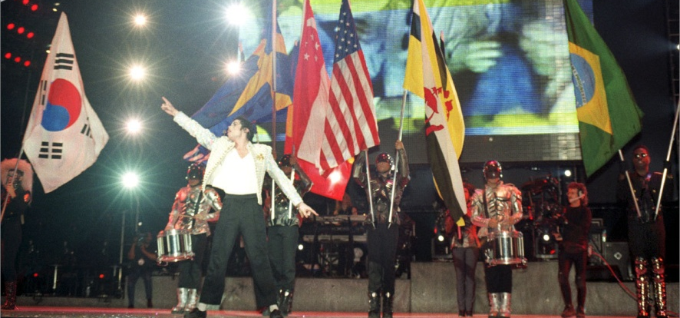
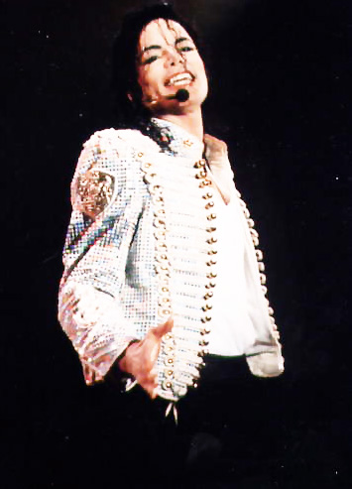
Michael returned to the stage wearing a beautiful white shiny jacket enrobed with pearls and beads that shined as he danced and graced the stage one more time with his magical feet. Several crew members were dressed as soldiers holding up flags representing peace and unity within each country. Behind him, the screen showed flags on behalf of the entire world concluding with Michael’s History promo statue and signature pose.

The audience screamed and hollered for the last time as Michael told them he loved them again. Several members of his crew and production team were seen taking down the sets and turning off the large screen when he turned to his fans saying he had one final song to perform as a surprise.

“Here it comes!” Jasmine said jumping up and down.

Michael surprised me and his fans yet again when he appeared on stage wearing his signature Egyptian style wardrobe for “Remember the Time”.

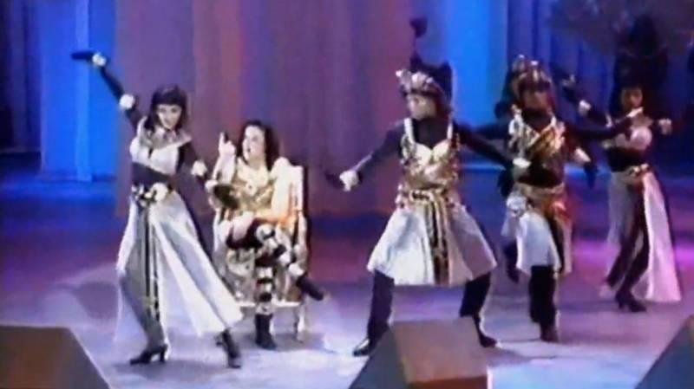

“OH MY GOD! ARE YOU SERIOUS?” Marie screamed feeling more excited than ever before.
“Ana! You have to watch this up close.” Jasmine said putting me in front of her.
“What is that crazy boy up to NOW?”

All of Michael’s female dancers wore beautiful Egyptian skirts made from sheer white chiffon embroidered with the most beautiful black and gold trimmings with tie up shirts that completed the look perfectly. Each one of them glanced in my direction as if they were signaling me to pay attention.

“He is definitely going to be the death of me.” I said trying to calm myself down.
“Don’t worry. He’s very good at doing things without being obvious.” Jasmine said as she and Marie placed me in between them.

The introduction to the song started to play and Michael sat in a chair facing the crowd.

“Why is he sitting down?”
“You’ll see.”
“You know I don’t like being in the dark, Jasmine.”
“Trust me. You will love this.”

I sighed and turned my head as I watched my future husband perform one of my most treasured songs. When the time came to sing the lyrics, the music suddenly turned off and Michael closed his eyes and placed his mouth directly onto his microphone:

“Do you remember when we fell in love? We were young and innocent then. Do you remember how it all began it just seemed like heaven. Do you remember?”
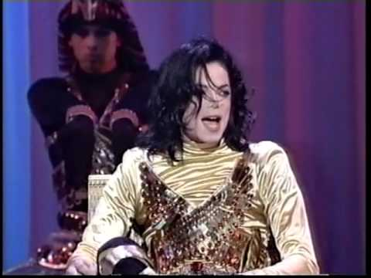

“He missed a part of his own verse!”
“There’s a reason for that.”
“HUH?”
“JUST WAIT AND SEE!” Jasmine said feeling annoyed.

The music began to play again and Michael continued.

“Do you remember? We’d be together all day long. Do you remember? Us holding hands? In each other’s eyes we’d stare…”

“He’s totally missing his own words!”
“DIANA! You’ll find out why in just a second!”
“But that’s not like him at all.”
“He’s doing something different this time!”

I was completely confused. The song, Michael sitting in a chair and his dancers looking at me with smirks on their faces was starting to annoy me.

“He’s about to do something, I can feel it!” Marie said.
“I don’t feel anything except anger right now!”
“SHHH! Be quiet and WATCH!!” Jasmine yelled.

Michael continued:

“Do you remember the time? When we fell in love? Do you remember the time when we first met girl?”

Michael looked in my direction briefly and winked as if he were trying to get my attention without being obvious.

“THAT’S IT! THAT’S THE SIGNAL!” Jasmine yelled.
“What signal?”
“SHH! LISTEN!”

He continued:

“Those sweet memories will always be dear to me. And girl, no matter what was said, I will never forget what we had—“

He then stood up from his chair and screamed looking at me directly with the biggest smile on his beautiful face:

“DIANA, MY BABY!”

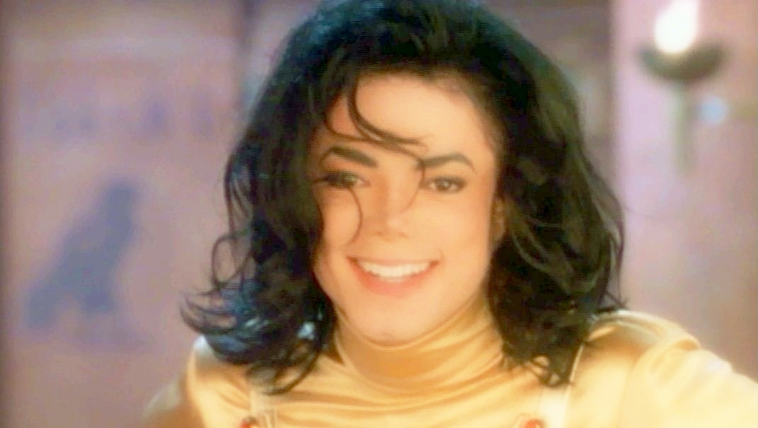

“WHAAAAT?” I shouted almost collapsing to the ground.
“YES YES YES!!!” JASMINE YELLED.
“OH MY GOD! HE IS GOING TO HAVE ME KILLED!”
“HOW SWEET!” Marie yelled.

The girls completely forgot about me and started cheering and hollering loudly as Michael performed the rest of the song with all of his signature dance moves. I had never seen the crowd so out of control throughout the entire night. His fans screamed so loud and cheered constantly making me believe I was at a football game instead of a concert.

Michael continued singing the beautiful song with my name:

“Diana remember? Those special times that just go on and on in the back of mind? Diana remember the time? When we fell in love? Diana remember the time, when we first met girl? I bet you remember. Diana I bet you remember. I bet you remember, Diana.”

“OH MY GOD. OH MY GOD. OH MY GOD. I CAN’T BELIEVE HIM!”
“HE’S SOOOOO SWEET!” Marie and Jasmine yelled as they danced next to me.

I felt my cheeks turning red. I was flattered but also completely embarrassed. Michael always knew how to catch me off guard with his wonderful yet unexpected surprises. Once the performance ended, Michael turned to his fans and told them he loved them more than anything and thanked everyone for attending before leaving the stage for the night. Several security guards helped people leave the venue safely while Chris came over to us saying we had to leave immediately and meet him at the back exit.

“You girls go first. I need to make sure Waleed doesn’t suspect anything and I have to make sure the crew knows what they’re doing.”
“YAAY! We made it through our first concert!” Marie yelled.
“Yes we did and it was fabulous! I can’t wait for the next one!”
“Will he sing to Diana again?”
“NO! I’ll make sure of it!”
“He told me he wanted to surprise her. Now that she knows, I think the thrill is gone.”

The girls headed towards the back exit and I checked on the workers to make sure everything was going according to plan. Waleed greeted me in the hall and asked me what I thought of the event.

“It was beautiful. Seeing Michael perform was an experience I’ll never forget.”
“He shocked us all with that last song of his.”
“I had no idea he was planning that.”
“Let’s hope it doesn’t happen again.” He said as he walked away.

Being around him made me feel uneasy. What Michael did for me was sweet but in Waleed’s eyes, it was clearly inappropriate and I knew it was something I had to bring up with him. Waleed was constantly keeping a close eye on Michael as he went to see him in his dressing room before I had the chance to even get my foot in the door. They had a brief conversation then Waleed stormed out of his room with a look of irritation on his face. Chris saw me and walked me to the back where the girls were waiting for me. It was his job, as per Michael’s orders to take me and the girls to and from the hotel and as well as each venue for each concert.

“Chris, do you know anything about Waleed?” I asked as he opened the limo door for me.
“I know I don’t like him.”
“You too, huh?”
“He’s a jerk.”
“Really? How so?”
“I can’t say. Confidentiality agreement.”
“I understand. Should I be worried about him?”
“Not really. Michael always puts him in his place.”
“That’s all I needed to know.”

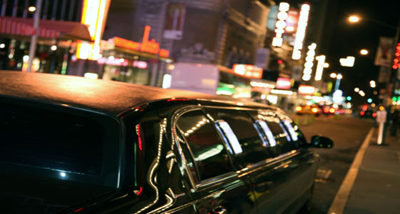

For his security, Michael’s entourage arranged to have three different limos (including ours) and a basic town car for Michael as a decoy so that if anyone were to try and harass him, they would suspect he would be in a limo while we ‘simple’ people were in the town car. I tried to catch a glimpse of Michael as he was being escorted in the car but the windows were tinted and he moved so quickly making it impossible to see him. His security and Waleed also went with him. As soon as the car began to drive away, Chris followed it.

“He’s on his way. We can leave now.” He said as he pulled away from the curb.
“I will NEVER, EVER forget this night!” Marie said as she stretched out onto the leather seat putting her legs up.
“Me neither! I can’t believe we just saw Michael Jackson perform LIVE!”
“Like I said, this is just the beginning!”
“I can’t wait! I hope it’s this exciting EVERY time!” Marie said.
“Girls, we need to make sure we stay professional.”
“Yes, Diana. We know and we will.”

*** AN HOUR LATER ***

Chris took me and the girls to our hotel to get the rest of our things. Michael had switched plans to have the three of us stay with him at his hotel after each concert but still kept our original reservations for the days that he would be rehearsing or busy with meetings, conferences or financial matters that didn’t include TSG. He also knew putting me in the same hotel as him repeatedly would cause grounds for suspicion with Waleed and his entourage.

“I got all my stuff!” Jasmine said as I waited for her in the limo. Marie followed her in and Chris graciously took us back to Michael’s hotel. We were all very anxious to see him so that we could congratulate him on a job well done on his first show in Europe. Chris parked underground at the very back of the hotel’s premises and let each of us out. A bellboy carried all of our things onto a large cart and took our items straight to Michael’s suite.

“I’ll take you girls upstairs to see him then I’ll be retiring for the night.”
“Are you still staying across the hall from us?”
“Yes. I never stay far away from Michael especially when he’s on tour.”
“You’re a loyal man, Chris.”
“I do my best.” He said as he kissed my hand.

Several security guards met us at the back entrance doors and escorted us to Michael’s penthouse. Surprisingly, there were no reporters or fans chasing us which had me concerned.

“Where are all the people?”
“We diverted the press and fans to another hotel in another city.”
“REALLY? That was clever.”
“As much as I don’t like Waleed, he knows how to stay one step ahead when it comes to Michael and his protection. He always tips off the press into thinking Michael is staying somewhere else when in fact he never really leaves the same hotel in the same city unless his next concert is at another location.”
“Michael deserves his privacy. Especially now more than ever.”

Once the elevator doors opened, the girls went across the hall to quickly change and wash up. Chris said goodnight to them and they said they’d meet me in Michael’s room later. Once Chris let me inside Michael’s suite, he kissed my hand again and said he’d be going to bed since it was already past 3 in the morning.

“Thank you for everything today. You were amazing on stage.”
“Shh, that’s a secret Miss Diana.”
“Please don’t be so formal with me.”
“I won’t be the day you and my boss get married.”
“You’re sweet.”
“I do my best. Goodnight.”
“Goodnight.”

I watched him as he entered his suite and closed the door. I then walked into Michael’s suite hoping to find him on the couch waiting for me but to my disappointment he was nowhere to be found. I noticed his bedroom door was closed. I quickly went to the kitchen to get a water bottle for him. I had a feeling he would be severely dehydrated and exhausted. Feeling anxious to see him, I opened the double doors to his bedroom and dropped the bottle from my hand and heard it burst open as my eyes caught a glimpse of the sight that was in front of me…..

