CHAPTER 21:
The Mystery Unfolds

My heart sank directly into my chest. I was completely stunned as I stood there looking at the most amazing sight I had ever seen in a long time. The room was filled with solar powered candles, the bed was covered in rose petals and a large white box lay on the bed. Suddenly, it hit me – Michael had re-created the same scene from five years ago at the hotel we stayed at in Rochester. A large sign cut in the shape of a heart rested on the center of the bed with three simple words written in large black letters:

“Do you remember?”

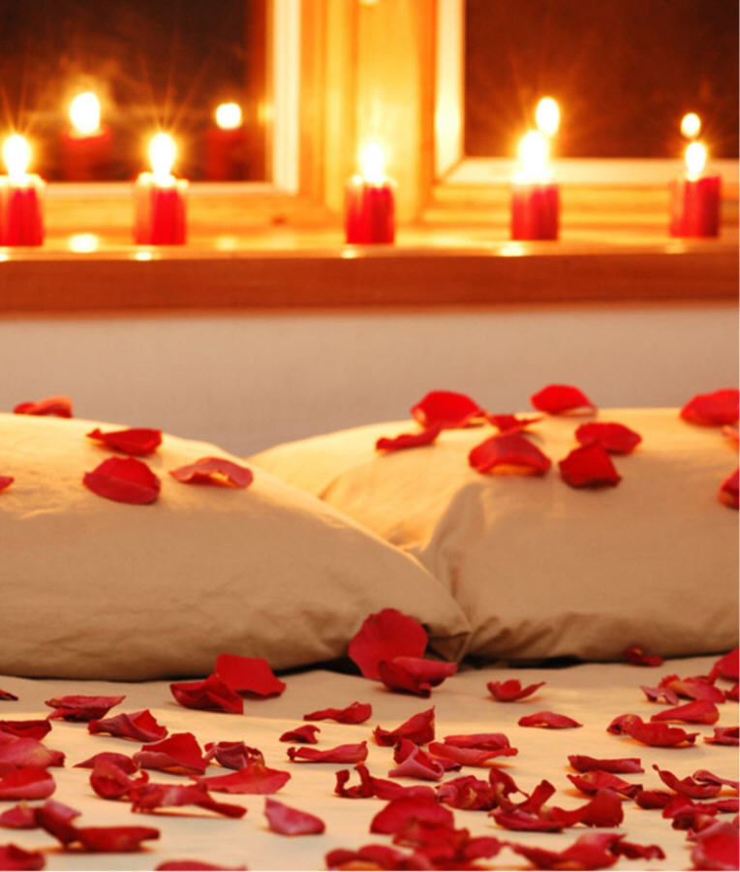

My eyes began to fill as I walked along the trail of candles towards the box. I gasped when I opened it and saw a beautiful black nightgown inside. Without giving it a second thought, I ran to the bathroom, touched up my hair and makeup and put the gown on. I realized the bottle I had in my hand had burst open causing the entire front entrance of the bedroom to be slippery and unsafe. I grabbed a few paper towels from the bathroom and wiped the floor when my hand landed on a black shoe.
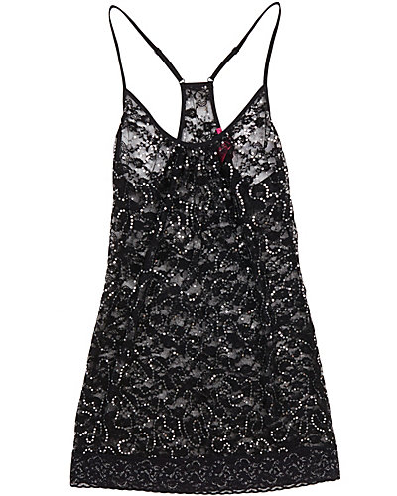
“What are you doing on the floor?” Michael asked.
“I spilled some water. I was just cleaning it up.” I said as I finished and stood up.
“Does this look familiar?” He asked giving me a hug.
“Not really. Why did you do this?”
“DIANA!”
“MICHAEL!”
“I did it for you.”
“Why?”
“Because I love you.”
“And?”
“Because you mean the world to me.”
“And?”
“I want to…to…”
“To…..”
“I want to be your bed friend.”

I laughed as I took him in my arms again.

“You must be exhausted.”
“Not as much as I thought I would be.”
“Really?”
“I’m used to feeling this way.”
“Have you eaten?”
“A bit. I got back a half hour ago.”
“The girls and I just arrived a while ago.”
“Where are they?”
“Changing in their suite. They’ll be here soon.”
“We better make this quick then.” He said winking at me.
“NO, MICHAEL!”

I went to the bathroom and threw away the wet paper towels. Michael grabbed the broken water bottle and threw it across the room not having a care in the world about where it would land. He lifted me up by my waist and placed me directly onto the bed. The sweet, flowery smell from the rose petals made my nose crinkle with joy. I hoped he wouldn’t have the energy to be intimate with me since he had just performed for two hours straight in front of 100,000 people. Of course, that didn’t make any difference to him as he was just as alert as ever.

“We can’t! The girls will be here soon!”
“Stop wasting time then, girl.”
“YOU’RE CRAZY!” I yelled as he pulled me closer towards him.

He gently placed himself on top of me.

“Did you like my surprise?”
“Of course, but you really shouldn’t have done that.”
“Why?”
“No one knows about us yet. I think you gave the press a reason to suspect you now.”
“You think I care? They always have something to say about me.”
“I know, but I don’t want this to affect my business or you in a negative way.”
“Diana, you worry too much.”
“Waleed wasn’t too fond of it either, Michael.”
“When did you talk to him?”
“After the concert. He cornered me and said he wasn’t expecting you to perform Remember the Time and didn’t want to see you do it again. I also saw him leave your dressing room looking furious.”
“He’s just mad because I didn’t tell him about it first. I don’t answer to him. I do what I want.”
“Michael, he’s your joint business partner.”

“So what? He doesn’t control me. No one does.”
“Not even me?”
He giggled and kissed my forehead.

“You only control one part of me, Diana.”
“And what part is that?”
“Give me your hand…”
“NO WAY!”

I slid out from underneath him and tried to leave the room but he grabbed my arm and asked me to lay down with him. I resisted at first but Michael looked so radiant in his black pants and dark grey shirt. I didn’t have it in me to resist him anymore.
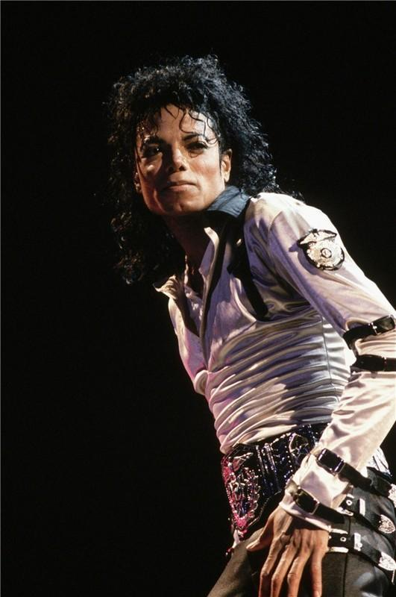
“You were amazing on that stage. The girls and I couldn’t stop looking at you.”
“I’m glad you enjoyed it.”
“Your energy on stage is beyond me. I have no idea how you keep up with yourself and everything that surrounds you.”
“It gets easier with time.”
“Really?”
“The first show is always the hardest. It becomes second nature to me after that.”
“HEY! I know that song.”
“That’s HUMAN nature, Diana.”
“Oh. Oops.”
“You still don’t know a thing about me.”
“YES, I DO!”
“Like what? In the back seat?”
“SHUT UP! That was five years ago. I’ve learned a lot about you since then.”
“Right.”
“I HAVE! Marie’s been schooling me about you.”
“I actually love the fact that you don’t know a lot about me.”
“Why is that?”
“I feel more like a human being instead of an entertainer around you.”
“You do?”
“Of course. You treat me like a person and not some famous celebrity. I love that.”
“To the world, you will always be Michael Jackson. To me, you will always be moonwalker and senior space man.”
“Come here, my sweet Liberian girl.”

He pulled me towards his gorgeous face and we kissed intensely and started rolling around on the bed. I heard Michael laugh as his lips were pressed against mine wanting desperately to lift my gown. My hands continued to push his away and he fought me several times wanting to undress me so badly.

“STOP IT!”
“Stop what?”
“You’re resisting me!”
“I have to.”
“Diana, I’ve been waiting to be with you like this all day. Please don’t deny me now.”
“I’m sorry but the girls will be here soon.”
“We would have been done by now.”
“Excuse me? I’m not a half ass lover.”
“Prove it.”
“MICHAEL! The girls will be here any minute! Can’t you control yourself for now?”
Without answering, he ripped his entire wardrobe off throwing it so far across the room that his pants landed on the couch in the living room and his shirt flew into the bathroom.

“Does this answer your question?”
Seeing him completely bare and exposed in front of my eyes detonated an explosive type fire between my legs. I tried my hardest not to give in but seeing him in the beautiful shining candlelight with his beautiful, long, dark, curly flowing hair and shimmering eyes made me fall victim to his needs. He crawled onto the bed and slowly pulled my gown from the strap. He ran his fingers up and down my legs making me squeal like a newborn child.

“I missed you, Diana.”
“Me too. You have no idea what thoughts were running through my mind while I was watching you dance.”
“I’m glad I wasn’t the only one thinking that way.” He whispered as he gently nibbled on my ear.
“You were too?”
“What do you think I was imagining with my finger?”
“OH MY GOD! That was SO sexy it had me going crazy. I tried not to show the girls. Jasmine was so turned on she actually stuck her own finger in her mouth!”
Michael laughed as he kissed my mouth sliding his tongue in charmingly like a snake slithering across a grass field. I cupped his face with my hands as he pulled on my nightgown asking me to lift myself up so that he could remove it.
“Michael, you know I can’t take it off.”
“Please? Just for a minute?”
“If the girls come to the door I won’t have to worry about putting it back on.”
“Diana, I really want to see your beautiful body…”
“You will. After they leave.”
He agreed and we cuddled against the bed as I ran my hands down his entire frame. Michael felt incredibly strong and muscular, nothing at all like before.

“Baby, you feel different.”
“In a bad way?”
“No, of course not. Your body just seems a lot more robust that’s all.”
“I get that way after performing.”
“Every time?”
“Yes. My body transforms into a fusion like state.”
“Is it serious?”
“No. It’s like a reflex.”
“Like a superhero?”
Michael laughed.

“Something like that.”
“Which superhero do you like?”
“Morph.”
“X-Men?”
“Yes. I love how he can change into anything.”
“You have that same ability, Mr. Jackson.”
“I do?”
“Absolutely. You can easily morph from a sweet, innocent man to a ravaging, sexy, suave gentleman in a matter of seconds.”
“Really?”
“You’ve also morphed into a werewolf, a maestro, a fat angry mayor, a skeleton, a gargoyle and a very handsome looking space man.”
“You won’t ever forget that, will you?”
“Of course not. You’re my sexy astronaut space man wrapped in gold.”
“You’re so sweet.”
“Michael?”
“Yes?”
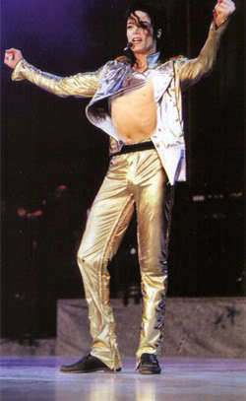

“I want your gold card.”
“My WHAT?” He asked trying not to laugh.
“Your big, gold nuggets.”
“What are you talking about, girl?”
“YOUR SPACE SHIP!”
“What about it?”
“MICHAEL! Are you serious?”
“Are YOU?” He asked changing his tone of voice to a deeper level.
“OF COURSE I AM!”
“About what?”
“You little—“
“What do you want?”
“NOTHING!”
I tried to get up but Michael tugged on my waist sliding me back towards him.

“I was just kidding.”
“I know.”
“You can tease me but I can’t tease you?”
“Right!”
“That’s not fair, Diana.”
“You’re about to find just how unfair I am.”
“NO, DIANA! Please don’t do that to me.”
“And why not?”
“I love you so much.”

Hearing the sincerity in his voice made me feel limp. He really knew how to make my defensive side crumble.

“I love you too.”
“I want you.”
“I know you do.”
“Don’t you want me?”
“Not really.”
“WHAT?”

I laughed as I grabbed him by the back of his head and held him against me.

“Michael, you really ARE innocent and so naïve.”
“Is that bad?”
“No, but it can be dangerous at times.”
“Did you see me perform that?”
“I was talking about YOU Michael, not your SONG.”
“I know. But did you see it?”
“Of course. I didn’t leave the stage the entire time you were on it.”
“That song always reminds me of you.”
“I hope that’s a good thing.”
“Anything to do with you is a good thing my wife.”
“I love when you say that.”
“Say what?”
“BOY! Don’t you start with me!”
He giggled as we kissed lustfully. Michael was longing to go further but I insisted on waiting until Marie and Jasmine saw him first.

“I’m aching so badly for you, Diana.”
“I know, baby. If they’re not here in ten minutes we’ll do it.”
“You’re scheduling our love making?”
“Of course. I’m a very busy lady.”
“Too busy to make love to your husband?”
“NEVER!”

To his surprise, I took a hold of his refined, admirable body and rubbed his package in between my legs. His mouth shivered against mine as his words felt like a warm breeze as they brushed lightly against my cheek.

“Diana, you are my life.”
“I know, Michael.”
“Will you marry me?”
“Didn’t I do that already?”
“I mean in front of a minister.”
“Yes, Michael.”
“Promise?”
“Yes, I promise.”

Feeling an enormous amount of sexual tension, Michael took me in his arms and placed me at the very edge of the bed making my legs dangle. I pulled him towards me and kissed him desirably wanting him to please me the best way he knew how. I felt the heat from his body transferring to mine as he pressed up against me leaving no space in between. He removed my nightgown and gently placed it next to me on the bed not wanting it to be damaged. He planted his fingers against my entire body making me quiver with thoughts of what he would do next. I felt his immeasurable shaft pressured against my labia desperately wanting to make its way through my inner walls.

“I love you, Diana.” He said as he leaned forward against me.
“I love you too.”
As soon as Michael began to penetrate, the girls arrived and knocked at the door.

“SHIT!” He yelled as he quickly stood up.

“MICHAEL! Since when do you curse?”
“I don’t usually. I’m going to annihilate those two!”
Seeing and hearing Michael so frustrated made me snicker to myself. I had never seen this side of him before. He grunted angrily under his breath as he and I both got dressed.

“What?” He asked reaching for his shirt and pants.
“You look so pissed off.”
“I AM! I was just about to make my move!”
“I told you they’d be here.”
“I know. I bet it was Jasmine’s idea.”
“Why would you think that?”
“I heard she’s been perving on you for days about our sex life.”
“’PERVING ON ME?’ Where did you learn that expression? And how did you know that about her?”
“Marie told me.”
“WHAT? LET THOSE TWO IN!”

I quickly put on a pair of jeans and one of Michael’s shirts. Once we both looked decent, we left the bedroom and headed towards the suite door. Michael suddenly took me in his arms catching me off guard.

“Diana, they can’t see me like this.”
“Like what?”
He grabbed my hand and placed it on his ‘gold card’. I tried my hardest not to laugh at him but I did.

“DIANA, DON’T LAUGH AT ME!”
“I’m sorry. I’m not. I swear I’m not.”
I continued giggling under my breath while the girls kept knocking. Michael pressed the intercom button near the door saying he’d let them in a minute.

“DIANA, I NEED TO HIDE THIS!”
“You can’t hide an erection, Michael.”
“WHAT SHOULD I DO?”
“You have to ’put it to use’.”
“HOW?”
“You have to ‘release’ yourself.”
“I would have if those two hadn’t showed up!”
“Go in the bedroom, put on a long shirt, wait ten minutes, think of something horrid and it’ll start to die down.”
“How do you know that?”
“I have a brother, Michael. I know these things.”
Without answering, Michael let go of me and headed for the bedroom. I grabbed his arm not wanting him to leave.

“What are you doing?”
“I didn’t say that was the ONLY way to get rid of it.”
I slipped my hand inside his pants and began relieving him of his embarrassment. It seemed to work quickly as Michael stood against me making the most rapturous sounds I had ever heard.

“Oh god, please don’t stop.” He whispered as I caressed him harder and faster.

He held onto me tightly digging his fingers into my back as I continued touching his most sensitive area. The feel of his firm and perfectly textured manhood in my hand was undoubtedly satisfying for both of us.

“You feel amazing, baby.” I whispered trying to finish quickly.

The girls were still at the door knocking profusely. I could hear them screaming with thoughts of worry thinking something was wrong with me or Michael.

“Baby, I have to let go now.”
“NO, PLEASE DON’T! I’m almost there.”
“What if they wake up Chris asking him to let them in here?”
“OH MY GOD. I didn’t even think of that. GO FASTER, DIANA! FASTER!”

I laughed as we both stood against the wall near the door. Seeing Michael so distressed made me feel bad but at the same time, also made me want him more. As much as I wanted to make love at that moment, I knew it wasn’t the best time and had to finish what he and I started before the girls interrupted us any further.

“Diana, you are so good at this.”
“Um, thanks?”
“Have you been practicing?”
“I have nothing to practice with, Michael!”
“Well, you do NOW!”
Michael’s voice went higher as he screeched against my ear making me feel insanely hot for him.

“Michael, don’t do that. You’re driving me crazy.”
“You make me want to SCREAM SO LOUD. PLEASE keep going!”
“I love that song.”
“This is not the right time to talk about that.”
“Stop pressuring me. Makes me wanna scream!”
“NOT NOW, GIRL!” He yelled making me laugh.

“ANA! MICHAEL! LET US IN! ARE YOU TWO OK IN THERE?”

“Please keep going just a little more. I’m almost there. I’m almost there.”
I continued stroking and rubbing him wanting to put him at ease as quickly as I could but Michael’s erection wasn’t subsiding. Feeling worried, I knew there was only one thing for me to do.

“This will definitely do the trick.” I said as I pulled my jeans and underwear down to my knees. I shoved him inside of me with every ounce of force I had.

“OH MY GOD, DIANA!” He screamed.
“SHHH!!! Hurry up and finish!” I whispered.

“ANA! IF YOU DON’T LET US IN IN 30 SECONDS WE’RE GOING TO CHRIS!”

“Hurry up!” I yelled.

Michael gently threw me up against the wall and pumped himself sharply inside of me as hard as he could. His proven dancing abilities were definitely an asset to him in that moment. He was finally relieved of his strain within seconds and exploded inside of me like a ruptured volcano. To his surprise and mine, I did the same.

“That was AMAZING. Thank you SO much.” He said as he kissed my sweat infused lips.
“Oh my god. We need to do that more often!”

“ANA, CHRIS IS WITH US. HE’S GOING TO LET US IN!” I heard Marie yell.

“GET TO THE ROOM NOW!” I said shoving him towards the bedroom doors. In a matter of two seconds, he closed the doors behind him and the girls Chris barged into the suite with Chris.

“HEYYY! HOW ARE YOU THREE DOING?” I asked like a complete fool.

“WHY THE HELL DIDN’T YOU ANSWER THE DOOR?” Jasmine asked looking completely terrified.
“Um, I didn’t hear it?”
“WHERE WERE YOU? IN ALASKA? We were banging loudly against the door.”
“Oh god, so were we!”
“HUH?”
“I MEAN – I was helping Michael write a new song. We were out on the patio and the doors were closed.
“We had to wake Chris up so that he’d let us in. Don’t EVER do that again!” Marie said as she came inside and sat down on the couch next to me.

I apologized to Chris as he stood in the doorway half-awake wearing a Santa Claus hat and fuzzy red pajamas.

“Chris, you look adorable.”
“Is Michael ok?” He muttered under his breath.
“Oh yeah, he’s fine. Just getting changed.”
“Good. Going I’m bed to.”
“HUH?”
“He’s going back to bed!” Jasmine said helping him back to his suite.
“Leave the door open! I’ll be right back.”

“I love your shirt.” Marie said as I went back to the couch.
“It’s Michael’s.”
“I guessed that. Where is he?”
“Doing what he does best – getting changed.”
“Is he feeling ok?”
“He’s perfectly fine. Very relieved.”
“About what?”
“His erect—UM, his first concert doing so well.”
“He was amazing.”
“Oh Marie, you have NO idea.”
“Huh?”
“Marie, his body is just so—“
“I’m back!” Jasmine said.
“JASMINE! WHY ARE YOU HERE?!” Marie yelled feeling disappointed.
“Why wouldn’t I be?”
“Ana was just about to tell me something!”
“Well, what’s stopping her?”
“It’s nothing. I just got caught up in the moment.”
“What moment?”
“A moment with Michael.”
“MOVE OVER, MARIE!” Jasmine yelled as she shoved her right off the couch.
“HEY! I WAS HERE FIRST!”
“SHUTUP! I NEED TO HEAR THIS! Go ahead, Ana. Don’t leave out A SINGLE detail!”
“Jasmine, you so need a life!”
“SO?!” She said making Marie and I laugh.
“You both know how to push my buttons.”
“Did Michael push yours yet?”
“JASMINE STOP!”

“Please don’t yell at my two favorite girls in the whole world!” Michael said as he opened the bedroom doors and walked towards us dressed in black. The girls jumped up from the couch and hugged him together making Michael smile brightly with flushed cheeks.

“YOU WERE AMAZING!” Marie yelled as she held him so close to her.
“INDEED! WE COULDN’T TAKE OUR EYES OFF YOU!”
“Thank you so much.” He said softly kissing their foreheads.

He and the girls sat next to me on the couch. Michael held me from behind and cuddled against my back as the girls sat across from us.

“Michael, are you feeling ok?” Marie asked.
“I’m much better now. I was really tense earlier.” He said trying not to give too much away.
“What happened?” Jasmine asked with concern in her voice.
“Yeah, Michael – what happened?” I asked putting him on the spot.
“Diana couldn’t keep her hands off me.” He laughed adorably catching me completely off guard.
“WHAT? HE’S LYING!”
“DETAILS PLEASE!” Jasmine said.
“She was grabbing me all over. I felt violated.”
“MICHAEL, STOP IT!”
“OOO WHAT PLACES EXACTLY?”
“JASMINE, KNOCK IT OFF! He’s just feeding your curiosity with bullshit.”
“WHO CARES? IT’S HOT! GO ON!”
Marie was laughing uncontrollably. Michael politely asked her to get him a bottle of water from the mini bar. She made her way over to the small fridge. When she opened it, she was amazed to see the large amounts of candy, chips, pretzels and chocolates that were inside.

“OH MY GOD. Michael, can I have something from here?”
“Of course!”
“Michael, those things are really expensive.” I whispered in his ear.
“It’s ok. She doesn’t need to know that.”
“Are you sure it’s alright?”
“Yes, you all can take whatever you want.”
“Marie, get me a snack too please!” I said as I browsed through the mini bar menu.
“What do you want?”
“Something chocolaty.”
“You have that right here.” Michael whispered as he took my hand.
“MICHAEL!”
“What? What?” Jasmine asked trying to find out what he said.
“NOTHING! Michael is being his usual, bratty self.”

Marie came back over to us and handed me a bar of milk chocolate and a bottle of water for Michael.

“What did he say to you? PLEASE tell me!!”
“Jasmine, you need to get laid.” Marie said unexpectedly.

Michael spit out his water and laughed hysterically at Marie’s comment.

“AMEN, MY SISTER!” I said as we both slapped hands.
“Marie, that’s not a nice thing to say.”
“I know but it’s the truth.”
“IT IS NOT!” Jasmine said playfully shoving Marie away from her.

*** TWO HOURS LATER ***

“It’s already 7am!” Jasmine said looking at a clock on the wall.
“That’s early for me.” Michael said. “I once went four days straight without sleeping.”
“WHAT?? WHEN?” I asked feeling incredibly worried.
“During the trial. I couldn’t sleep at all. It was the worst time of my life.”
“Those days are over now.” Marie said trying to make him feel better.
“I know but they still haunt me.”
“They do?” I asked holding his hand.
“All the time. That’s why I always ask you to stay with me. I hate being alone with my thoughts sometimes.”
“Michael, while you were suffering during those horrific days your fans suffered with you.”
Hearing Marie’s heartfelt words made his eyes fill. The girls came to his side to comfort him. Marie rested her head on his shoulder and Jasmine lightly massaged the top of his back.

“We always knew you were innocent.” Marie said.
“Yes, we did and Marie NEVER stopped fighting for you.”
“Really?”
“Yes! She failed two classes because she was so focused on you and the trial.”
“JAS!”

Michael lifted her head in shock.

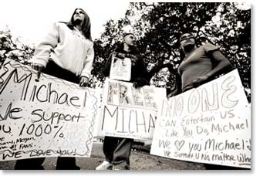
“Is that true?”
“I wanted to support you and had no way of going to California. I knew I couldn’t ask Ana because you two weren’t together anymore and Jasmine was married and a mom. I couldn’t travel alone at the time and was angry that I couldn’t be there for you. I knew you needed me so I gave up focusing on school and put all my energy into defending you.”
“AND she started a protest in our neighborhood too.” Jasmine said.
“Don’t tell him that!”
“Why? It was remarkable! She and her other friends held up signs, played your music and films every single day, wore shirts and buttons with your name on them saying you were innocent. She did more for you than anyone else we know. It was beautiful. Marie is definitely your most dedicated fan, Michael.”
“It was also Marie who came up with the name for TSG Productions.” I added.

Feeling incredibly overwhelmed and flattered, Michael kissed Marie’s forehead thanking her for all that she did for him. He then kissed the back of Jasmine’s hand and told us all he was so grateful that we supported him during the most dreadful time in his life.

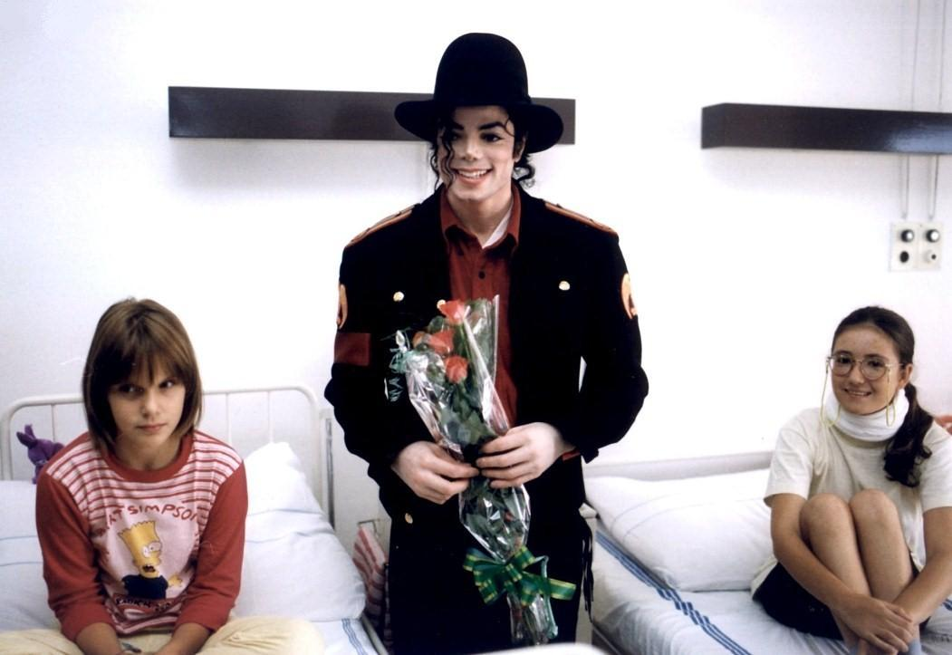
“It’s late. We should all go to bed.” Jasmine said.
“Michael, when is your next concert?”
“In three days in Cologne.”
“At least we get a break in between.”
“You three do. I have rehearsals and will visit the orphanages here.”
“You’re a sweet man, Mr. Jackson.” Marie said making him giggle.
“I think it’s time we leave the lovebirds alone, Jas.”

Michael walked the girls to their suite and made sure his guards were fully visible surrounding the most important areas around him. When they informed him he would be safe and the entire floor was secure, he closed the door making sure it was latched and joined me back on the couch again.

“Are you ok?” I asked as he lay on top of me.
“I’m tired, Diana.”
“I know, baby. I can tell.”
“I just want to lay here with you if that’s ok.”
“Of course. I’d like that.”

I massaged his back and shoulders trying my best to soothe him of any discomfort he had. His took my hand in his and kissed my finger.

“Thank you for wearing my ring, Diana.”
“You don’t need to thank me. It’s my engagement ring. I still wear the other one too.”
“You still feel like a dream to me.”
“I do?”
“I wake up every morning asking myself if your part in my life is real.”
“I do the same thing.”

He lifted his head and faced me.

“Please don’t ever leave me.”
“I’d rather die.”
“DON’T say that.”
“Sorry. But it’s true.”
‘I love you, Diana.”
“Hmm…I think I love you too.”
He started tickling me making me shriek with laughter. I managed to break free from him and ran into the bedroom where he caught me making us both land on the bed. I locked his legs underneath mine forcing his body to flop onto mine like a goldfish out of water.

“You’re the best thing that’s ever happened to me, Diana.”
“I feel the same way about you.”
“Will you go with me to my next rehearsal?”
“I’d love to but I think it’s best that we keep things at a distance in public.”
“Why?”
“Waleed is starting to suspect me.”
“Did he tell you that?”
“Not with words.”
“Let me deal with him.”
“Michael—“
“Diana, don’t let him get to you. I’ve known him for a long time. He’s over protective and paranoid about every single one of his business matters.”
“I think it’s more than that.”
“If it is, I’ll find out. In the meantime, I’d love for you to be with me.”
“Will you be going to the orphanages tomorrow?”
“Yes and the hospitals too.”
“I’d love to join you.”
“YOU WOULD?”
“Of course. Why do you sound surprised?”
“I was hoping you’d say that. I’ve wanted to ask you to go with me for so long.”
“Why didn’t you?”
“I was afraid you’d say no.”
“WHY?”
“I didn’t think you’d want to be around children for a while…”
He touched my stomach and hugged my waist tightly.

“Thank you so much for agreeing to go with me. I love you even more now.”
“Your happiness is my happiness, Michael. We’re not two, we’re one. I’m your shield and you are mine, remember?”
“Why are you so perfect?”
“Because I’m with you.”
He smiled and kissed me before standing up to change again.

“Michael you really need to stop doing that so often.”
“I can’t sleep in this!”
“Why not?”
“It’s not comfortable for me.”
“Take it off then!” I said winking at him.
“You’d like that, wouldn’t you?”
“Can I do it for you?”
“You want to undress me?”
“YES! YES! YES!”
“Girl, you’re crazy. I’ll be right back.”
He went to another room where several pairs of his clothing were. I slipped under the blankets and waited for him to return so that we could cuddle together. I lay my head against the fluffy, soft white pillow watching each of the solar powered candles slowly extinguish their flame. I felt my eyes beginning to close. I could hear the sounds of cars and trains passing outside from the bay window across from the bed. The lights of Germany were truly breathtaking. Michael was lucky to travel all over the world and be adored by millions of fans from so many different races, backgrounds and ethnic groups. I knew it made him happy and he never took any of it for granted. The more he knew he was loved, the more humble it made him.
I felt his presence as he walked back in the room and lay down next to me. The warm, cozy sensation radiating from his arms made me feel entirely guarded from danger. I felt him gently blow on my cheek before whispering in my ear.

“I love you cupcake.”
“I love you too space man.”
“I’m sorry. Did I wake you?”
“No. I was waiting for you to come back.”
“I hope I didn’t take long.”
“I’d wait a lifetime for you.”
“I think five years was long enough for the both of us.”
“You are so right.”
“Diana?”
“Yes?”
“Our kids are going to be so cute.”
“I know. I hope they look like you.”
“Why me?”
“Because you’re cute too.”
“Girl, stop it.”
“You KNOW it’s true!”
“It is not.”
“YES, IT IS!”
“I’m just me, Diana.”
“Who you are is beautiful.”

He tilted my head towards his and kissed my lips gently.

“I hope we always stay this way.”
“Me too.”
He linked his fingers with mine and held my hand tightly.

“Diana?”
“Yes?”
“I miss orbiting you.”
“GOODNIGHT, MICHAEL!”

He laughed as I turned to my side and wrapped his loving arms around me. We both watched the sun as it broke through the clouds making its way to the highest point in the sky. We still couldn’t adjust to the time difference and Michael told me he had rehearsals in less than three hours. I closed my eyes and the two of us floated away into our dreams.

*** A FEW HOURS LATER ***

“ANA! WAKE UP! IT’S ALMOST 5!” I heard Jasmine say as she and Marie barged into my room.
“How do you two manage to wake up on time?”
“It’s easy for us. We don’t pull all-nighters like you and Michael do.”
“I don’t have a choice. Michael’s schedule is always hectic. Is he at rehearsal?”
“He always is. Chris said he’d be back by 9 which gives us girls some time to explore the city!”
“I called Gerwin and asked him to be our tour guide.”
“Who?”
“Gerwin – the guy I met at the coffee shop?”
“OH, RIGHT!”
“Did you see him at the concert, Marie?” Jasmine asked.
“No but that’s my own fault. I never left the stage. He obviously had no way of finding me.”
“He doesn’t know anything, does he?” I asked Marie sitting up in bed.
“No, and it’s going to stay that way.”
“Ana, get dressed! We ordered room service and Gerwin will be here in an hour.”
“He knows we’re staying here?” I asked sounding worried.
“Nope. I told him to meet us downstairs. I said we had a business meeting here.”
“Very good, Marie. You know how to handle yourself with strangers.”
“I know. I’m good!”
“Are you sure it’s safe to be travelling with this guy? This isn’t Los Angeles and we don’t exactly know him.”
“Chris will be our chaperone and chauffeur. He’s our safety net in case this guy turns out to be a creeper.”
“I can’t wait to meet him.”
“Hurry and get dressed. The food will be here soon.”
“I’ll be right there. I just need to find something to wear.”
“Wear something of Michael’s!” Marie suggested.
“I can’t do that! What if one of his fans sees me dressed in his clothes?”
“What are the chances of someone knowing it’s his?” Jasmine asked.
“Good point. I’ll see what I can find!”
“CAN I SEE HIS UNDERWEAR?”
“JASMINE! You are trying my patience!”
“I swear I was kidding. I don’t want to see them. I’d rather see what he has inside them!”
“JAS!”

I chased after her in the suite rushing past Marie as she laughed her head off and pulled out a small camera from her pocket. She took pictures of me and Jasmine being silly and play fighting then took a few of herself making kissing faces. The doorbell rang and Marie went to answer it knowing it was room service.

“Jas! You need to QUIT.”
“You love it, Diana.”
“I used to. Now you’re getting annoying.”
“Is that what you say to Michael too?”
“JASMINE!”

She and I hugged each other as she kept teasing me continually. The hotel staff came in and started setting up the food. I ran to the bedroom to shower and freshen up. I put on one of Michael’s plain black t-shirts underneath my black blouse and used one of his military sashes as a belt to accessorize the red skirt I had on. I wanted to wear his fedora but hesitated since I didn’t want to take over his classic style or give too much away to the public about our relationship. Once my hair and makeup were set, I went back to the living room and joined the girls.

“It’s about time!” Marie said.
“Ana, you look beautiful. I love the belt.”
“It’s his. I hope he doesn’t mind.”
“He’ll love it on you.”
“What are we eating?”
“They just set it up and left. Let’s find out!”

The girls and I followed the smells that lingered in the room as we made our way to the serving tables. We opened a few lids of silver from several different trays and couldn’t believe the amount of food that was in front of us. It was all healthy and cooked from scratch. Jasmine and Marie grabbed their plates and headed straight for the main course of chicken, fish, rice, potatoes and vegetables while I filled up on two different kinds of salads and dinner rolls. Just as we were about to sit at the dining room table, the suite door opened and Michael walked in.

“OH MY GOD! WHAT A PLEASANT SURPRISE!” I screamed as I ran and hugged him tightly.

The girls followed me and Michael kissed their foreheads saying he missed us all and came back to spend time with us before the next round of his rehearsals began.

“We were just about to eat – join us!”
“I can’t eat before rehearsals. It slows me down.”
“Does that mean you didn’t eat this morning?”

“I did but I always eat at least three hours ahead of rehearsal time. That way it’s digested before I start to dance.”
“So THAT’S why you’re such an early bird!” Jasmine said.
“Yes, exactly.”
“Have a bun at least!” Marie said.
“I already have two.” He said pinching my behind.
“YOU ARE SO BAD!”
“Crap! Marie where’s that camera of yours?!”
“SHUT UP, JAS!”

Michael laughed and said the way we all interacted with each other made him happy. I took his hand and led him to the table and the girls followed. As we were leaving the room, the doorbell rang.

“I’ll get it!” Marie said.
“Are you girls expecting someone?” Michael asked.
“I completely forgot to tell you. Marie met someone.”
“SHE DID? WHEN? WHERE?”
“Yesterday while we were out having coffee and getting pampered for the concert.”
“Who is he?”
“I don’t know. He agreed to show around us town today and Chris will be coming with us.”
“Good. I don’t want you three wandering around alone in this city.”

Marie greeted him at the door and hugged him as he came inside. Jasmine, Michael and I all stepped forward anxiously wanting to meet the mystery man that Marie was interested in. Surprisingly, the unknown man didn’t remain a mystery for very long.

“MICHAEL?”
“GERWIN?”

