CHAPTER 24:
The Rainbow after the Storm

*** TWO DAYS LATER ***

St. Marien Hospital, Cologne, Germany. June 2, 1997.

I woke up in a hospital bed with the sounds of a heart rate monitor and the sensation of an IV in my arm. I looked around the room hoping to find someone to explain what I was doing there but I was alone. I started having flashbacks of what happened earlier and couldn’t stop myself from crying. I closed my eyes hoping it was all a bad dream but my wish was shattered once the girls walked in with a doctor by their side.
“Thank god you’re awake.” Marie said as she came and kissed my forehead.
“We were so worried about you.” Jasmine said coming to the other end of the bed holding my hand.

“You gave us quite the scare, Ms. Dean.” The doctor said as he picked up my chart and started writing.
“Dr. Klein?”
“Yes. How are you feeling?”
“My head feels like it’s been through a grinder.”
“That’s a very common side effect for people who have experienced what you just did.”
“What happened to me?”
“You suffered from what’s called a transient ischemic attack. Also known as TIA.”
“What is that exactly?”
“A mini stroke.”
“WHAT?!”
“It could have been worse.” Marie said.

“She’s right. You had a very mild case due to the extreme breakdown your body went through. It seems like you were under a tremendous amount of pressure which caused your brain to go into shock.”
“Was it serious?”
“If you had been under any more stress, it could have been.”
“Dr. Klein, do you work in Europe?” Jasmine asked.
“I work in several different facilities around the world. Right now, due to his tour, I’ve transferred my practice according to his travel dates. I need to stay close to Michael as often as possible.”
“OH MY GOD! WHERE IS MICHAEL?”

The girls looked at each other without saying a word. Dr. Klein also seemed lost for words.

“WHERE IS HE?”
“Ana…” Marie said softly.
“What happened to him?”
“Diana…Michael is in stable condition but…”
“But WHAT?”
“He’s also a patient here. Under observation.”
“What for?”
“He’s been temporarily sedated.”
“WHAT? NO!”

I tried to get up from the bed but the IV in my arm made it difficult for me to stand. The girls tried to calm me down and Dr. Klein insisted that I stay put for now.

“What about his concert? He is scheduled to perform in Cologne tomorrow!”
“We ARE in Cologne, Diana.” Jasmine said.
“We are?”
“Yes. You and Michael were both airlifted from the hotel in Bremen. These two ladies took care of all your responsibilities while you were unconscious. Michael’s co-partner Waleed did a fabulous job diverting the press and fans from finding anything out. Other than a few speculators, no one knows what really happened.”
“But his concerts…”
“His dates will be adjusted accordingly if necessary. I don’t see him not being able to perform tomorrow provided he gets the rest that his mind and body desperately needs.”
“So he IS going to be alright?”
“There’s no doubt in my mind. We had no choice but to do what we did in order to safely temperate his body back to normal. Michael was very distraught and his mind was in a very fragile state. He needed to forget the extreme animosity around him.”

Suddenly, I felt responsible for everything that happened. Did I take things too far? Was I reading too much into things? Should I have just stayed and tried to work things out?

“When can I leave here?”
“Given the nature of your job and Michael being who he is, we’ll run a few more tests on you two and keep you both under observation for now. I know you’re a busy woman and if everything looks normal, you should be able to leave in the morning.”

I thanked Dr. Klein as he left. I knew he had other patients to take care of and I didn’t want to occupy all of his time.

“We’re so glad you’re ok.” Jasmine said as she squeezed my hand.
“Girls, tell me the truth – how is he?”
“He’s fine. We saw him a while ago. He looks okay.” Marie said.
“This is all my fault. I pushed him over the edge.”
“Don’t say that. You both were just upset.”
“Upset? I hit you to the ground and the man held onto me like I was about to jump off a cliff.”
“Diana, don’t overthink it. Whatever happened is in the past. You and Michael will work this out. This will bring you two closer together, you’ll see.”
“Where’s our marriage certificate?”
“It’s in a safe place.” Marie said.
“How safe?”
“Chris has it and we all know he can be trusted.”
“What about my flight?”
“We took care of that too.” Jasmine explained. “I called the airline and canceled your flight saying you had changed your mind about leaving. I didn’t want your name linked to a medical emergency so I didn’t tell them what happened and because it was less than 24 hours since you booked it they reimbursed you. Chris, Marie and I brought all of your things with us on the flight here and took them to the hotel already. Everything is ok.”
“Thank you so much, girls.” I hugged them tightly feeling the love in their warm embraces.

“Marie, have you heard from Gerwin?” Jasmine asked.
“He called me from the airport saying he’s taking the next flight here.”
“He knows?”
“I had to tell him. He knew you two were arguing when he came to the hotel.”
“I hope we can trust him to keep his mouth shut.” Jasmine said.
“I don’t think we have to worry.” Marie said.

*** GERWIN’S POINT OF VIEW ***

BREMEN INTERNATIONAL AIRPORT

“Attention passengers. Flight 1203 to Cologne will be boarding in ten minutes.”

Gerwin anxiously waits at the gate wanting to board his flight when he receives a phone call from an unknown number.

“Hello?”
“Where is he?”
“Cologne. I’m on my way there as we speak.”
“I’ll be there by tonight. We’ll meet after dark.”
“Indeed.”
“Do you have it?”
“Yes. Be sure to bring the cash with you.”
“Don’t worry about me. Just make sure you have what I need and don’t even think about trying to cross me. You have NO IDEA what I will do to you.”
“I have no doubt in my mind and would never do such a thing. You have my word.”
“I want him destroyed, Mr. Vogel.”
“He’s already on the verge of it.”
“What do you mean?”
“He and Diana had a massive fight. They’ve both been hospitalized.”
“YOU IMBECILE! WHY DIDN’T YOU SAY THAT IN THE FIRST PLACE?!”
“I thought you didn’t care about what happens to him?!”
“I don’t want him DEAD you idiot! I’ll be in touch later.”
“Hello? Hello?”

“Flight 1203 is now ready for boarding. All passengers please arrive at gate 130 immediately.”

Feeling nervous, Gerwin boards the plane. He has no idea why this specific person would want to destroy someone who, according to them means so much to them. Gerwin clearly has no idea what he’s getting himself into but he doesn’t care. All he sees his dollar signs. Dollar signs that will help launch his record label and turn him into a rich, successful business man equal to the standards of Diana. Something he’s been dreaming about for years.

*** DIANA’S POINT OF VIEW ***

“Ana, you need to eat something.” Marie said handing me a cup of red Jell-O.
“I don’t feel like it. I really want to see him.”
“You will tomorrow. I’m almost certain you both will be discharged at the same time.”
“Let’s see what’s on TV.” Marie said trying to change the mood in the room.

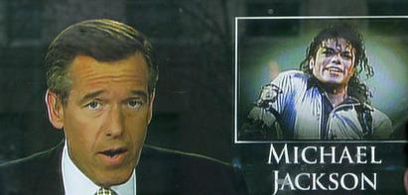
As soon as she turned it on, news of Michael’s condition was on every single news channel.

“Singer and superstar Michael Jackson has been hospitalized in Germany after a series of health issues just days after his first concert in Bremen…”

“HOW THE HELL DID THEY FIND OUT?!”
“It wasn’t anyone at TSG. We all signed confidentiality agreements.”
“It couldn’t have been anyone from Kingdom either. Waleed also made everyone sign them.”
“Oh god. Fans and paparazzi are going to be flooding this place any second.”
“You spoke to soon, Diana.” Jasmine said as she looked out the window.
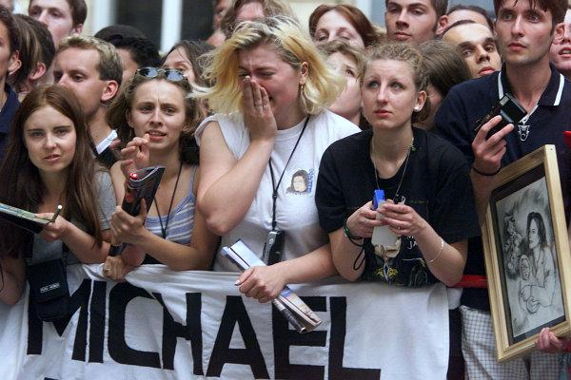
“There’s a crap load of them already here.”
Marie ran to the window and confirmed several hundred people were standing outside the main entrance with signs saying “Get well, Michael.”
“We love you, Michael.” and “We are praying for you!” held high. Within seconds, more and more people came and stood outside chanting his name wishing him a speedy recovery. I turned up the volume on the TV wanting to know more.

“There are also rumors that Jackson has been personally involved with his tour promoter, the renowned CEO of TSG Productions, Diana Dean.”

“OH MY GOD!” I yelled. “I’m going to lose my business. I can’t believe this. I knew him singing that song would come back to haunt me!”
“Calm down, Ana.” Marie said coming back over to me.
“CALM DOWN? I COULD LOSE MY JOB!”
“It’s only rumors, Diana. Michael has always been the subject of press for years.”
“But I haven’t been unless it’s good news. Michael is totally going to be the death of me.”
“Diana, you knew what Michael was like from the very beginning but you chose to be with him anyway because you love him and knew it was the right thing to do. Why would you second guess that because of a few reporters? The world is going to find out eventually that you two are together anyway. So what if they find out sooner?” Marie asked.
“She’s got a point.” Jasmine added.
“I’m not ashamed to tell the world we’re together. I just didn’t want it to come out like this and neither did he. I have no idea what I’m going to do now. I guarantee you whoever leaked this information to the press was an insider.”

Just then, Gerwin walked into the room.

“YOU’RE HERE!” Marie yelled running into his arms.
“I came straight from the airport. How are you Diana?” He asked giving me a bouquet of flowers and a get well balloon.
“I’m fine, thank you. It was sweet of you to come.”
“Any friend of Marie’s is a friend of mine. How is Michael?”
“He’s ok. Sedated for now.” Jasmine said.
“Is he in danger?”
“Apparently, no.” Jasmine said. “It’s just to calm him. He was in pretty bad shape earlier.”
“It was quite the struggle for me to get in here. His security is making arrangements for additional guards to stand outside his door. The doctors and nurses on his floor are all going insane.”
“We don’t know how the press found out.” Marie said. “According to the doctor, Waleed had created a clever diversion.”
“You can’t trust everyone you come in contact with, Marie.” I said looking directly at Gerwin.

He gulped so loud that everyone in the room heard him. The sweat on his brow made it seem like he was obviously guilty of something.

“I will check on Michael. I’m glad you’re ok, Diana.” He said as he headed for the door.
“Gerwin?”
“Yes?”
“Did you talk to Michael in Bremen?”
“Briefly, yes. Why do you ask?”
“What did he say to you?”
“Nothing. I tried talking to him but he asked me to leave.”
“And you did?”
“Yes, after seeing Marie I went back to my hotel.”
“You didn’t come in contact with anything or anyone else?”
“Not at all.”
I could tell by the look on Gerwin’s face he wasn’t being completely honest. Something about him just wasn’t sitting well with me. My only problem was I had no way of proving my doubts about him.

“Marie, I’ll call you later.” He said as he left the room.

Jasmine kept looking out the window staring at the increasing amount of people standing outside. Seeing the love they had for Michael was definitely a sight worth seeing.

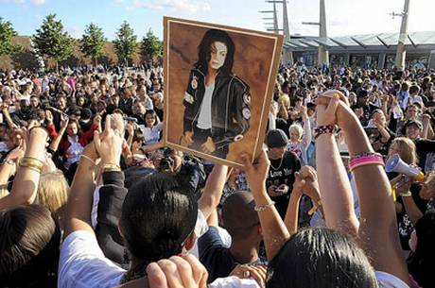
“It’s remarkable how much power that man has.” Jasmine said.
“Michael will always be loved, he’ll never have to go a day without his fans.”
“But he only has one person in his heart.” Jasmine said looking directly at me.
“I know where you two are going with this!”
“Ana, you can’t throw this away. Michael really needs you now.”
“Why is everything ALWAYS about him? The way he feels, the way he is, the way he works. What about ME and what I feel?”
“Your feelings count too but what you and Michael have together is precious and rare. Your relationship with him is like a diamond in the rough.”
“What makes you think that?”

“Michael has always wanted to be treated like a normal human being. In his eyes, the only person that has ever done that is you. That is what attracted him to you at the museum. You on the other hand don’t have a family life anymore and have been trying to keep yourself busy with TSG so that you don’t feel the pain of being alone. You both hide behind your careers as a means to escape the harsh reality that’s around you. Michael has a family that you can share with him. They may not be perfect but they’re there. Katherine loves you, his sisters love you and there is no amount of wealth in the world that can ever replace that. And if you two decide to have a family of your own one day, that will also help bring a lot of joy to your lives.”

Jasmine’s words were always so full of wisdom. For someone so young, she really knew what she was talking about. Marie was so touched she went to the window and hugged her saying thank you for speaking what she said was in her heart all along.

“I don’t think we can just pick up where we left off at this point. There is a lot of physical and emotional damage that needs to be repaired.”
“You both can work on that together and we know the perfect place for you to start.”
“And where is that?”
The girls looked at each other and smiled. It was obvious they were up to something. They both walked towards the bed and sat on opposite ends of me. I knew I needed to prepare myself for what they were about to say so I sat up straight and adjusted the pillow against my back.

“There is a great solution to repairing your relationship with Michael.” Jasmine said smiling.
“We think it would be a great way for the two of you to start over.” Marie added.
“What are you two talking about?”
“Marry him, Diana. Here. In Europe. While he’s on tour.”
“ARE YOU OUT OF YOUR MINDS?!”
“It’s the perfect plan!” Marie said.
“FORGET IT! The press already thinks we’re together and I was about to leave him! There’s no way in hell that can happen especially since he’s in the same hospital as me!”
“Diana, why do you think that fight happened in the first place?” Jasmine asked.
“Because Michael was being a prick!”
“Has he ever treated you that way before? Even five years ago?”
“Never.”
“Did Michael agree to you leaving him yesterday?”
“He asked me to.”
“Did he actually say the words ‘Diana, I want you to leave me.’”
“Of course not.”
“Did he not beg you to stay with him once he came to and realized what he said was wrong?”
“What are you getting at, Jasmine?”
“Something is affecting him Diana. Something HUGE. He needs a change unrelated to music and dance. Michael needs to shake the world with more than just his own feet.”
“And what better way to do that than to announce his engagement to the most beautiful, successful and established CEO in North America?” Marie asked with a gleaming smile on her face.
“Were you two thinking about this while I was unconscious?”
“Of course! Well, that and you getting better.” Marie said laughing.

“We know you love Michael and that you two are meant to be together.”
“If he didn’t want to be with you, he genuinely would have given up. But like he said, YOU are the one who can save him and you won’t have to do it alone. We’ll both be there with you every step of the way.”
“It’s your decision. We just want to see you both happy.”
“If not for us, then for cupcake and space man. Please give it some thought, Diana.”
“Girls, we can’t just announce something this big out of nowhere. The media will freak if they find out about our relationship. We had already planned what we were going to do and say after his tour was over.”
“That’s the beauty of it, Diana.” Jasmine said. “David and I weren’t expecting to meet and get married the way we did either but it happened. Sometimes spontaneous decisions are the best ones. You didn’t expect to meet and fall in love with him but you did. You weren’t expecting him to put your name in lights but he did and you certainly weren’t expecting him to propose and give you TWO rings but he did.”
“Why would you drop something in five minutes that you’ve been holding onto for five years?” Marie asked.

I glanced at my hands and looked at my rings. Michael really was the love of my life and I couldn’t picture myself without him. I promised I’d stay by his side and help him through his struggles and if I couldn’t accept him at his worst then I certainly didn’t deserve him at his best.

“I’ll think about it.” I said. “This wasn’t exactly how I pictured my time in Europe. I just want to get out of this place. Thank god for medical insurance.”
“We’ll stay here until you leave.” Marie said.
“You and Michael deserve each other. Every relationship has rain but it’s how you dance in it that matters.”

Jasmine’s words reminded me of the night Michael and I danced in the rain together. We both vowed to stay together no matter what and I wasn’t about to break my vows before having a chance to actually say them.

“So are you in?” Marie asked.
“Like I said, I’ll think about it.”
“That’s all we need to hear…for now.” Jasmine said giggling.
“We love you, Ana.” Marie said hugging my side.
“Yes we do and so does Michael.” Jasmine said holding my hand. “And I’m still waiting to watch the film of you two in bed!”
“JASMINE!”

She and Marie laughed crazily then went back to the window to see Michael’s fans. The news was still talking about our ‘secret relationship’ causing more turmoil by the second. All I could do was lay my head back wondering how Michael was doing and the thoughts that must be going through his mind.

*** GERWIN’S POINT OF VIEW ***

More than 50 guards stood outside Michael’s hospital room. Gerwin heard his entourage on the phone with several members of Michael’s family informing them that he was alright and the media was exaggerating their stories about his health. He sees Michael resting peacefully outside his room window. He hears the loud, repetitive chants from his fans outside praying that he pulls through. He starts questioning himself as to whether or not his most recent ‘business deal’ was such a good idea. Gerwin had a squeaky clean record but was growing tired of his constant struggle to become a name in the world. He knew the only way for him to move forward was to use Michael’s name even if it meant tarnishing his and Diana’s image.

His phone vibrates in his pocket and he runs across the hallway answering it in complete secrecy.

“Hello?”
“Cologne Cathedral at midnight. Bring what you have.”
“I should be saying that to you.”
“Don’t keep me waiting.”

Gerwin hung up and took one last look at Michael before leaving his floor. He wiped the sweat off his forehead as he went inside the elevator to see Marie again. He was never one to gain something out of another person’s loss but all he could think about was the money he’d be making and the fame he would get in exchange for wrecking someone else’s. Someone that the world loved and adored since he was a child. Someone who was sedated in a hospital bed fighting for his life.

*** DIANA’S POINT OF VIEW ***

Paparazzi and fans were crowding all sections of the hospital trying to know more about Michael’s condition. Waleed, feeling obligated and horrible for his co-partner arrived at the scene and released a public statement to shed light on what was going on:

“My co-partner, Mr. Jackson and his tour promoter Ms. Dean are both in stable condition. There is no cause for concern at this time and we at Kingdom International would like to request the public to please respect Mr. Jackson’s and Ms. Dean’s privacy during this time. This unfortunate incident should not, in any way affect Mr. Jackson’s concerts or tour dates with the exception of a few minor delays. Thank you for your support and Michael loves you all very much.”

“That was nice of him.” Marie said as she heard his words.
“It should at least make his fans happy and provide them with some comfort.” Jasmine added.
“This is just the beginning.” I explained. “Michael told me he knew how to handle people in his line of work. I thought I did too until this happened.”
“Sooner or later the press will move onto another story, Diana. Michael’s name will always be on every magazine or newspaper for years to come. Whether he donates money or starts another tour, he is THE face of entertainment.”
“I guess you’re right.”

Gerwin returned a few minutes later saying he was leaving and would come back in the morning.

“Thank you again for being here.” Marie said hugging him.
“It’s no trouble at all.”
“Did you see him?” I asked.
“Through the window.”
“How does he look?”
“Peaceful. I think he needed whatever they gave him.”
“You’re a sweet guy, Gerwin.” Jasmine said. “Marie is lucky to have you.”
“I think I’m the lucky one.” He said kissing her forehead making her blush.
“Please get some rest, Diana. Call me if any of you need anything.”
“Thank you.”

Marie walked him down the hall. Jasmine came and sat in a chair next to me giving me a bottle of water.

“Something about him just isn’t right, Jas.”
“What do you mean?”
“Gerwin is too smooth.”
“He’s a good guy, Ana. You’re just overly paranoid.”
“How is it that he can leave his work in Bremen and fly to Cologne in less than 24 hours?”
“We did that too, Diana.”
“That’s different. We are following Michael’s tour dates. He’s just starting a record label.”
“He is his own boss like you. He can do whatever he wants.”
“I guess.”

*** LATER THAT EVENING ***

Chris and Waleed came to visit Michael and I then took the girls out to dinner. Dr. Klein came to see me again and said my test results were normal and I’d be discharged in the morning. As I lay helplessly in my bed, all I could do was think about Michael. He was so close yet so far. I wanted to be with him and tell him things would be ok and I still wanted to be with him. I missed his eyes, his touch, his beautiful skin and childlike laughter. I prayed that he would forgive me for putting him through so much distress. I realized in that moment how plagued Michael’s life was with difficulty and all he needed someone to save him from drowning.

I still had no idea what he was hiding from me but what I did know was that I would help him conquer his fears, even if it meant marrying him in a haste to rid people of their awful opinions about him. He was the love of my life, my true source of happiness and my greatest inspiration. I was foolish to think I could go back to LA and live my life without him. I was too involved to turn away from him now. He was a part of me. A part that I couldn’t sever even if I tried.

The girls returned from dinner bringing me a hamburger and a chocolate milkshake.

“I can’t eat this.” I said smelling its wonderful aroma.
“Sure you can. Dr. Klein said it was ok.”

I took a few small bites and sipped on the thick creamy goodness of the milkshake and felt it cool my entire system as it went down my throat with ease.

“Michael hasn’t eaten.” I said remembering the obvious.
“Actually, he has.” Jasmine said.
“How do you know?”
“He’s awake now. We just saw him.” Marie said smiling.
“HE IS?! WHY DIDN’T YOU TELL ME?”
“He told us not to until you ate. He knew you wouldn’t want to touch anything knowing he hadn’t eaten.”
“You two are always putting him before me.”
“We have to. He’s Michael.” Marie said laughing.
“How is he?”
“He’s fine.” Jasmine said. “We brought him some snacks and he asked about you.”
“And?”
“We told him you were ok. He smiled beautifully and said to tell you he loves you.”
“He did?” I asked as tears filled my eyes.
“See, Ana? Michael doesn’t want to give up. Why would you want to?”
“I didn’t say I was, I said I’d think about it.”
“WELL…I have some GRRRREAT ideas for your dress!” Jasmine said pulling out several dozen bridal magazines from a large black bag.
“AND FLOWERS AND CAKES!” Marie added also taking out magazines from her own bag.
“GIRLS! I didn’t say YES yet!”
“Marie and I need to make decisions NOW if we want the very best at your wedding.”
“Oh my god. You two are too much for me. Does Michael know about this?”
“KNOW about it? It was HIS idea!” Jasmine said proudly.
“WHAT?”
“Diana, you need to rest. Leave all of the details to Marie and I. We know what you and Michael want to see on your big day.”
“I HAVENT AGREED TO IT YET!”

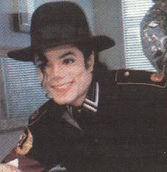
“But you will, my sweet girl.” Michael said as he entered my room looking as handsome as ever.

The girls screamed like typical fans and ran over to him hugging him tightly. He kissed their foreheads and thanked them for not giving up on him when he needed them the most.

“How did you get out of bed?” Marie asked.
“I’m a brave soldier. Nothing can keep me down.”
“Amen to that!” Jasmine said,
“I’m being discharged.” He explained. “My tests came back normal and I told Dr. Klein I needed to get out of here. I feel awful for having this hospital bombarded with so many people outside. Plus I need to rehearse for tomorrow and help plan my own wedding too of course.” He said winking at me.

“You look handsome. I love what you’re wearing.” Jasmine said looking at him dressed in all black.
“You don’t look like someone who was sick, Michael. You heal supernaturally.” Marie said kissing his cheek making him blush.

He thanked them and politely asked if he could have a minute alone with me. The girls happily said yes and headed for the door allowing us a moment of privacy.

“Ana—“
“NO JAS! We are NOT going to have sex on this bed!”
“DARN!” She yelled as Marie pushed her out the door.
“You are such a pervert!” She said closing the door on her way out.

I rolled my eyes and giggled as Michael came and sat next to me on the edge of the bed.

“How are you?” He asked putting my hair gently behind my ear.
“Physically, I’m ok. It’s my heart that hurts.”
“I know. I’m sorry for the things I said to you. I never wanted you to leave.”
“I never wanted to either but you didn’t give me a reason to stay.”
“Is it too late to do that now?”
“I don’t know, Michael. Being with you isn’t easy. You refuse to allow me in your life as a whole. It’s like you filter me through and just show me the beauty of your fame and nothing else.”
“Diana, I’m new to relationships. I’ve never had someone in my life as wonderful as you.”
“I’m new to it too, Michael. You were my first in more ways than one.”
“So, where do we go from here?” He asked linking both of his hands with mine.
“I wish I knew.”
“Diana, I can’t force you to stay with me. I know that now. But I really can’t see myself without you. Five years was long enough. If you walked out of my life now, I don’t know what I’d do. My muse would be gone. I’d have no reason to wake up and do what I do.”
“That’s an intense amount of pressure you’re putting on me.”
“I don’t mean it that way at all. My intention is to show you how important you are to me. I made a huge mistake by grabbing a prescription bottle instead of your hand. We both reached for each other before losing ourselves in all this madness. That, to me means that you are the one who can and will keep me going. I don’t want to lose the one person that has always seen the good in me even when I didn’t see it in myself. I learned my lesson and I will NEVER do that to you, the girls or to myself ever again.”

“Can you promise me that?”
“I’m trying, Diana. Doesn’t that count for something?”
“It does but I don’t want you saying one thing and doing another like you have in the past.”
“I won’t make promises I can’t keep but I will promise you that I am going to try and change for the better a little more each day. I can’t live without you, Diana. You are my everything.”
His words were sincere and full of love. All I could do in that moment was stare in his eyes as they shined with innocence and beauty. His wavy black hair rested against the side of his face shielding him from his insecurities. I let go of his hands and pulled him closer towards me taking his face in my hands.

“I still love you.” I whispered against his lips.
“Will you marry me?”

I gently kissed his lips feeling him instantly quiver. His hands fell onto my back and he pulled himself closer to me not wanting to separate his lips from mine.

“I’ve wanted to do that for so long.” I said as he held me in his arms.
“I love you, Diana.”
“I love you too.”
“Do you still have our marriage certificate?”
“Marie gave it to Chris. It’s safe.”
“Thank god.” He whispered.
He placed his hand against the side of my head and cradled me like a child.

“You have to tell Waleed about us, Michael.”
“I did.”
“How did he take it?”
“It doesn’t matter. His feelings about us aren’t important. I’m doing what I want to do for once.”
“I don’t want our relationship to ruin your business matters or your career.”
“My fans will love me even more when they find out I have found someone outside of the celebrity world to spend the rest of my life with. I went through this with Lisa and I’m fully prepared to deal with it now. I have absolute faith in my fans, Diana. They won’t let me down.”

Waleed and Chris came in the room telling Michael his entourage was ready to take him to his hotel and he had to leave immediately since the crowd outside was getting worse by the second.

“I’ll be right there.” He said asking them to wait outside.

“You better go.” I said kissing his cheek.
“You didn’t answer my question, Diana.”
“What question is that?”
He giggled remembering our little teasing game.

“You won’t ever stop that will you?
“Stop what?”
Michael bit his bottom lip and looked down as if a thought had suddenly entered his mind.

“I’ll be right back.” He said getting up from the bed.
“Where are you going?”
“It’s a surprise.”

He left the room and started talking to Waleed and the girls. I could tell from their facial expressions they were planning to do something to surprise me. I saw Marie’s face light up and Jasmine jumped up and down. As soon as they realized I was watching them they all maintained their composure. Dr. Klein suddenly appeared and Michael briefly spoke to him with his guards surrounding him. I saw him shake his head yes when Michael came back in the room.

“You’re going home tonight, Diana.” Michael said.
“I AM?”
“Yes. Dr. Klein will discharge you so we can both go to the hotel together.”
“Stay with me tonight?” I asked.
“I will for the rest of my life.” He said as he kissed my lips.
One of the nurses came and removed the IV from my arm. She bandaged the mark it left and helped me up from the bed. Marie had a pair of clothes in her overnight bag and gave them to me to wear. Jasmine helped me change in the bathroom and ran her fingers through my hair as I touched up my lips with her gloss making myself look presentable for the press parked outside the facility.

“You look beautiful.” Michael said as he helped me gather my things. He and the girls helped me to the admitting desk where I signed my discharge papers.

“It’s just a matter of time before you start signing my last name.” Michael whispered as he kissed my ear.

I smiled knowing his feelings for me hadn’t changed even after I told him I no longer wanted to be a part of his life. I felt happy knowing my love for him was strong enough to go against my mistake of wanting to let him slip through my fingers again.

As Waleed and Michael’s security huddled over us, we forcefully made our way through the hospital rushing through enormous crowds of fans and paparazzi trying to get to Michael’s driver and his black SUV. Several cameras were clicking and microphones were being thrown in everyone’s face from one direction to the next. Michael held me tightly as we both walked through the main exit when suddenly he stopped and asked everyone to clear his path.

“What are you doing?” I asked as cameras and microphones were placed directly around us.
“Something I should have done before we left LA.”

He got down on one knee making the entire crowd gasp in shock.
“OH MY GOD! HE’S GOING TO DO IT!” Jasmine yelled as several staff members came running to see what was happening in their hospital.

“From the first moment I saw you, I knew you would be special to me.” He said.

“Michael, stop!” I whispered.
“You weren’t a fan of mine and I loved that. You saw me as a normal human being and instantly, I became attached to you.”
“Michael!”

“I can’t see myself without you. Not now, or ever Diana. I love you with every ounce of me. Will you please marry me?”
His fans screamed with joy as several cameras clicked our faces as if they had just seen a UFO land.

“Say YES ANA!” I heard Marie yell in the background.

“You are CRAZY! I can’t believe you would put me on the spot like this!”
“Will you do it?” He asked winking his eye at me.
“YES!”

Everyone cheered as Michael stood up and held his hand with mine in the air wanting everyone to see our union as well as the ring on my finger. Fans and reporters were pushing through causing havoc getting closer and closer towards us.
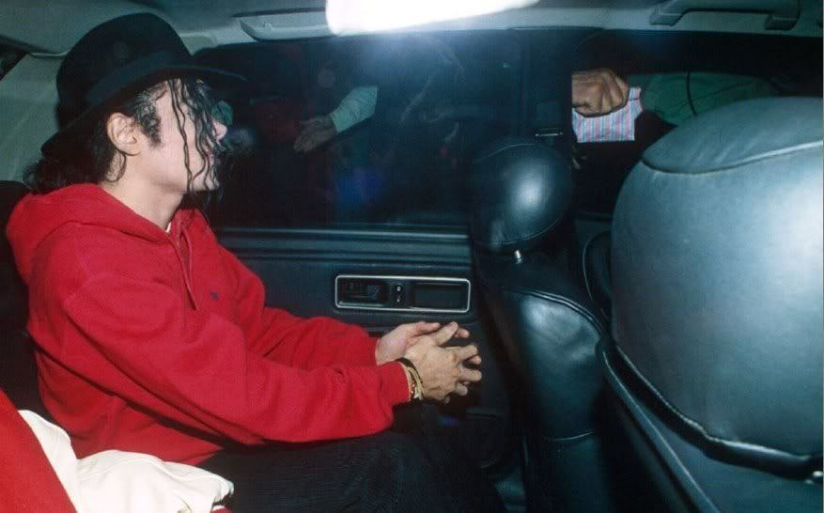
“OK THAT’S ENOUGH!” One of his guards said as he covered us both and got us safely inside the vehicle. As soon as we were all in, Michael’s fans began tapping and hitting the windows wanting to see the now engaged pop star. Michael stuck his head out from the moon roof and waved to his fans and cameras as the vehicle drove out of the hospital parking lot.
“I CAN’T BELIEVE YOU DID THAT TO ME!” I yelled hugging him tightly.
“It worked like a charm, Michael!” Marie said giving him a high five.

“YOU KNEW ABOUT THIS?”
“Well, DUH!” Jasmine said hugging Michael from behind.
“I did too.” Chris admitted putting his head down in shame.
“CHRIS? OH MY GOD!”
“Sorry, Diana. I couldn’t tell you. Michael’s orders.”
I got up from my seat and gave him a bear hug. It seemed like the storm was coming to an end. Now that the world knew about our relationship, there wasn’t a thing anyone could say or do to try and damage or steal what was now officially mine.

“Are you feeling ok?” Michael asked placing his thumb across my lips.
“I’m fine. Just overwhelmed.”
“I can’t wait to have you to myself again.” He whispered as I rested my head on his lap.
“MAKEUP SEX!” Jasmine yelled.
“Obviously, Jasmine!” Michael replied with a smirk.
“MICHAEL!”
“What? It’s not like it won’t happen.”
“I just got out of the hospital.”
“So did I. What’s your point?”
I started tickling him and he tackled me to the seat laying me gently on my back. The girls teamed up with him and also tickled me endlessly almost making me kick them. Marie pinned my legs down and Jasmine held my arms down while Michael kept putting his hands all over me. I had never felt happier than I did at that moment. I knew nothing could possibly go wrong.

“THIS IS SUCH A GREAT DAY!” Jasmine yelled letting go of me. “Marie, take a picture!”

She reached in her pocket but couldn’t find it. She searched her purse, bag and other pockets but it was nowhere to be found. Chris and Jasmine also searched their belongings and didn’t have it either.

“That’s strange. I have no idea where it went.” Marie said as she continued searching.
“I’m sure it’s in your suitcase.” Michael said. “You must have put it in another bag when you were packing in Bremen.”

*** GERWIN’S POINT OF VIEW ***

He drove straight to his hotel from the hospital feeling excited about the thought of becoming a millionaire. He pulled into the parking lot ready to toss his keys to the valet when he opened his dashboard and pulled out a small silver camera. He picked it up and smiled an evil grin as he read the engraved name on its side:

“Marie Ann Harper.”

*** DIANA’S POINT OF VIEW LATER THAT EVENING ***

Excelsior Hotel Ernst, Cologne.

We arrived at our hotel which was about an hour away from the hospital. Michael and I were starting to feel better and stronger by the minute. Dr. Klein sent mine and his medications to the hotel since we left in such a hurry. We both ate light meals with the girls and they made sure mine and Michael’s things were neatly organized. The production crew adjusted to their new surroundings and Jasmine went to the venue where Michael was scheduled to perform tomorrow to make sure the sets had arrived on time and were being assembled correctly. Chris and the girls had their own suites across the hall from Michael and I and things were starting to go according to plan again.

Michael and I cuddled on the couch as the news of our engagement spread like a vicious fire.

“I still can’t believe you did that.” I said watching mine and his pictures on the big screen.
“How else would we get the press to leave mine and your health issues alone?”
“Michael, you’re a genius!” Marie said. “Instead of giving them a reason to delve into your personal issues, you gave them something positive to obsess about!”
“Exactly. See? She gets it.” Michael said petting me like a cat on his lap.
“I love you, Michael.”
“You do?”
“More than I ever have before.”
“Will you show me?”
“You’d have to orbit me first.”
“GIRLS, GET OUT!” He yelled.

“HEY! Be nice to my friends.”
“I’m kidding. But can I please?” He asked like a little boy in a candy store.
“We both need to rest and you have rehearsal in the morning.”
“I’m a warrior, Diana. I have the strength of ten men.”
“Not tonight, baby. Maybe in a few days.”
“We’ll see how long you can resist me.”
“Is that a challenge?” I asked getting up from his lap.
“What if it is?”
“Boy, you won’t last five minutes!”
“Neither do you every time I get inside you.”
“I accept the challenge. Let the game begin.”

“What are you two talking about?” Jasmine asked as she and Marie made their way over to us.

“Michael is being silly as always.”
“I guess we have a lot of planning to do for real now.” Marie said.
“So, when’s the big day?”
“We haven’t thought that far yet.”
“Actually, I have.” Michael said.
“You HAVE?”
“Yes. Since the tour will be over in mid-October, I’d like to get married in November.”
“That’s fine with me. Do you have a specific place in mind?”
“As a matter of fact I do.”
“And where is that?” Marie asked.
“Sydney.”
“AUSTRALIA?” All of us girls said at once.
“Is that a problem?” Michael asked looking puzzled by our reaction.
“That’s GREAT!” Jasmine said. “Inside the Opera House!”
“JAS! We’ve got dress, cake and flower shopping to do!” Marie said as she got up from the couch hugging Michael and I wanting to leave him and I alone.
“Goodnight you two. Don’t do anything I wouldn’t do!” Marie said.
“At least not without the video camera on!” Jasmine yelled as they closed the door.

“Poor Jasmine.” Michael said. “She must really miss her husband to be that sex crazed.”
“She’s just a brat. She’s been asking me about that subject since the day she found out you and I were together again.”
“Did you tell her?”
“HELL NO.”

He giggled making me smile.

“Why not?”
“Because a lady doesn’t kiss and tell.”
“We do a lot more than kiss, Diana.”
“I’m well aware of that, thank you.”
“So, what do you think? Does Australia sound ok to you?”
“I think so. It’s still five months away. We have plenty of time.”

I looked at the clock on the wall and noticed it was almost midnight.

“We should get some sleep.” I said getting up from the couch.

Michael stood up and headed towards the patio doors. He opened the beautiful, stain glass doors by its antique gold handle and stood on the balcony admiring the gorgeous, multi colored city lights. I knew something was on his mind. He always loved to be surrounded by nature when he was bothered.
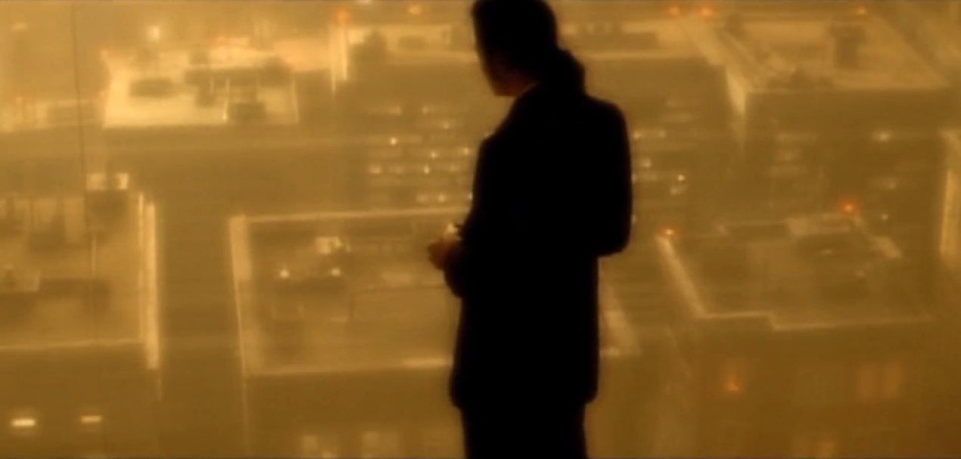

“What’s wrong, baby?” I asked holding him from behind.
“I never got the chance to visit the children.”
“I’m sorry, Michael. That’s my fault.”
“Don’t blame yourself. I’m also responsible.”
“We can always make up for it here.”
“I plan to but I made arrangements to do another show in Bremen. I feel like I owe it to my fans there since I caused them so much grief by being hospitalized.”
“That’s very sweet. You are always thinking about them.”
“I have to. I love them.”
“They love you more.”
Michael took my hands and spun me around placing me in front of him as he held me from behind.

“Did you take your medicine?”
“Did you?”
“Of course.”
“Me too.”
“I think you will be happy to know that Chris went through my things when we were in the hospital. He got rid of all my bottles except for the painkillers.”
“Michael, those are addictive too.”
“I know, but I still need them to help me with my headaches.”
Hearing Michael say ‘he still needed them’ worried me. I was starting to think he really did have a problem with prescribed narcotics.

“Do you take them every day?”
“I have to. They help me get through the day.”
“How often do you take them?”
“Why are you asking?”
“I’m just trying to understand your symptoms.”
“I don’t keep track of how many I take in a day. I take them every time the pain gets too strong.”

Michael was being passive again. His ‘problem’ started to worry me but I knew I wasn’t able to do anything about it at that particular moment. We both had just been hospitalized and the last thing I wanted to do was have another argument. Whatever Michael’s issue was, I knew I had to be the one to help him fight it. I also knew becoming his wife would allow me all the access in the world to his personal belongings and if I needed to do anything drastic to help him, I wouldn’t have any trouble getting it done.

“We should get some rest.” I said letting go of him.
“Are you sure you’re ok?”
“I’m fine. Just really tired.”
We went inside and got ready for bed. I noticed Michael’s painkillers on the night stand and watched him carefully thinking he would take them before lying down. To my surprise, he didn’t give them a second look and rested his head against the down filled pillow asking me to join him. I quickly changed into my silk nightgown and got under the covers hoping the chill from the night air wouldn’t make me cold. As beautiful as Germany was, the climate was quite strong making me sensitive to wind.

Michael snuggled up to me and started running his hands down my legs. I knew what he had on his mind and needed to remind him that it wasn’t going to happen.

“Not tonight, baby.”
“I know. I was just remembering what your touch felt like.”
“I missed you, Michael.”
“I missed you more.”
“I hope we can move through this new phase of our lives easily.”
“Me too.”

He ran his finger down my cheek and kissed my lips softly asking me to come closer to him. Our bodies became one and the heat radiated between the two of us. Being in his arms again made me feel safe. I closed my eyes and prayed that feeling would not go away for the third time in my life. His hands began travelling and I reminded him of our little bet.

“Are you asking to lose, Mr. Jackson?”
“I can’t resist. I haven’t felt your body in days.”
“Do you surrender?”
“Yes, Diana. I do.”
“I knew you wouldn’t last.”
“Come here, girl.”

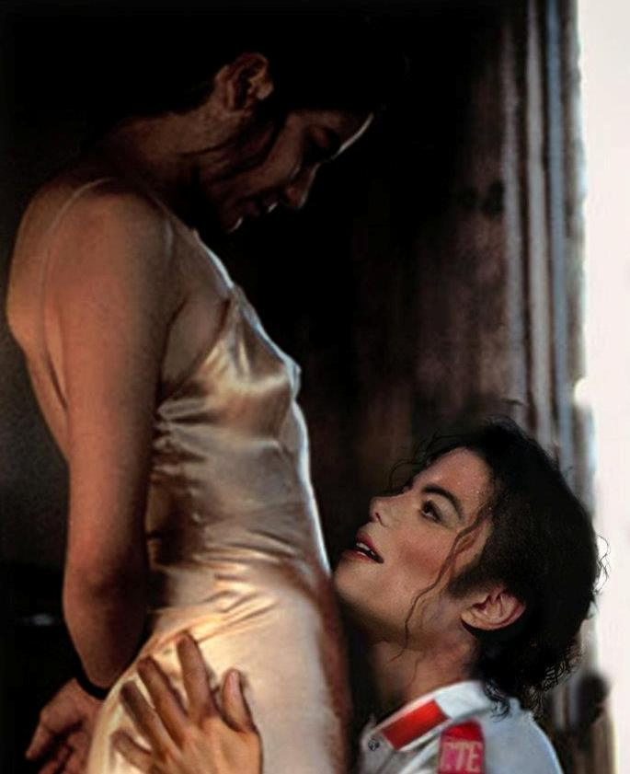
He dragged me towards him and lifted my nightgown. I quickly removed his pants and we both felt each other’s body from top to bottom. His steady gasping made my heart race. I could tell he felt emotional and wanted to make sure I was ok. Once I convinced him I was, Michael turned off the lamp in our room forcing us to rely on nothing but the dazzling city lights outside the large, stain glassed window. He entered me swiftly making it seem like it was our first time all over again. I placed my hands on the back of his head as he continued pushing deeper making me moan his name continuously in his ear. Being with him felt right. There was nothing in the world that could ever make me want to break ties with the man the world infamously called ‘the gloved one.’

*** GERWIN’S POINT OF VIEW ***

Cologne Cathedral, 12:30AM

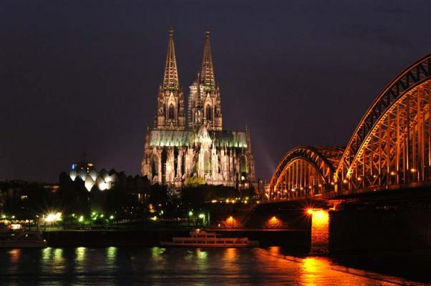

He parks his car in the distance and runs towards the famous landmark breathing deeply. He feels anxious yet excited thinking he’s finally going to get the big break he’s been waiting for. He approaches the dark figure who obviously doesn’t look happy to see him.

“You’re half an hour late!”
“I lost track of time.”
“Do you have it?”
“And something else.”
“Where is it?”
“Where’s my money?”
The person hands Gerwin a briefcase ensuring him his funds were inside.

“What do you have on him?”
“This.”

Gerwin hands them an envelope with a photograph of Michael and Diana’s signed marriage certificate.

“Impressive.”
“I thought it would be.”
“What else do you have?”
“These.”

He then hands them several photos of Michael and Diana kissing, hugging and staring into each other’s eyes in New York, LA and Bremen.

“Where did you get these?”
“I have my ways.”
“They better not be fake.”
“Does this look fake to you?”

He shows the person Marie’s camera with her engraved name.

“She left her camera in my car.”
“Interesting.”
“You don’t seem surprised.”
“How perceptive of you to notice.”
“What is that supposed to mean?”
The person threw several magazines and tabloids in Gerwin’s face feeling more infuriated than ever.

“YOU FOOL! They announced their engagement today! This shit is useless to me now that the whole world knows they are together!”

Gerwin, shocked out of his mind had no words as he saw the news of Michael and Diana’s surprise across every headline in bold black print.

“How can this be? I was just with them today!”
“They’ve been discharged and announced it leaving the hospital.”
“I can’t believe this. I had no idea.”
“Of course you didn’t you clueless troll.”
“Will you STOP with the name calling?!”
“When you stop acting like a moron.”
“What do we do now?”
“Add insult to injury.”
“Huh?”
The person scoffs in Gerwin’s face and grabs him by his neck.

“You will take a photo of something and give it to the press.”
“What kind of photo?”
“That’s for me to know and you to take a snap shot of.”
“When? Where?”
“His concert is tomorrow. Find a way to get backstage and into his dressing room. I’ll be in touch again tomorrow morning.”
The person lets go of him and starts to walk away covering themselves with a thick black overcoat, hat and sunglasses. Gerwin, thinking he just hit the jackpot opens the briefcase and finds it completely empty.
“YOU SET ME UP!”
“Your evidence is worth nothing therefore you get nothing.”
“You can’t do this to me!”
“If you do what I ask tomorrow, I’ll double your offer.”

Gerwin’s eyes popped out of his sockets.

“YOU WILL?”
“Don’t mess this up.”

As he watches its reflection in the distance, Gerwin smiles happily to himself as he walks back to his car thinking he’s now back in the safety zone. All he had to do was take a photo of something and he’d become rich. So rich that he could finally set his career on fire and become the man he’s always wanted to be. He laughed thinking his fate would be sealed by just a simple click of a camera.

