CHAPTER 28
Harsh Realities & Discovered Mysteries

Michael came out of the back room and joined us in the main living room. Marie and Jasmine put on their coats and Chris called saying he was on his way to take us all to the conference. Waleed and Michael’s security were downstairs waiting and of course, a boat load of paparazzi and photographers were swarming the entire hotel from every corner. It didn’t matter how many decoys he had, Michael’s fans and several media sharks always found him some way.

“Everything ok?” I asked as he put on his sunglasses.
“Of course. I just want to get this conference over with. The sooner it’s done the faster I can get to rehearsal.”

The girls and I were ready to leave. Marie still had a stomach ache and Jasmine looked like she had been out partying all night.

“You two look hilarious.” Michael said pointing and giggling.
“Hey! We never laugh at you!” Jasmine said.
“You two are exactly why I don’t eat junk food or drink alcohol.”
“HA HA VERY FUNNY. OW!” Marie said clutching her stomach for dear life.

Chris arrived at the suite door. Michael, not liking what he was wearing (which, in reality looked absolutely fine) quickly decided to change and look ‘more presentable’ for his conference. Waleed called the suite informing us that the lobby was clear and Michael’s guards were all in place ready to take him and all of us outside and into the SUV.

“I look horrible! I’ll be right back.”
“Michael, you look FINE!” I yelled.
“No, I don’t. I wore this to the hospital. I have to change.”
“Michael, you are way too fussy about your appearance.”
“I have to be. You changed too, Diana.”
“I had to. My dress had candy prints on it from the kids.”
“I won’t take long.” He said as he darted inside the bedroom.
We all waited for what seemed like hours for Michael to come out of the room. Chris looked at his watch several times saying if we didn’t leave now, Michael would be late to his own press conference which was scheduled to be shown live around the world.

“What is taking so long?” Waleed asked as he barged into the suite terrifying us all.

The four of us all said one word in unison which was enough to shut him up.

“MICHAEL!”

“Oh good Lord. What is that dancing penny loafer doing now?”
“Changing his clothes as always.”

Waleed rolled his eyes then walked to the bedroom door knocking on it loudly.

“I AM TWO SECONDS AWAY FROM OPENING THIS DOOR AND DRAGGING YOUR BLACK OR WHITE, THRILLER, BILLIE BOB ASS IN THE SUV!”

“That’s Billie JEAN, sir.” Chris said trying his hardest not to laugh.
“Whatever his name is. MICHAEL! GET OUT HERE NOW!”
“It’s a HER.” I added.

He looked up at me embarrassed with rosy cheeks. I couldn’t believe Michael’s own business partner didn’t know the names of his songs. I giggled quietly to myself thinking about it.

“THAT’S IT!” Waleed yelled. “I’M COMING IN THERE AND I’LL SHOW YOU WHO’S BAD!”

Just as he was about to open the door, Michael came out surprising all of us beyond belief.

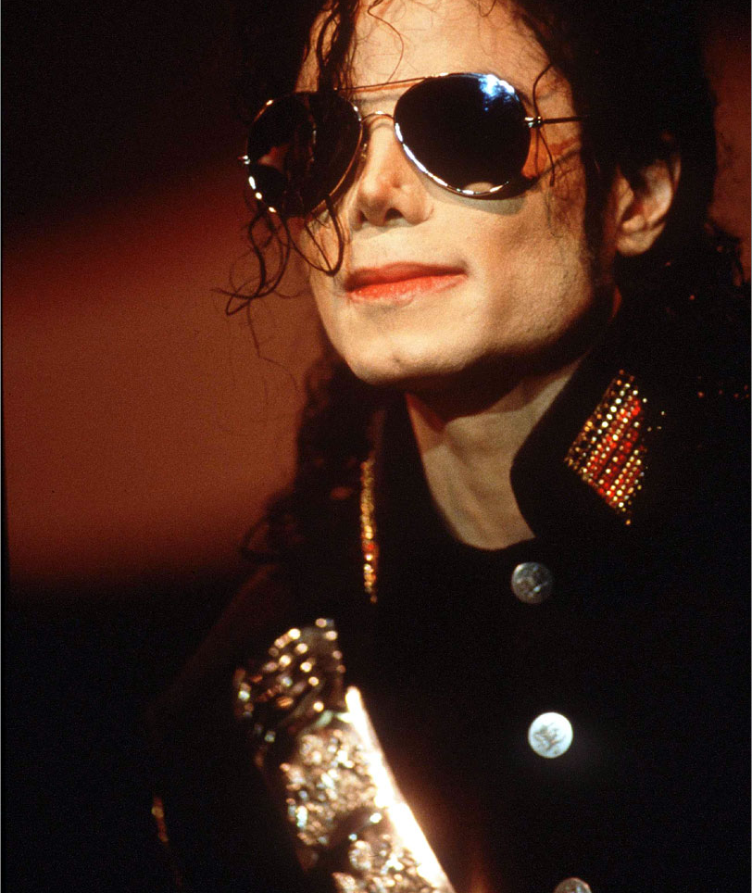
“Do I look ok?” He asked sweetly and innocently. His voice alone could put an end to every war in the entire world.

“Michael…” Marie said completely blown away.
“Oh my god. Why the hell aren’t I single?” Jasmine asked.
“GIRLS!”
“Ahem! You look very nice, Michael.” Marie said.
“Yeah, yeah what she said.” Jasmine said eyeing him as if he were a piece a meat she desperately wanted to sink her teeth into.

“LET’S GO!” Waleed said heading for the door. “He’s coming down now.” He announced speaking directly into a baby monitor type device.

I gathered my purse, phone and jacket and we headed out with Chris towards the elevator when Michael suddenly grabbed me holding me behind the door.

“You never complimented me.” He whispered pulling me close to him.
“I didn’t know I had to.”
“I only believe them when they come from you.”
“You don’t believe the girls?”
“It’s YOU I want to impress.”
“You always look amazing, Michael. If I were to compliment you on your appearance, I’d never stop praising you.”

“I love you, girl.” He said as he ran his hand up my dark grey skirt.
“Michael! What are you doing?”
“I can’t want to devour you when we get back.”
“Boy, you’re crazy!”
“You have NO idea. I REALLY want to fuc—“
“MICHAEL!” Waleed yelled from across the hall.

I forcefully let myself go from him allowing his several guards to crowd around as they protected the greatest entertainer in the world with their large, overbearing bodies. Once we entered the elevator, Michael tugged constantly at my skirt.

“What is it?”
“Give me your phone please.”
“What for?”
“I want to write something.”
“What for?”
“Please, Diana?”

I rummaged through my purse and pulled it out for him. He smiled brightly as he opened the notepad feature and began entering several different words.

Feeling curious, I peered over my shoulder wanting to know what he was writing. Michael noticed and pulled away so I couldn’t watch what he was writing. With the glare of Waleed, Chris, the girls and all five of Michael’s bodyguards surrounding us in the small, sardine canned elevator, Michael handed me my phone with slightly trembling hands.

“I WILL HAVE MY WAY WITH YOU IN THIS ELEVATOR.”

My eyes widened as I read his message. I burst out laughing and quickly hid my phone in my purse not wanting anyone around me to read his erotic message.

“What is it?” Waleed asked.
“Just thought of something.”
“Well, this is NO time to laugh. We need to get this conference over with. Michael, do you have any idea how much this is costing us?”
“I’m aware of the financials, Waleed.” Michael replied with a serious look.
“I just hope that psycho you were once married to finally gets the picture. I still don’t know what you ever saw in her.”
“HEY! Don’t say that to him.” Marie yelled. “What would YOU do if the world turned against you during the lowest point in your life and the only person who you thought could try and save you was her?”
“Marie, don’t.” Michael said shaking his head at her.
“I don’t have to discuss the trials and tribulations of life with you, little girl.” Waleed said looking down at Marie as if she were an infant. “I knew the meaning of the word difficulty before you knew how to spell your name.”
“I’m a WOMAN, not a little girl and that just makes you OLD in my eyes!”
“MARIE!” I yelled.
“Don’t piss him off.” Jasmine said. “He’s not worth it.”
“I don’t care. NO ONE talks shit about Michael around me and gets away with it. NO ONE.” She said looking directly at Waleed.

Michael subtly grabbed her hand and squeezed it as a way of saying ‘thank you’ for her loyalty to him. Chris and the guards snickered but maintained their composure. No one had ever talked to Waleed in such a way. Being royalty, he was always obeyed and never disrespected. As soon as the elevator doors opened, cameras were clicking in our faces and members of Michael’s entourage stood in front of the doors and walked us all out of the lobby towards his driver’s signature black SUV.

“I remember this car.” Michael said looking at Bill, his driver.
“I thought you’d want to roll up in style again.” He said tossing Michael his keys.
“Not today. I need to be driven.”
“Good. I don’t need you burning up my engine or mileage again.”
Michael laughed as we got inside the vehicle. Chris, finally getting a break from driving Michael in a limousine everywhere sat in the mid-section of the vehicle next to the girls. Waleed sat in the front seat and Michael and I both sat at the very back. He grabbed an unopened bottle of water from the cup compartment next to him and took a few sips as we all fastened our seatbelts and left the Dorint Park hotel parking lot.

“It’s an hour drive.” Bill said turning his head towards us. “I suggest you all get comfortable back there and NO spilling water on my leather seats!”
“OOPS!” Michael yelled scaring the day lights out of Bill.
“He’s kidding, relax.” Waleed said physically turning his head back towards the road.

Once on the highway, Marie pulled out her disc man from her purse and popped in her ear phones entering a world of bliss which consisted of nothing but all of Michael’s wonderful songs. Jasmine tilted her head against the car window groaning loudly.

“You still feel sick, tea flower?” Michael asked gently rubbing the back of her shoulder.
“Yes!”
“Would you like some painkillers?” I asked reaching for them in my purse.
“I don’t think they will work. Only time can heal this.”
“What’s wrong, Miss Jasmine?” Chris asked genuinely concerned.
“I have a migraine.”
“I’m sorry to hear that. Do you get them often?”
“This is definitely the first AND last time! I am NEVER drinking again.”
Waleed, eavesdropping on our conversation, turned his head and raised his brow looking directly at me as if I were the culprit.

“What?” I asked.
“Miss Dean, it is strictly against Kingdom International’s policy and code of ethics to consume certain types of drugs and/or alcohol while associating with our clients and projects.”
“She’s not employed by YOU. She works for ME and I am fully aware of the rules and regulations, thank you.”
“Good. Be sure not to forget.” He said turning his head away from me.

“Is he always like that?” I whispered to Michael.
“Only when I have to be, Miss Dean.” Waleed replied.

I scoff as I try not to lose my temper. I suddenly had a strong distaste for Michael’s co-partner.

“Don’t let him get to you.” Michael whispered as he pulled me towards him putting his arm around me.
“I miss your body.” He whispered as he gently pushed the side of my head against his chest having my ear directly below his mouth.
“I love you.” I whisper.
“I love you more, Diana Jackson.”
Hearing him call me by that name made my stomach flutter. I put my hands over my face as Michael giggled and removed them saying I looked adorable when I blushed.

“Did you like what I wrote in the elevator?”
“Very much.”
“Will you let me?”
“Let you what?”
“Oh god, I knew that was coming.”
“No, baby.” I whispered running my hand down his chest. “Save that for later.”
“Diana, you’re bad!”
“No, that would be you with your sexy black wardrobe and dangly little chains…”

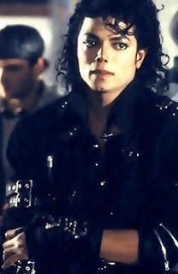
Michael bit his bottom lip and turned his head, giggling as he faced the window.

“Are you blushing, Mr. Jackson?”
“I very well could be.”
Jasmine, with her head against the window, turned and faced us grinning in delight.

“Don’t even think about it, tea flower!” Michael said without looking in her direction.
“How did you know I was watching?!”
“I have my ways. Nothing’s going to happen in the back seat.”
“Unless we want it to.” I whispered in his ear making him turn ultimately red.

Luckily, Marie and Chris were sharing her earphones and not paying attention to us. Jasmine put her head on Marie’s shoulder trying her hardest to feel better.

“How’s your stomach Marie?” Michael asked gently tapping her back.
“It’s still crampy but I think hearing your songs are helping.”
“What are you listening to?”
“I WANT TO LOVE YOU, PYT!” Chris yelled without thinking.

“AHEM. Excuse me.” He said as he fixed his tie trying to maintain his professionalism.
“It’s ok, Chris.” Michael said patting his back. “I’m honored that you like my work.”
“LIKE IT? I’ve loved your work since the day you and those magical feet walked into Motown and auditioned for Mr. Gordy.”
Michael’s eyes were filling. He loved and admired Chris’s loyalty to him and his entire family since he was a child and never took him for granted.

“Marie? Why don’t you give me your CD so we can all listen to it?” Bill suggested.
“Oh god, NO!” Michael yelled.
“YES, PLEASE DO!” I yelled.
“Oh good Lord not again!” Jasmine yelled.
“What’s wrong?” I asked.
“She was listening to him nonstop when you two were at the hospital. I was going crazy!”

Michael looked heartbroken and gasped loudly.

“You don’t like my songs tea flower?”
“Of course I do! You know that. But not over and over and over and over again.”
“That’s the best way to hear them!” Marie yelled as she happily gave her CD to Bill.

“Which album is it?” Michael asked.
“History of course!”
“Oh god.” He said rolling his eyes.
“It’s YOUR album, baby.”
“I know, but—“
“We don’t need to hear this.” Waleed said angrily as he removed the CD from the stereo.
“HEY!” Everyone yelled in the car.
“This is exactly why we are having this press conference. That psycho is horrible!” He flung the CD back to Marie and she put it away giving Bill her “Bad” CD instead.

“I hope THIS ONE is better.” Marie said as Bill put the CD in his stereo.

Michael, not saying a word put his head down and sighed. His disappointment and despair was clearly visible in his eyes and I could feel the hurt with every breath he took.

“Michael…” I lifted his head up by his chin.
“Why did I ever get involved with her Diana?”
“Because you loved her.”
“I thought I did.”
“No, Michael. You DID.”
“It wasn’t anything like my feelings for you.”
“People love in different ways, Michael.”
“I guess.”

The rest of the car ride was completely Michaelicious. The girls were energized and dancing in their seats while the men, Waleed included bopped and swayed their heads to Michael’s songs enjoying every beat, lyric and rhythm praising him in between each and every one. Michael, humbled by his incredible talent smiled brightly with flushed cheeks as we all sang his beautiful words and snapped our fingers.

“YOU GOT TO STOP IT, YOURSELF BRUTHA! WHOOOOO!” Chris yelled without thinking again making us all laugh.

Michael laughed uncontrollably and put his head down rubbing his forehead as everyone, myself included continued singing his marvelous tunes of art.

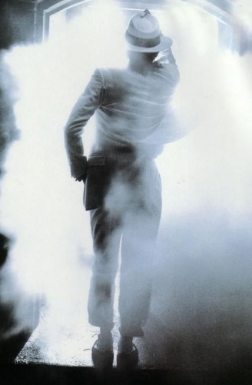
“ANNIE, ARE YOU OK? WILL YOU TELL US THAT YOU’RE OK?” Everyone sang.
“Oh god, PLEASE STOP IT!” Michael yelled burying his adorable face in my shoulder.
“We love you, Michael.”
“I know. But it’s embarrassing.”
I lifted his head and kissed his lips gently. He immediately felt better and could not stop smiling the whole time his CD was playing in the vehicle.

*** 45 MINUTES LATER ***

“Diana, wake up.” Michael whispered in my ear. “We’re almost there.”
“I had no idea I fell asleep.”
“Everyone did.”
I got up from Michael’s embrace and noticed everyone (except Bill) had droopy heads and closed eyes.

“I guess this tour has been hectic for all of us.” I said as I grabbed my compact from my purse and quickly touched up my hair and makeup.
“I meant what I said in the elevator, Diana.”
“I’m sure you did.”
“Will you do it?”
“Do what?”
“DIANA!”
“MICHAEL!”

“What are you two yelling about NOW?” Marie asked as she opened her eyes.
“Nothing. Michael wants to do something.”
“What?” Marie asked.
“Yeah, what?” I asked looking at him.
“Diana wants to tie me up.”
“WHAT?!”
“REEEEALLLY???!!” Jasmine yelled as if she had heard the greatest news of the century.
“Uh huh.” Michael added. “And she wants to gag me.”
“WHAT THE—“
“What’s going on?” Chris asked.
“Nothing! Michael, you are SO going to get it.”
“She wants to punish me now too.”
“OH MY GOD!”

“Ana is a freeeak!” Marie said.
“I SWEAR TO GOD I’LL WORK FOR FREE IF YOU LET ME WATCH! PLEEEEEASE!!!”
“SHUTUP JAS!” I yelled.

“You all are a piece of work.” Waleed said trying not to laugh. “Those kinds of terms are strictly forbidden where I come from.”
“What words, sir?” Jasmine asked.
“Tie up and gag.”
“Why is that?” Michael asked.
“They are taboo. America is a very free land.”
“Indeed.” I said.
“No wonder you’re so uptight. You need a woman.” Chris said under his breath.

We all cracked up laughing and Waleed had a confused look on his face. Who knew a car ride with the King of Pop’s entourage would be this much fun?

Suddenly, Jasmine cell phone rang.

“That’s David.”
“Really? I’d love to say hello.” Michael said.
“No unscreened phone calls, Michael.” Waleed ordered.

“WHAT THE F—“
“DIANA!” Michael put his finger on my mouth.
“He won’t even let you take calls?”
“Diana, it’s for my own protection.”
“What the hell can a person do to you on the phone?”
“Death threats, stalking warnings, voice recordings. All kinds of things.”
“Has that happened to you before?”
“Not a word, Michael.” Waleed said.
“Why don’t you just-“
“Diana, NO.”

I scoffed in complete displeasure and turned my head facing the window to my left. Jasmine answered her call and told David she was in a car full of people and would call him back and reminded him to watch the press conference scheduled to air live.

“Diana…” Michael said taking my hand in his.
“Why do you get mad so easily?”
“I don’t like control freaks, Michael.”
“Except in the bedroom.”
“STOP.”
“You know you love it when I tell you what to do.”
“You never do that.”
“There’s always a first for everything, Diana.”
“And a last.”
“Diana!”
“Michael!”
“What’s up with the constant name shouting?” Marie asked.
“Yes, do tell.” Chris said.
“He starts it. I finish it.”
“Not always in that order.”
“MICHAEL! SHUTUP JAS!”
“Darn!”
“Perv.” Marie said under her breath.

The entire car laughed and oohed at me making my cheeks flush with complete embarrassment. I playfully hit Michael on his shoulder before burying my head in his chest.

“I’m only kidding. It’s not like that at all.” He said rubbing my back.
“Looks like we’re getting close.” Bill said as we saw large crowds of press and cameramen setting up their equipment. Video cameras were also being set up from every angle and we noticed several helicopters flying above us trying to get an aerial view of the event.

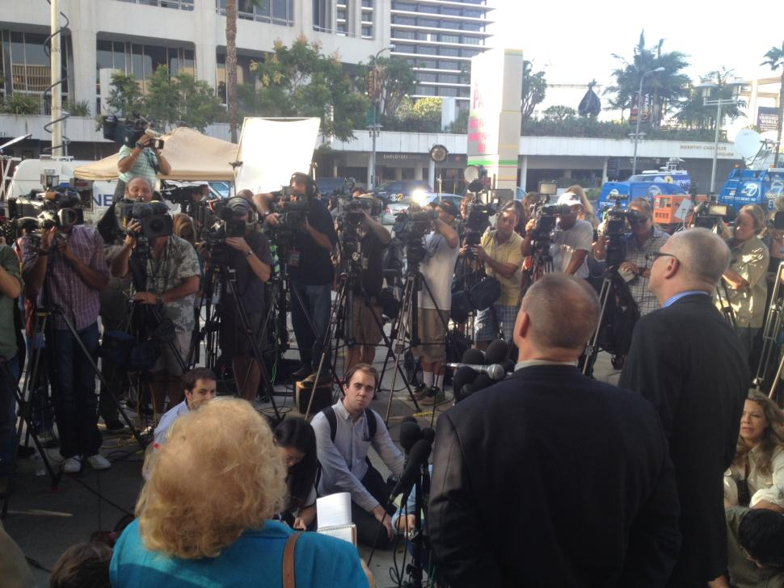

“Jeez, this is more exposure then when you left Los Angeles!” Jasmine said looking at the huge crowds in the distance.
“I know. The whole world will be watching.”
“Remember the agreement and contract details, Michael.” Waleed said.
“I’d have to forget them first.” Michael said under his breath.

Bill’s SUV was bombarded with people from every direction. The constant thumping and tapping on the vehicle was making Jasmine’s hangover even worse.

“STOP IT!” She yelled as she rolled her window down halfway.
“Hey! Some of them are my fans, tea flower.”
“I know and I don’t mean to be rude. It’s just annoying when they do that over and over.”
“That’s why you should know your limit and stick to it.” Waleed said.
“You are a real—“
“Jasmine, NO.” I said sternly.

“Don’t let him get to you, please. For my sake.” Michael said to us all whispering as low as he could. “I know he can be a jerk but he’s very good with business and financial matters.”
“We won’t have to deal with him after the tour, right?” Marie asked.
“No, our contract ends the night of the last concert.”
“Thank god!” I said sighing with relief.

“We have arrived.” Bill announced as he pulled into the venue parking lot and turned off the ignition. Waleed’s monitor went off informing him that we all needed to clear the vehicle but Michael had to stay inside since the facility was not properly secure for his arrival yet.

“I’ll get out with him.”
“You don’t have to, Diana.”
“I want to.”
“That’s not necessary.” Waleed said as he opened the back door. Everyone else got out and was escorted inside quickly.
“Diana, you need to go without me. I’ll be fine.”
“Why can’t he go in now?”
“The building is not secure enough.”
“Meaning there aren’t enough security guards?”
“Exactly.”
“I see more than 50 guards here. Is that not enough?”
“Diana…”
Waleed, who seemed angry with my inquisitive question groaned and spoke slowly as if I were a child sitting in a classroom.

“Michael will be out in the open. This is not an indoors event. He will be OUTSIDE. His protection is crucial during this time. Do you understand what I’m saying?”
“WALEED—“
“NO, Diana!”

My future husband’s voice was the only thing that stopped me from putting the arrogant prick known as Michael’s business partner in his place. Not wanting to cause a scene, I stepped out the vehicle. Waleed offered his hand to me but I shrugged and pushed it away.
“Good luck, baby.” I said as I stood by the car door and kissed his forehead. “You look so handsome. I know you will only speak the truth.”
“Thank you. I love you.”
“Love you too.”

Several guards covered me as I entered a massive old fashioned structure. It seemed medieval looking and all signs and directions were written entirely in German. I scanned the area searching for the girls hoping Marie could translate where we were. At the same time, I kept a close eye on Michael and waited for him to get out of the SUV. In a matter of seconds, I saw several of his guards help him out of the vehicle and hovered over him immediately with their large frames.

Michael turned his head and waved at me with his million dollar smile as he was being taken away towards a distant area enclosed from the general public.

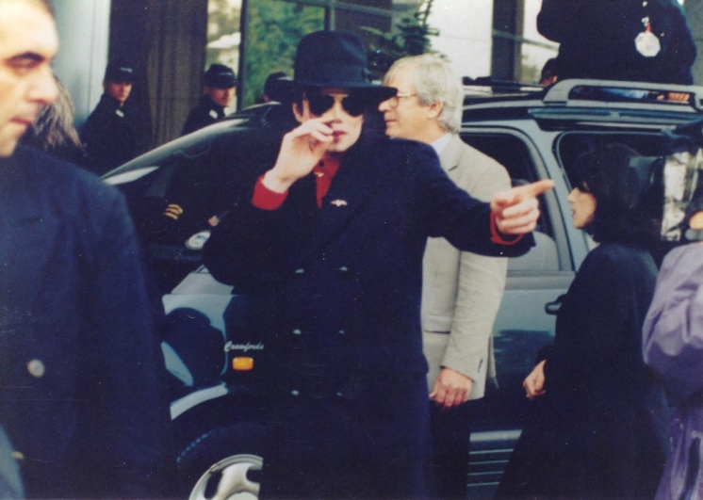
“Will you EVER have a normal life, baby?” I asked subconsciously. The question left my mind as soon as I heard Marie and Jasmine as they peered around the building with their eyes wide open. Marie couldn’t stop taking pictures at every corner cheerfully laughing and wowing as she saw several antique looking pictures and stained glass windows.

“Marie, what city is this? It doesn’t look like we’re in Bremen.” Jasmine asked as the two of them and Chris came over to me.
“We’re in Hamburg.” Marie explained. “My grandparents were born here.”
“What is this building called, Miss Marie?” Chris asked.
“City hall. One of Germany’s finest and historic buildings.”
“THIS is city hall?” I asked looking completely amazed.
“It sure is. Nice, isn’t it?”

I couldn’t help but behave like a tourist as I wandered the halls of the beautiful monumental building. Several beautiful pieces of artwork lay against the walls in perfect mahogany and gold colored frames. Marie spent her time shuffling between myself, Jasmine and Chris as we all needed her expertise in German language and culture.

Ten minutes later, Waleed came over to us saying the conference was about to begin. As we made our way outside, he took me aside and said he needed to discuss business matters with me.

“Miss Dean, it’s very important that you do not stand next to Michael while he is speaking to the public about what happened.”
“Why is that?”
“In order to maintain your image, we need to let Michael handle the questioning himself. If the reporters get out of hand, I will stand in on his behalf.”
“Does Michael know you are asking me not to get involved?”
“He does but he does not agree.”
“Neither do I. If I have something to say, I sure as hell will say it.” I began to walk away.
“Miss, Dean! You will violate TSG’S legal contract with Kingdom International.”
I stopped walking and slowly turned around facing him. As I saw him standing just steps away, I smirked and walked towards him. I stood, shoulder to shoulder, face to face with him not backing down even in the slightest bit. I pulled a copy of the contract from my purse and handed it to him.

“You mean THIS contract?”
“Wait, this can’t be the right one.” He said skimming it briefly.
“Then what contract are you referring to, Mr. Al-Waleed bin Talal?”
“How dare you take my full name?!” He shouted with his eyes widened. “Have you forgotten who I am?!” He seemed astonished by the fact that I actually knew what it was.

“You see Mr. Talal, in AMERICA, the country WE come from, we do not worship, obey, take orders or wait on any man hand and foot like the women in your anti-feminist, narrow minded country. I know EXACTLY what my rights and obligations are and what I can and cannot say in public and private. I also don’t want or need you to misunderstand or midjudge my position during this tour or in your co-partner’s life, business AND personal. You may have been born a king’s nephew but the only person I know, care about, recognize and regard as actual royalty is the King who Moonwalks, breaks every record in the world just by breathing into a microphone and most importantly is also the one who put these rings on my fingers.”

I waved my hands in front of him flashing my most cherished pieces of jewelry.

“I hope that you will keep these facts in mind until this tour comes to an end.” I said as I took the contract from his hand and put it back in my purse. “We may not be in America at the moment but it’s definitely a woman’s world now and you men just happen to be living in it. Get used to it, Waleed. It’ll make your life A WHOLE LOT easier.”

I turned around and walked away with grace in my strut clicking my bright red stiletto high heels on the pavement beneath me. I flipped my hair across my shoulders and smiled with confidence not bothering to look back even once. Marie, Jasmine, Chris and a few guards all cleared my path allowing me to walk through the crowd with their jaws wide open from being blown away by my words. NO ONE was going to tell me how to live my life. Especially my life with Michael Joseph Jackson.

*** 30 MINUTES LATER ***

HAMBURG RATHAUS
(City Hall, Hamburg, Germany)
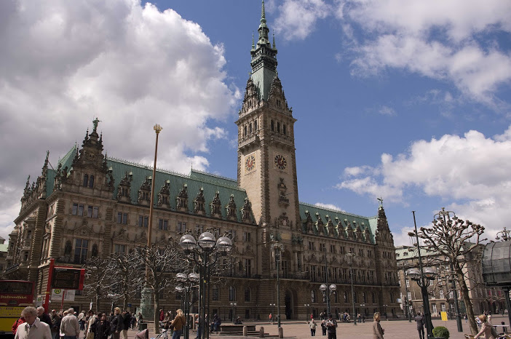

“Good afternoon ladies and gentleman.” Waleed said as he approached the podium speaking directly into the dozen microphones planted at the top of the base.
“I’d like to begin by saying thank you to the German authorities for allowing Mr. Jackson and I to start the History tour here. We couldn’t have asked for a better, more beautiful place to begin this wonderful journey of ours.”

“What a brown noser.” Jasmine said.
“Tell me about it.” I said looking over at Michael who was standing with three dozen guards at the far end of the podium stage.

Our eyes met and I winked at him wishing him luck. His beautiful, curly hair rested peacefully on the left side of his charmingly refined face. I dangled my hand in front of my face as a way of telling him he looked stunning and to possibly remove a few strands of hair before he stood to speak. Dismissing his immeasurable, severe sense of shyness from my mind, Michael smiled ever so pleasantly before putting his head down slightly and turning a hint of crimson in his delicate, pillow like cheeks.

“He’s so adorable.” Marie whispered.
“Look at him blushing for you.” Jasmine said jabbing my arm in a playful manner.
“Thanks girls.”

“And now without further delay, I’d like to introduce my co-partner and friend. The King of Pop, Mr. Michael Jackson.”

Within seconds, the entire venue’s lights were turned on, the fans from across a gated field started to scream and all of the guests and attendees stood on their feet honoring the man known as the Gloved One.

Michael’s guards took center and corner stage first. He looked behind him several times as if he were waiting for some type of signal. A large white tent was set up behind him for privacy. I assumed he was waiting for permission to walk across the stage. Once cleared, he gracefully walked across wearing his trademark military inspired outfit and his curly hair rested comfortably against his picture perfect skin. He removed his sunglasses as he began to speak into the microphones.

“Thank you everyone for your well wishes during this difficult time. Germany has a very special place in my heart and I’d also like to thank the people of this beautiful country for allowing me the chance to grace your abode with my presence.”

“Damn, he’s smooth.” Jasmine said.
“He’s been talking in public since he was five years old. What do you expect?” Marie said.
“That’s my beautiful Moonwalker.”

“As you all know, an unfortunate incident occurred during my most recent concert that was completely beyond my control…”

“Oh god, here it comes.” Marie said.

Before Michael could even explain himself, the questions began.

“Are you and Lisa Marie getting back together?”
“Is your relationship with Diana Dean all for publicity?”
“Are you still using, Mr. Jackson?”
“Is it true that Diana is pregnant with your child?”
“Why did you settle out of court if you knew you were innocent?”
“BECAUSE HE WANTED TO MOVE ON WITH HIS LIFE, YOU SON OF A—“
“MARIE!” I yelled trying my hardest to restrain her.

Michael looked at Marie and shook his head telling her to please be quiet. He knew she was just trying to defend him but that was something he knew he had to do on his own.

“Please don’t make things worse for him.” Jasmine said. “He knows we are on his side.”
“I wish people would stop harassing him so much.”
“We all do, Marie.” I said. “But Michael knows what he’s doing and what is best for him. All we can do is support him as much as we can.”

“There has been a lot of speculation about my relationship with my ex-wife.”

I flinched hearing him use that term.

“The truth is, what happened was an unexpected shock of events that she is entirely responsible for. It was nothing but a cruel, deliberate and jealous attack to try and terminate what I know is the best thing that has ever happened to me.”

I smiled hearing his beautiful words. Within seconds, Michael was bombarded with so many other unnecessary questions about his personal life, appearance, concerts and his trial. Feeling overwhelmed, he put his hand over his face and looked down as if he couldn’t handle the pressures of the conference anymore. Seeing this, Waleed appeared on stage again as the guards removed Michael and kept him at the far end of the podium as he composed himself out of harm.

“He’s so broken.” Marie said.

Feeling helpless, I walked towards the podium to comfort him. As I made my way towards him, Michael shook his head no as a way for me to stay back. I mouthed to him that I loved him and he shook his head and looked down.

Waleed answered several of the reporters’ questions as vaguely as possible. In the end, he simply requested that the public keep an open mind and realize that Michael is a human being just like everyone else. Hearing his words made Michael feel better but the three of us could see right through him.

“He is so full of shit.” Jasmine said under her breath. “He is PAID to say the things he’s saying.”
“That may be true but we all know how innocent Michael is.” Marie added.

I kept quiet and continued listening to Waleed speak on behalf of his co-partner. The fans at the far end of the gates hollered and screamed with so much love in their voices as Michael stepped down from the stage and waved to them all.

“He really DOES love his fans.” Jasmine said.
“Of course. They are his lifeline.” I said smiling as I watched his face light up with joy.
“So are you, Diana.” Marie said playfully pushing me.
“Stop it.”
“You know it’s true!”

“Girls, we need to leave now.” Bill said as he crept up behind us. “The crowd is growing and beginning to get hostile.”

As we all made our way towards the SUV, Michael and his guards escorted him to the vehicle as reporters and cameramen tried their hardest to get in his face and take photos and ask more questions. Once the girls got inside, Waleed noticed me stepping in and gave me an evil look as he went around me and sat in the front seat.

“I’m so glad that’s over.” Michael said putting his head back against the seat.
“Me too!” Marie and Jasmine both said fastening their seatbelts and getting comfortable.
“You have to rehearse now, baby?”
Michael shook his head yes and immediately closed his eyes.

“We’re going straight to the studio now to drop you off since it’s on the way.” Waleed said. “We’ll take the rest of you back to the hotel afterwards.”

*** THREE HOURS LATER ***

We finally arrived back at the hotel. The girls felt better but were extremely exhausted and decided to use the hotel spa to relax and pamper themselves with facials, pedicures and massages. I had no energy to go with them and said I would stay in the room and relax. Once they left, I finally had some peace and quiet to myself.

I turned on the TV and saw the coverage of Michael’s press conference on every channel. The hotel staff left a card under our front door saying they would bring us our meals once we returned. I wasn’t feeling hungry and just decided to take a nap. As I made my way onto the soft, down filled bed the phone rang.

“Hi, baby.”
“Pardon me?”
It was a woman.

“AHEM. Excuse me. I thought you were someone else.”
“Is Mr. Jackson with you, ma’am?”
“No, he’s at rehearsal.”
“There is a call for him. Would you like me to take a message?”
“Did he receive any other calls today?”
“No, ma’am.”

I didn’t want to invade Michael’s privacy but had to know who was calling him so frequently.

“Can you please put the call through to me?”
“Certainly, ma’am.”
“Thank you.”

Within seconds, a loud clicking noise came through the receiver.

“Diana?”
“Yes. Who is this?”
“I’m surprised you do not recognize my voice.”
It was a woman with an unfamiliar accent.

“I’m sorry. Have we met before?”
“Not yet, dear. I understand Michael is rehearsing?”
“He is. Have you called him before?”
“Several times.”
“How do you know him?”
“Oh dear, everyone knows Michael Jackson. But he and I have a very ‘different’ type of relationship.”
My heart pounded. I had no idea who this woman was and didn’t know how to find out without sounding like a rude, insecure, possessive fiancé.

“I will try calling him again tomorrow. I look forward to meeting you.”
“I can tell him to call you back if you’d like.”
“That won’t be necessary. I know he is performing and I would not want to interfere in any way. I just called to tell him I saw the press conference and wanted to offer my full support.”

My heart was still racing. I clearly had no idea who this woman was.

“It was wonderful to finally hear your voice, Diana. Thank you for taking my call.”
“It was my pleasure.”
“Goodbye for now.”

I immediately called the front desk.

“How can we help you, Miss Dean?”
“I need a huge favor.”
“Of course. Anything.”
“Is there a way you can track phone calls?”
“Absolutely. I can send you a list of all of your incoming and outgoing calls during your stay with us if that’s what you’re looking for.”
“Perfect. And can you please include all calls from the last time we were here?”
“Certainly, Miss Dean.”
“Thank you. Please call and let me know when it’s ready. I will come and get it from you myself. Also, please be sure to keep this strictly confidential.”
“Of course. Anything and everything to do with our clients always is. I will let you know when I have it ready for you.”
“Thank you.”

I didn’t want to have to go down this road but hearing an unknown woman’s voice asking to speak to my future husband and having a ‘different’ kind of relationship with him awakened a huge sense of fear and uncertainty in me. The thought of Michael speaking to another woman made my skin crawl and I needed to find out exactly who she is and what she wants, even if it meant going behind his back to find out.

