CHAPTER 29
Surprised in the City of Lights

I waited anxiously for the front desk to call me with the phone list. The girls came back from the spa looking very rejuvenated. Jasmine dyed dyed her hair dark purple and Marie added brown highlights to hers. They also had facials, pedicures and hour long massages by men who, according to Jasmine were ‘hotter than the fires of hell.’
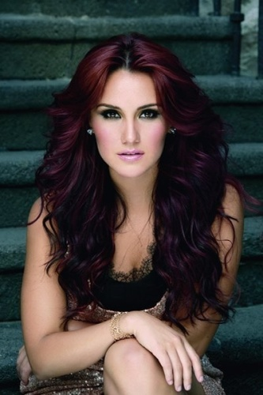
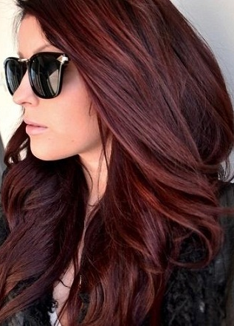
Marie’s Hair

Jasmine’s Hair Marie’s Hair

“Ana, you missed out!” Marie said as she glanced at her reflection in the silver tinted floor length mirror next to the bed.
“You both look beautiful. I’ll join you two next time.”
“Are you ok?” Jasmine asked as she came and sat down next to me on the bed.
“I’m worried about something.”
“The conference?” Marie asked as she came and joined us.
“No, something else.”
“Maybe we can help?”
“I think Michael is cheating on me.”
“WHAT?! THAT’S IMPOSSIBLE!” Marie yelled.

“Ana, why would you think something like that?”
“He’s been talking to some woman behind my back.”
“That doesn’t mean he’s cheating, Diana.” Jasmine explained. “Michael has had several platonic relationships with women.”
“I know, Jas. But this woman has been calling him a lot. She’s also the one who’s been leaving him messages all the time.”

“Have you talked to him about it?”
“I tried. He said I’d find out in a month.”
“What the heck does that mean?”
“I have no idea. But I’m going to find out who she is before then.”
“How?”
“I’ve asked the hotel staff to give me the phone records.”
“DIANA! Are you nuts? You’re spying on him!”
“I am NOT! I just want answers. I can’t sit around and be naïve about this whole thing.”
“Diana, I really think you are jumping to conclusions.” Jasmine explained. “Michael would never do such a thing, especially now with the whole conference thing. I’m sure she’s just a friend who is helping him get through these tough times.”
“That’s MY job, Jasmine. He shouldn’t be running to another woman for comfort.”
“Diana, you sound very insecure.” Marie said.
“ME? INSECURE?”

“YES, YOU!” Jasmine yelled. “This is not like you. Why would you ever doubt that man’s loyalty towards you? He’s never given you a reason to suspect him.”
“That doesn’t mean he won’t ever do it. Unfaithfulness always starts from somewhere and usually it’s someplace small like a phone call.”
“I really think you are making a big mistake. Please don’t look at the phone records.” Marie said. “Michael would never do that to you. If he’s asked you to wait a month, then do just that. He’s most likely planning a surprise for you or all of us.”

I sighed. Maybe the girls were right. I owed it to Michael to give him the benefit of the doubt. If he truly had someone else in mind, it wouldn’t be like him to hide it from me. The media would also speculate and create gossip about it.

A few seconds later, the phone rang.

“Hello?”
“Miss Dean?”
“Yes?”
“Your phone records are ready. Please come to the front desk.”
“Thank you. I’ll be right down.”

I hung up the phone and both girls looked at me puzzled.

“Ana, PLEASE don’t.” Jasmine said grabbing my arm as I stood up from the bed.
“I have to go downstairs. Can one of you please light the fireplace? It’s freezing in here!”
“I’ll do it.” Marie said and she got up and went to the living room.
“I won’t look at them, Jasmine. I’ll just get them and keep them in my suitcase.”
“Ana, you DON’T need them at all. Michael loves you. He would never anything stupid to jeopardize your relationship.”
“You and Marie have so much faith in him.” I said as we both walked out of the bedroom towards the front door.
“Of course we do. Michael is innocent. Always has been. Always will be.” Marie said smiling as she turned on the switch to the gas fireplace.

When I entered the elevator and headed down to the lobby, I wondered if the girls were right. Am I really insecure? Is Michael’s relationship with this woman strictly platonic? Should I ask him about her again?

The elevator dinged and the doors flung open. I made my way to the front desk and a pretty blonde woman wearing a navy blue uniform and small hat greeted me with a friendly smile.

“Here you go, Miss Dean.” She said handing me a medium sized brown envelope.

I thanked her as I took the envelope and made my way back to the suite. Once I reached the main hallway, Chris was on his way down.

“Going somewhere?” I asked.
“To pick up your fiancé.” He said with a big smile.
“You seem to love your job.”
“I do. Very much.”
Suddenly, I realized if anyone would know Michael, it would definitely be Chris.

“Chris, before you go, can I ask you something?”
“Of course, Miss Dean.”
“What is Michael like? I mean, his character, nature, personality? Has he always been the way he is with me and the girls?”

Chris smiled and laughed gently to himself.

“Mr. Jackson has always been a wonderful person.” He explained. “He has the most sincere and loving personality I have ever seen. His generosity knows no bounds and he truly loves you with everything he has in him. He would rather die than lose you.”

Chris’s words touched me. My eyes began to fill as he made his way into the elevator.

“So, you’re saying I have no reason to suspect him?”
“None whatsoever. He is all yours. I know that man better than I know myself. You will never have a reason to doubt him and you know why?”
“Why?”
“Because Mr. Jackson will never give you one. You have my word, Miss Dean.” He smiled and the elevator doors closed taking him downstairs.

As I stood in the hallway with the envelope in my hand, I knew Chris’s words were the truth. He had no reason to lie to me. I smiled as I made my way towards the suite door. I knew exactly what I had to do. As my hand reached the door, the phone rang again.

“I’ll get it!” Marie yelled as she jumped on the couch picking up the cordless handset.
“MICHAEL!” She yelled.
“LET ME TALK TO HIM!” Jasmine said as she grabbed the phone from Marie’s hands.
“You two never leave him alone.” I said shaking my hand.
“Someone seems happy today.” Jasmine said as she put Michael on speaker phone.

“I AM happy. I’m talking to my two favorite princesses in the whole world.”
“Aww, you are the sweetest man ever.”
“Where is my queen?”
I gasped.

“She’s right here.”
“I’ll be right there.” I said as I walked towards the fireplace. Without hesitation, I threw the envelope directly into its flame watching the brown paper crumble and turn to ash. I smiled knowing I would never have to do something like that again.

“I’m proud of you.” Jasmine whispered as she came over to me and lightly touched my shoulder. “Your husband is waiting for you.”
“Jas, you’re the best.” I said hugging her.
“Hey! What about me!” Marie yelled as she made her way towards us.

“Helloooo? King of Pop on the line! You forgot about me!!”

“How can we possibly forget you, baby?” I said as I pressed the handset to my ear and turned the speaker off.
“Are you saying you’ve tried?”
“Many times but I was unsuccessful.”
“I guess I’m unforgettable.”
“That and so much more.”

Marie and Jasmine felt hungry and headed downstairs to the hotel restaurant in the lobby. Once they left, Michael suddenly decided to turn things around.

“Do you miss me?”
“Always.”
“What are you wearing?”
“MICHAEL!”
“What? I can’t ask?”
“I’m wearing a dress.”
“What color is it?”
“Red.”
“Is it short?”

I rolled my eyes and decided to play along.

“Super short. So short you can see my ASSets.”
“Will you let me take it off?”
“If you beat my other fiancé to it.”

Michael gasped.
“I’M KIDDING. I swear.”
“Diana, please don’t ever joke about that. I can’t stand the thought of another man touching you.”
“I feel the same way about you.”

“You don’t have to worry about that. No woman will ever take me away from you.”
“Can you promise me that?”
“Are you doubting me?”
“Honestly?”
“Yes.”
“I am and I have been ever since you got those messages that you still haven’t told me about.”
“Diana, believe me. It’s not what you’re thinking it is.”
“Then why won’t you tell me who she is, Michael?”
“It’s a surprise. You will find out in a matter of time.”
“She called again.”
“SHE DID?”
“You’re surprised?”
“Did she reveal who she was?”
“No. I tried to find out but she was vague.”
“GOOD.”
“And you say I have no reason to be suspicious?”
“You don’t. It will be worth the wait.”
“Fine.”
“I love you, girl.”
“I love you too.”
“I hope you believe me.”
“I do, Michael.”
He giggled childishly.

“What is it?”
“I can’t wait to hear you say that in Australia.”
“I’m looking forward to it.”
“Me too.”
“Will you be back soon?”
“No. I’m going to the venue from here in a few hours.”
“Have you eaten?”
“Yes.”
“Good boy.”
“Will you reward me?”
“Not for something you’re supposed to do.”
“In that case, I’ll eat some more.”
“You’re silly.”
“Only with you.”
“Enjoy your rehearsal, baby.”
“Thank you.”
“You’re amazing.”
“You think so?”
“Of course. Do the moonwalk for me?”
“I always do.”
“Love you.”
“Do you?”
“MICHAEL!”
“Hehehe.”
I gasped hearing his adorable laughter.

“OH MY GOD! YOU ARE SO CUTE!”
“Stop it.”
“It’s the truth!”
“Thank you. I’ll see you at the venue later?”
“Of course.”
“Diana?”
“Yes?”
“I really want you in the elevator.”
“STOP IT.”
“I want to take off all your clothes—“
“MICHAEL.”
“Shove my fingers in your—“
“ENOUGH!”
“Put you against the mirrored walls and shove my big—“
“GOODBYE, MICHAEL!”

He laughed as I heard him hang up. The girls came back and brought me a club sandwich, salad and root beer float.

“You are redder than a tomato.” Marie said referring to my cheeks.
“OOOH! Did you and Michael have a naughty conversation?”
“NO! And even if we did it’s none of your business.”
“Jas, you really need to get laid.” Marie said making me laugh as I enjoyed my wonderful food.

*** LATER THAT EVENING ***

Michael’s second concert in Bremen was a complete success. He performed with so much energy, style and grace and made everyone cheer with excitement and joy. The girls and I were so happy that he was finally able to relax and be his usual self on stage doing what he did best leaving his fans with nothing but fond and wonderful memories of him.
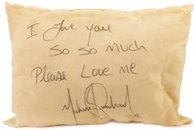
At the hotel, hundreds of his fans gathered below our suite and Michael lovingly waved to them all and signed pillows, blankets and towels throwing them down from the balcony. He was truly a beautiful vision. One that I never wanted to lose.

“What?” He asked as he saw me standing near the balcony doors.
“You’re glowing, Michael.”
“Am I?”
“Yes. You look very happy.”
“It must be because I’m here with you.”
He pulled me towards him and gave me a kiss making the crowd beneath us roar loudly.

“Why do you give them a reason to cheer?”
“I can do that without even trying.”
“I know, I’ve seen it.”
“I love you girl.”
“I love you too.”
Michael waved to his fans once more and said he loved them all and was going to bed. Jasmine entered the suite and informed us of our upcoming flight details.

“We’re leaving in the morning, you two.” She said as she came in with a large stack of documents. “Make sure you get plenty of rest. We have a busy morning.”
“Where are we going again?” I asked.
“Amsterdam.”
“I’m so excited to go there.” Michael said, “I’ve always wanted to visit the Netherlands.”
“Me too!” Jasmine said as she put our itineraries on the coffee table.

“Marie’s already in bed. I checked on Chris next door and he’s good to go. Waleed is at his hotel with the entourage, security guards are outside and Bill will take us all to the airport in the morning. Is there anything else you two need before I go to bed?”
“You’re amazing, tea flower.” Michael said as he hugged her tightly.
“Thank you. I try.”
“You are the best assistant a girl could have.”
“Ok, enough with the sappy stuff. Have a good night lovebirds!” She said as she left the room.
“Be up and ready by six. Our flight leaves at nine. Goodnight.”
“Goodnight, Jasmine!” We both said.
“And PLEASE use the video camera!”
“GO TO BED JAS!”

She giggled and closed the door. Michael and I changed into our nightwear and went to bed.

“She is something else.” I said as Michael pulled me towards him.
“Tea flower?”
“Yes. She is so insistent on knowing what goes on between us.”
“She won’t have to worry about that for long.”
“Oh? Why is that?”
“I have a surprise for her.”
“REALLY?”
“Yes, but it’s a secret.”
“You won’t even tell ME?”
“Not yet.”
“Please?”
“What do I get?”
I smiled as I got up and placed myself directly on top of him.

“Anything you want, baby.”

Feeling excited, Michael placed my hair behind my ears and noticed something unexpected.

“Diana, you’re missing an earring.”
“I AM?! OH MY GOD!”
“Don’t worry. We’ll find it.”
“Michael, these earrings mean a lot to me. They remind me of you.”
“I’ll help you look for it.”

We got up from the bed, changed our clothes again and Michael checked all of the floors in the entire suite.

“I’ll look in the hallway, baby.” I said as I opened the suite door.

Michael’s guards were all in place watching me closely. I explained I was looking for something and they offered to help. Ten minutes later, I saw Michael walking towards me in the hallway with a sense of concern on his face.

“Did you find it?”
“No. I’ll keep looking.”

While Michael and his guards were busy scouring the floors, I subtly pressed the elevator button. When it arrived, I asked him to come inside and help me look for it. I peeked outside the doors and noticed his guards were still busy searching every corner of the hallway. Once the doors closed, I quickly pressed the emergency stop button.
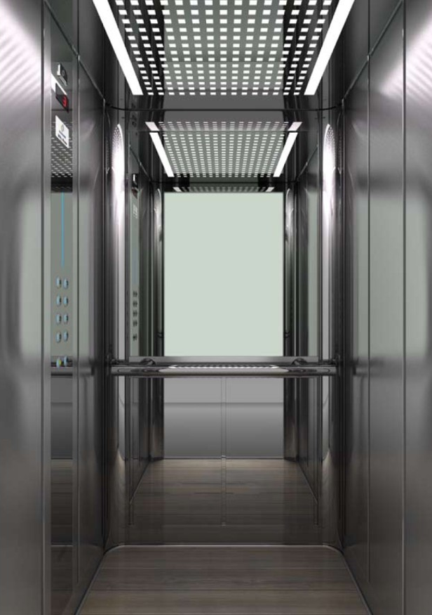
“DIANA! What are you doing?!”
I slowly walked towards him and wrapped my arms around his waist.

“Letting you have your way with me.” I hissed into his ear.
“You set me up, girl.”
“Of course I did. Now take me.”
He placed me against the right side of the mirror lined wall and ran his hands up my legs. I felt him tug on my panty as he removed it within seconds with just one hand. With his other hand keeping me up, I quickly unbuttoned his shirt, unzipped his pants and threw them on the floor. To my surprise, my pink shirt and blue jeans joined his clothing instantly. We were surrounded by gorgeous, beveled lined mirrors which made the moment even more erotic for the both of us.

“I can see you from all sides.” Michael whispered as he touched my frame from top to bottom.
“So can I. You have the most amazing body.”
“Stop it.”
“I’m serious. I love it.”
“I love yours.”
“Show me.”
“With pleasure, Diana.”

He lifted me up against the mirrors and placed two fingers inside me. My hands were moving in every direction swiftly against the glass as the cold sensation pressed against my skin making it seem like I was lying on a bed of sheer ice. He moved his fingers in circular motions with just the right amount of speed. Not too fast and not nearly too slow. I moaned against his ear exciting him more and he continued with a third finger pushing deeper and deeper giving me enormous urges of pleasure and ultimate satisfaction.

“Harder baby.” I said as he ravaged my mouth with his tongue.

I reached beneath me and firmly grasped his most sensitive area making him gasp in between each breath. Michael’s hair was beginning to cling to his now sweaty face. I took my free hand and gently removed it allowing myself to see his enchanting eyes and glistening skin.

“You are so beautiful.” He said as he continued fondling me. My body was beginning to tighten around his fingers and he too could feel it. He slid his fingers out of me slowly making me wince and beg for more. He then laid me down on the floor and placed himself on top of me. With one swift move, Michael tore my legs apart and jammed himself into me without any sign of hesitation. I screamed at the top of my lungs as he plunged his body completely into mine. As our hips glided against each other, I grabbed his captivating head of hair and pulled on it slightly as he placed his hands on my chest, squeezing every inch with his long, masculine fingers.

“Don’t stop. PLEASE don’t stop!” I whined as he continued moving on top of me. All I could think about in that moment was making love to this man for the rest of my life. I never wanted to be without him. I opened my eyes and saw tears flowing from his. I wiped each one and kissed his cheeks before devouring his cherry lips one more time.

“Diana, you always feel so tight.” He moaned in my ear drenching my body internally even more. “I’m so glad to be your only one.”
“You always will be. I promise.”
I pressed his body firmly against mine as he continued pummeling me more and more with every thrust. I screamed his name several times begging him to keep going but to my disappointment, our end was fast approaching. We both held on as long as we could until the tight sensations of each muscle in our bodies began to give up. With one long and last push, Michael and I both became stiff and released ourselves with our lips pressed against each other.

I could feel each and every one of his convulsions as he wrapped his arms around me against the elevator floor. His heart was pounding excessively and his breathing became ragged and unsteady. I rubbed his back gently and kissed the side of his sweat infused face hearing him giggle as I blew gently into his left ear.

“Thank you, Diana.”
“For what?”
“Letting me have my way with you.”
“You’re welcome. I hope you enjoyed it.”
He lifted his head and cupped my face between his hands.

“You have NO idea. I hope we can do this again.”
“Me too.”

He then bit his bottom lip slightly and winked at me. In a matter of seconds, reality came back to us and we realized we had to get back to the suite before security tried to force the doors open. Michael and I giggled as we got dressed and saw several fingerprints smeared all over the mirrored walls. One print in particular stood out the most.

“Diana, that’s your butt!” Michael said pointing and laughing at it.
“IT IS NOT!”
“Yes, it is. You can see the round shape.”
“No, you can’t. Stop looking.”
“It’s right there, look!”
“MICHAEL, CUT IT OUT!”
He continued staring and giggling like a little boy every two seconds. Feeling totally embarrassed with flushed cheeks, I pushed the red button again hoping the elevator would take us back upstairs. We quickly straightened ourselves out seconds before the doors flung open. Michael’s security team surrounded the entire upper hallway relieved that the two of us were ok and out of harm.

“Thank god you’re alright!” Chris said as he touched Michael’s shoulder.
“We’re fine. Diana was missing an earring and we went looking for it.”
“How did the elevator get stuck?” One of his guards asked.
“I’ll let Diana answer that.”
“I have no idea.” I said shrugging my shoulders. “One of us must have accidentally pressed the emergency stop button while searching.”
“Right. What she said.” Michael replied trying his hardest to keep a straight face.
“The important thing is you two are ok. Michael, you KNOW you are NEVER allowed to enter an elevator by yourself.”
“I’m sorry. It won’t happen again.”
“Unless we want it to.” I whispered in his ear making him blush.

“I see something on the floor.” Chris said. He kneeled down and noticed my other earring on the elevator floor directly below my ‘butt print’.
“Is this what you were looking for?” He asked holding it up.

I touched my ear not realizing the other one had fallen out.

“Yes, thank you.”

I giggled as Chris handed me my diamond musical note piece of jewelry. I held it firmly in my palm and thanked everyone for their help as Michael and I walked back to the suite and headed straight for the bedroom.

“You have the other one, don’t you?”
“Of course.” I said making my way to the vanity desk and holding it up for him.
“Girl, you are so smart.”
“I know.”

We crawled back into bed and cuddled all night. The faint sounds of bustling traffic and chanting fans kept us awake for what seemed like hours. As we lay against each other, I couldn’t help but stare at Michael. His twinkling eyes shined effortlessly in the dark resembling a beautiful reflection of a sparkling lake at sunrise. He mesmerized me in that moment and all I could do was lie against my white, satin lined pillow and admire him for the beautiful man that he was.

*** THREE WEEKS LATER ***

Ritz Hotel, Paris, France
June 27, 1997

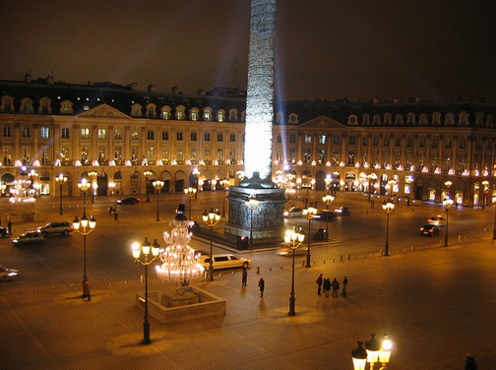
It’s been almost two months since the History tour began. Michael had performed in front of thousands of adoring fans in different cities such as Amsterdam, Kiel and Milan. As we travelled from one city to another, Michael and I were seeing less of each other. Due to the extreme media attention his press conference gained, Waleed suggested the two of us spend time apart and stay in separate hotel suites to keep the press from harassing us about our relationship. After much arguing and contesting, Michael and I decided to listen to his wishes and become somewhat distant while trying our hardest not to forget the fact that we were still very much in love.

Our phone calls were few and far between and it seemed like he and I weren’t even engaged at times. Michael was doing his best to keep busy and stay positive by visiting several hospitals, orphanages, and schools entirely on his own with only a few guards by his side. As much as I yearned to accompany him, I knew his public image was something he needed to alter on his own and I was happy to temporarily step out of his spotlight.

“Come on girls! We’re going to be late!”
“I’m ready!” Jasmine said looking as stunning as ever.
“Me too!” Marie said wearing one of the most beautiful dresses I had ever seen.
“WOW! You both look absolutely gorgeous.”

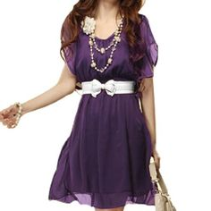
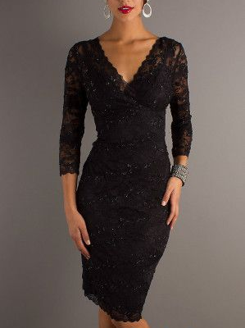

Jasmine’s Dress Diana’s Dress Marie’s Dress

“So do you Ana.” Marie said. “No one can pull off designer labels like you!”
“Amen to that.” Jasmine said.
“Thank you.” I said as my cheeks turned all shades of red.

“We don’t look overdressed do we?” Jasmine asked looking at herself in the full length mirror.
“No way! We’re in the most romantic city in the world. We have to look and feel our best. What if there are cute guys in the audience?”
“You can have them, Marie. We’re both taken.”
“Well, I don’t mind looking.” Jasmine said under her breath.

“This has got to be one of the fanciest hotels in the world.” Jasmine said admiring our room situated at the east wing of Michael’s Presidential Suite. “Michael knows how to travel in style.”
“It’s not Michael’s choice.” I explained. “He couldn’t care less about fancy hotel rooms. This is all Waleed’s doing. Since he and Michael are business partners, he has to make sure he has the finest of everything to make himself look good.”
“Well, he is royalty where he comes from.” Marie added.
“Only by birth.” I said under my breath.

Chris knocked on the door and Marie let him in.

“You three are barely recognizable. You should be on the cover of every magazine!”
“Chris, you are always too kind.” I said playfully nudging his arm.
“PHOTO TIME!” Marie yelled.

She pulled her camera out of its pouch and we all took group and individual photos of each other smiling and making funny faces.

“Where’s our gold star?” Jasmine asked.
“At the venue waiting anxiously for his bride to be.”
“I know why too.”
“He wants a good luck smooch!” Marie said.
“No, that’s not it.”
“Dressing room sex?”
“NO, JASMINE!”
“You have to admit, that would be pretty hot!
“Jasmine, you REALLY need to get laid.”

Chris cleared his throat loudly reminding us that he was still in the room. We gathered our things and headed out the door. As always, the girls walked along the red carpet and posed for the cameras with their signature kissing faces and duck lips.

Chris and a few guards escorted us through the crowds. From the corner of my eye, I noticed a young teenage girl with beautiful straight brown hair and emerald green eyes. She waved at me and her beautiful smile immediately caught my attention. I could tell she wanted to say something to me so I walked towards her. She was shocked and started trembling as I came closer to her.

“Hi sweetie. Are you a fan of Michael’s?”
“Of course. He’s helped me through so many difficult times. He’s the only one I listen to.”
“I can see the love you have for him in your beautiful eyes. Would you like to meet him?”

The young girl screamed loudly and held her heart as she tried to breathe normally.

“What’s your name?”
“Erica.”
“I’m sure I can arrange for you to meet him.”
I reached in my purse for a pen and a napkin. I wrote down my cell number and asked her to call me whenever she was able to.

“I don’t know how to thank you.”
“You don’t have to. Michael will be thrilled to meet you.”
“This means so much to me.”

She tried to hug me but security kept her within distance. As she took the napkin from my hand, I noticed two large white bandages wrapped around both of her wrists. I gasped unintentionally and she quickly pulled her long sleeves down and took the napkin from me. In the words of Michael, I knew right then and there, there was something different about this girl.

“Do you live in Paris?”
“Yes.”
“Please call me tomorrow. We are only here for two days.”
“I will. Thank you.”

“Miss Dean, we must get you and the girls inside the limo now.” Chris said as he gently placed his hand on the small of my back.

I waved at Erica then turned my back and ran quickly towards the limousine. The girls followed but couldn’t stop posing for the cameras and waving at everyone. Marie, feeling like Marilyn again, blew kisses and waved at the cameramen with her flirtatious giggles and eye winks. Jasmine, also feeling like a celebrity spun around in circles showing off her beautiful dress and high heels. I rolled my eyes at them as Michael’s guards covered us all the way across the carpet until we got inside the vehicle.

“You girls really love this stuff, don’t you?” I asked.
“Of course! We are the best in the business!” Marie said as she opened the moon roof.
“We need to enjoy these moments while we can!” Jasmine said joining Marie.

Once Chris got into the driver seat, he received the signal to leave and we exited the hotel parking lot and left for concert 12 of the History tour.

***AN HOUR LATER ***

“We’re almost there, girls!” Chris said.
“This doesn’t look like a venue.” Marie said as she lowered her window.
“It’s not a venue at all, Miss Marie.”
“What is it then?” Jasmine asked.
“A football stadium.”
“WHAT?!” We all screamed at once.
“Michael never told us he was performing OUTDOORS!”
Chris laughed then said it was a surprise and Michael didn’t want any of us to know.

“That little sneak!” Marie said.
“I think it’s cool! We’re going to see him light up an entire field!” Marie said.
“I just hope it’s not too cold for him. He’s not used to extreme wind chills.”
“He’ll be fine, Ana. He’s a big boy.” Jasmine explained. “He’s traveled all over the world. Besides, he wears several layers of clothing under his gold suit.”
“And how do you know this?” I asked intrigued.
“How else does he change in between songs so quickly?”
“Good point.”

As soon as Chris pulled into the stadium parking lot, he was told to wait until we had clearance and full security to enter safely.

“Can any of you see Bill’s SUV?” I asked.
“I can! He’s here.” Marie said as she peeked her head out of the moon roof.
“Thank goodness.”
“You don’t have to worry about him, Miss Diana. He’s very well protected.”
“I know, but I can’t help but be concerned about him. He hardly eats or sleeps and overworks himself way too much all for the sake of his fans.”
“He’ll ease up once the tour is over and you two get married.” Marie said. “For now, just stay positive and never stop reminding him that you love him.”
“Marie, how did you get to be such an expert on relationships?”
“I remember what you two were like five years ago, Ana. I’ve also seen Jasmine and David together. I know what true love looks like. I just hope I get to experience it one day.”
“I promise you will.”
“I thought I had already.” She said putting her head down. Jasmine and I knew she was referring to Gerwin at that moment.
“I’m sorry, Marie. I know you were starting to really like him.”
“I was until I found out how much of a sleaze ball he is.”
“Well, that’s all in the past now and it’s his loss. I guarantee you will find someone who will sweep you off your feet.”
“And he could very well be here in France!” Jasmine added. “Like you said, this is the most romantic city in the world.”
“Heck, if I was twenty years younger I’d be with you Miss Marie!”
“Aww, Chris. You’re sweet!”

She smiled and Chris parked the limo. Several guards surrounded the doors and once they had the ok to open the doors, Chris was asked to step out first followed by the girls then myself. The stadium from the outside looked incredible. As we all stood by the entrance doors, a cold wind rushed through making us feel completely alive and ready to see the King of Pop perform one more time.

Parc des Princes Stadium
Paris, France
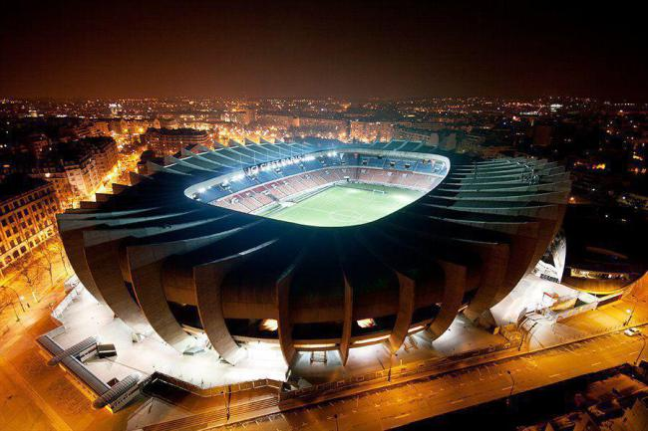

“Where is he?” I asked Waleed as I saw him and his entourage members standing inside a large grey tent situated at a far corner behind the stadium.
“Getting ready. You all can see him but he takes his position in fifteen minutes.”

Several security members guarded Michael’s dressing room door and let us in. Karen was putting the final touches on his hair and makeup and Michael couldn’t help but fly out of his chair once he saw me and the girls.

“There you are!” He said hugging us all.
“Good luck.” Jasmine said kissing his arm.
“We’ll be watching as always.” Marie added.
“You look amazing, baby.”
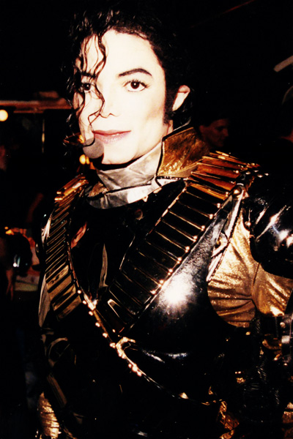
“I always wear the same thing.” He said giggling.
“And it looks stunning every single time.”
“Can I get a girl version made for me?” Marie asked.

“You can have mine when the tour is over, Marie.”
“REALLY?”
“HEY! WHAT ABOUT ME?!” Jasmine yelled.
“You can have the leg pads.”
“What about me?” I asked.
“You get everything that’s inside the suit.”
“DAAAAMN! Diana, you are one lucky woman!” Jasmine yelled.

I rolled my eyes and did my best to hide my rosy cheeks. Karen, who was listening from behind us giggled to herself and shook her head.

“Do you find us amusing?” Michael asked.
“Very. But if it’s not too much trouble, I’d love to have your helmet.”

“NO WAY! IT’S MINE!” Marie screamed.
“Marie, she’s Michael’s makeup artist. Let her have it.” I whispered.
Marie sighed deeply and agreed. “Ok, it’s yours.”

“I’m kidding. I can live without it.”
“YAAY! IT’S MINE! IT’S MINE!”

“YO GOLDILOCKS!” Bill said as he barged in the room. “You got five minutes to make yourself look pretty! CHOP CHOP!”

Michael giggled as Bill closed the door.

“It’s time for you to light up the city of Paris, Mr. Jackson.” Jasmine said making him turn red.
“Stop. I’m just being me.”
“No star in any sky will ever shine half as much as you do.” Marie said.

Michael smiled and hugged them both again. As they were leaving, Michael stopped them and announced he had a surprise for Jasmine. I realized I had forgotten to ask him about it after our sudden ‘elevator incident.’
“FOR ME? What is it?”
“I think you need this now more than ever.” Michael said as he slowly made his way towards the dressing room door. “Close your eyes.”

Marie covered them for her and Michael opened the door slowly. Her surprise was definitely one that shocked us all in a good way.

“Open your eyes, Jasmine.” Michael said.

