CHAPTER 31
Rubbing Elbows with Royalty

As I stood in front of the infamous Eiffel Tower, I felt serene and content. Michael and I shared a glass of champagne underneath the stars overlooking the breathtaking landmark and shook each of the violinist’s hands thanking them for their beautiful rendition of Michael’s song. Once they finished, Michael signed autographs and photos for each of them.

“I wish we could stay here longer.” He said kissing my forehead.
“It’s ok. Being here with you is fabulous even if it is just for a few minutes.”
“I promise we’ll come back here again one day.”
“I’m looking forward to it.”

We kissed briefly before noticing Chris signaling us to return the limousine. Bill and another man from Michael’s security escorted us to the vehicle and led us both inside.

“We have a bit of time to spare.” Chris said from the driver’s seat. “Would you like to head straight to the venue with Sir Miss Diana? Or should I drop you off at the hotel?”
“I think the girls can meet me at the venue. I’d rather stay with Michael.”

Chris nodded and left the enchanting park entry way. I opened the moon roof and stuck my head outside to catch one more glimpse of the sensationally lighted tower that stood in front of us.

“That is one gorgeous landmark!” I said to Michael who was dialing a number from the car phone.
“It really is. I’m glad you enjoyed it.”
“Who are you calling?”
“Waleed. I need to make sure he’s at the venue already.”
“I should call the girls too.”

After we completed our calls, Michael and I cuddled each other against the leather seats without saying a word. The venue was an hour away from the famous tower and the only thing we could both think of to kill time in that moment was to fall asleep in each other’s arms. Just then, a thought from earlier in the day came to mind.

“Michael, I miss the kids.”
“So do I.”
“When do we fly back to Germany?”
“A week but I’m going to Munich, Diana.”
“That’s only an hour flight from Bremen. I really want to see Bela and Angela again. We promised we’d visit them again.”
“I know. I’ll make sure we do.”
“Thank you, baby.”

He kissed my ear and squeezed me tight. His soft lips caressed my neck and his long eyelashes curled against my cheek. As he closed his eyes, I too did the same drifting away in a peaceful yet brief paradise of tranquility.

*** AN HOUR LATER ***

“We’re almost there!” Chris yelled.
“Thank you.” I replied noticing Michael was still asleep.

I couldn’t help but stare as he lay comfortably against the seat. I gently pressed my lips to his waking him instantly.

“I’m sorry. I just couldn’t help myself.” I said as he opened his eyes.
“It’s ok. I enjoyed it. Are we there?”
“Almost.”

He sat up and grabbed a water bottle from across his seat. As he opened it, the limo suddenly jolted splashing water across his face. I handed him a napkin and giggled as he wiped it from his face and clothing.

“Hehehe, you got wet.”
“So did you earlier.”
“MICHAEL!”
“You started it!”
“And you definitely finished.”
“I always do, Diana.” He said winking at me.

I rolled my eyes and lay on top of him waiting to arrive at Parc De Princes for his second and final concert in Paris. Once at the venue, Michael’s entourage had the same routine as always. They escorted him directly from the vehicle inside and the entire gang smiled and cheered as we made our arrival.

“Soooo, how was your date?” Marie asked.
“It was lovely.”
“I knew it would be!” Jasmine said jumping up and down.
“Wait, you two KNEW?”
“DUH! We all did.” David said smirking.
“YOU TOO?”
“Of course. Michael wouldn’t leave me out of it.”
“You all are too much.” I said hugging each of them.
“Ok, enough with the sappy stuff. Our gold star has a show to do.”
“How was your day out?” I asked them all.
“Great! We were here earlier checking on the workers and signed paperwork before we did our own thing. I can’t even remember the last time I’ve shopped this much.” Marie said.

While Michael was putting on his gold suit, we took our places near the stage platform and waited for him to wow the crowd again. Jasmine’s face lit up like an angel as she expressed how happy she was that David was with us. I kept looking at Marie who, even though was happy to be single and fabulous had a sense of longing in her eyes.

“Did you hear from Erica?” She asked.
“Not since Bill dropped her home.”
“She seemed nice.” David said.
“Yeah, she is. I was surprised how calm she was with Michael. You would think she had met him before or knew him personally like we do.”
“Really?” Jasmine asked.

I shook my head.

“Maybe she’s just very reserved.” David explained. “You mentioned she had bandages on her wrists. She must’ve been through something traumatic and doesn’t feel any other type of emotion yet.”
“Maybe you’re right.”

“Miss Dean, he wants to see you.” Bill said as he approached us.
“Everything ok?”
“Yes. He just needs your final touch.”
“OOOOOH! He wants you to touch him, Ana!” Jasmine said.
“YES, HE DOES!” I said trying to sound excited. “Do you want to watch?”
“DO I?!” She yelled as she smiled from one ear to the other.
“Pervert!” Marie yelled.
“Marie, you can come too!”
“OKAY!” She yelled.
“Wait, wait. What’s going on?” David asked scratching his head.
“It’s a girl thing, honey.” Jasmine explained. “We’ll be right back.”

I shook my head as we all went to Michael’s dressing room. I knew exactly what he wanted me to do but of course, the girls didn’t. Boy, where they in for a surprise.

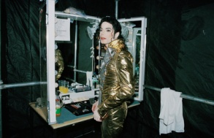

“You look amazing as always.” I said kissing his lips.
“Enough with the small talk!” Jasmine said. “GO AT IT!”
“What?” Michael asked looking puzzled.
“I told the girls they could watch us.”
“Watch us do what?”
“You know…what I always do to you before your concerts…” I winked at him hoping he’d play along with me.
“OHHHH THAT! SURE!”

“MARIE, GIMME YOUR CAMERA!”
“One step ahead of you!” She yelled as she pulled it out of her purse.
“Sit down, baby.” I said helping him to his chair.
“Karen already did the right one. She left the other one for you.”

“WHOA. Michael’s got TWO women?!” Jasmine asked.
“Of course, Jas. We can’t deny Karen.”
“SWINGERS!” Marie yelled.

Michael tried his hardest not to burst out laughing as I grabbed the eyeliner applicator from the makeup table and opened it. I gently placed my index finger beneath his lower eyelid and carefully applied the liquid makeup almost effortlessly. With a final stroke of the brush, it was done and the girls were left speechless.

“All done!” I said kissing Michael’s cheek before showing him the finished product in the mirror.
“Thank you, wife.”
“WAIT! THAT’S IT?!” Jasmine asked disappointed.
“What were you expecting?” Michael asked.
“YOU TWO SET US UP!” Marie yelled.
“WELL, DUH!!!” We both said laughing.

Poor Jasmine looked devastated. It seemed like she had just been to the funeral of a loved one. Marie snickered then joined in our laughter before wishing Michael good luck and leaving with Jasmine to join David backstage.

“Even with David here, she is still so into our business.” Michael said.
“I guess that won’t ever change. Maybe one day I’ll cave and tell her a little snippet of the things we do behind closed doors.”
“Diana…you said cave.”
“Yeah?”
“I love yours.”
“STOP!”

He giggled and kissed my lips once more before Bill interrupted us.

“TWO MINUTES, GOLD FOIL!”
“Thank you. I’ll be right out.”
“Gold foil?”
“One of many nicknames.”
“And you don’t mind them?”
“Why would I? It’s just for fun.”
“I love how you’re sweet to your employees.”
“I have to be. I always talk about loving people and accepting them for who they are. I can’t say one thing and do another.”
“I know, baby. You are no hypocrite.”
“I try not to be.”
“I’m proud of you, Michael.”
“You are?”
“Yes. You are truly one of a kind.”

He giggled and blushed as his index finger brushed his bottom lip making me lust for him.

“You’re so cute when you blush.”
“Stop it.”
“You know it’s true!
“Thank you.”
“Shall we go?”
“Not yet.”

Michael ran across the room and grabbed his helmet that was perched against a small table. I smiled and kissed his lips quickly before helping him put it on.

“I don’t know which piece I like better.” I said looking at him in full attire. “I love the suit, pads, chest plate AND the helmet.”
“You’ll have to fight Marie for them all.” He said in a muffled voice.
“She can have them. As long as I get to keep you.”
“You had me at hello, Diana.”
“So did you.”

He winked at me through his helmet and took my hand as we made our way out of the dressing room. Bill and a few guards escorted us again to the corner of the tent where Michael was to stand in position as usual.

“Good luck.”
“Thank you.”
“I love you.”
“I love you more.”

I walked away and stood next to the gang while Michael burst through the stage and lit up the entire city of Paris for the last time.

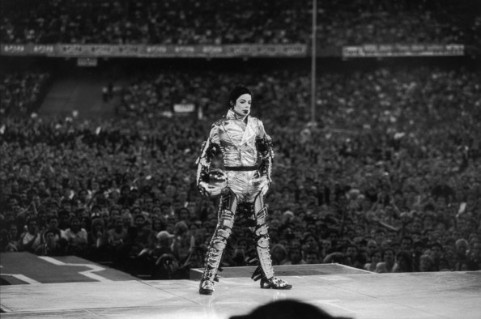

*** ONE WEEK LATER ***

Bremen, Germany

July 6, 1997

It’s been a month since History began. After leaving France, the tour headed to Austria where Michael performed in front of 500,000 fans breaking the record for the biggest concert in European history. His second and final concert in Munich was scheduled for tonight. Instead of rehearsing, Michael and I decided to take a small detour back to Bremen to visit the children at the hospital one more time.

“It’s good to see you both again.” Dr. Amberg the Chief of Staff said. “Your little fans have been asking about you for quite some time.”

Michael smiled beautifully and gave Dr. Amberg five large bags of toys, books, candies and pictures of himself for the children and staff.

“Where are the little bundles?” I asked looking around.
“In the play area. They have no idea you are visiting.”
“Really?” Michael asked with his high pitched voice.
“Not a clue. But there is one person we couldn’t stand to leave in the dark about your arrival.”

Michael turned his head to the right and noticed little Angela running across the hallway. He ran in her direction and bent down grabbing her in his arms and kissing her cheeks.

“How are you, my sweet?” Michael asked as she giggled and blushed ten shades of pink.
“Good. I missed you.”
“I missed you more.”
“Hi, angel.” I said running my hands through her beautiful, brown wavy hair.
“Thank you for coming back.” The little girl said as Michael put her down and held her little palm inside his.

“Baby, we have to get back to the airport in two hours.” I said looking at my watch.
“I know. We’ll spend some time with these kids, quickly see Bela then go.”
“I’m sorry we have to rush this visit.” I said to Dr. Amberg. “Michael’s tour is in Munich today and we went against his schedule just to come back here and see the children.”
“That really is very sweet of you.” Dr. Evans said from behind me. “It’s wonderful to see you both back here again.”

Michael kissed her cheek and hugged her as little Angela snuck over and clutched onto my leg. She seemed paler than before and her eyes were slightly dilated. I knew the adorable little girl had just been medicated. Dr. Evans and Dr. Amberg walked Michael towards the play room and I followed with Angela in my arms.

“Look!” She said as she slightly turned her head.
“It still looks beautiful on you.” I replied smiling and kissing her button nose as I saw the barrette I gave her in her hair.

I joined Michael and both doctors in the play room and watched him interact with the children. As always, they were overwhelmed and shocked with happiness as he read stories and fed each of them animal crackers. Little Angela refused to be put down. I happily carried her around the entire time Michael and I visited all of the children.

*** AN HOUR LATER ***

“Baby, we have to leave.” I whispered.
“I know. I wish I could stay.”
“Aren’t you coming back a third time?”
“Not here. I’ll be up North in Berlin.”

I felt bad for Michael. Being around children always made him happy and content. It was heartbreaking to know we were going to walk out of the hospital knowing we wouldn’t come back. At least not for quite some time.
“We’ll figure something out, Michael. Even if it means going against your schedule again, we’ll make it work.”
“I love you, Diana.”
“I love you too and so do these kids.”

He kissed my forehead making the children ooh and aah. Michael giggled innocently and turned bright shades of scarlet as each child sat on his lap as if he were Santa Claus on Christmas day. After reading a short story, handing out toys and giving all the children small pieces of candy, Michael and I said our goodbyes and left the playroom with little Angela still tugging away at us. This time, at Michael’s pants.

“Please don’t go.” She cried.

Knowing she loved to be held, Michael picked her up and kissed her cheek again.

“I have to, sweetie. But I’ll be back again.”
“Don’t go. I love you.” She grabbed him tightly wrapping her chubby little hands around the back of his neck.

Michael felt emotional instantaneously. His eyes filled and Dr. Evans came and took Angela out of his embrace apologizing for her clingy behavior.

“She’s never been exposed to anyone as famous as you.” She explained. “As I mentioned before, Angela doesn’t have visitors and latches onto anyone who gives her the slightest bit of attention.”
“I understand.” Michael said as he wiped the tears from his eyes. I squeezed his hand gently informing him I was there to help comfort him and he smiled back at me winking his eye.
“Can we see Bela now?” I asked Dr. Evans.
“Of course. I’ll take you to him.”

Angela was sent back to her room with another nurse on duty. We hugged and said our final goodbyes to her and Michael promised he’d do his best to visit her again. I knew that was one promise he’d certainly never break, even if it meant putting his life on the line. When we arrived at Bela’s unit, the entire ward was quiet.

“Where are the children?” Michael asked.
“They have already been sedated and put to sleep. This ward is very strict. Visitors are not allowed after a certain time.”
“I’m sorry. You mentioned that to us the last time we were here.”
“It’s alright.” Dr. Evans explained. “Dr. Amberg made a special exception for you two given your hectic schedules.”

She walked us to Bela’s room where he lay peacefully in his small hospital bed. Michael and I crept towards him to get a better view of his angelic face when suddenly we both noticed an enormous change in his appearance.

“Doctor, he looks different from before.” Michael said gasping and squeezing my hand. “What happened to him?”
“Bela has a severe disease. I can’t disclose his information to you but he needs a new liver.”
“Will he die?” I asked hearing my own voice crack.
“If we don’t find a liver, then yes. Possibly within a year.”

“NO! NO!” Michael yelled as he became frantic. “I won’t let him die. I CAN’T let him die!”
“Baby, calm down.”
“NO DIANA! I’m not going let him die. This sweet, sweet angel. No matter what it takes, I will make sure he survives. I’m going to find a liver for him.

“Mr. Jackson, please—“
“NO!” He yelled again. “I will contact my Heal the World Organization and make sure we find one for him. I won’t let him die. Even if it means giving him my own liver. I’ll gladly do it and I don’t care what it costs or what I have to do. I WILL SAVE HIM!”
“Baby…”
Just then, we heard small groaning noises. Bela opened his eyes and smiled lighting up his greenish colored face with a tint of red.

“Hi, sweetheart.” I whispered kissing his tiny forehead.
“Remember me?” Michael asked.
“Yes…” Little Bela said sounding weak and incredibly frail.

After opening his little brown eyes completely, Bela sat up and jumped into Michael’s arms squeezing him as hard as he could. Michael, not wanting to hurt the little boy gently placed his arms around his back and held him crying a few tears of sadness and happiness the same time. Not wanting to cause anymore strain, I asked Dr. Evans in private if it was ok to talk to Bela and she informed us it would be ok as long as we didn’t make him speak a lot of words at once. I whispered this information in Michael’s ear as he kissed Bela’s cheek and left the room wanting a minute to himself.

Seeing Bela’s condition broke him and me to pieces. I knew Michael was upset and felt extremely helpless. I was grateful that he had his own organization that would help Bela and provide him with a healthy liver and eventually, a much healthier life. Michael came back in the room and spent more time with Bela by giving him toys, candy and read him a story. Our visit with him was short but sweet and we decided to leave once Bela seemed tired and sleepy.

Time was going by faster than the speed of light. Our flight to Munich was 90 minutes away and the drive to the airport alone was a half hour. Michael and I said goodbye to Bela and kissed his adorable face as he drifted away into his pure, childlike world of dreams.

“I’ll be in touch with you soon.” Michael said to Dr. Evans and Dr. Amberg as we waited for Chris to arrive near the front entrance. “I will see to it that HTW finds a liver for him. I won’t let him die. He doesn’t deserve it.”
“We appreciate your kindness.” Dr. Amberg said as he wiped tears from his eyes. “I just hope it’s not too late by the time you do, Mr. Jackson.”
“It won’t be.” I said trying to ease the tension around everyone. “Michael and I will make sure we his organization stays on top of this and finds one even if it means cancelling the tour to do so.”

Michael walked around Bela’s entire ward and saw all of the children sleeping comfortably in their beds. I walked beside him rubbing his back as he tried his hardest to be strong for all of the brave little soldiers he was looking at with helpless eyes and a broken heart. Chris arrived to pick us up and as always, the paparazzi followed him snapping photos of Michael and I as we excited the hospital. Once we said our goodbyes to both doctors, Michael handed them a sheet with his tour dates informing them which city we would be and when just in case Bela’s condition was to worsen.

“We’ll definitely keep you informed.” Dr. Amberg said.
“Thank you for visiting us again.” Dr. Evans said hugging us both.

Chris and a few guards hovered and escorted us to the limousine. Once the huge crowd of people couldn’t get any closer to us, Chris pulled out of the facility lot and headed straight for the airport. Michael rested his head on my shoulder and didn’t speak a word. I knew from his silence that he was completely and utterly torn about Bela’s condition. I tried to comfort him by leaning him against me. His face rested on my arms and I could feel every breath he took blowing gently onto my skin.

“I know you want to save him, Michael.”
“I don’t want to. I HAVE TO. Bela is a little boy. He deserves to live like everyone else, Diana.”
“I know, baby. I know.”
“I will contact my people in LA as soon as we land so they can start the process.”
“Will you tell Waleed?”
“No and don’t tell the girls either ok?”
“You have my word.”

He leaned up and kissed my lips as Chris continued driving to the airport. A heavy rainfall began and heaping drops of water fell against the car windows. I looked down and noticed Michael also had large teardrops streaming from his eyes. I realized in that moment, he and Bela were now spiritually connected and Michael was definitely going to save that little boy’s life.

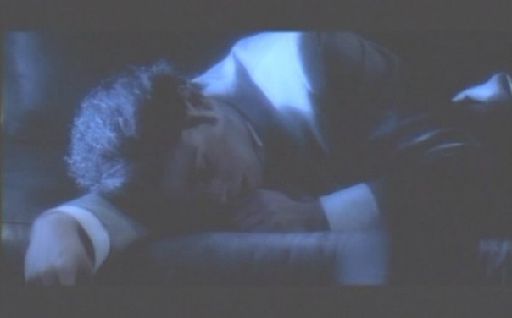

*** TWO HOURS LATER***

SOFITEL BAYERPOST HOTEL
MUNICH, GERMANY

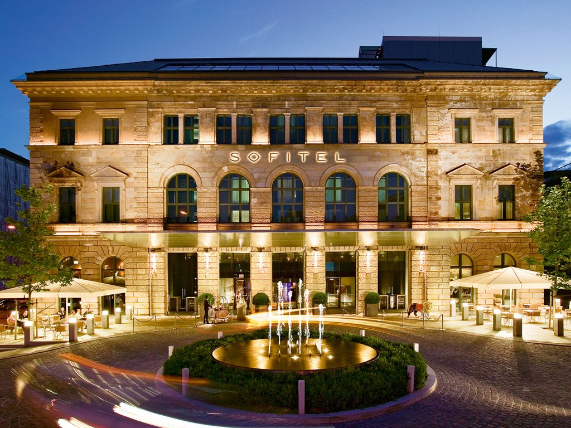

Once we landed in Munich, Michael used my phone to contact his authorities in Los Angeles. After explaining Bela’s situation to them, the hunt for a new liver began. After Michael’s concert finished, the gang decided to go sightseeing since David was leaving in a few days. Michael and I headed straight to the hotel and went to bed. He became quiet and very deep in thought not speaking more than a few words to me the entire day after leaving the hospital.

“Why are you so distant from me?” I asked holding him in my arms as we lay in bed.
“I can’t get that boy’s face out of my mind, Diana.”
“I know. He’s been on my mind too.”
“I need to save him, Diana. I have to.”
“You can and you will, Michael. I believe in you.”
“I hope God has the same faith in me.”
“He does. I believe He brought you into Bela’s life for a reason. If anyone can help him, it’s you.”
“I really hope so.”

I kissed his nose and closed his eyes with my hands. Once he fell asleep, I gently pulled back his hair from his face and kissed his cheeks before falling asleep in his arms.

*** SIX DAYS LATER ***

JULY 12, 1997
HOTEL CAFÉ ROYAL
LONDON, ENGLAND
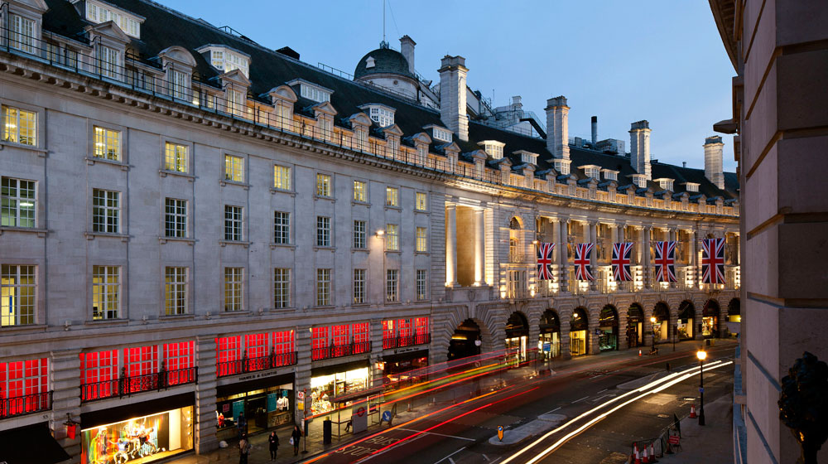

After completing his second set of concerts in Germany, Michael’s tour arrived in one of the most infamous and highly regarded cities in the world. In another attempt to avoid unnecessary and unwanted media attention, the girls and I flew to London on our own leaving Michael to arrive with Waleed and his entire Kingdom International staff. After checking, the girls unpacked their belongings and came over to our suite.

“FINALLY!” Marie yelled as she and Jasmine came through the door.
“I’m SO glad we’re here!” Jasmine said. “I’ve always wanted to visit London.”
“It’s a great city.” Michael explained as he came out of the bedroom showered and looking as handsome as ever. “I’m so glad to be back here again.”
“We’ve never been here before.” I said looking out of the living room window. “London seems so fancy and historic.”
“IT IS!” Jasmine said looking also peering out of the window next to me. “I can’t wait to hit the malls, boutiques and coffee shops here!”
“There was no way I could do a tour all over Europe and not come to London. Waleed had to pull some strings but as soon as the authorities knew he was booking three shows for me at Wembley, they welcomed us with open arms.”

“Baby, when do you need to be there?”
“The concert is at seven. Chris will take me to rehearsal in an hour.”
“I want to see the sights!” Marie yelled as she pulled out her camera and took photos of our suite.

“Marie, we just got here and will be in London for the next five days. Chill out.”
“No way!” Jasmine said. “We have TONS of places to go. I made a schedule to see all of the famous landmarks when we’re not busy with the tour junk.”
“JUNK?” Michael asked raising his brow.
“I mean the fabulous, awesome, wonderful History tour.”
“That’s more like it, tea flower.” He said giggling.

“Michael, I don’t have a nickname.” Marie said.
“Of course you do.”
“Which is?”
“Butt head.”
“MICHAEL! THAT’S NOT NICE!” I yelled.
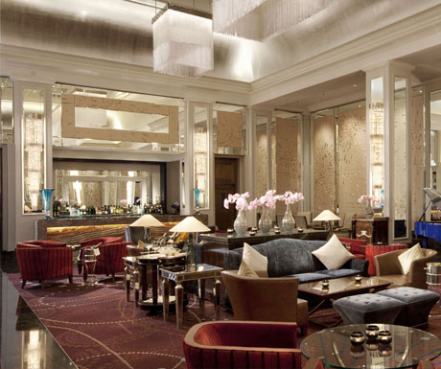
“I’m kidding. I’ll have to come up with one.”
“Man, these hotels are no joke!” Jasmine said walking around admiring each room. “I could really get used to this!”
“It’s not easy, tea flower.”
“It sure looks like it!” Marie said browsing around taking more photos.

“Hotels are fun but not when you can’t remember which one you are in every day and when you are forced to enter through the back doors and don’t see what their lobbies look like.”

“I’m sorry that you have to go through that.” I said kissing his forehead. “You’re right – it really isn’t easy living out of a suitcase.”

“I love my fans. I do it for them.”
“We love you more, Michael.” Marie said running towards him giving him a hug.
“I needed that, Marie. Thank you.”
“You’re welcome.”
“You’re like a big, cuddly bear.” She said squeezing his back.
“THAT’S IT! BEAR!” Michael yelled.
“Huh?”
“Your nickname – you’re my bear, Marie.”
“I LIKE IT!”

“Well, now that crisis has been solved.” Jasmine said. “I’m going to change and hit the streets for some English tea. Marie, wanna come?”
“SURE!”
“You two lovebirds want us to bring you something?”
“I can’t have caffeine.” Michael said.
“I’m ok too. I think I’m going to have a nap.”
“VIDEO—“
“SHUTUP JAS!” Marie said as she shoved her out the door.

I laughed as the girls left. Chris was in the adjacent suite and poked his head in saying he arrived and would take Michael to rehearsal in 30 minutes.

“That soon?”
“Yes, sir. We must stay on time. London is an hour behind from Germany.”
“Oh, that’s right.” He said peering over at the antique grandfather clock across the long corridor. “Thank you for reminding me. I’ll be ready.”

Chris nodded and smiled as he closed the door. I made my way outside to the patio where, as always, hundreds of reporters and fans were cheering for the one and only King of Pop.

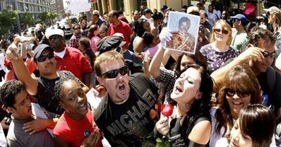

“They follow you everywhere, don’t they?” I asked looking down at them from the balcony.
“I’m used to it.”
“I know. I think they are starting to grow on me now too.”
“I’m glad to hear that, Mrs. Jackson.”

I went back inside and plopped down on a large red sofa chair waving Michael over to sit on top of me. He eyed me suspiciously as if he were secretly trying to tell me something.
“Why are you looking at me like that?”
“I like the way you’re sitting in that chair.”
“You just like seeing my legs open.”
“Yes, I most certainly do.”
“You want it?”
“Do you?”
“There’s only one way to find out.”

As he closed the double glass patio doors and walked towards me, the phone in the suite rang interrupting our first potential session of ‘lovemaking in London.’ Knowing Michael was not allowed to answer anonymous calls, I got up from the chair and answered the cordless handset placed on the coffee table in the living room. Before I could answer, a young lady with a strong British accent addressed me on the other end.

“Miss Dean, there is a phone message for the other guest staying with you. For security purposes, we cannot disclose his name.”
“I understand. Did they leave their name?”
“No, ma’am but it was a woman.”

I gasped. It was her again.

“What is it?” Michael asked.
“What is the message?” I asked the lady on the phone ignoring his question.
“She has requested that he call her back as soon as possible.”
“Is it a local number?”

“She did not leave her number, ma’am. She was convinced he would know exactly who she was.”
“Thank you for informing me.”
“You’re welcome. Would you be requiring anything further this evening?”
“No, thank you.”

I hung up and eyed Michael viciously as if I wanted him dead.

“What’s wrong?”
“She called again.”
“Oh god. I completely forgot.”
“Who is she, Michael?”
“You’ll find out soon.”
“I want to know NOW.”
“Diana—“
“NO, Michael. Enough is enough. Who is this woman and why does she keep contacting you? As your fiancé, I deserve to know!”
“You WILL know. It’s a surprise. Just trust me, please?”
“Ok, fine.”
“Have I ever given you a reason to doubt me?”
“No.”
“Then why start now?”

I realized he was right.

“I need to return that call. It’s important I do before I leave for rehearsal.”
“Ok.”
“Hey…” He lifted my chin with his fingers. “Don’t worry ok? I love you.”
“I know. I love you too.”

He quickly strolled across the hallway towards the corridor and into the grand dining room.

*** MICHAEL’S POINT OF VIEW ***

“Well, hello there stranger.”
“Hi. How are you?”
“I’m fine. How are you?”
“Better. I’m sorry I haven’t kept in touch with you.”
“You know how much I worry about you.”
“I do and I’m sorry.”
“I forgive you this time. Welcome to London, Mr. Jackson.”

He giggled as he continued his conversation.

“Why, thank you. But if you recall, I’ve been here before.”
“I am aware of that, sir.”
“Why so formal?”
“I have to be. The King has arrived in my city.”
“Stop it.”
“You know it’s the truth.”
“You’re beginning to sound a lot like my fiancé.”
“How is she?”
“She’s well. Really anxious to know who you are.”

“We recently had a brief encounter on the phone.”
“I know, she told me about it. Thank you for not revealing yourself to her.”
“It’s no problem. When will I see you?”
“I’m here for five days. I made sure I had time to see you.”
“Please being her too.”
“Of course. I know she will be shocked to meet you.”

“MICHAEL! Chris is on his way to pick you up!” Diana yelled from across the hall.
“I’ll be right there, Diana.”

“I have to leave for rehearsal soon.”
“I’m proud of you, Michael.”
“You are?”
“I read about your visit to the hospital in Bremen.”
“Oh yes. I have an important task I need to take care of there.”
“I wish you nothing but the best.”
“I know and thank you. How are you coping with your situation?”
“I’m alright. It’s your friendship that keeps me going.”
“You’re a sweet woman.”
“I do my best. I just wish he realized that.”
“It’s his loss. Just like I was for Lisa Marie.”
“Oh Lord! I read about her too.”
“I can’t even get into that now. She’s a big mess that I need to clean in LA.”

“MICHAEL! Chris is here!”
“Thank you, Diana. I’ll be right there.”

“I have to leave for rehearsal. I’ll call you again tomorrow.”
“Please do. I must meet you both.”
“I promise I won’t leave here without seeing you. You are the reason I asked Waleed to extend my stay in London to five days instead of three.”
“You are the greatest friend in the world. I’m glad we kept in touch all these years.”
“Me too.”
“I love you, Michael.”
“I love you more.”

*** DIANA’S POINT OF VIEW ***

“Everything ok?” I asked as Michael came out of the grand dining area.
“Of course. I just had something to take care of.”

Chris waited near the entrance as Michael grabbed his jacket, fedora and sunglasses from the top of the bedroom dresser.

“Get some rest, sweetie.” He said as he kissed my forehead. “Please be ready by 6. Chris will come back and take you girls to the venue.”
“I’ll be sure they are ready. Have fun and be sure to eat and take breaks.”
“I will, I promise.”
“Love you.”
“Love you more.”

I walked Michael to the elevator with Chris and his guards and waited for him to enter. Once he was out of sight, I went back to the room and called the girls reminding them to return to the hotel by 5 so that we could leave on time. To my surprise, a familiar voice was in the background.

“Marie, who is that?”
“You won’t believe it – Erica!”
“ERICA? FROM GERMANY?”
“Yup! Wanna say hi?”
“Sure but how did you two get acquainted with her?”
“She was at the same coffee shop as us. She said she’s here for medical treatment.”

Not wanting to be rude and pry into her personal life, I decided not to ask Erica about her health issues. But I also couldn’t help but wonder why a girl who had no signs of harm on her wrists would keep them bandaged. I wanted to invite her to the concert but didn’t want it to interfere with her health in any way.

“Ana, are you still there?” Marie asked.
“Yes, sorry. Put her on please.”

“Hi, Miss Dean.”
“How are you?”
“I’m ok. Could be better.”
“I hear you are in town for treatment.”
“Yes.”
“I’m sorry to hear that. Please call if you need anything.”
“Thank you. Please tell Mr. Jackson I said good luck for tonight.”
“I will.”

“She left the coffee shop, Ana.” Marie said coming back on the line.
“Is Jasmine still with you?”
“She’s interviewing random guys wanting to know if any of them will date me for the next five days!”
“WHAT?”
“It’s fun. Who knew the Brits were so cute?”
I rolled my eyes and smiled knowing those two were enjoying themselves.

“Just make sure you two are back by five.”
“Will do, boss lady!”
“Later, butthead.”

*** LATER THAT EVENING ***

WEMBLEY STADIUM
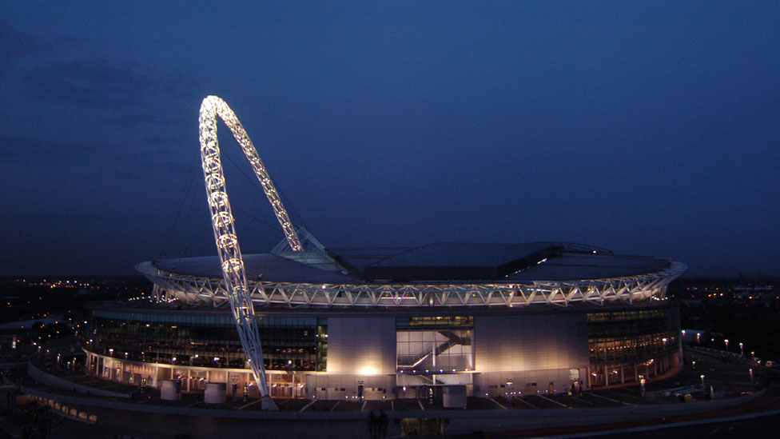
LONDON, ENGLAND

“Michael, you were amazing!” Jasmine said as we all came back to the hotel suite.
“As always!” Marie added.
“Thank you girls. I love you both but I really don’t care right now. I need to shower and change!” He said running into the bedroom.

“Jeez, someone is anxious!”
“He’s always like that after everything he does. Needs to be clean and change clothes twenty billion times a day. I swear the day the world suffers from a fabric shortage, we can easily blame it on Michael Joseph Jackson.”
“I HEARD THAT! DON’T MAKE ME PUNISH YOU, GIRL!”
“OOOOH WILL YOU PLEASE?!”
“I’m not even going to tell you to shut up anymore Jas. I give up.”
“GOOD! MICHAEL, CAN I WATCH?”
“SURE!”
“WHAT?!”

“He’s kidding.” Marie said snickering to herself.
“He better be!”
“MICHAEL, WERE YOU JOKING?”
“DUH!”
“WHAT THE FU—“

The suite doorbell rang interrupting Jasmine’s dirty word. Marie went to answer and a few staff members came to check on us and see if we needed anything before going to bed. I went to the bedroom to ask Michael and noticed he was in the bathroom and the water was running.

“Michael, do you want to eat or drink anything?”
“No, I’m going to bed soon.”
“Alright.”
“Diana?”
“Yes?”
“Join me?”
“UM, NO!”

Michael stepped out of the shower and started walking towards me. Before I could turn around, he grabbed my hand, placed me against the bathroom wall near the door and tightly compressed his dripping wet lips against mine. Wanting to go further, he then placed his saturated hands over my waist and pulled my dress off in less than a nanosecond.

“Michael, NO! The girls—“
“It won’t take long.”
“But, the water is running.”
“So join me.”
I smiled as I saw his stunning watery eyes and perfect but damp body pressed against me.

“I’d love to.”

He removed the rest of my clothing and threw it across the room. I quickly locked the door and Michael took my hand and placed me inside the shower with him following me. As the water from the showerhead poured down upon us, a thought came to mind.

“Baby, we’ve done it in here before.”
“So?”
“I want to try something different.”
“How?”

I stepped out of the shower and sat down on the one place no one would ever think to have sex. Michael smiled profoundly and walked over to me making puddles on the floor as he came closer towards me.

“You are such an amazing lover. Where do you come up with these ideas?”
“I have my ways. But it’s you who brings it out of me.”
“You bring it out of me too, Diana.”
“Good. I’m glad.”
He bit his bottom lip and smiled as he picked me up gently placing his arms against my back. Switching positions, he then sat down where I was and placed me directly on his lap. As his hands began travelling ‘down south’, I pelted myself into him and rode him hard right on top of the toilet seat.

“OH MY GOD, THIS IS AMAZING!” I yelled trying my hardest not to be too loud.
“Girl, you always feel so good. I wish I could implant myself inside you.”
“OOH, that’s a pretty thought.”
He giggled and continued pushing me into him with as much force as he could.

“Diana, I’m going to go any second.”
“Me too.”
His and my end was fast approaching. Michael began his high pitched screeching against my ear. I pressed my hand against his mouth and he let out a suppressed cry as we both liberated ourselves in the most sensual and loving way.

“Oh god that was awesome.” I said kissing his watery lips.
“I love you, girl.”
“I love you too. I have to get back to the girls now.”
“I have something to tell you later.”
“So do I. But it’s not serious.”
“Neither is what I have to say.”
“You sure you don’t want anything?”

Michael lifted me up and placed me back in the shower. He stood at a distance watching me as I quickly rinsed and towel dried myself.

“I have everything I need for tonight.” He said smiling brightly.

I quickly put my clothes back on and fixed my hair trying my hardest not to look like I had just been ‘sexed’. Michael returned to the shower and did his thing. I went back to the living room to join the girls and noticed them both sitting on the couch with huge smiles on their faces.

“What?” I asked staring at them.
“Do you want to tell her? Or should I?” Jasmine asked Marie.
“You can do the honors.”
“We heard and watched you two!”
“WHAT?!”

“Only for two seconds. Man, you two are hot as shit!”
“I AM SO GOING TO KILL YOU!”
“I knew I’d get to see you both in action one day!” Jasmine said as she and Marie darted out the room towards their suite.
“Don’t you DARE say a word to anyone, you two! I mean it!”
“Your secret is safe with us, girl!”

I closed the door and blushed a million shades of red and pink. Michael came out of the shower looking refreshed and on cloud nine.

“You will not believe what those two did!”
“I know. I heard.”
“Are you not embarrassed?”
“I am but at the same time I’m not. I’m glad Jasmine finally got her peep show over with. Now we can finally move past her being so damn horny.”
“YOU’RE HILARIOUS!” I said bursting out laughing.
“It’s true!”

We both crawled into the massive and luxurious in suite water bed. The mattress sprung up and down making it seem like Michael and I were on a boat or surfing.

“This is weird.” He said trying to turn on his side. “I’m not used to this.”
“I like them! They are squishy!” I said bouncing on it making waves.
“Stop! It’s annoying.” Michael said.
“It’s fun! You like trampolines!”
“Yes, but this isn’t one of them.”
“Okay, I’ll stop for now. What did you want to tell me?”
“I’m taking you somewhere tomorrow.”
“REALLY?”
“Yes and it’s very fancy so you’ll need to dress up. VERY FORMALLY.”
“I’m assuming you will be dressed up as well?”
“Yes.”
“What time are we going?”
“In the afternoon. I will finalize the details in the morning.”
“I’m excited!”
“You should be. Goodnight.”
“Goodnight, baby.”

We kissed passionately until we both could no longer move and think. Michael’s head landed on my pillow and I lazily threw my arm around his waist before we both floated away into sleepy land.

*** THE NEXT DAY ***

“Diana, you’re STILL not dressed?” Michael asked as he knocked on the bedroom door.
“Not yet!” Marie yelled as she and Jasmine helped with my hair and makeup. “Beauty takes time!”
“We have to leave in ten minutes!”
“Almost done, baby.”

“Ana, you look amazing. Cinderella would be jealous.”
“You don’t think it’s too prom looking?”
“Not at all. Michael asked us both to make you look ball beautiful.”
“I have no idea what this man has planned.”
“I think it’s something special and super romantic, like the incident at the Eiffel Tower.”
“He really needs to stop trying to impress me. He already has me and he will for the rest of his life.”
“I don’t think he’s trying anymore.” Jasmine explained. “I think he likes doing romantic things for you now that he has someone to shower his love upon.”
“Jas, you are always right.”
“I know. And you two look great together – especially on the toilet!”
“JAS!”
“Sorry. I won’t bring that up again. That’s Michael’s job.”
“HAHA!” Marie burst out laughing.
“You girls are horrible!”
“And yet you still love us!”
“Indeed.”
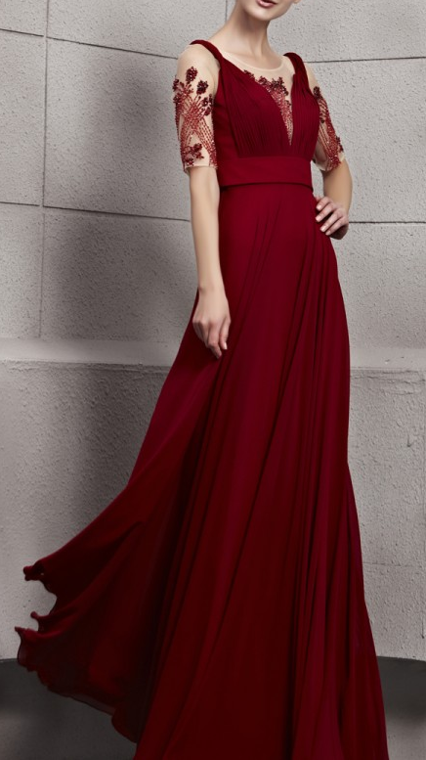
Ten minutes later, the girls opened the bedroom door and Michael looked at me with his eyes widened and his jaw open hitting the ground as if he were seeing something truly spectacular for the first time in his life.

“Oh my god.” He said to himself. “How did I get so lucky?”
“You waited five years.” Jasmine said.
“And so did she.” Marie added.
“Thanks you two. I think that’ll be all for now.”
“Have a great time. Take pictures if you can!” Marie said giving me her camera.
“I’ll try. You look handsome too, baby.”
He smiled and blushed with his signature giggle. As usual, Chris arrived on time and escorted the two of us with Michael’s guards in the escalator to the ground level of the hotel. Once in the limo, Michael and I made ourselves comfortable since Chris mentioned the drive would be about an hour. He also informed us that he would be taking David to the airport in the morning since he was not able to miss any more days of work.

“Now can I know where we’re going?”
“It’s a surprise.”
“Can you at least give me a hint?”
“It’s a building with people inside.”
“Michael, that is so vague.”
“That’s the point.”

I rolled my eyes and waited patiently trying to catch the view from the tinted windows. Michael, not wanting me to have any clues, did not allow me to open the moon roof as he didn’t want me to know anything at all. I grunted in anger and looked away in the opposite direction of Michael’s face.

“Why don’t you ever let me surprise you?”
“I’m used to getting my way and always being in control. Running my own business has made me very dominant, Michael.”
“I know, I can tell.” He said eyeing me with curiosity.
“That never bothered you before.”
“And it still doesn’t. Although it does get me thinking…”
“About what?”
“In time, Diana. In time.”

I frowned at him and rolled my eyes again making him giggle and kiss my cheek.

*** AN HOUR LATER ***

“We’ve arrived, sir.” Chris said. “You will need to stand with security at the main gate.”
“Diana, I’ll be right back.”
“Where are you going?”
“I need to make sure we can get in without being hassled.”
He stepped out of the limo and dozens of his guards stood in front of him. Michael peeked his head through the door and placed a blindfold on me.

“Michael! This thing will ruin my makeup!”
“Hush, girl!” He said as he lifted me out and walked me somewhere.

I heard a loud creaking noise from what sounded like a heavy iron gate. Michael, still keeping me uninformed took me on a very long walk. It seemed like we had passed an entire football field.

“Stay here, please.” He whispered as we both stopped. I heard Bill’s voice and a few other guards gather around us and walk next to me.
“I’ll be right back.”
“Where are you going? Don’t leave me blindfolded alone!”
“I won’t be far. I’m just going to say hi to someone.”

I heard his footsteps in what seemed like a grand ballroom. There were so many voices of men, women and children and the air was permeated with fancy smelling perfumes and colognes. A few minutes later, I heard Michael greeting someone.

“FINALLY! We meet again.”

I immediately recognized the voice. It was the phone message woman.
“It sure has been a long time.”
“So, it has. Is that her?”
“Yes. She has no idea.”
My heart was racing a mile a minute as I heard two sets of footprints approaching me. One of them belonging to a woman obviously wearing high heels. Michael came and stood directly behind me and whispered in my ear.

“Ready?”
“YES!”

He slowly lifted the blindfold.

“Open your eyes, sweetheart.”

As I did what he asked, my emotions were unexplainable. Everything felt like in a dream. The ballroom, the atmosphere, the aura, the people, the place. Could it be?

“MICHAEL, ARE WE AT—“
“Welcome to Royal High Tea in London, Diana.”

