CHAPTER 32
The Mourning After

BUCKINGHAM PALACE
LONDON, ENGLAND

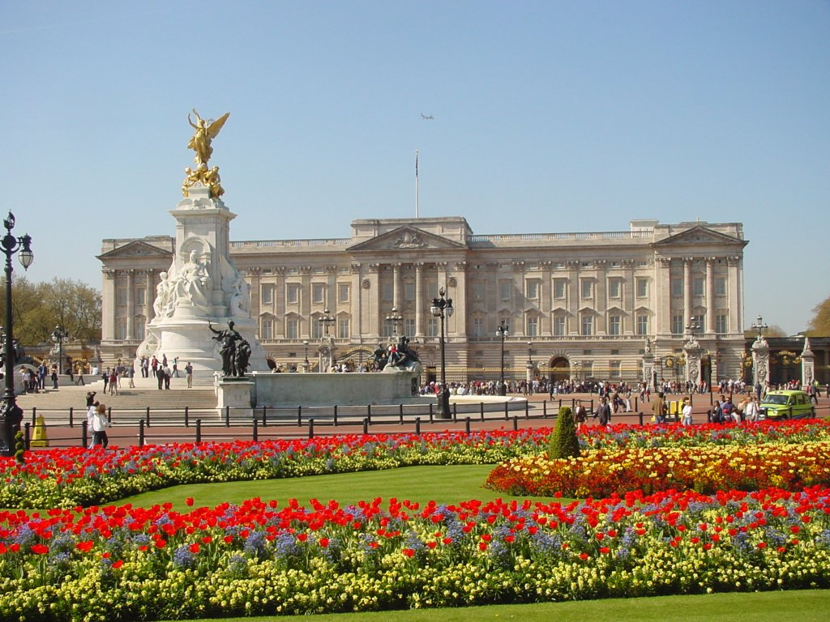

I stood next to Michael with enlarged eyes and an open mouth. I couldn’t believe I was standing in one of the elaborate places in the entire world - the Arlington ballroom inside Buckingham Palace.

“Surprised?”
“OF COURSE!”
“I’m glad.”

Michael’s guards stayed in the room but kept their distance taking their positions making sure he and I were still being safeguarded at all times.

“There’s someone I want you to meet.” Michael said taking my hand.
“Oh my god. Michael, not the queen!”
He giggled.

“No, Diana. She’s not easily accessible even for me.”
“Really? She refused to see you?”
“Not exactly. The British Royalty has rules about timing, types of visitors, strict security requirements and a few other things.”
“I heard another set of footprints. Where did that person go?”
“You’re about to find out.”

He walked me across the ballroom to a grand staircase where several people were lined up according to rank and class. Michael and I stood at the very end of the line and waited for members of the Royal family to appear and greet us. I couldn’t stop fidgeting. Michael was so much more relaxed than I was.

“Nervous?”
“Um, yeah!”
“Don’t be. You look beautiful.”
“Thank you. I can’t believe this is happening.”
“I felt the same way when I first came here. You’ll be fine.”
A few minutes later, several members of the Royal family entered and shook hands with everyone according to their position in line. My heart sank as I saw one of the most graceful people in the world enter with her assertive poise and exquisite persona. Seeing her finally put things in perspective.

“OH MY GOD! SHE’S THE ONE CALLING YOU?!”

Michael smiled and winked at me.

“Why didn’t you tell me?”
“Would you have believed me if I did?”

I realized he was right. I always assumed the worst and thought Michael was being unfaithful. All this time he was just being a friend to one of the most influential and humble people in the world – two traits they both shared. She slowly made her way across the line greeting each person along the way. As she came closer to Michael, my feet were shaking and I just couldn’t keep myself together.

“Michael, I’m nervous. What if she doesn’t like me?”
“Don’t be silly. What’s not to like?”
“I’m serious!”
“So am I. Just be yourself. You both have a lot in common.”
“Like what?”
“Your names!”
“Ok, that’s one thing. What else?”
“You’re both women.”
“WELL, DUH!”
“Shh! She’s coming!” He quickly stood upright and smiled brightly.

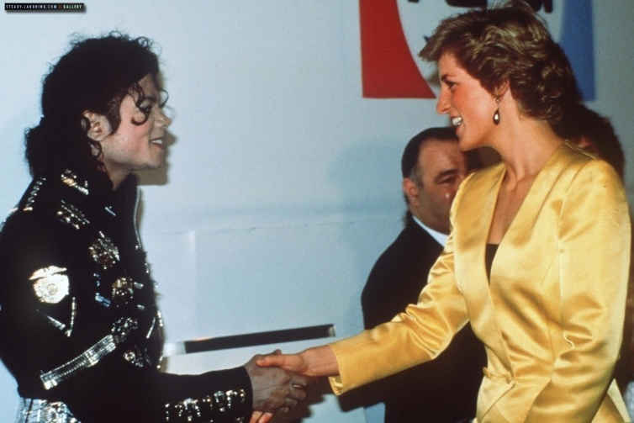
“Thank you so much for attending.” She said as she made her way towards us. Michael bowed his head and gently kissed her hand.
“It’s my pleasure. There’s someone I’d like you to meet.”

OH.MY.GOD I thought. This is it.

“Diana, I’d like you to meet one of my closest friends. The former Princess of Wales.
Lady Diana.”

I had no idea how to greet her. I curtsied and she laughed adorably.

“Please no formalities.” She said taking my hand in hers. “I’ve wanted to meet you for so long. Michael has told me so much about you.”
“It’s an honor to meet you, Miss Lady.”
“Please, call me Diana.”
“Oh gosh no. That’s too informal.”
“Your fiancé said the same thing to me when we first met. I believe he’s now comfortable addressing me by my name. Most likely because you also carry it.”
“You are so beautiful.”
“And you. I adore your dress.”
MY DRESS? I thought. Compared to her, I looked like a homeless bum.

“I love yours.”
“Thank you. I must meet the others. Please stay and enjoy yourselves. I will catch up with you again.”

Michael and I thanked her as we made our way towards the banquet room and sat at a table reserved for us near the Royal family’s head table.

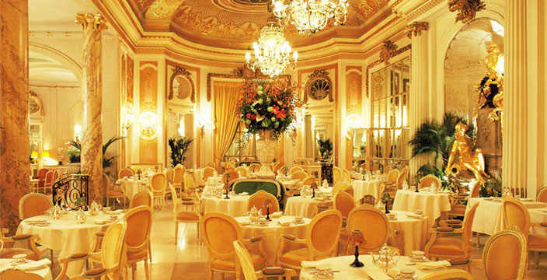

“Baby, this place is really exquisite.” I said looking at all the antiquely designed walls and artwork.
“I knew you’d like it.”
“Thank you for bringing me here. I love you.”
“Diana, we can’t say those words here.”
“Why not?”
“It’s taboo to use certain words near the British Royals.”
“REALLY?”
“Yes. We can’t even hold hands.”
“WHAT—“
“SHHH!” Michael put his hand over my mouth and smiled looking around the room making sure no one heard us.

“It’s like a law, Diana. We have to respect and follow their rules.”
“No wonder she left Charles.”
“That’s one reason but yes, exactly!” Michael said laughing under his breath.

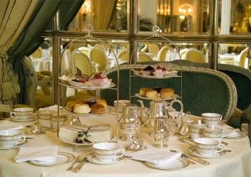
Several dozen butlers, maids and caterers dressed in formal suits and dresses served us our tea in very elegant teacups with saucers, silver cutlery, and soft, white cloth linen napkins. Michael placed one in his lap and I did the same not knowing if that was the right thing for me to do.

“Good girl.” He whispered.
“I don’t know what to do.”
“Just follow my lead. You’ll be ok.”

A few minutes later, a loud trumpet began playing and everyone rose to their feet.

“We have to stand up now.” Michael whispered helping me up.

Prince Charles and his two charming sons walked into the room from across the grand entrance arriving with a few Royal guards dressed in fine black tuxedos and perfectly polished shoes and ties.

“They are one handsome family!”
“Just like ours will be one day.” Michael whispered.
“I want to kiss you.”
“Me too.”
“I guess we’re not allowed?”
“Do you really think these people will stop me?”
“What happened to the rules?”
“I’m Michael Jackson. I make my own rules.”
“That’s the Moonwalker I know and love!”

He smiled and kissed me quickly on my right cheek making sure no one noticed.

“You’re beautiful.” He whispered as he squeezed my hand. “You make me so happy.”
“The feeling is mutual, Mr. Jackson.”

Once the Royal family took their seats, everyone sat down and continued enjoying their delectable teas, coffees, sandwiches, pastries and fruits. I noticed Lady Diana was not seated with the rest of her family.

“Baby, why is she sitting with her side of the family and not his?”
“She and Charles are divorced. It was finalized the day before my birthday last year.”
“So they can’t even sit together?”
“Not anymore. The only reason she’s even here is because of her children.”
“Really?”

Michael shook his head.

“She is no longer a member of the Royal family. But because she bore two sons, she still holds the title as a “Lady” since they both will be heirs to the throne one day.”
“You’re telling me she’s only here because she gave the queen two grandkids?”
“Exactly.”
“So if she had no kids at all with Charles she wouldn’t be allowed to be here?”
“Never.”
I was shocked. I had no idea a woman who dedicated her life to the Royals and their family would be banished in such a way. I figured that was why the concept of divorce was looked down upon according to the rights of the queen and her Monarchy.

*** TWO HOURS LATER ***

High Tea was almost over. Lady Diana kept looking at us making sure Michael and I enjoyed ourselves and weren’t being harassed by anyone. Michael signed a few autographs but wasn’t allowed to take photographs – another rule made by the Royals. Charles and his sons greeted us formally by shaking mine and Michael’s hand.

“You look just like your mother.” Michael said gently patting the top of William’s head. The young man simply smiled and shook his head.
“And you, little one, have your father’s face.” I said looking at Harry. He too didn’t say a word and smiled.

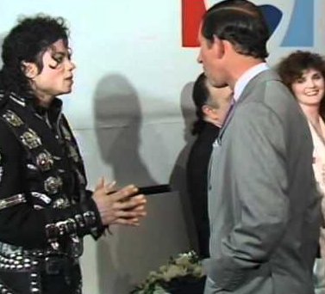
The Prince of Wales was a man of few words. He immediately noticed his ex-wife staring at us and seemed rather uncomfortable with us being there.

“If you’ll please excuse us.” He said as he took his children by their hands and walked away.

“What’s his problem?”
“He never liked me.”
“Really? Why?
“He thought me and his ex-wife were…”

I covered my hand to keep myself from bursting out laughing.

“SERIOUSLY?”
“Yes. It was a disaster. She and I stopped talking for months because of that.”
“Were you two?”
“OF COURSE NOT!”
“Just checking.”

“She’s always been a dear friend of mine. We have so much in common. She too has had her share of being scrutinized by the media. There were times when she’d call me in the middle of night crying because she couldn’t handle some of the things going on in her life. She only stayed for her sons in the end.”
“Then what happened?”
“It’s a long story and I don’t think she’d want me to tell anyone. Charles was possessive and didn’t pay attention to her. There were several infidelity rumors about him too. Picture my life in the form of her and you’ll understand.”

I had no idea that Lady Diana had such a troubled life. I was glad that Michael was able to help. Like he said, if anyone could understand, it would definitely be him.

“Thank you for telling her about me.”
“Why wouldn’t I?”
“She’s so perfect and stunning. I’m just…me.”
“Don’t say that again! You are my perfect princess. My own Lady Diana.”
“You’re so sweet. Thank you.”

Not being allowed to kiss was frustrating. Michael grabbed my hand and kissed the inside of my palm as we took our seats and finished our snacks and beverages. Lady Diana approached us again thanking us endlessly for attending the Royal event and said she would be attending Michael’s last concert in London in a few days.

“Please be sure to perform Dirty Diana, Michael. You know how much I love that song.”
“Oh god. I don’t want to sound disrespectful towards you. I sometimes feel horrible for choosing that name. Who knew it would have such an impact in my life later on?”

Lady Diana and I both giggled at the same time.

“Call it fate or prediction - it was meant to have that name for a reason.” I said.
“I think you may have found your intellectual match, Mr. Jackson.” Diana said making me blush.
“She’s a very smart woman. It comes with the name.”
“I agree.” She said smiling at the two of us. “Please do keep in touch with me.”
“I certainly will. Thank you for having us here and please feel free to contact us anytime as well.”
“I apologize for any misconception I may have caused.” She said holding my hand.
“In what way?”
“Michael and I didn’t tell you who I was because he wanted it to be a surprise. My calls were repetitive and I didn’t want you to think he was being disloyal behind your back.”
“I have to admit – the thought did cross my mind. I had no idea it was you calling. I didn’t even recognize your accent. I apologize.”
“No need.” She said looking at the two of us. “You two are a beautiful couple. I wish you the very best.”
“Thank you. We’re both here for you too and happy belated birthday.” Michael said holding her hand.
“Oh Lord, I feel old.”
“You are NOT!” Michael scolded her. “I’m three years older than you.”
“Oh my word. Michael YOU are old!” She joked laughing gracefully.

Seeing their friendship made me realize how precious Lady Diana was to Michael. Her grace, elegance and class astounded me. Michael briefly told her about Bela and she offered to help in any way she could. Seeing them smile and laugh together made me appreciate her so much more. Michael had definitely found a solid friendship with her. A friendship that I knew he held so dearly in his heart. Lady Diana was more than just a broken woman. In Michael’s eyes, she was his hero.

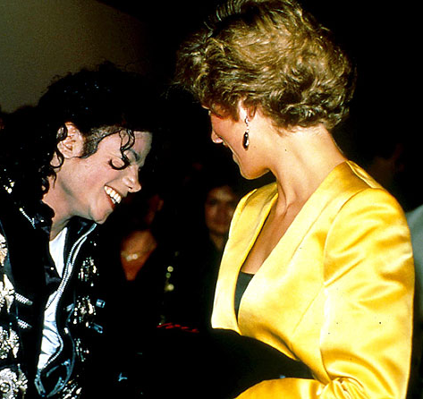

“It’s time to go.” Bill said as he approached us. “You have rehearsal. Chris is waiting.”

Michael and I bowed in front of Diana once more and she smiled. Even though she was no longer a part of the Royal family, Michael and I still considered her to be trying our best to make her feel loved and appreciated.
“I’ll reserve two seats for you at the venue.” Michael said as Diana walked us to the grand entrance.
“Take care of yourself, Michael.” She said. “You know how much I worry about you.”
“And I about you.” He said trying his hardest to sound formal given where we were. “I’ll try if you do.”
“It’s a deal.” She said hugging him.

“You carry my name with such dignity.” She said. “Michael has truly found his own princess.”
“Please.” I said trying not to cry. “I don’t deserve such praise from you.”
“Oh, but you do. Michael was very distraught when you left him. He and I shared many, many sleepless nights on the phone together. We both were going through the pains of separation. I prayed every night begging the Lord to bring you back, even if it meant destroying my own marriage.”
“Oh my god. I can’t even fathom that.” Michael said putting his head down.
“Neither can I. Thank you for having so much faith in us.”

“Michael was never himself after you left and neither was I in my own relationship. We quickly became each other’s support system. You have no idea how much you have impacted his life. You are closer to him than his own veins.”
“You are wonderful to talk to.” I said admiring her beautiful eyes and lips. “I understand now why Michael and you became so close.”

Bill reminded us again that we had to leave. Diana was also ordered by a few Court Royals that she too had to return to the event taking place in the ballroom.

“I’m sorry for keeping you. We’ll be in touch again.” I said leaving with Michael’s guards.
“Until next time, your Highness.” Michael joked as he kissed her hand and walked beside me.

She watched us leave until we were no longer in sight. Michael waved to her from the moon roof of the limo showing her how much he loved and appreciated her. What she didn’t realize was Michael slipped something inside her palm when he subtly kissed her hand before parting. As soon as we left the Royal grounds, Lady Diana felt something in her hand and opened it:

You will always be my princess.
I love you, Diana.
Michael.

Tears formed in her eyes as she read each word handwritten by her best friend. She smiled to herself and snuck the note inside her red jeweled clutch purse and regained her posture before entering the grand ballroom with her head held high. She no longer felt scared and alone. Nothing could ever happen to her now. She had her best friend and his fiancé by her side.

July 17, 1997

Wembley Stadium, London, England

Michael’s final concert in the United Kingdom was minutes away from beginning. All he could think about was his Royal best friend sitting across the left side of the stage with charm and dignity.

“She’s still not here! Where could she be?” Michael asked pacing back and forth in his dressing room wearing his gold garments.
“She’ll be here.” I said sitting him down and applying his eyeliner.
“It’s not like her to be late. She’s a Royal – she knows all about timing.”
“Michael, she’s also a target to the press like you. She must be held up trying to get annoying photographers out of her way or something. The girls are on the lookout. She’ll be here.”
“I hope so. I put Dirty Diana in the show just for her.”
“Hey! You never did that for me!”
Michael started to sing:

“Do you remember the time? When we fell in love? Do you remember the time when we first met?”

“Sound familiar?”
“Oh. Right. Oops.”

He giggled and kissed my forehead. I proudly showed him my finished product in the mirror and he gave me the ok then continued pacing again.

“SHE’S HERE! SHE’S HERE!” Marie and Jasmine both yelled barging into the room.
“THANK GOD.” Michael said relieved.
“I told you so!”
“I know. I was just worried that maybe something happened to her. Has she sat down?”
“We just heard the announcement and everyone stood up as she came in.”

“FIVE MINUTES, GOLDEN EGG!” Bill yelled.
“Thank you.”

“I like gold nugget better.”
“It likes you just as much.”
“Can I have it?”
“Of course.”
“GIRLS, GET OUT!”
“Oh please, it’s not like we haven’t seen it before.” Jasmine said.
“I’ve wanted to ask you two about that. How did you manage to see us?”
“Through the keyhole.” Marie said. “We heard noises and assumed you two were doing it so we got curious but then felt guilty and stopped watching. Ana’s a freak!”
“I AM NOT!”

“YO GOLD DUST! Your special lady friend is waiting! LET’S MOVE!” Bill said barging in again.
“I’ll be right there!”

Bill rolled his eyes and closed the door again.

“We’ll take our leave now, sir.” I said bowing jokingly to my future husband.
“Stop it. Did David arrive home safely, Jasmine?”
“Yes. He’s really jet legged but doing fine otherwise.”
“I’m sorry he couldn’t stay longer.”
“It’s ok. He has work and little man to keep him busy.”

“HEY GOLDFINGER--”
“I KNOW, BILL! I’LL BE RIGHT THERE!”

The girls and I couldn’t help but laugh at Michael’s adorable nicknames.

“We’ll see you on stage!” Marie said.
“Break a leg! Well, not literally.”
“Thank you, tea flower.”

Michael put on his helmet and took my hand as we walked with his guards to the ground floor underneath the stadium. I wished him luck and kissed him briefly as he took his position beneath the railings. I kept a close eye on him until he was no longer in sight making sure he was safely put in place before leaving and joining the girls.
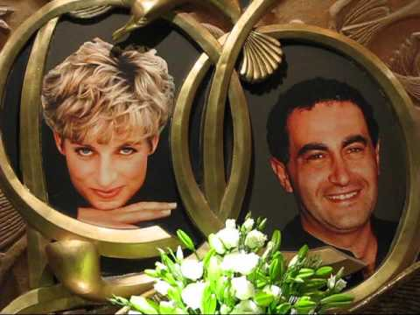
“Whoa. Charles got some serious plastic surgery done on his face!”
“That’s NOT Charles Jas!” Marie said. “That’s her new man, Dodi-Al Fayed.”
“HE’S A HUNK!” Jasmine asked looking at the former princess of Wales.
“I wonder if he has a brother.” Marie asked.
“I could find out.”
“What’s she like, Ana?”
“She’s a wonderful person. Very graceful. Full of poise and elegance. “

I waved to her and smiled as she turned and waved back. Michael’s opening film appeared on the big screen making the fans scream and cheer like always.

“I never get tired of hearing his fans.”
“Me neither.” Jasmine said. “It’s kind of soothing in a way.”

As the concert went on, the girls and I noticed Diana was having the time of her life. She smiled and clapped for her most cherished friend the entire time he performed. It was obvious that she loved watching him in his element.

“How long have they known each other?” Jasmine asked.
“Ever since Bad. She attended his concert with Charles then.”
“Wow! That was almost ten years ago!” Marie said.
“I know. Michael never mentioned her to me before.”
“Can you blame him? You always assume the worst when it comes to Michael, Diana.”
“I know. I’m trying to stop.”
“And you’ve improved.” Marie said.
“Thanks.”

“She’s really beautiful.” Jasmine said. “I don’t mean to be a creeper but I can’t just stop looking at her. And her new man is really cute!”
“Did you meet him too, Ana?”
“No. Just her. Charles and their two sons shook hands with us but that was it.”
“Ugh, he was a fool to let her slip away.” Jasmine said.
“That’s what Michael says too.”

*** LATER THAT EVENING ***

As a special treat, Michael spoke to his fans and addressed his best friend’s presence by asking everyone in the venue to clap in her honor. Diana stood graciously and blew kisses as her new man smiled and admired her feeling proud to call her his.

“I love you, Diana.” Michael said facing the Princess and glancing in my direction.

“Aww, he means the both of you.”
“I know, Jas. He’s being sweet.”
“That name always comes back to him somehow.” Marie said. “First with Diana Ross, then his song and now with you two.”
“I know. It’s scary.”
“I’m sure he loves it.” Jasmine said.

He finished the concert by performing her favorite song smiling and blushing as he sang his last verse. Michael made eye contact with me and winked as his face lit up against the stage lighting causing the entire venue to yell and scream even louder. As I stood watching him with flushed cheeks and a dainty smirk, he concluded the concert by speaking a final time saying he loved all of his fans and wished them a safe journey home before leaving the stage in his trademark space ship.

*** AT THE HOTEL ***

The girls and I laid on the oversized chaise lounges in the living room relieved to be back in the suite. Michael wanted to make sure his best friend would be safe while leaving the venue and arranged for several of his guards to follow her vehicle to ensure her safety. The Princess of Wales’s face was plastered on every TV channel as news reporters and photographers followed her leaving the stadium. Michael’s entourage tried creating a diversion for the paparazzi but this didn’t stop the media sharks from harassing his entire procession of vehicles as they exited the facility attempting to protect his lady friend.

“Are you safe?”
“Yes, Michael.”
“Good. Did you enjoy the show?”
“You know I did. Thank you for performing the song.”
“You’re welcome. Mr. Fayed is a lucky man.”
“You think so?
“Of course. The girls think he is quite a looker.”
“That he is, much like you.”
“Stop it. I’m happy to see you with someone else.”
“And I you, Michael.”
I knocked on the bedroom door wanting to make sure Michael was ok.

“Can I come in baby?”
“Of course!”

“I just wanted to make sure you were alright.”
“I am thank you.”
“I’ll leave you alone.”
“Sit with me.”
“It’s ok. I’ll let you two talk.”
“Are you sure? You can say hi.”
“I’m too nervous. Please tell her for me?”
“Sure.”
I closed the door allowing the best friends to continue their conversation in private.

“She’s lovely, Michael.”
“Much like you.”
“Oh Lord. I am no Saint.”
“You are the closest thing, Diana.”
“After you, I suppose.”
“You over compliment me.”
“As do you, my crystal gloved friend.”

They both laughed in unison.

“When is the glorious King of Pop departing my city?”
“In the morning.”
“This saddens me deeply.”
“I’ll visit again.”
“I do not wish to wait another 8 years to see you in person, Mr. Jackson.”
“I promise it won’t be that long.”
“I will hold you to that.”
“You have my word.”
“Take care of yourself, Michael.”
“I will if you will.”
“It’s a deal.”
“You will be the first to get my wedding invitation.”
“Is that so?”
“Yes. I refuse to get married without one of my most cherished friends by my side.”
“Another request I shall hold you to, sir.”
“Thank you, Princess.”
“Michael, you are one of few that truly understand me. I value your friendship in ways you could not even begin to imagine.”
“The feeling is mutual.”
“Enjoy the rest of your tour, Mr. Jackson.”
“Thank you, Ms. Spencer.”

“Oh my word! I must say I am impressed.”
“Are you now?”
“Very much indeed.”
“I’m glad I amuse you.”
“Like no one else.”
“Goodnight, Michael.”
“Goodnight, Diana.”

*** SIX WEEKS LATER ***

HOTEL D’ANGLETERRE
COPENHAGEN, DENMARK

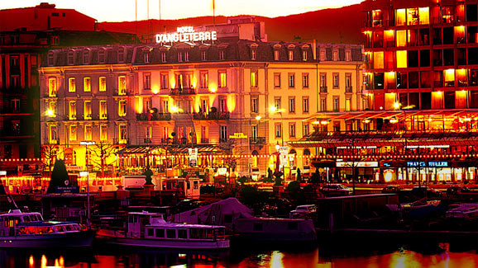

AUGUST 29, 1997

The History tour is just six weeks away from coming to an end. Michael’s concerts across Europe were completely and officially sold out in a matter of minutes in just a few of the continent’s most prestigious countries such as Switzerland, Sweden and Norway. Five days ago while touring in Finland, Michael broke another record by being the first entertainer to have his own platform stage custom built over a massive ice rink at the Helsinki Olympic Stadium. The country’s Chief of State and Head of Government awarded Michael with a gold plated medal and a black marbled plague thanking him for performing in their country and for his ongoing success as the world’s biggest selling artist with the biggest selling album, second biggest selling album, biggest selling multi-disc album and biggest selling remix album of all time under his colossal belt of achievements.

In addition to his remarkable and successfully completed goals, this day was extra special for the entire gang for two reasons: it was Michael’s 39th and coincidentally, Marie’s 30th birthday. Knowing Michael had never celebrated his birthday due to his strict Jehovah’s Witness beliefs, Diana was unsure about saying the words ‘happy birthday’ and giving him a present. After speaking to her two favorite people in the world (aside from her fiancé) she decided to gift him in a way that she knew her future husband would definitely appreciate and certainly never forget.

“It’s all set!” I said coming through the suite door seeing the girls eating an array of buffet items set up at the far end of the room.
“What is, Ana?” Marie asked as she sipped her orange juice out of a fancy looking goblet.
“Michael’s birthday present from all of us!”
“Did you tell Waleed about it? I’m sure he’ll be pissed if you.”
“I ran it by him. He said it was out of the budget and a waste of time and money since Michael doesn’t celebrate his birthday. That sure as hell didn’t stop me from doing it anyway.”
“That’s the Diana Dean we know and love!” Jasmine said taking a bite of a freshly baked blueberry scone.

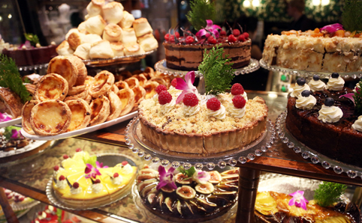

“These goodies look really yummy!” I said making my way over to the buffet table.
“Have some! They’re all Marie’s favorites – courtesy of Mr. Jackson along with the huge diamond necklace and couture dress designed by the one and only Anne Klein.”
“It’s beautiful and so me! I’ll wear it to the concert tonight.”
“That’s my Moonwalker – always spoiling the ones he loves.”

“This gift is my favorite!” Marie said dragging an oversized teddy bear from across the room. Michael had it custom made for her and programmed his own voice into it every time the nose was pressed.

“To the sweetest, cutest and softest bear in the world – happy birthday!”

“That is just too adorable for words.” I said admiring the large, plush toy.
“Good luck getting that past customs on the way home.” Jasmine said.
“Michael said he’d take care of that for me. I guess he’ll package it in a box and stow it as luggage. I just hope it doesn’t get damaged.”
“I doubt it. He’ll make sure it stays in one piece for you. Is he still at rehearsal?”
“As always.” Jasmine said buttering another scone.
“Have something, Ana. It’s all really good!” Marie said grabbing a piece of banana bread.

“Why aren’t you two out sightseeing or at the spa?”
“We were waiting for you to get back so we could all go together as part of Marie’s birthday.”
“Oh gosh, I want to join but I have to pick out an outfit for tonight plus check on the workers at the venue. Waleed mentioned there were some damaged wires from transporting the equipment from Finland.”

“Michael took care of it this morning.” Jasmine explained. “His technicians repaired everything then he gave Marie her gifts before leaving for rehearsal with Chris. He wanted us to enjoy ourselves, not worry about anything and have fun on Marie’s special day.”
“That man is always thinking about others before himself. Has he called?”
“Not yet.” Marie said. “Come on, Ana! It’ll be fun. You haven’t gone anywhere with us since the tour started!”
“I know, but I have to stay on top of things.”
“Like the toilet seat!”
“JAS!”
“AHEM! Sorry.”

“I don’t want to seem unprofessional. I have to make sure the workers do their jobs, the contracts get obligated and carried out, and Michael’s wardrobes are put in place...”
“He specifically said not to stress about anything today. You deserve a break, Diana. You haven’t relaxed at all since we left LA.”
“You’re right – so, what are we doing?”
“Spa, shopping and brunch at some bistro that Chris recommended.”
“Sounds wonderful.”

*** LATER THAT DAY ***

“We really needed this!” Jasmine said as we came back from our fabulous day out.
“I’m glad you finally got to join us, Ana”
“Anything for our bear on her birthday.”
“I’ll call the front desk and check for any missed calls.” Jasmine said making her way towards the phone.

Michael still hadn’t called. I didn’t want to assume the worst. I figured he was still rehearsing and needed every moment to focus on his craft. Jasmine said there were no messages at the front desk and the buffet items had been taken away. A note from the hotel staff was left on the coffee table saying Marie’s birthday cake was in the fridge. She didn’t want to eat it until Michael was back from the concert so we decided to wait until then to eat the deliciously looking confection. Chris knocked at the door saying Bill had just left to take Michael to the venue. I asked if he heard from Michael and he didn’t either.

“Why hasn’t he called any of us?”
“Today is his birthday, Miss Diana.”
“I know. That’ why I thought he’d call for sure today.”
“He doesn’t like to be reminded of this day.”
“What? Why?”
“It’s a difficult day for him. It’s always been since he was a child. Mr. Jackson has never celebrated his birthday due to his religious upbringing. We have all tried to celebrate and make him feel happy but he refuses to be reminded of the day he was born.”
“I can’t imagine him hating his own birthday.” Jasmine said.
“I wouldn’t say he hates it. He just has a very strong disliking to it.”
“Well, I’m definitely going to change that. He’ll love his birthday after he sees what I have planned.”
“Mr. Jackson is also homesick. He misses his family and animals a lot.”
“Poor Michael.” Marie said. “We’ve all been so on the go with everything, we never even thought about how he’d be feeling so far away from Neverland and Havenhurst.”
“Trust me, he won’t feel that way for long.”

*** LATER THAT EVENING ***

PARKEN STADIUM
COPENHAGEN, DENMARK

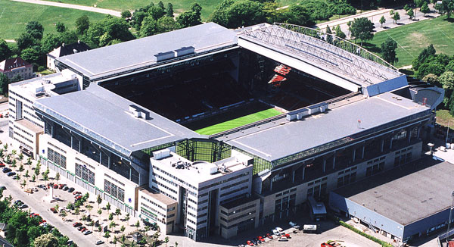

As usual, Michael’s concert was a success. The girls and I arrived late due to congested traffic, unnecessary media reporters and photographers harassing us at the hotel. Michael was already in the middle of his ‘Smooth Criminal’ routine when we arrived. I noticed him smile and giggle as he saw the three of us appear from backstage.

“Stay here, you two. I have to check on his gift.”
“Can we help?” Marie asked.
“Keep your eye on him for now and make sure he doesn’t leave. He MUST be on stage for this!”

I scurried backstage near the security area. Chris confirmed all of the arrangements and every detail was set and perfectly in place. It was just a matter of timing now. I couldn’t wait to see the look on his face!

*** AN HOUR LATER ***

“Ana, the concert’s half over.” Marie said. “Where is it?”
“It should happen any second now.”
“Happen?” Jasmine asked.
“Just watch.”

Suddenly, Michael’s “You Are Not Alone” routine was interrupted (intentionally at that part) by a 60 man marching band dressed in full Mounty uniforms. The look on Michael’s face was priceless. He knew exactly what it was for and who was behind it.

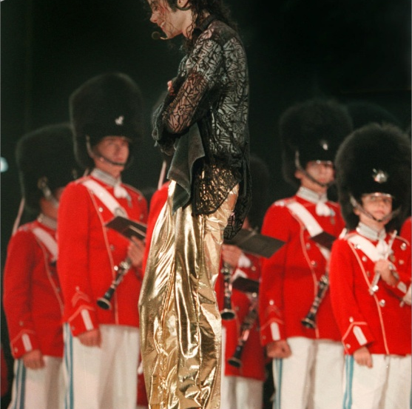
“OH MY GOD! HIS FACE! HIS FACE!” Jasmine yelled. “MARIE! GET THE CAMERA!”

She took several photos of Michael and his fans reaction to the unexpected, pleasant surprise. He glanced in our direction and shook his head at me knowing I was fully responsible for what he was witnessing. Two of Michael’s stage crew members also presented him with a massive six tiered cake with large sparklers poking out from each end with an inscription in the middle of each layer:

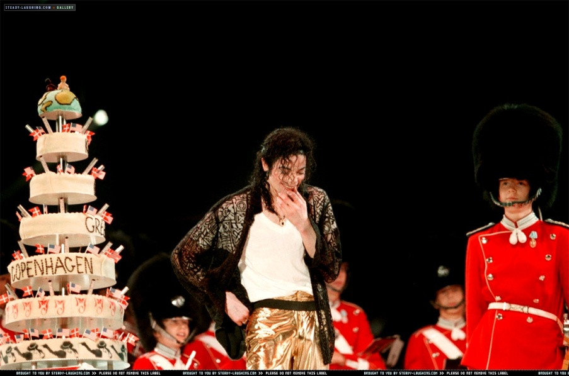

“Happy
Birthday
Michael
Greetings
Copenhagen
Denmark”

Michael tried his hardest not to cry. Marie continued taking pictures of him from every angle hoping he wouldn’t get over emotional. I had the biggest urge to run on stage and hug him but didn’t want to ruin his magical and historic moment on stage. The entire venue sang ‘happy birthday’ as Michael listened, watched and smiled like the angel he was.

“That’s incredible. Thank you so much.” He said facing his stage crew and audience,

The girls and I pointed upwards asking him to watch the dazzling fireworks directly in front of him.

“OH MY GOD! THAT’S UNBELIEVABLE!” He yelled seeing the grand finale of his own toe standing silhouette draped entirely in red fireworks – one of his favorite colors.

Michael was so touched. He could not stop thanking everyone for a wonderful and extravagant birthday gift. He repeatedly looked around and said he loved everyone very much from the bottom of his heart.

“I DON’T KNOW WHAT TO SAY – I LOVE YOU!” As he glared at everyone in the venue, they hollered and screamed for the one man that loved his fans just as much as they loved him.

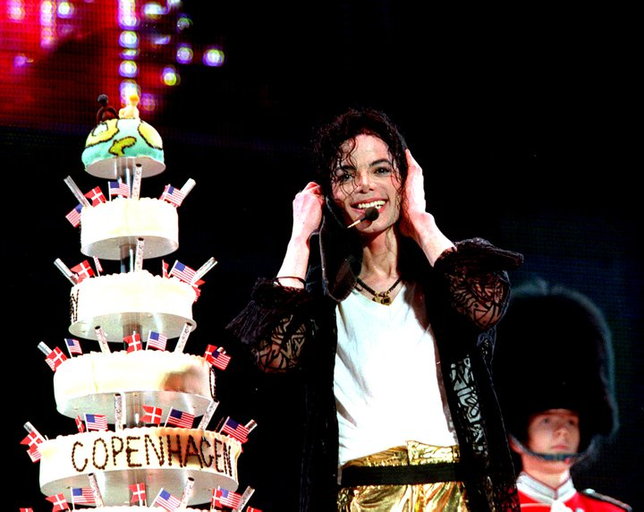

“And NOW for the best part! Wait here!” I said running towards Chris.

He had his phone ready in his hand. I hurried to the sound operators who kindly re-programmed the equipment to the microphone on stage that Michael used to sing into. The entire venue’s lights turned off and Michael was left speechless as Chris walked onto the stage and stood beside him smiling as he wished his employer a very happy birthday.

“We have one more surprise for you, sir.” He said facing the audience. “Look behind you!”

A beautiful picture of Michael’s equally iconic and glamorous best friend appeared on the big screen. His fans went ballistic. Seeing the legendary Dame Elizabeth Taylor on screen was Michael’s breaking point. I knew he needed comfort but what he and everyone else didn’t know was that the end result of his surprise would definitely take do that on my behalf. Chris then placed the phone in his hand directly against the microphone.

“HAPPY BIRTHDAY, MICHAEL!” Elizabeth said directly into the microphone. “I LOVE YOU!”
“I LOVE YOU MORE, ELIZABETH!” Michael replied. “I WISH YOU WERE HERE.”
“I AM HERE!” She replied before appearing on stage from behind him.
“OH MY GOD!” Jasmine and Marie both yelled jumping for joy. “HOW DID YOU GET HER?!”
“I have my ways.”

Michael cried as he lovingly held his best friend in his arms. Their embrace was long yet full of undying friendship and love for each other. I smiled from ear to ear knowing I made him happy on the most important day of his life. Michael looked over at me shaking his head again as he wiped his tears away with a small black cloth given to him by the stage crew. I mouthed the words ‘I love you’ to him and he winked at me before eating a small piece of his cake then feeding it to Liz and the crew members on stage.

Elizabeth sat on a chair near the edge of the stage and watched her best friend conclude his concert with more unexplainable energy, passion and drive than ever before. The night was completely spellbound and full of happiness. I knew this would be a night to remember. A night that Michael Jackson would never forget. A night that would definitely go down in ‘history’.

*** AT THE HOTEL ***

Michael wanted to spend time with his newly arrived friend after the concert ended. He quickly showered, changed and sprayed on his favorite cologne before joining me and the girls in the living room as he waited for Chris to arrive. Waleed transported Michael’s massive birthday cake to our hotel and he shared it with the hotel staff after we took a few pieces for ourselves and ate them along with Marie’s cake. We all sang ‘happy birthday’ to her as she cut the first slice and we took turns feeding her. Jasmine affectionately smeared icing all over her face. After a good laugh and several photos later, we were all relaxing comfortably on the chaise lounges in the living room when Michael came out of the bedroom looking like he had a lead role in an upcoming film.

“Well, don’t you look handsome birthday boy?” I said giving him and hug and a kiss.
“You girls are incredible.” He said as he sat down next to me. “I don’t know how to thank you.”
“I think I speak for all of us when I say the look on your face tonight is all the thanks we need.”
“How did you get in touch with Liz?”
“Let’s just say your ‘Lady’ friend has a lot of connections in this world.”

Michael shook his head as he happily remembered his favorite Princess in London. The phone in the suite suddenly rang lighting up his brightly colored face even more.

“Perfect timing.” I said looking down at my watch. “I suggest you answer it, baby.”
“Diana, you are too much sometimes.”
“But you love me anyway.”
“Even more than before.”
“AWW, HOW SWEET!” Marie said making me blush.

Michael stood up and ran to the bedroom anxious to speak to the one person he waited anxiously to hear from all day. Hearing her delightful, accented voice on the other end made him flourish and grin perfectly.

*** MICHAEL’S POINT OF VIEW ***

“Happy birthday, my dearest friend.”
“Thank you. I’m so glad to hear from you today.”
“I apologize for the delay. I was occupied by someone’s massive History concert on TV.”
“You watched me?”
“Oh, heavens YES! I wasn’t going to miss your fiancé’s birthday gift to you. How is Ms. Taylor?”
“She’s well. A very pleasant surprise for sure. I am about to go to her hotel. She leaves in the morning.”

“You sound happier, Michael. Knowing this brings my heart much joy.”
“You’ve always wished for nothing but my happiness, Diana.”
“And you for me.”
“I’m delighted to know our wish came true.”
“Second star to the right and straight on till morning – isn’t that what you said?”
“Yes, Wendy.”
Diana knocked on the door telling Michael that Chris was on his way to pick him up.

“Is that your darling fiancé?”
“Would you like to say hi?”
“If she doesn’t mind.”
“Of course not.”

Michael told me his beloved friend wanted to speak to me. Since it was his birthday and the fact I had turned her down once before, I agreed and cleared my throat before saying hello in the most formal and polite way I knew how without sounding rehearsed.

“How are you dear?”
“Just fine. Thank you for calling and helping me bring Ms. Taylor here.”
“It was the least I could do.”
“I’d love to see you again.”
“And I you.”
“Will you attend our wedding?”
“That’s simply an offer I cannot refuse.”
“Michael won’t go through with it without his Princess by his side.”
Michael lovingly rubbed my back as his way of saying thank you for being so kind and affectionate towards his dear friend.

“I don’t want to take up a lot of your time. I know it’s very late in London.”
“So considerate – you are definitely his match.”
“Thank you. I don’t mean to be forward but you also have a lovely man on your arm.”
“I do believe that’s true.”
“Goodnight, Ms. Lady.”
She laughed so distinctively that it instantly became engraved in my memory. I gave the phone back to Michael and left the room allowing him to speak to his friend in private again.

“You must sleep. I don’t want you staying up all night worrying about me anymore.”
“Why, Mr. Jackson I must say I am quite appalled.”
“Oh? And why pray tell is that, Ms. Spencer?”
“Have you no shame? Blatantly accusing the former Princess of Wales of thinking about you at night!”
“I’m not accusing you. I’m telling you – you are guilty as charged and you can stop doing it now.”
“I must admit, thoughts of you were replaced quite some time ago.”
“I’m glad he did that. I wish you all the happiness in the world.”
“And I you, Michael. He is taking me to Paris tomorrow.”
“The city of romance – I was there a few weeks ago.”
“I know. You stayed at his father’s hotel. I also heard about your proposal at the Eiffel Tower.”
“I’m sure he will do something just as wonderful for you.”
“I am content with Dodi, Michael. I don’t need extravagance or trumpets blown about anymore. I had enough of that life with Charles.”
“I understand.”
“These last few concerts will take a toll on me. I’ll call you when I get back to LA.”
“When do you leave Europe?”
“Mid October.”
“I shall long to hear from you until then, Mr. Jackson.”
“You know you can call me anytime anywhere in the world.”
“I am aware of that, kind sir.”
“You are an irreplaceable woman in my life, Diana.”
“Oh, my word. I must say I am deeply flattered to hear that.”
“I’m glad. I’ll let you rest now.”

“I love you very much, Michael. May the Lord be with you at all times.”
“Thank you. I wish the same for you.”
“If I don’t see ever you again-“
“Diana! Why would you say something like that to me?”
“Please stay strong, Michael. I shall always be with you.”
“Diana…”
“Goodnight, Michael.”
“Goodnight.”

An icy cold chill ran through his entire body as he hung up the phone. Michael was never one to believe in the unknown until an overwhelming sense of clairvoyance embodied his mind that night. He was unsure about what it was trying to tell him exactly but what he did know was that this strange, ethereal force came with great power. Unexplainable, unimaginable power that frightened him dreadfully. This force was rare and not one to be ignored or tampered with. This force was known to linger around those that it felt deserved a warning. This particular force wreaked of one thing and one thing only – death.

*** AN HOUR LATER ***

Visiting with Elizabeth Taylor was always a treat for Michael. He adored her company and always enjoyed having tea and multiple conversations with her. But this time, he was distracted. Something was bothering him but he couldn’t figure out what it was.

“Michael dear, you seem so lost. What’s wrong?” Liz asked as she poured her friend another cup of tea.
“Something’s not right, Elizabeth.” He said putting the cup of hot liquid near his mouth. “I can feel it.”
“What exactly are you feeling, Michael?”
“I have no idea. It’s very unsettling.”
“I’m sure it’s nothing. You may just be exhausted from all the constant touring and travelling.”
“You might be right. Thank you for coming. I missed you.”
“I missed you too. I was surprised to get a call from the Princess of Wales. She and I haven’t spoken in quite some time.”
“She’s a special woman.”
“That she is.”
“I must get back to the hotel and let you rest. Have a good and safe flight tomorrow, Elizabeth.”
“It was great seeing you again. Your fiancée is a lovely woman, Michael.”
“Thank you.”
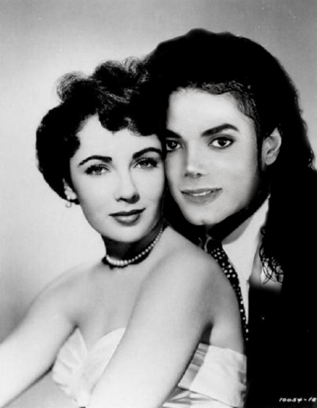
“I love you.”
“I love you more.”

The two best friends hugged each other before departing. Chris and his guards escorted Michael to his limousine as he disguised himself in a black surgical mask and thick black overcoat before heading back to his hotel and returning to his beloved fiancé.
AUGUST 30, 1997

News of Lady Diana and Dodi Al-Fayed was making headlines on every TV channel and magazine across the globe. She was seen leaving the island of Sardinia on a private jet with her new partner and spotted by several media reporters upon her arrival in Paris. Michael, not having to worry about rehearsal since his next concert was four days away in Belgium, decided to stay an extra day in Copenhagen so that he could spend quality time with his three favorite girls. He tried his hardest not to seem troubled but the unknown force disturbing him from the previous night continued to hang over him excessively. Michael couldn’t shake the fact that something wasn’t right. His instincts were known to never deceive him. He knew he had to take action to try and ease his mind from the awful cloud of discomfort surrounding him but he had one major problem – he just didn’t know how.

AUGUST 31, 1997 – 12:23AM

“NO! NO! NO!”
“Michael, wake up! You’re having a bad dream.”
“NO! DON’T!”
“MICHAEL!”
“NO! PLEASE! NO!”

“MICHAEL!”

He opened his eyes and sat up on the bed looking around as if he were trying to find someone.

“OH MY GOD, DIANA!”

Michael pulled me towards him and held me as tight as he could. His body trembled in fear and his entire face was drenched in sweat and panic.

“Someone I know is in danger. I can feel it.”
“No one is in danger, Michael. Everyone you know is perfectly fine.”
“Diana, something’s happening to me. I can’t explain what it is and it’s scaring me.”
“Michael, it was just a bad dream. You stopped taking your prescription medications too. You are most likely having withdrawal symptoms.”
“Don’t let me go, Diana. Please DON’T let me go.”
“I won’t. It’s ok, Michael. Everyone is alright.”
“I love you so much.”
“I love you too.”

1:00AM

My cell phone rang on the night table jolting me awake. Half asleep, I answered trying my best to understand what the person on the other end was saying.

“Hello?”
“Miss Dean?”
“Yes?”
“This is Dr. Amberg calling from the Children’s Hospital and Burn Center in Bremen. I apologize for disrupting you at this hour.”
“No, please don’t apologize. What is it doctor? Is it Bela?”
Hearing me say the little boy’s name awakened Michael forcing him to believe that his nightmare could have possibly been about him.

“Bela? What’s wrong with Bela?! Give me the phone, Diana!”
“SHH! Wait Michael!”

“We’ve just been informed that there may be a match for his liver transplant. However—“
“MICHAEL! Dr. Amberg said they might have found a liver.”

He snatched the phone from my hand with wide eyes and a heightened sense of hope.

“Is it true, doctor?”
“It’s not guaranteed but there is a possibility. Heal the World has already made all of the arrangements for Bela to fly to the donor’s location immediately.”
“Where is it?”
“Paris.”
“I’m going back there. I need to be with him.”
“Mr. Jackson, that really isn’t necessary at this time. I just wanted to inform you that as of now, there is a slight chance. Bela will be flown to Paris along with my team of fully equipped staff so that we are able to move forward with this process as quickly as possible.”
“Please call and let us know as soon as you have more information, doctor. Bela has to survive.”
“We are doing the very best that we can, Mr. Jackson. I’ll be in touch again soon.”
“Thank you.”

4:00AM

My phone rang again. Thinking it would be Dr. Amberg, I answered. It was Jasmine.

“Diana, you need to come to our suite right away.”
“What’s wrong, Jas? Are you ok?”
“Just get over here NOW and DON’T wake up Michael.”
“Jasmine, why are you—“
“NOW, DIANA!”
“Ok, I’m coming.”
“DON’T wake him up!”
“I won’t.”

I looked at Michael and saw him sleeping peacefully. Not wanting to wake him, I quickly crawled out of bed and put on my plush white robe provided to us by the hotel staff. I glanced over at Michael again making sure he wasn’t awake before stepping out of the bedroom. As soon as I opened the suite door, dozens of Michael’s guards were crowding around the suite hallway with looks of panic, shock and confusion on their faces. Several questions were being asked among themselves as I walked by them all.

“He’s definitely going to lose it.”
“The rest of the tour will have to be canceled.”
“Who’s going to tell him?”
“We need his full medical team on standby.”
“Someone call Waleed!”
“Get his family on the phone!”

Within seconds, more and more of Michael’s guards arrived from the elevators and stairways. Michael was perfectly safe. What was the problem? Was it Elizabeth? Katherine? Joseph? Michael’s siblings? Neverland? Thousands of worst case scenarios ran through my head. Jasmine saw me standing in the hallway trying to get some answers. She forcefully pulled on my arm and shoved me inside her suite directly into the living room. Marie was sitting on the couch sobbing uncontrollably as she watched and listened to the breaking news report. My eyes swelled. My heart pounded with pain. The room was spinning. Everything was slowly fading to black. I was cold. I was frozen. I was shocked. I was devastated.

My heart was hurting and my head felt like it had been squeezed in a vice. All I could think about in that moment was her beautiful voice, her elegant poise and her sweet, caring nature towards all humankind.

“NO! NO! THIS CAN’T BE TRUE! NO! NOT HER! NOT HER!”
“Ana—“
“OH MY GOD! MICHAEL!”

I ran out of the suite rushing across the hall needing to be with my fiancé. I had to be the one to tell Michael, to comfort him, to hold him. Tell him it was all just a big hoax. That Lady Diana was still alive and well. That she was still with us and we would see her again very soon. I bolted through the door and saw Chris, Waleed, security guards, hotel staff members and police officers all waiting around as if something were about to happen. As they all stared at me with confusion in their eyes, I ran to the bedroom and saw Michael passed out on the floor surrounded by an army of paramedics and nurses.

