CHAPTER 33
Oblivious Temptation

TO MY BELOVED READERS:

Tears of happiness cloud my eyes as I write these words to you. After three months of pushing boundaries, hair pulling, screaming fits and opening several doors that led me towards new and improved creative control, I am proud to say that The Flame That Still Burns has officially come to an end. THANK YOU for your endless love and support during this incredible adventure. You are truly the reason why I create. I am proud to say I love doing this more and more every time a new idea is born and brought to life. I hope you enjoyed experiencing phase two of Michael and Diana’s journey together. Don’t cry because it’s over – smile because it happened!

Seeing my future husband unconscious on the floor disturbed me. I wanted to be the one to break the news to him but was obviously too late. My head began spinning again making me feel incredibly lightheaded. Chris and Waleed tried to remove me from the scene but I resisted begging to stay near Michael. He needed me just as much as I did.

“What happened?”
“He fainted. His vitals are all over the place.” A paramedic said. “We have to get him to the hospital immediately.”
“Oh god, the tour.” Waleed said.
“Michael’s on the floor and all you care about is the tour?!” Marie yelled as she and Jasmine ran inside the room by my side.
“Stay out of my business, little girl.”
“I’M A WOMAN!”
“Barely.”
“SHUT THE HELL UP!”
“HEY!” I yelled wanting to put an end to their stupid argument.

“He’ll be alright.” The paramedic said as he and several others were gathering their equipment. “He’s just extremely fatigued. His blood pressure has dropped and in an undeniable state of shock. We must take him to the emergency room.”
“I’ll go with you.”
“We will too.” The girls said.
“You all can roll with me.” Bill said grabbing his keys from his pocket. “Chris will join us too.”
“Yes, sir.” He said as he and Bill headed out the door towards the elevator.

“This is horrible.” Waleed said. “We need to come up with a diversion quick. The press is going to have a field day with this too.”
“Do whatever you want.” I said rolling my eyes. I couldn’t believe how selfish and unreasonable he was being. His business partner just received the worst news of his life all he could think about how the press would react.

It took over an hour for Michael to arrive at the hospital. He was rushed through a back entrance and taken straight to an admitting room. Chris, the girls and I followed the ambulance in Bill’s SUV and arrived at the same time. Michael was awake but not speaking. As heartbroken as I was, I knew he was in worst shape then I could ever be. I had to be strong for his sake. Marie tried her hardest not to cry but seeing her favorite entertainer in despair again wasn’t something she or any one of us expected. Especially just two days after Michael and Marie’s birthday.

“Marie, it’s going to be ok.” I said rubbing her back as she stared at him through his room window.
“He’s so broken.” Jasmine said. “She was more than a friend to him.”
“I know, Jas.”
David called Jasmine as soon as he heard the news. Waleed and the others took care of Michael’s calls from Liz and his family. The entire hospital was surrounded by chaos and security guards. I had never felt so helpless. Michael needed me and I had no idea what to do or say to make him feel better. This was definitely a time when Michael Jackson was completely inconsolable.

“You can see him now.” One of the specialists on duty said as he came out of Michael’s room. “I’ve examined him. He’s alright physically but extremely desolated. His vitals are still weak. We will keep him under observation.”

I thanked the doctor as the girls went to see him. Thousands of fans and reporters flooded the hospital from every corner. Marie closed the window curtains allowing Michael to grieve in private for his now lifeless best friend.

“Baby…”

He didn’t look at either of us and stared aimlessly at the wall to his left. Tears flowed like rivers from his grief stricken eyes. I sat next to him and held his hand as the girls wiped his face and brushed his hair away from his face.

“She’s in a better place now.” Marie said.
“Looking down at you wishing you nothing but the best.” Jasmine added.

Michael was still quiet.

“Baby, please say something.”

Silence.

He blinked his eyes and squeezed my hand letting me know he was listening. I didn’t know if he wanted us to continue speaking. All we could do in that moment was cry. Not just for the loss of Lady Diana but also because we knew that she took a portion of Michael’s spirit with her. Chris and Waleed came in the room wanting to see their employer and business partner. The girls and I left allowing them to see and speak to Michael in private.

Thousands of scenes flashed through my mind. Lady Diana’s smile, grace, beauty, her accent. It all just seemed like a dream. A complete figment of everyone’s imagination. We sat in the waiting room not knowing what to do or say. The girls sat beside me and rubbed my back trying their hardest to comfort me but nothing seemed to work. I missed my friend. Michael’s friend. I missed the former of Princess of Wales. She was and would always be irreplaceable.

“I’m terribly sorry, Michael.” Waleed said trying to help his business partner cope with his loss. “I can’t even begin to imagine how heartbroken you must be right now.”
“Our thoughts are with you and with her, sir.” Chris said.

Michael was still silent and kept staring at the wall across from him listening to the chants of his fans outside of the hospital facility.

“Is there anything we can do for you?” Waleed asked.
“I need to make a statement.” Michael said without turning his head. “I need a pen and a notepad. Can one of you please bring me one?”
“I’ll get it for you, sir.” Chris said as he ran out of the room.

When he returned, Chris gave Michael a few black pens and a large notepad filled with white, unlined paper. Michael thanked him and immediately started writing.

“I need you to read this on my behalf tomorrow when the world discovers that she is no longer with us.” Michael said to Waleed. “Find out when her funeral will be and if a memorial service is taking place. I will be there.
“But, Michael the tour—“
“I DON’T CARE ABOUT THE TOUR!” He yelled making Chris and him cover his ears. “DIANA IS GONE. MY BEST FRIEND IS GONE. I NEED CLOSURE!”
“I understand. I’ll take care of it.”
“I want to be alone now.” He said looking at his notepad and writing a few more words. “Please call my fiancé in here. I’ll give her my statement when I’m finished and she will give it to you.”

Waleed and Chris left the room without saying another word.

“Miss Diana, he’s asked to see you.” Chris said as he came into the waiting room.
“Just me?”
“Yes. He’s writing a public statement.”

I thanked Chris as I stood up from my chair and went to Michael’s room. He looked very deep in thought. I closed the door and sat on the edge of the bed noticing several words scribbled in his notepad with his trademark cursive script.

“What are you writing, baby?”
“Something about her.”
“I’m sure she will love it.”
“Thank you.”
“How are you feeling?”
“I’ve been better.”
“I’m here for you.”
“I know. I’m glad.”

He stopped writing and held my hand in his.

“I’m sorry we haven’t spent a lot of time together. I didn’t even thank you for everything you did for my birthday. It was all very sweet.”
“You don’t have to thank me – I was only thinking of you.”
“I can’t believe she’s gone.”
“I know, Michael.”
“She was the one in my dream. The one in danger. I couldn’t save her. I feel like this is all my fault.”
“Please don’t say that. You didn’t know this was going to happen.”
“But SHE did.”
“What?! How?”
Michael explained the details of his last conversation with the Princess of Wales to his fiancé. He also mentioned the strange, disturbing feeling that haunted him and regretted the fact that he didn’t pick up on his intuition sooner.

“If only I had known she was the one—“
“Michael, you couldn’t have predicted something like that.”
“She knew, Diana. She knew something would happen to her. Oh god I can’t even say that name anymore. It seems like nothing but an awful curse to me now.”
“I’m sorry, Michael. I really am.”

“Don’t think of it as a curse.” Jasmine said as she and Marie walked in the room. “Think of it as a blessing. Every time you say her name, you will think of her. When you marry Ana, you will think of her. When you visit London, you will think of her. The Princess will always be alive through you two.”
“Thank you tea flower.” Michael said as she gave him a hug.
“Just remember, every time you wear your glove, she’ll be there.” Marie said. “I read that was her favorite thing about you other than Dirty Diana.”
“It was.” Michael explained. “She used to call me her crystal gloved friend.”
“And you always will be.” I said kissing his cheek.

Michael finally smiled putting all of our minds at ease. Bill took the girls to the hotel and Chris stayed behind as he and I waited for Michael to finish his statement before Chris took me to the hotel. I left Michael alone with his thoughts and stood by his room window as he finished writing exactly what was in his mind and heart.

"The sudden loss of Diana, Princess of Wales, is one of the greatest tragedies of the millennium. Diana was a friend to the world. As one who has been under scrutiny the majority of my life, I speak with authority when I say that the paparazzi, supported by the tabloid’s animalistic behavior, have become acceptable in modern society. The world's acceptance of this practice, if continued, will accelerate tragedies of this magnitude.”

*** LATER THAT DAY***

“Good morning Miss Dean. I apologize for intruding again. I wanted to call and offer my support to Mr. Jackson during this difficult time and inform you two about Bela.”
“Please don’t apologize. Thank you for your concern. How is Bela?”
“I’m afraid I have some good and bad news.”
“Okay…”
“The procedure was unsuccessful. Bela’s body rejected the donor’s liver almost instantly.”
“Oh, no. I’m sorry.”
“There is more.”
“Okay…”
“He also suffered from severe blood loss throughout the course of the operation. A series of unexpected complications arose giving us all quite a scare.”
“OH MY GOD! Doctor is he—“
“No, Miss Dean.”
“THANK GOD!”
“The good news is we were able to successfully give Bela a blood transfusion with the help from another patient also being treated in the same hospital as Bela at the time. Because of this, Bela is now out of danger and has returned to the Children’s Hospital with all of us in Bremen.”

“That’s wonderful. I’m sorry the operation fell through but I’m so relieved that Bela is ok.”
“Miss, Dean there is something else.”
“Yes?”
“This is completely against protocol. At the cost of losing my job, I trust that you will keep this information in the strictest of confidence.”
“You have my word doctor.”
“Coincidentally, Bela was treated in the same hospital that she had been admitted to”
“Who are you referring to?”
“Several vials of blood samples were drawn from her body…”
“Who, doctor?”
“If it wasn’t for the accident, Bela would no longer be with us. “
“Doctor, I’m not following you. Who you are talking about?”
“Bela’s savior was none other than the Princess of Wales, Miss Dean.”

My phone slipped out of my hand. Time stood still in that moment. My heart felt like it had literally stopped beating. My legs were numb and the room was spinning again. The news of losing one of Michael’s best friends was difficult enough. After hearing Dr. Amberg’s news about Bela, my emotions turned in an uncontrollable downward spiral. I dropped to my knees and thanked her for her generous, noble deed of unknowingly saving a child’s life while fighting for her own. Dr. Amberg was right – Lady Diana WAS a savior.

SEPTEMBER 13, 1997

After two days of partial recovery, Michael was discharged from the Amager Hospital in Copenhagen and repaired a portion of his broken heart and spirit as he went on with his tour. He knew in his heart his best friend would not want him to stop living making it easier for him to move forward with his life and career. Michael persisted on gracing the stage in Belgium and Spain in his gold wardrobe, bejeweled glove and signature fedora. Unfortunately, his unhealed sense of mourning quickly came back to haunt him resulting in the History tour being temporarily postponed at Waleed’s and Michael’s own request. Due to his contractual obligations, Michael was not able to attend Diana’s funeral but was granted temporary leave by Kingdom International and TSG to attend a private memorial in her honor at St. James’s Church in Los Angeles.

The gang requested to go with him but Michael was the only one permitted to dismiss himself from the tour. The girls saw the memorial on TV and watched Michael closely as he sat in silence with his guards by his side. Several people spoke beautifully about the former Princess of Wales. When leaving the church, Michael was asked to say a few words about his deceased friend but did not want to comment on the matter. His words were few but very sweet and sincere:

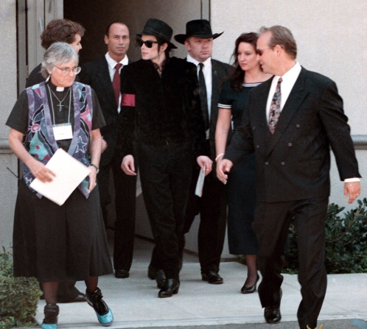

“Honoring my friend who is no longer here. Thank you, I love her.”

OCTOBER 12, 1997

JOHHANESBURG, SOUTH AFRICA

With just one concert remaining, Michael’s History tour was becoming a bittersweet memory. The gang eventually started coming to terms with the end of one of the biggest events in history. Final disclosure agreements, contracts, confidentiality agreements and statements were all discussed, stamped, certified and sealed. As time went on, Michael gradually adjusted to his life without the presence of one of his closest friends. He stopped sitting by the phone in his hotel rooms, staring at her pictures, losing hours and hours of sleep and no longer deprived himself of food and nutrition. With a lot of help from his favorite girls including Elizabeth, Michael learned to smile and regained his confidence again by taking care of himself the way he did before the horrific tragedy struck him in August. The girls spent every waking moment with Michael cheering him up more and more everyday by playing board games, watching cartoons, movies, having pillow fights, telling jokes and eating lots of delicious food and pastries.

While visiting the motherland, former President Nelson Mandela requested to meet the iconic Pop star and arranged to have afternoon tea with him. In an effort to console him for his loss, Mr. Mandela suggested to Michael that he purchase a home and move to South Africa in order to retrieve his lost health and happiness. Michael thanked Mr. Mandela for his thought and agreed to look into the matter possibly one day down the road. Mr. Mandela also invited Michael and Diana back to Johannesburg to celebrate his grandson’s fifth birthday in January. Michael humbly accepted the invitation as he happily agreed to visit the former president again in the new year. In an effort to announce the end of his tour, Mr. Mandela formed a small press conference in Michael’s honor thanking him for choosing his native country to visit and for his remarkable contributions made to the performing arts.

Nelson Mandela:

“He has made a great contribution to art, to music, and I am very happy that he is in our country.”

Michael Jackson:

“It is my pleasure. It is my honor to be here in South Africa. I love you people very much. I’ve had the time of my life here. I’ve had so much fun. I hate to leave and I’m definitely looking for a home here to buy because I would love to spend the rest of my life here. We are definitely coming in January and this is a wonderful, lovely man. I love Nelson Mandela very much and thank you for all your hospitality and all your love. Thank you very much.”

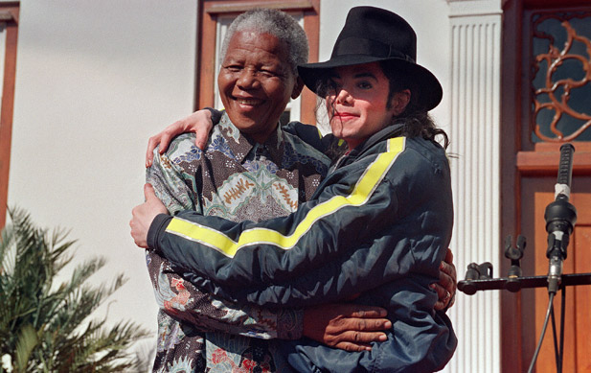

OCTOBER 15, 1997

FAIRMONT ZIMBALI RESORT
DURBAN, SOUTH AFRICA

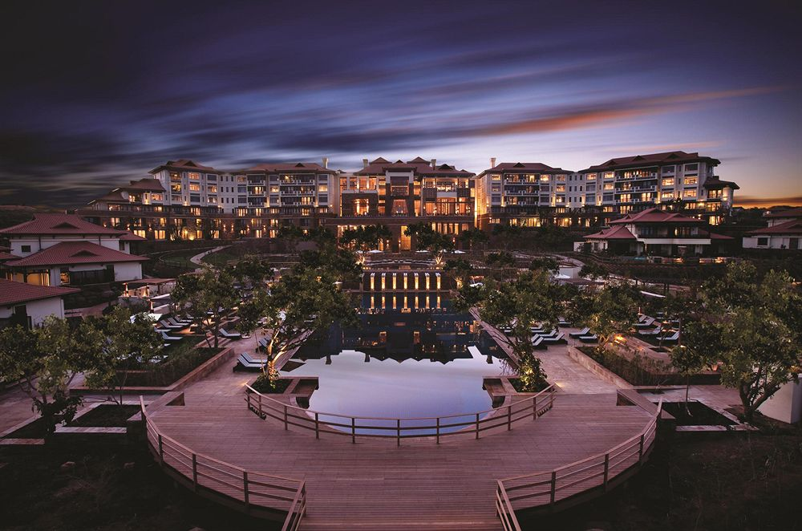

“This is it you two.” I said looking at the girls dressed in their final concert outfits. “It’s been one hell of a tour.”
“I’ll say!” Marie said coming out of her suite in a black dress and red flats. “We’ve certainly come a long way since we left Los Angeles.”
“I can’t believe it’s been five months.” Jasmine said. “We all gained and lost a few things but we managed to pull together and survive the storm.”
“Yes, we have. I’m glad that Michael is doing much better now too. Seeing him mourn is definitely not something I want to experience again anytime soon.”
“Especially on tour.” Marie added. “I really do miss her though.”
“We all do but I don’t think anyone misses her as much as Michael.” Jasmine said.

Chris knocked on the door ready to drive us to the venue. He had tears in his tears as he complimented me and the girls saying how beautiful we looked one more time.

“It’s been a pleasure driving you three ladies around Europe.” He said tipping his hat to us. “I will definitely miss you all.”
“Just because the tour is over doesn’t mean we won’t see each other again.” Marie said wondering why one of Michael’s most loyal employees would say such a thing.
“Didn’t Mr. Jackson tell you?”
“Tell us what?”
“I have decided to retire from my position as Mr. Jackson’s driver.”
“WHAT?!” We all screamed in unison.

“I thought you all knew!”
“NO! Michael never said a word about it.”
“I suppose he’s forgotten with everything he’s been through. I told him before we left Los Angeles. I also informed Mr. Talal about it.”
“Chris, we are really going to miss you!” I said as me and the girls gave him a group hug.
“All good things must come to an end.” He said with a half-smile. “It’s been wonderful knowing you three lovely young ladies.”
“Please tell me you will attend the wedding.”
“I most certainly will.”
“When is your last day with us?” Jasmine asked.
“My final task will be taking you three to the airport from here. I plan to stay here in Germany for a few more weeks to visit my family after that.”
“Oh, Chris. That soon?”
“I’m afraid so.”
“Do you know if Michael has found another replacement?”
“I’m sure he has but we have not discussed those details.”

Chris’s news made me feel sad all over again. Losing Diana was one thing but Chris’s retirement was another loss for all of us. I was happy he decided to retire but distressed over the fact that I wouldn’t see him again. In the past five months, he and I became quite close. The girls adored him and he always has such wonderful wisdom to provide. He was a father figure. A friend. An advisor. Someone we could call our own. Chris was never just Michael’s driver. To us, Chris was and will always be considered family.

MICHAEL’S FINAL CONCERT
KINGS PARK STADIUM
DURBAN, SOUTH AFRICA

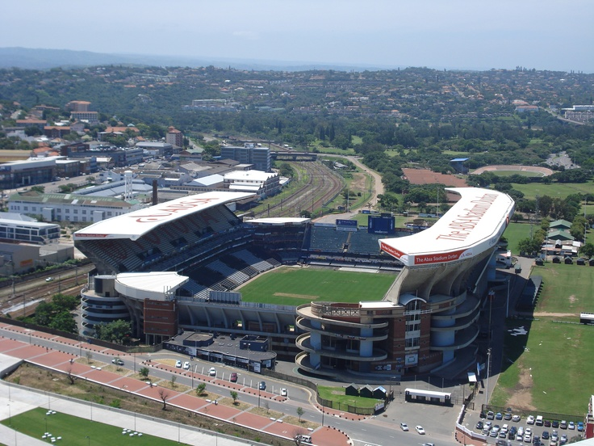

“I can’t believe this is the last time I’m ever going to wear this.” Michael said as I helped him button up his gold vest. “It feels so surreal.”
“I know it does, baby. I can’t tell you how proud I am of you.”
“You are?”
“Absolutely. You have been a very brave soldier during these past five months. You definitely are a warrior covered in rhinoceros skin. I am honored to be your fiancé. I love you very, very much.”
Michael smiled as tears began to prick his eyes. I kissed his cheek and applied his eyeliner to his left eye for the last time.
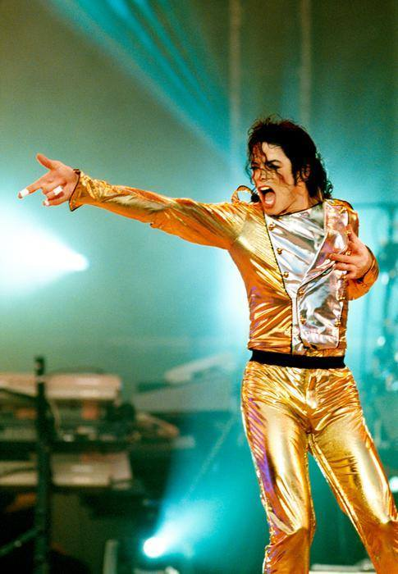
“Ready?” I asked giving him his helmet.
“As I’ll ever be.”
“Did you give the audio crew her picture?”
“Yes. Everything is set.”
“Perfect.”

I took Michael’s hand and walked with him towards the edge of the stadium tent. Michael and I hugged not wanting to let go of each other.

“I never would have made it these past five months without you.” He whispered in my ear. “You are my rock, Diana. My friend, my lover, my everything.”
“You are all of that and more to me, Michael.”
“Thank you for always believing in me.”
“A king never falls far away from his throne, Michael. And if by some chance he does, his queen is always be there to lift him up again.”
“I needed to hear that. Thank you.”
“You’re welcome. Now get in that space ship of yours and blow the roof off this sucker!”

He giggled and hugged me one more time.

“Good luck.”
“Diana?”
“Yes, baby?”
“Can I lick you?”

I laughed and rolled my eyes happy to know my fiancée had finally healed.

“Welcome back, space man.”
“I love you cupcake.”
“I love you too.”

He winked at me and left to take his position. I waited until he was no longer in sight then joined the girls at the edge of the stage for the last time.

“All good?” Jasmine asked.
“Perfect.”
“He’s ok?” Marie asked.
“Yes. He’ll be fine.”

In honor of her memory, Michael dedicated his last three concerts in South Africa to his best friend. Lady Diana’s picture appeared on the big screen behind him as Michael brought several children on stage during his final performance of ‘Heal the World’. He looked up and blew a kiss in the air telling his dear Princess that she was still very much alive inside of him. She was gone but certainly never forgotten and Michael made sure of it for the rest of his life.

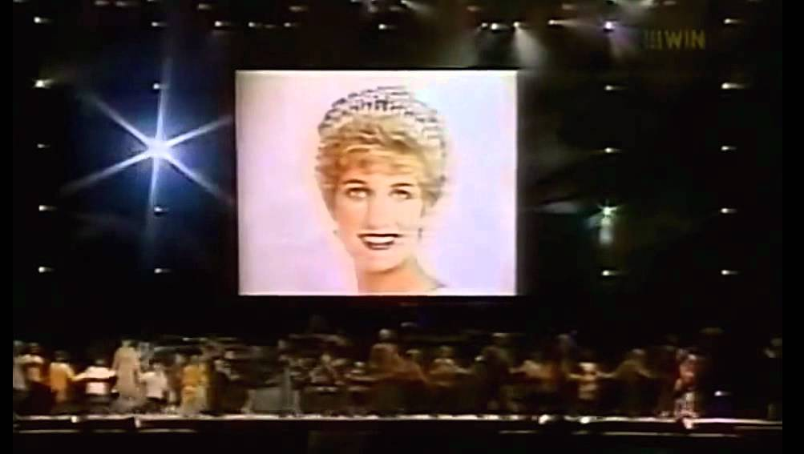

Michael’s last concert brought flash backs of the past five months to all of us. While the girls and I stood backstage watching and observing his every move and hearing his every word, each sequence brought to life had a wonderful memory behind it providing us all with a great sense of closure. We definitely had our share of tears, laughter, confusion, happiness and sorrow but one thing was for sure: if ever given the opportunity, we wouldn’t change a thing. We were a team. We were a family. We were, as of that moment, a part of history. Michael’s HIStory.

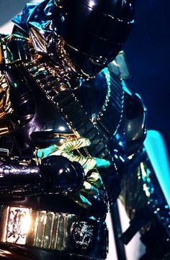

OCTOBER 17, 1997

“Welcome back, Mr. Jackson.”
“Thank you. How is he?”
“Wonderful thanks to you and your organization.”
“Can I see him?”
“Absolutely. Follow me.”

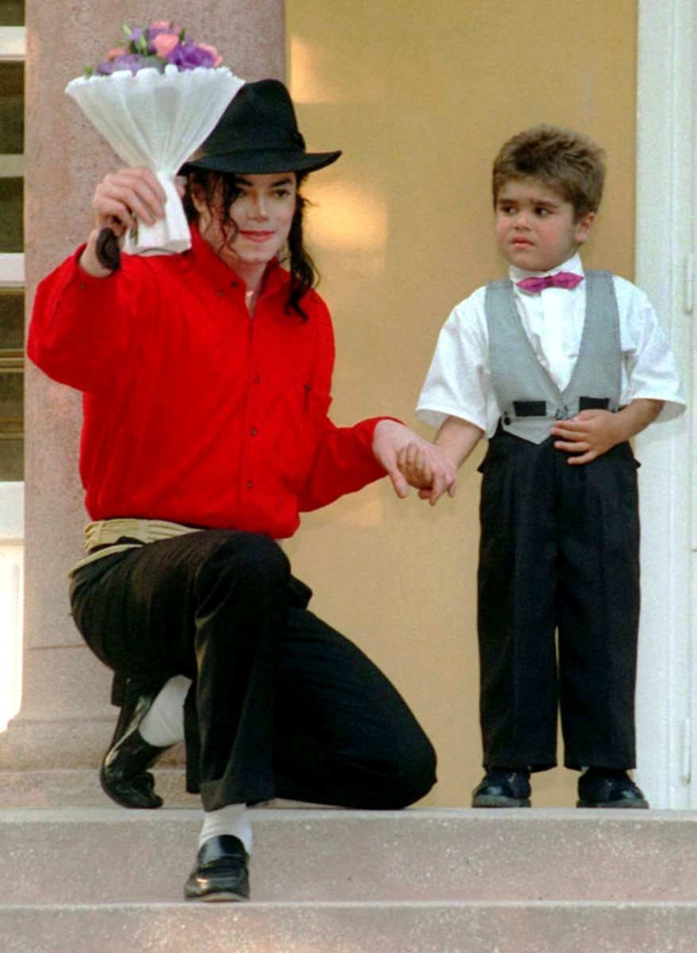
Two days after his last concert, Michael’s wish came true. A perfectly healthy liver was found for Bela resulting in a successful operation giving the little boy who, at one point, only had a year to live an opportunity to begin a fresh and wonderful start to his new life. Once the tour came to a close, all but one of Michael’s contractual obligations with Kingdom International and TSG had been honored. He returned to the Children’s Hospital in Bremen once more to meet the happy and healthy little boy he helped save before leaving Europe to return to Los Angeles. As he and Dr. Amberg made their way to Bela’s ward, Michael was surprised to see the little bundle of joy running around and no longer confined to a bed. Bela saw Michael walking towards him and quickly ran across the hall jumping playfully in his arms.

“How’s my favorite little man?”
“Good.”
“You are more handsome than me and getting bigger and stronger too!”
“Thank you.”
“For what?”
“Being my super hero friend.”

Michael’s eyed filled as the little boy wrapped his arms around his neck. He kissed Michael’s nose and he returned the gesture as they both giggled and tickled each other in the hallway. Dr. Evans saw Michael from across the room and came over to see him adding to his already fabulous day by giving him more good news.

“You’ll be happy to know that your other little angel is also progressing quite well.”
“Angela? Really? She is?”
“Yes. She is responding to treatments very well.”
“Can I see her?”
“I’m afraid she is no longer here.”
“Where did she go?”

“Home. With her family. After your second trip, her mother finally realized how important it was to be a part of her daughter’s life. She came to visit her regularly. Once Angela was strong enough to be on her own, she was discharged.”
“That’s wonderful. Diana will be so happy to hear that.”
“She didn’t join you today?”
“She planned to but her coworkers roped her into one more girl’s day before we leave for Los Angeles.”

“Thank you again for everything.” Dr. Amberg said coming out of the children’s play room. “Your generosity and contributions to this hospital will never be forgotten, Mr. Jackson.”
“I’m just fulfilling my duty, Dr. Amberg.” Michael said smiling humbly. “I don’t need to be thanked for any of this. Children are our future. Without them, there would be no us.”
“We both concur.” Dr. Evans said as she stood next to her Chief of Staff. “We hope that you will visit us again one day.”
“I plan to. Please give my best to Angela.”
“We will.”

Michael said goodbye to Bela and hugged him once more. Dr. Amberg said he would be kept under observation for a few more days then, if all goes well, Bela would be discharged and live with his mother and grandmother in Hungary. As Michael watched the little boy walk to his room with Dr. Evans to take his medicine, a phantom wind howled in his ear.

“Congratulations, Michael. You did it.”
“No, WE did it. You have no idea how much I miss you.”
“Stay strong. I shall always be with you.”
“Thank you for helping me save his life.”
“I was just fulfilling my duty. I love you, my crystal gloved friend.”
“I love you too.”
“Goodbye.”
“Goodbye, Princess.”

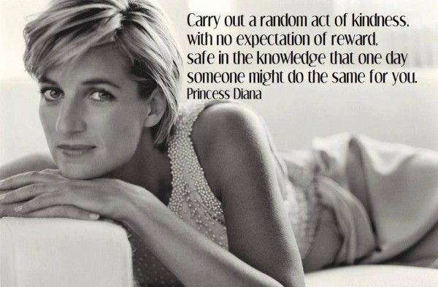

“Ana, now that the tour is over, you need to tell Michael your secret.”
“I know, Jas.”
“Given the circumstances, I think it will make him feel better too.”
“I was thinking the same thing. Thank you for telling David not to say anything.”
“I didn’t say a word. He knew not to open his mouth.”
“I’m nervous, Jasmine.”
“Don’t be. Everything will be fine.”
“That’s the last of our bags!” Marie said as she and Chris stood by the hotel suite door. “The time has come to officially say goodbye to Europe.”

I tried my hardest to hold back tears all day but as soon as we left the suite, my eyes instantly filled. As we entered the elevator, I looked to my right and remembered the ‘butt print’ and giggled to myself as tears of happiness streamed down my face. Marie and Jasmine put their hands on my back and comforted me as we way made our way down to the lobby.

“Did Michael call?”
“Yes, Miss Diana. He and Waleed have safely reached the airport and are waiting for us to arrive.”
“I’m glad he made it. I don’t even want to think about the amount of people there right now.”
“We’ll zip in and out of there in no time.” Marie said as she took a few last minute photos with her camera. “I am definitely going to miss those red carpets.”
“You and me both!” Jasmine said posing for Marie to take her picture.

The girls and I were stunned at the sizeable amount of paparazzi and photographers invading the airport when we arrived. As usual, Michael’s guards stood by the limousine door waiting for their signal to let us out. As soon as Chris exited the vehicle, we all cried tears of happiness. He had successfully completed his final task – driving the girls and I to the airport.

“No tears, Miss Diana.” He said as he wiped them from my face. “I wish you and Mr. Jackson the very best.”
“You can call me Michael now.” He said approaching us at the runway.
“Oh, no sir. I couldn’t possibly.”
“It’s an order from your ex-boss.”
“Maybe one day.”
“I’m really going to miss you, Chris.”
“And I you, Michael.”

Hearing his best friend’s words come out of Chris’s mouth made Michael tear up. Although she was no longer with him, it amazed Michael how Diana’s spirit still lingered amongst the people that he loved. He knew in that moment she would truly ‘always be with him.’

“You’re staying in Germany?” Jasmine asked as she hugged him for the last time.
“For now, yes. I have family here that I haven’t seen in quite some time.”
“Please keep in touch with us.” Marie said as she too hugged him for the last time. “I won’t forget what you said about being with me had you been 20 years younger.”
“Perhaps in the next life, Miss Marie.”
“If I’m not already taken.” She replied looking directly at Michael making him smile and blush.
“AHEM! WE HAVE A FLIGHT TO CATCH!” I said feeling incredibly jealous.

“You know I’ll always be yours.” Michael said as he kissed my forehead.
“Yeah, yeah. Goodbye, Chris. We will never forget you.”
“Nor I, Miss Diana. I wish you all a safe and pleasant flight home.”
“We love you, Chris.” Michael said hugging his now ex-employee.
“The feeling is mutual, sir.”
“Always formal even at the very last minute.”
“Not this time. I wish you all the happiness in the world. Congratulations Michael and Diana.”

The four of us smiled and cried at the same time. Waleed signaled Michael from the plane saying he needed to board as the aircraft was now ready for takeoff. We stood there on the runway and watched Chris as he sat in the driver’s seat of the limo and drove away exiting the airport terminal. The final rule in Michael’s and my contractual agreement with Kingdom was that he and return to Los Angeles separately. However, feeling incredibly generous and somewhat sentimental, Waleed surprisingly offered to bend his own rule allowing for Michael and I to fly back home together. We both decided it would be best to adhere to the term and mutually agreed to honor the final clause in an effort to maintain TSG’S and Kingdom International’s code of ethics. Waleed, impressed by my level of professionalism shook mine and the girls’ hands before boarding the aircraft.

“It’s been a pleasure working with you, Miss Dean.”
“I’m glad to hear that.”
“May we do this again someday.”
“Perhaps. If the future allows it.”

Our own flight was also prepared for takeoff. The girls said goodbye and hugged Michael as they headed and boarded the plane. Waleed also boarded leaving Michael and I alone at the top of his flight deck.

“I’ll see you in the morning.” He said kissing my forehead.
“I’m looking forward to it.”
“I guess I’ll need a tuxedo really soon.”
“Indeed, Mr. Jackson.”
“I can’t wait to make you my wife.”

“There’s something I need to tell you when we get home.”
“About what?”
“Me.”
“What ABOUT you, Diana?”
“I can’t say right now. Just know that we need to have a talk before we start planning the wedding.”

Michael’s face went from calm to concerned.
“Please don’t tell me you’re having second thoughts.”
“No, not at all. We’ll talk tomorrow. Enjoy your flight.”
“I love you.”
“I love you too.”

We kissed and hugged before I walked down the stairs and watched Michael and his guards boarded the plane. As the flight deck folded itself, the door closed and the aircraft slowly made its way to the end of the runway. I boarded our flight and sat next to the girls who were making good use of what was left of their European business trip by drinking champagne out of fluted glasses and eating chocolate covered strawberries.

“I am definitely going to miss this!” Jasmine said taking a big bite out of the ripened fruit.
“Me too! I wish we could take these home with us!”
“We have strawberries in America too, Marie!”
“I know. But they don’t taste as good as these ones!”
“I guess that means TSG will have to bring us back!” Jasmine said as if she were giving me a hint about a potential holiday.

“Don’t even think about it. We have five months’ worth of catching up to do at the office, not to mention plan the wedding and clean up Michael’s mess with Lisa Marie and Gerwin.”
“More importantly, we have to pick out what you’ll be wearing UNDERNEATH your dress!”
“I’m saving that part for the honeymoon.”
“OOOOH! DON’T HURT ‘EM ANA!” Jasmine yelled.
“I think Michael would enjoy it.” Marie added.
“YOU TWO ARE TERRIBLE AND YES, I LOVE YOU ANYWAY!”

As both flights departed the Bremen International Airport runway, Michael and Diana had no sign of the upcoming storm that was fiercely brewing. While the sounds of wedding bells rung in their ears, Michael had a brand new turn of events pre written in his fate. An unforeseen turn that would definitely leave things upside down and inside out. A turn that was quickly coming his way without any warning signs. A turn that would morph into a lethal twister ready to devour and destroy anything that came in its way specifically targeted to attack Michael’s most important and loveable asset.

CAPITAL RECORDS
LOS ANGELES, CALIFORNIA
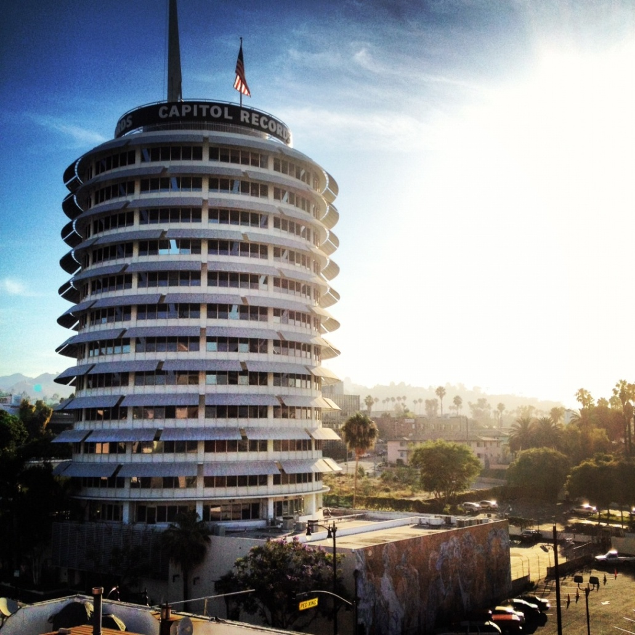

“Welcome back.”
“Thank you, sir.”
“What do you have for me?”
“She has officially left Europe. Her flight is scheduled to arrive tomorrow morning via LAX.”
“Did you do what I asked?”
“Of course, sir.”
“Are you sure she will get the message?”
“Her office administrator took it. She said she would give it to her right away.”
“Excellent. I expect her to call back sometime tomorrow afternoon.”
“Is there anything else you’d like me to do?”
“Pray that she calls. Otherwise you will be looking for employment elsewhere.”
“I understand, sir.”
“That woman has been in my radar for quite some time. I need to rescue her from that weirdo she calls a fiancée and I need to do it as soon as possible.”
“I left the message and your business card at the front desk. I have no doubt that she will be intrigued and will call you upon her arrival.”
“You may leave now.”
“Thank you, sir.”
“Thank YOU, Erica.”

“Ugh, this is going to be one long ass flight!” Jasmine said stretching out her legs in her oversized chaise style plush seat.
“Go to sleep. Time will go by faster!” Marie said closing her eyes and putting on an eye patch.
“You have to admit, this trip was definitely worth it.”
“For sure, Ana. I just wish we had a much happier ending.”
“I know. I’m glad we tied up all of our loose ends on time. I just hope we didn’t forget to do anything important in Germany.”

“OH SNAP!” Marie yelled. “I totally forgot. Ana you had a message left for you at the front desk at the hotel in Bremen.”
“I did?”
“I was in the lobby taking some last minute pictures and the lady at the desk gave it to me asking to pass it onto you.”
“Who is it from?”
“I don’t remember.” Marie said rummaging through her purse trying to find it.
“AH! Here it is.” Marie handed me a pink piece of paper and a business card.

Cameron T. Garivey
CEO
Capital Records
310-415-7544

The message written on the pink paper said to call his office and set up a meeting with him. I had never seen or heard of this man before. I also had no clue why he wanted to see ME of all people.

“Have either of you girls heard of Cameron Garivey?”
Jasmine spit out her champagne and almost choked to death.

“HE CALLED YOU?!” She asked shocked out of her mind.
“Who is he?”
“HE’S SO DAMN HOT!” Jasmine yelled.
“You think every guy is hot!” Marie said rolling her eyes.
“THANK YOU, MARIE! I didn’t ask what he looked like Jasmine. I asked who he is.”
“He’s the CEO of Capital Records.”
“I can see that on his card.”
“Ana, he’s loaded to the max.” Jasmine said wiping her face with a napkin. “He is your match when it comes to the world of business.”
“So in other words, he’s my competitor. I’ve never heard of him before. He can’t be new. Capital has been around longer than TSG.”
“Yes and before you came along they were number one in music production and event coordination for more than ten years.”
“So this Mr. Garivey is pouty that a woman has beaten him at his own game. This will be a very interesting meeting.”
“You’re actually going to SEE HIM?” Jasmine asked.
“Of course. I take great pleasure in reminding men in this business who really runs the show. If it can work on Waleed, it can work on this guy too.”

OCTOBER 18, 1997

LAX AIRPORT INTERNATIONAL ARRIVAL TERMINAL
LOS ANGELES, CALIFORNIA

After the longest 14 hours of our lives and feeling completely enclosed by airplane congestion, the girls and I finally arrived and were more than happy to be back in Los Angeles. As always, Michael’s fans and media reporters swarmed the airport from all ends with banners welcoming the King of Pop home again after a five month hiatus.

“It’s great to be home!” Marie said.
“Indeed!” Jasmine said. “When is Michael arriving?”
“Another hour or so. He had a two hour layover in Amsterdam.”
After touching down on time and passing through security, the girls and I noticed our TSG guards waiting for us at the arrival gate and had all of our belongings with them. They greeted us with warm hellos and welcomed us back as we rushed past the fans and dozens of reporters trying to get as much information as possible about Michael’s tour and his best friend’s untimely passing.

“I guess I better call this guy back now.” I said eyeing Cameron’s business card again.

I dialed the number on the card and a young sounding receptionist answered. I gave her my name and she confirmed my meeting with the CEO for tomorrow morning at 9.

“Ana, isn’t that too early? I mean we just got back and we’re all really jet legged.”
“I might as well get it over with. I’m very curious to know why he wants to see me.”
“Will you tell Michael about him?”
“Why wouldn’t I?”
“I think he might get suspicious.”
“Of ME?”
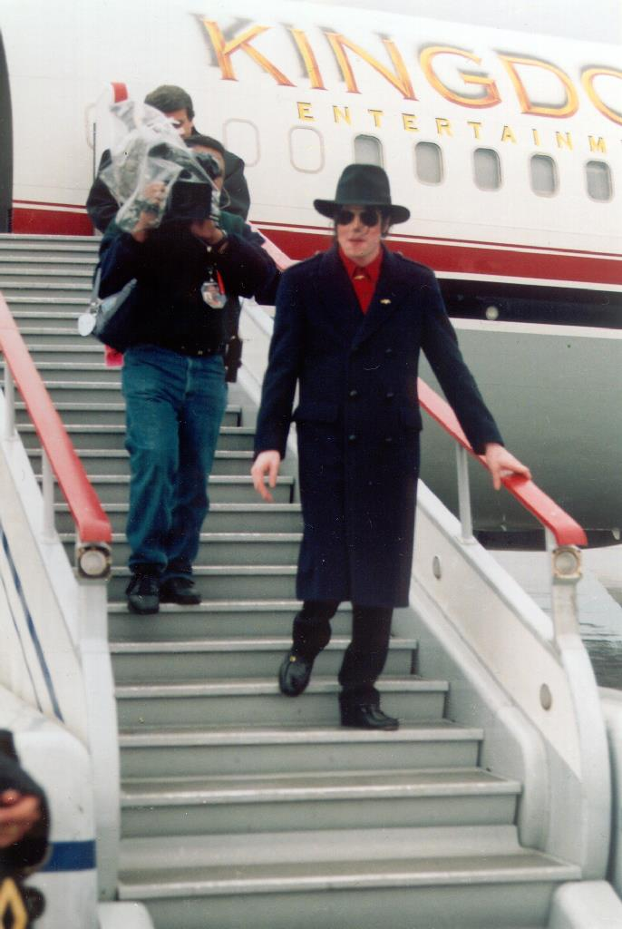
“No, him.” Jasmine explained. “Cameron Garivey is your equal when it comes to your career. He’s also REALLY REALLY handsome. Michael might feel jealous or intimidated.”
“My baby doesn’t get jealous.” I said. “Besides, these rocks on my fingers aren’t just for show. I wear them with pride and for good reason. I’m not going anywhere unless it’s with Michael and he knows it.”
“Just be careful.”
“I will. You two get some rest. I’ll call you both tomorrow. ”

Our TSG guards graciously helped with my luggage and carried them inside and into my living room. After thanking them for their wonderful service, I tipped them as a courtesy making them very happy. A few hours later, Michael called saying he arrived at Neverland. He sounded exhausted and said he didn’t want to do anything but rest. I mentioned my meeting with Cameron to him and he was pleased to hear that another successful businessperson wanted to meet me. I smiled knowing he kept an open mind and didn’t object to me going to see someone who, according to Jasmine was ‘my career match’.

After unpacking some of my things, I took a bath and went straight to bed. As soon as my head hit the satin lined pillow, thoughts of Mr. Garivey came to mind. So many questions floated around in my head. Why did he want to meet me? Why hadn’t I heard of him before? How did he know where I was? Why did he wait so long to contact me?

“Good morning. I’m here to see Mr. Garivey.”
“Your name?”
“Diana Dean.”
“Please take a seat. I’ll see if he’s available.”

To my surprise, Mr. Garivey had extremely attractive women working for him. Not one of them looked bigger than a size three and all of them had flawless looking hair and makeup. It was apparent to me that Mr. CEO had enormously high standards.

“Mr. Garivey will see you now.” A young blonde goddess said as she walked me towards his office.

THE END!

PART THREE IS CURRENTLY IN THE DEVELOPING STAGES!
THANK YOU FOR READING!
I LOVE YOU ALL!

